Supplementary materials

Three-step modal assignment approach; Inverse-probability-of-treatment weighting (IPTW)
- First, patients assigned were assigned to latent classes (clusters) by modal assignment based on posterior probability. Second, the IPTW approach was used to create a pseudo-population in which the baseline characteristics of the patient clusters were approximately the same. The pseudo-population is a weighted population in which there is no confounding covariates and the treatment assignment are independent of each other. Finally, weighted regression models were fitted to assess the endpoints of interest. The three additional exploratory clusters were defined as detailed in the Methods.

Multivariable regression models
For each type of healthcare resource utilization (HRU), the presence of dispersion and excess zeros was assessed and appropriate models employed to account for either or both circumstances. For all-cause hospitalizations, nasal polyps (NP)–related emergency department visits, and other visits, incidence rate ratios (IRR) were estimated using zero-inflated Poisson regression models, weighted by stabilized IPTW and adjusted for residual confounding and selection bias. For NP-related hospitalizations, IRR were estimated using weighted Poisson regression models, and further adjusted for residual confounding and selection bias. For all other HRU types, IRR were estimated using weighted zero-inflated negative binomial regression models and again adjusted for residual confounding and selection bias.

Supplementary Figure 1. Patient eligibility criteria
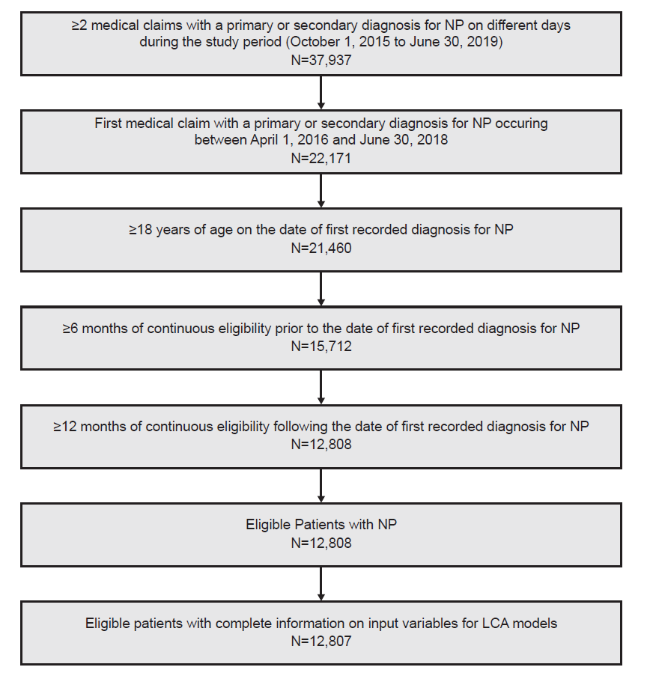
LCA, latent class analysis; NP, nasal polyps.

Supplementary Table 1. Input variables used to identify patient clusters
Category | Variable
Demographic characteristics | Age at index date (18–30 years, 31–40 years, 41–50 years, 51–64 years, 65–74 years, ≥75 years)
Demographic characteristics | Sex (male, female)
Allergic eosinophilic, or inflammatory comorbidities* | Allergic rhinitis
Allergic eosinophilic, or inflammatory comorbidities* | Asthma (mild/moderate, severe, none)†
Allergic eosinophilic, or inflammatory comorbidities* | Chronic obstructive pulmonary disease
Allergic eosinophilic, or inflammatory comorbidities* | Inflammatory bowel disease
Allergic eosinophilic, or inflammatory comorbidities* | Rheumatoid arthritis
Allergic eosinophilic, or inflammatory comorbidities* | Aspirin-exacerbated respiratory diseases
Allergic eosinophilic, or inflammatory comorbidities* | Atopic dermatitis
Allergic eosinophilic, or inflammatory comorbidities* | Psoriasis
Allergic eosinophilic, or inflammatory comorbidities* | Hashimoto's thyroiditis
Allergic eosinophilic, or inflammatory comorbidities* | Allergic fungal rhinosinusitis
Allergic eosinophilic, or inflammatory comorbidities* | Eosinophilic esophagitis
Allergic eosinophilic, or inflammatory comorbidities* | Cystic fibrosis
Allergic eosinophilic, or inflammatory comorbidities* | Graves' disease
Allergic eosinophilic, or inflammatory comorbidities* | Multiple sclerosis
Allergic eosinophilic, or inflammatory comorbidities* | Lupus
Allergic eosinophilic, or inflammatory comorbidities* | Myasthenia gravis
Allergic eosinophilic, or inflammatory comorbidities* | Chronic inflammatory demyelinating polyneuropathy
Allergic eosinophilic, or inflammatory comorbidities* | Guillain-Barré syndrome
Oral corticosteroid‡ | Any use
Oral corticosteroid‡ | ≥7.5 mg prednisone-equivalent for >90 days
Oral corticosteroid‡ | ≥4 courses
Intranasal corticosteroids‡ | Any use
Intranasal corticosteroids‡ | Duration of treatment (none, ≤60 days, 61–180 days, 181–365 days)
Oral antibiotics‡ | Any use
Oral antibiotics‡ | Number of courses (0, 1, ≥2)
Montelukast‡ | Any use
Montelukast‡ | Duration of treatment (none, ≤60 days, 61–180 days, 181–365 days)
Surgery | Any NP surgery within 6 months of the index date
Surgery | Any NP surgery within 12 months of the index date
Surgery | Number of NP surgeries within 12 months of the index date (0, 1, ≥2)
*Allergic, eosinophilic, or inflammatory comorbidities were identified using ICD-10-CM diagnosis codes and evaluated during the evaluation period (spanning the 6 months prior to and the 12 months after the first diagnosis of NP). †Patients were considered to have severe asthma if they had any claims for medium to high dose inhaled corticosteroids/long-acting beta-agonists, identified using GPIs, consistent with treatment strategies for GINA 4 and GINA 5 patients, as outlined in GINA asthma treatment strategy.¹⁷ ‡Medications were identified using GPI and HCPCS codes and evaluated during the 12-month period following the first observed diagnosis of NP. Duration of treatment was defined as the continuous period starting on the day of the first claim for a medication class to the last day of supply or administration claim of any medication of the same class. Discontinuation of a NP medication class was defined by a gap in supply or administration ≥60 days.
GINA, Global Initiative for Asthma; GPI, Generic Product Identifier; HCPCS, Healthcare Common Procedure Coding System; ICD-10-CM, International Classification of Diseases, Tenth Revision, Clinical Modification; NP, nasal polyps.

Supplementary Table 2. Identification and characterization of CRSwNP clusters
 | 8-Cluster LCA Model | 7-Cluster LCA Model | 6-Cluster LCA Model | 5-Cluster LCA Model | 4-Cluster LCA Model | 3-Cluster LCA Model | 2-Cluster LCA Model
BIC* | 52879.0 | 55627.0 | 59704.5 | 64869.0 | 71440.4 | 79577.4 | 91396.2
AIC† | 50261.3 | 53337.4 | 57743.1 | 63235.7 | 70135.3 | 78600.5 | 90747.4
Entropy‡ | 1.0 | 1.0 | 1.0 | 1.0 | 1.0 | 1.0 | 1.0
*The BIC is a penalized-likelihood criterion that estimates the posterior probability of an LCA model being correct. Lower BIC values correspond to a parsimonious and correct model. †The AIC is a penalized-likelihood criterion that estimates the relative distance between the unknown true likelihood function of the data, and the fitted likelihood function the LCA model. Lower AIC values correspond to a parsimonious and correct model. ‡Entropy is a model-based metric for measuring the degree of accuracy with which an LCA model assigns individuals into a cluster. Values range from 0–1, with values closer to 1 indicating a more precise assignment and less classification error.
AIC, Akaike information criterion; BIC, Bayesian information criterion; CRSwNP, chronic rhinosinusitis with nasal polyps; LCA, latent class analysis.

Supplementary Table 3. Original unweighted baseline patient characteristics for CRSwNP patient clusters
 | Cluster 1  (reference)  N=4076 | Cluster 2  N=2201 | Cluster 3  N=2093 | Cluster 4  N=3168 | Cluster 5  N=1269
Age, mean (SD) | 60.3 (16.9) | 60.1 (16.5) | 57.2 (15.6)* | 55.2 (16.7)* | 52.0 (15.8)*
Female sex, n (%) | 1630 (40.0) | 794 (36.1) | 1016 (48.5)* | 1165 (36.8) | 573 (45.2)*
Allergic, eosinophilic, or inflammatory comorbidities,† n (%)
Allergic rhinitis | 841 (20.6) | 461 (20.9) | 725 (34.6)* | 840 (26.5)* | 547 (43.1)*
Asthma | 631 (15.5) | 308 (14.0) | 772 (36.9)* | 448 (14.1) | 456 (35.9)*
COPD | 359 (8.8) | 217 (9.9) | 271 (12.9)* | 285 (9.0) | 182 (14.3)*
Medication usage, n (%)
OCS | 746 (18.3) | 487 (22.1) | 792 (37.8)* | 953 (30.1)* | 616 (48.5)*
INCS | 329 (8.1) | 762 (34.6)* | 600 (28.7)* | 684 (21.6)* | 413 (32.5)*
Oral antibiotics | 597 (14.6) | 412 (18.7)* | 530 (25.3)* | 702 (22.2)* | 418 (32.9)*
Montelukast | 103 (2.5) | 70 (3.2) | 1,056 (50.5)* | 150 (4.7)* | 603 (47.5)*
All-cause HRU, mean (SD)
Hospitalizations | 0.06 (0.28) | 0.05 (0.22) | 0.06 (0.30) | 0.05 (0.24) | 0.05 (0.28)
ED visits | 0.43 (1.33) | 0.37 (1.08) | 0.54 (1.73) | 0.59 (1.83) | 0.72 (3.67)*
Outpatient visits | 7.86 (10.40) | 7.51 (9.58) | 8.17 (9.65) | 7.45 (8.37) | 8.00 (9.56)
Other visits‡ | 1.34 (5.26) | 1.50 (6.65) | 1.60 (5.90) | 1.32 (5.14) | 1.68 (7.92)
Healthcare costs, USD,§ mean (SD) | 16,765 ($46,605) | 15,205 (36,051) | 17,837 (44,249) | 15,878 (40,453) | 17,752 (37,712)
Hospitalizations | 3345 (29,881) | 2261 (11,622) | 3000 (19,044) | 2234 (12,672) | 2812 (16,891)
ED visits | 1617 (4683) | 1672 (7575) | 2211 (8016) | 1804 (5553) | 2177 (8150)
Outpatient visits | 8112 (23,338) | 6913 (22,380) | 7318 (14,635) | 8025 (30,335) | 7989 (18,327)
Other visits‡ | 1030 (9701) | 855 (4184) | 801 (3510) | 708 (3813) | 862 (6731)
Pharmacy | 2660 (13,439) | 3504 (17,465) | 4506 (19,531)* | 3108 (11,600) | 3911 (11,390)
*Standardized differences comparing each NP patient cluster (ie, NP clusters 2–5) with the reference cluster (NP cluster 1). For each variable, a standardized difference less than 10% was considered to be an inconsequential imbalance between clusters under comparison, per Austin 2009. Standardized differences greater than 10% in magnitude are denoted with "*". †Allergic, eosinophilic, or inflammatory comorbidities were identified using ICD-10-CM diagnosis codes. ‡Other visits included but were not limited to home/hospice care visits and visits at nursing facilities. §Cost values were from the payer perspective and inflated to 2019 USD.
COPD, chronic obstructive pulmonary disease; CRSwNP, chronic rhinosinusitis with nasal polyps; ED, emergency department; HRU, healthcare resource utilization; ICD-10-CM, International Classification of Diseases, Tenth Revision, Clinical Modification; INCS, intranasal corticosteroids; OCS, oral corticosteroids; SD, standard deviation; USD, US dollars.

Supplementary Table 4. Original unweighted patient characteristics for nonsurgery, NP surgery, and high-cost NP surgery clusters
 | Nonsurgery clusters*  N=8370 | NP surgery clusters†
 | Nonsurgery clusters*  N=8370 | NP surgery cluster  N=4437 | High-cost NP surgery cluster‡  N=888
NP surgeries during the observation period n (%)
0 | 7864 (94.0) | 0 (0.0) | 0 (0.0)
1 | 493 (5.9) | 3967 (89.4) | 691 (77.8)
≥2 | 13 (0.2) | 470 (10.6) | 197 (22.2)
NP surgery type, n (%)
FESS | 471 (5.6) | 4167 (93.9) | 872 (98.2)
Balloon sinuplasty | 81 (1.0) | 794 (17.9) | 175 (19.7)
Polypectomy | 29 (0.3) | 385 (8.7) | 67 (7.5)
Other procedures | 5 (0.1) | 55 (1.2) | 10 (1.1)
Comorbidities during the study period, n (%)
Allergic rhinitis | 5226 (62.4) | 3009 (67.8) | 659 (74.2)
Severe asthma | 445 (5.3) | 283 (6.4) | 77 (8.7)
COPD | 2021 (24.1) | 984 (22.2) | 170 (19.1)
Allergic fungal rhinosinusitis | 55 (0.7) | 84 (1.9) | 34 (3.8)
Cystic fibrosis | 33 (0.4) | 27 (0.6) | 14 (1.6)
NP medication usage during the observation period, n (%)
OCS | 5104 (61.0) | 3350 (75.5) | 728 (82.0)
INCS | 3703 (44.2) | 1970 (44.4) | 383 (43.1)
Oral antibiotics | 3503 (41.9) | 2205 (49.7) | 469 (52.8)
Montelukast | 2445 (29.2) | 1457 (32.8) | 374 (42.1)
*Combined clusters 1, 2, and 3 (no NP surgeries within 12 months of NP diagnosis). †Combined clusters 4 and 5 (≥1 NP surgery within 12 months of NP diagnosis). ‡Annual total NP-related costs in the ≥80th percentile of total NP-related costs ($23,260).
COPD, chronic obstructive pulmonary disease; FESS, functional endoscopy sinus surgery; INCS, intranasal corticosteroids; NP, nasal polyps; OCS, oral corticosteroids.

Supplementary Table 5. Original unweighted sample all-cause and NP-related HRU and healthcare costs for combined CRSwNP patient clusters
 | Nonsurgery clusters*  N=8370 | NP surgery clusters†
 | Nonsurgery clusters*  N=8370 | NP surgery cluster  N=4437 |  | High-cost NP surgery cluster‡  N=888
All-cause HRU, annual, mean (SD) |  |  | p-value§ |  | p-value§
Hospitalizations | 0.15 (0.46) | 0.14 (0.42) | 0.395 | 0.17 (0.52) | 0.942
ED visits | 0.96 (2.34) | 1.22 (4.48) | <0.001 | 1.57 (8.29) | <0.001
Outpatient visits | 18.50 (18.55) | 19.95 (16.13) | <0.001 | 22.36 (17.36) | <0.001
Other visits | 3.59 (10.70) | 3.51 (11.66) | 0.777 | 3.38 (10.98) | 0.300
NP-related HRU, annual, mean (SD)
Hospitalizations | 0.01 (0.08) | 0.01 (0.09) | 0.230 | 0.03 (0.15) | <0.001
ED visits | 0.06 (0.28) | 0.08 (0.34) | <0.001 | 0.11 (0.48) | <0.001
Outpatient visits | 1.89 (2.50) | 3.03 (2.26) | <0.001 | 4.30 (3.10) | <0.001
Other visits | 0.11 (1.34) | 0.13 (0.81) | <0.001 | 0.13 (0.66) | <0.001
NP surgery-related HRU, annual, mean (SD)
Hospitalizations | 0.00 (0.01) | 0.01 (0.07) | <0.001 | 0.02 (0.12) | <0.001
ED visits | 0.00 (0.01) | 0.01 (0.08) | <0.001 | 0.01 (0.09) | <0.001
Outpatient visits | 0.03 (0.15) | 0.76 (1.06) | <0.001 | 1.23 (1.77) | <0.001
Other visits | 0.00 (0.22) | 0.03 (0.19) | <0.001 | 0.01 (0.15) | 0.002
All-cause healthcare costs, annual, USD║, mean (SD) | 17,322 (36,275) | 32,627 (40,112) | <0.001 | 57,807 (52,727) | <0.001
Hospitalizations | 2885 (12,007) | 3036 (12,562) | 0.437 | 4404 (16,318) | 0.852
ED visits | 1727 (5,070) | 1918 (5,765) | 0.022 | 2294 (5,583) | 0.002
Outpatient visits | 8425 (22,967) | 22,630 (24,876) | <0.001 | 44,217 (29,739) | <0.001
Other visits | 957 (5513) | 1122 (6172) | 0.028 | 1126 (5608) | 0.880
Pharmacy | 3328 (14,168) | 3922 (17,164) | <0.001 | 5767 (25,389) | <0.001
NP-related healthcare costs, annual, USD║, mean (SD) | 1723 (4747) | 15,585 (13,125) | <0.001 | 36,218 (13,790) | <0.001
Hospitalizations | 180 (2087) | 356 (3713) | 0.217 | 1368 (7924) | <0.001
ED visits | 104 (847) | 204 (1887) | <0.001 | 437 (3582) | 0.001
Outpatient visits | 1335 (3842) | 14,744 (12,836) | <0.001 | 34,108 (14,310) | <0.001
Other visits | 48 (798) | 223 (1479) | <0.001 | 222 (2210) | <0.001
Pharmacy | 56 (252) | 58 (236) | <0.001 | 82 (289) | <0.001
NP surgery-related healthcare costs, annual, USD║, mean (SD) | 622 (3188) | 14,397 (12,504) | <0.001 | 33,845 (13,276) | <0.001
Hospitalizations | 2 (197) | 250 (3021) | <0.001 | 959 (6403) | <0.001
ED visits | 5 (335) | 141 (1842) | <0.001 | 307 (3514) | <0.001
Outpatient visits | 608 (3159) | 13,817 (12,431) | <0.001 | 32,419 (13,962) | <0.001
Other visits | 7 (221) | 190 (1374) | <0.001 | 160 (1963) | 0.002
*Combined NP Clusters 1, 2, and 3 (no NP surgeries within 12 months of NP diagnosis). †Combined NP Clusters 4 and 5 (≥1 NP surgery within 12 months of NP diagnosis). ‡Annual total NP-related costs in the ≥80th percentile of total NP-related costs ($23,260). §p-values were calculated using Wilcoxon rank sum tests. ║Costs are measured in 2019 USD.
CRSwNP, chronic rhinosinusitis with nasal polyps; ED, emergency department; HRU, healthcare resource utilization; NP, nasal polyps; SD, standard deviation; USD, US dollars.

