Variant angina is associated with myocarditis
Xin Xu^{1,2}, James Jiqi Wang^{1,2}, Hu zhao^{1,2}, Kun Miao^{1,2}, Guanglin Cui^{1,2}, Yuxuan Zhang^{1,2}, Xiaoyun Yang^{1,2}, Junfang Wu², Dao Wen Wang^{1,2}

¹Division of Cardiology, Department of Internal Medicine, Tongji Hospital, Tongji Medical College, Huazhong University of Science and Technology, Wuhan, China. ²Hubei Key Laboratory of Genetics and Molecular Mechanism of Cardiological Disorders, Wuhan, China.

Corresponding authors:
Dao Wen Wang, MD, PhD and Junfang Wu, MD, PhD
Division of Cardiology, Department of Internal Medicine
Tongji Hospital, Tongji Medical College
Huazhong University of Science and Technology
1095# Jiefang Ave.
Wuhan 430030, P. R. China
Tel and Fax: (86-27)8366-3280
E-mail: dwwang@tjh.tjmu.edu.cn or junfang.wu@tjh.tjmu.edu.cn
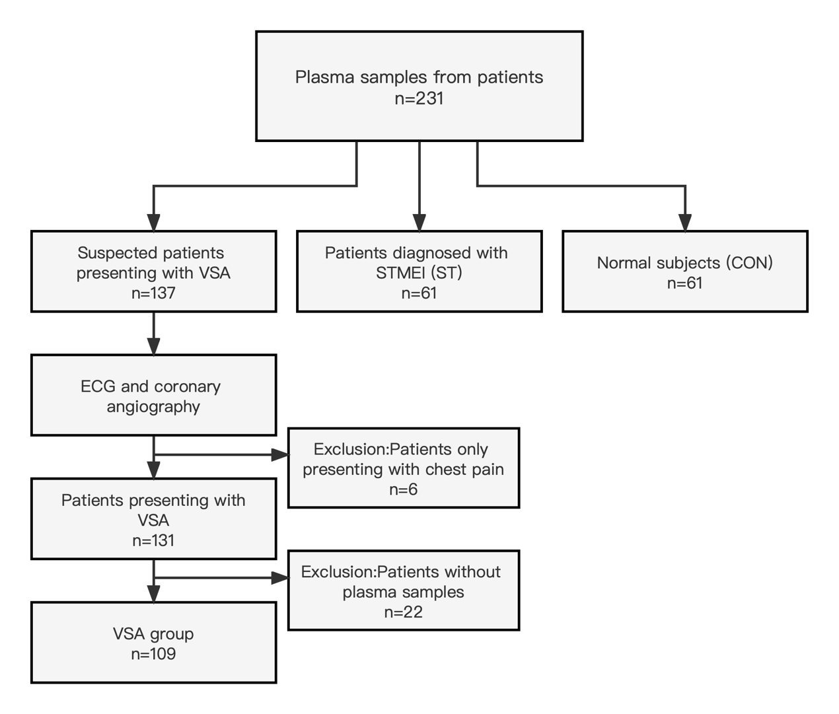
Supplementary Figure 1 Study flowchart.
VSA, vasospastic angina pectoris; STEMI, ST segment elevation myocardial infarction; CON; ECG, electrocardiogram.

A.
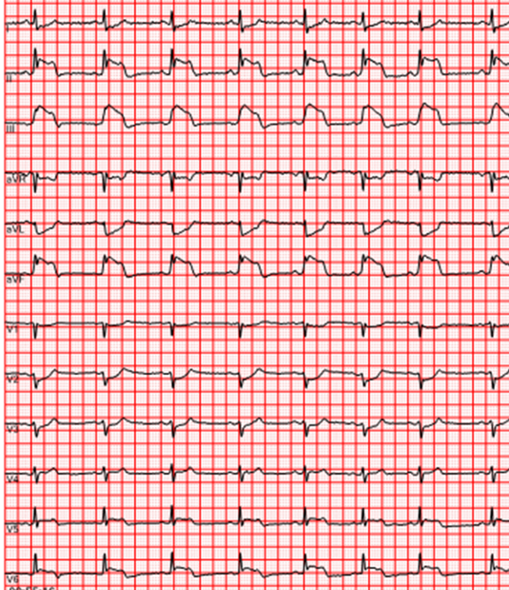
B.
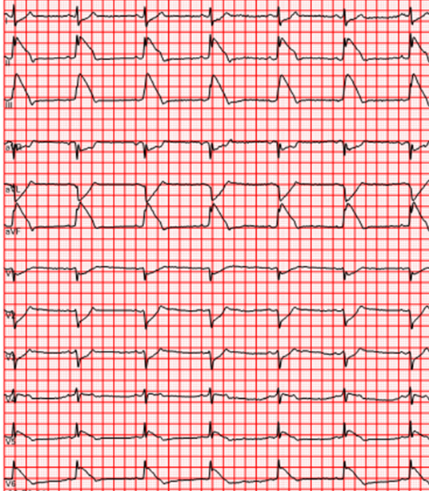

C.
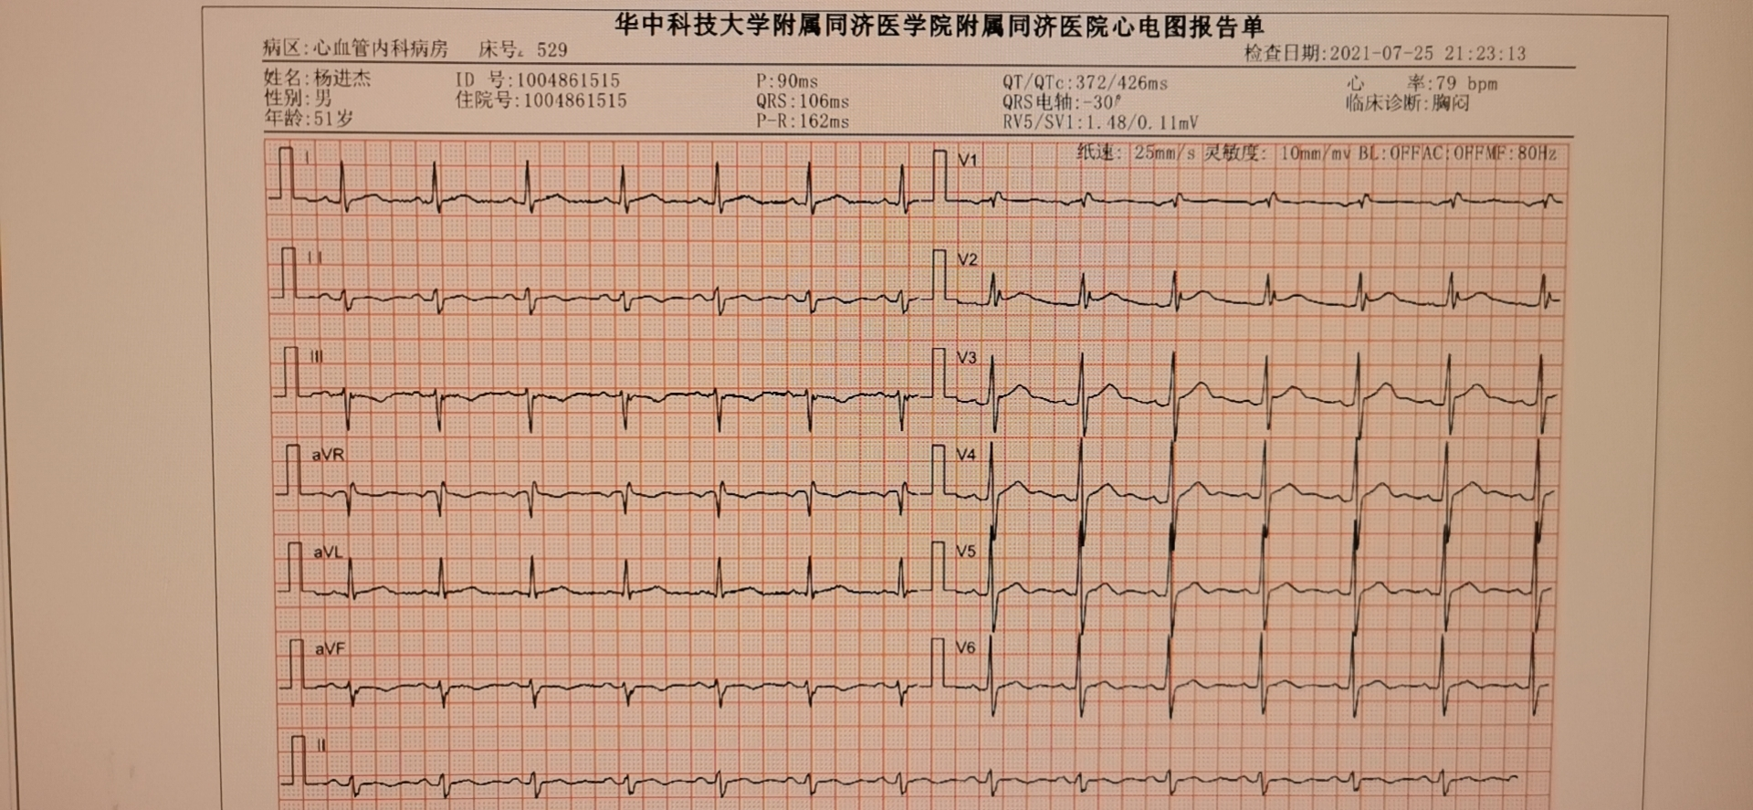
D
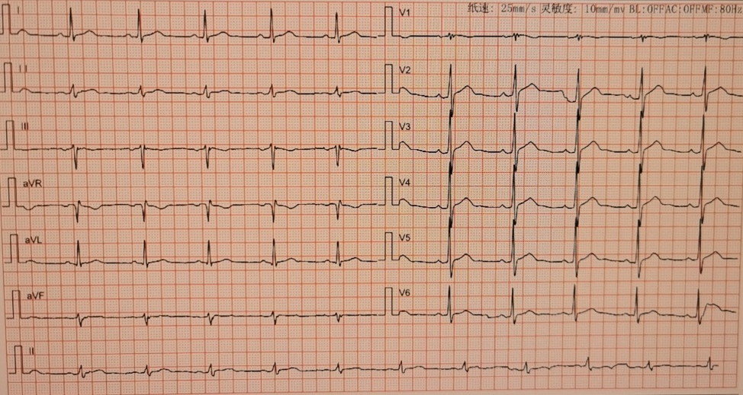

Supplementary Figure 2. Electrocardiography (ECG) of Case 1. A, Representative ECG of the patient one year ago when he had angina pectoris; B, recorded ECG 6 months ago at severe angina occurrence during hospitalization because he had recurrent angina occurrence; C and D, ECG immediately after angina relief and ECG recorded during outpatient follow-up one month after discharge, respectively.

A.
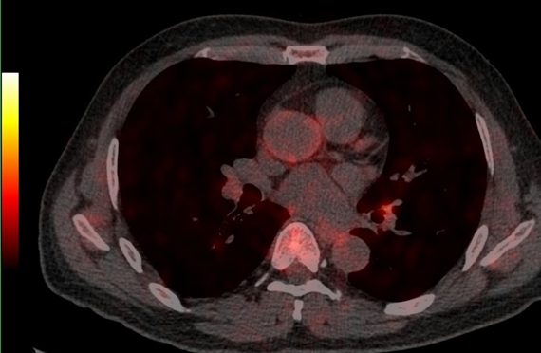


B.
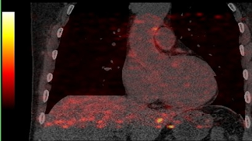


Supplementary Figure 3. Representative ¹⁸F-FDG PET/CT images of case one (A, B). FDG uptake was enhanced at the spastic proximal LAD, aorta and left ventricle.

(A) (B)
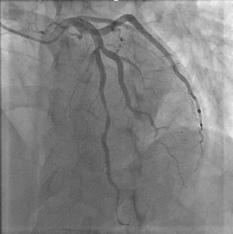
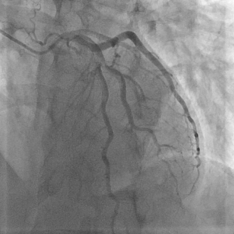

(C) (D)
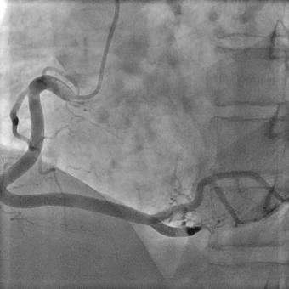
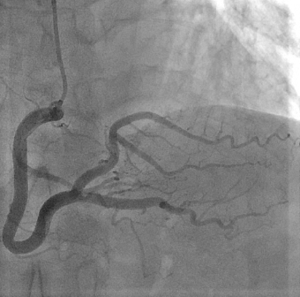

Supplementary Figure 4. Results of coronary angiography of case one. (A) shows spasm in mid LAD of coronary artery and after intracoronary infusion of nitroglycerine this spasm LAD was relaxed (B); (C) shows severe spasm of posterior descending coronary artery (right coronary artery) and (D) the severe spasm was relieved after intracoronary infusion of nitroglycerine.

(A)
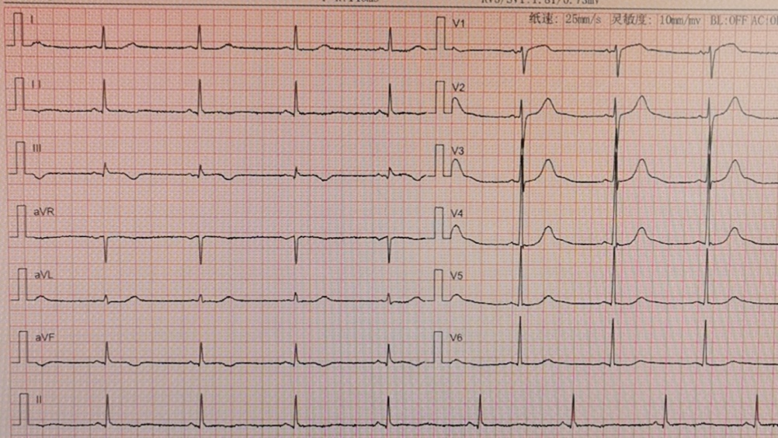

(B)
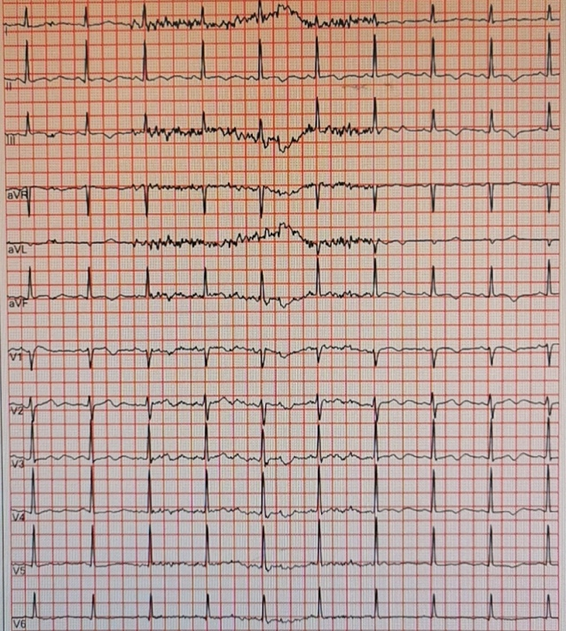

(C)
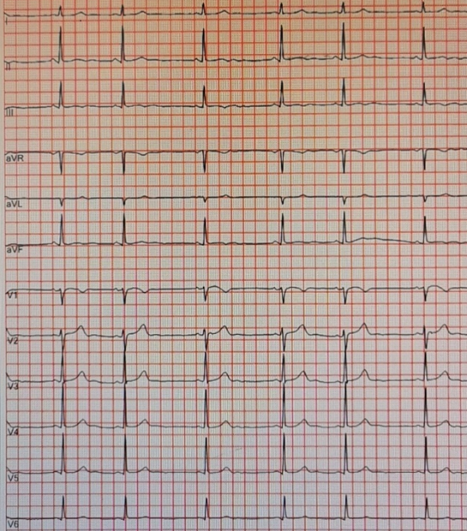

(D) 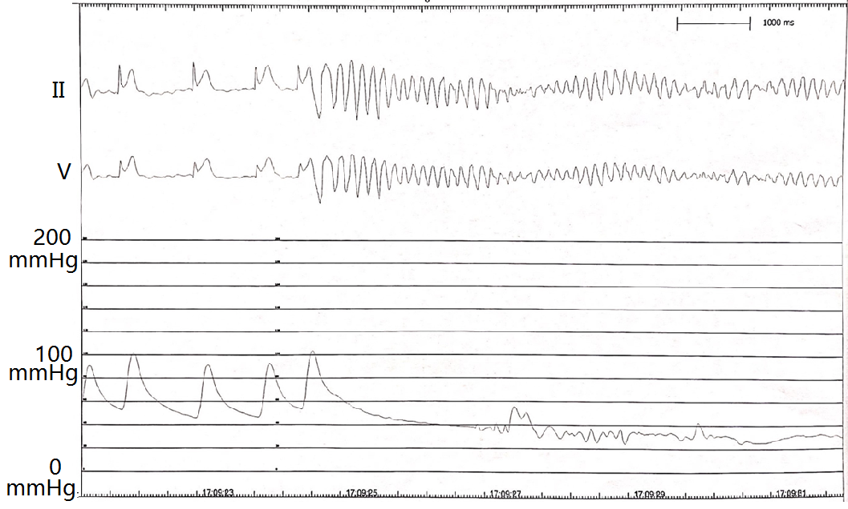
Supplementary Figure 5. Electrocardiography (ECG) of Case 2. A, ECG at normal condition; B and C, Holter monitoring ECG: B, at normal condition; C, the patient had mild chest discomfort; D, ECG and intra-aorta blood pressure recordings at right coronary angiography, when the patient had severe angina and then lost his consciousness, the recordings showing ST segment elevation and immediately ventricular fibrillation, and also blood pressure reduced extremely low level. Right coronary artery shows diffuse spasm (see Figure 5).

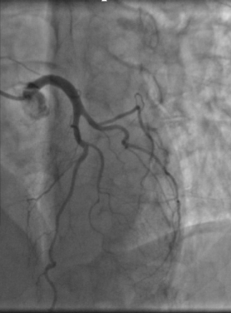
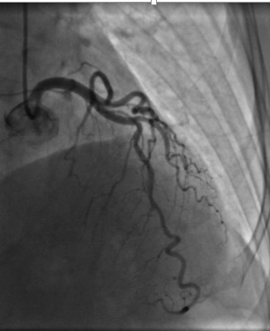

(A) (B)

(C)
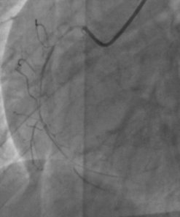
Supplementary Figure 6. Coronary angiography imaging. A, diffuse mild spasm of left coronary artery, and B, after intra-coronary artery nitroglycerine infusion, spasm disappears. C, right coronary angiography induced sever angina attack and immediately ventricular fibrillation (also see Figure 6).

(A) (B)
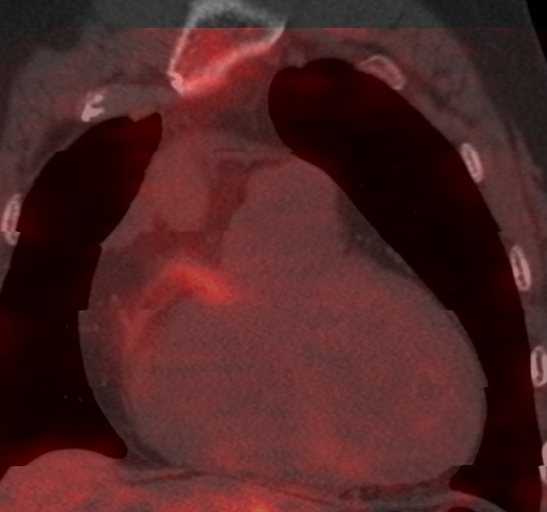
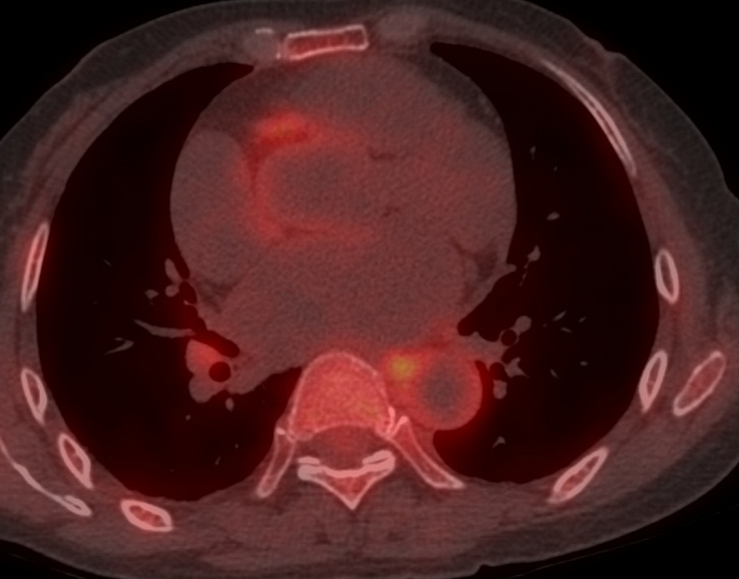

Supplementary Figure 7. Representative ¹⁸F-FDG PET/CT images of case 2 (A, B). FDG uptake was enhanced at the spastic proximal right coronary artery and left ventricle.

STROBE Statement—Checklist of items that should be included in reports of cohort studies
 | Item No | Recommendation | Page  No
Title and abstract | 1 | (a) Indicate the study’s design with a commonly used term in the title or the abstract | 1
Title and abstract | 1 | (b) Provide in the abstract an informative and balanced summary of what was done and what was found | 1
Introduction
Background/rationale | 2 | Explain the scientific background and rationale for the investigation being reported | 2
Objectives | 3 | State specific objectives, including any prespecified hypotheses | 2
Methods
Study design | 4 | Present key elements of study design early in the paper | 2
Setting | 5 | Describe the setting, locations, and relevant dates, including periods of recruitment, exposure, follow-up, and data collection | 2
Participants | 6 | (a) Give the eligibility criteria, and the sources and methods of selection of participants | 2
Variables | 7 | Clearly define all outcomes, exposures, predictors, potential confounders, and effect modifiers. Give diagnostic criteria, if applicable | NA
Data sources/ measurement | 8* | For each variable of interest, give sources of data and details of methods of assessment (measurement). Describe comparability of assessment methods if there is more than one group | 3
Bias | 9 | Describe any efforts to address potential sources of bias | NA
Study size | 10 | Explain how the study size was arrived at | NA
Quantitative variables | 11 | Explain how quantitative variables were handled in the analyses. If applicable, describe which groupings were chosen and why | NA
Statistical methods | 12 | (a) Describe all statistical methods, including those used to control for confounding | 2, 3
Statistical methods | 12 | (b) Describe any methods used to examine subgroups and interactions | NA
Statistical methods | 12 | (c) Explain how missing data were addressed | NA
Statistical methods | 12 | (d) If applicable, describe analytical methods taking account of sampling strategy | NA
Statistical methods | 12 | (e) Describe any sensitivity analyses | 3
Results
Participants | 13* | (a) Report numbers of individuals at each stage of study—eg numbers potentially eligible, examined for eligibility, confirmed eligible, included in the study, completing follow-up, and analysed | 3,4
Participants | 13* | (b) Give reasons for non-participation at each stage | 6
Participants | 13* | (c) Consider use of a flow diagram | Supplementary file page 1
Descriptive data | 14* | (a) Give characteristics of study participants (eg demographic, clinical, social) and information on exposures and potential confounders | 4
Descriptive data | 14* | (b) Indicate number of participants with missing data for each variable of interest | NA
Outcome data | 15* | Report numbers of outcome events or summary measures | 5, 6, 7
Main results | 16 | (a) Give unadjusted estimates and, if applicable, confounder-adjusted estimates and their precision (eg, 95% confidence interval). Make clear which confounders were adjusted for and why they were included | NA
Main results | 16 | (b) Report category boundaries when continuous variables were categorized | NA
Main results | 16 | (c) If relevant, consider translating estimates of relative risk into absolute risk for a meaningful time period | NA
Other analyses | 17 | Report other analyses done—eg analyses of subgroups and interactions, and sensitivity analyses | 8
Discussion
Key results | 18 | Summarise key results with reference to study objectives | 9
Limitations | 19 | Discuss limitations of the study, taking into account sources of potential bias or imprecision. Discuss both direction and magnitude of any potential bias | 10
Interpretation | 20 | Give a cautious overall interpretation of results considering objectives, limitations, multiplicity of analyses, results from similar studies, and other relevant evidence | 9,10
Generalisability | 21 | Discuss the generalisability (external validity) of the study results | 9,10
Other information
Funding | 22 | Give the source of funding and the role of the funders for the present study and, if applicable, for the original study on which the present article is based | 10
*Give information separately for exposed and unexposed groups.

Note: An Explanation and Elaboration article discusses each checklist item and gives methodological background and published examples of transparent reporting. The STROBE checklist is best used in conjunction with this article (freely available on the Web sites of PLoS Medicine at http://www.plosmedicine.org/, Annals of Internal Medicine at http://www.annals.org/, and Epidemiology at http://www.epidem.com/). Information on the STROBE Initiative is available at www.strobe-statement.org.

von Elm E, Altman DG, Egger M, Pocock SJ, Gøtzsche PC, Vandenbroucke JP; STROBE Initiative.
The Strengthening the Reporting of Observational Studies in Epidemiology (STROBE)statement: guidelines for reporting observational studies.
PLoS Med. 2007 Oct 16;4(10):e296. PMID: 17941714

