Supplementary materials
Supplementary Figure 1: Clinical feature selection using LASSO regression.
a b c
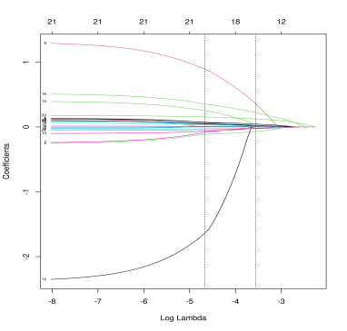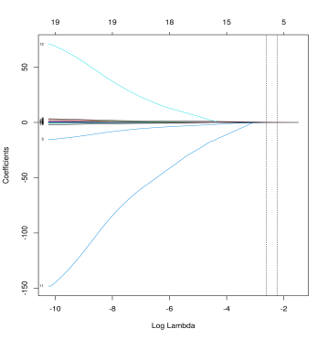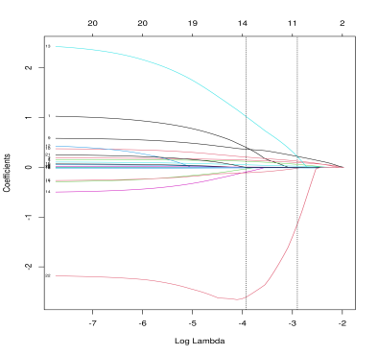
d e f
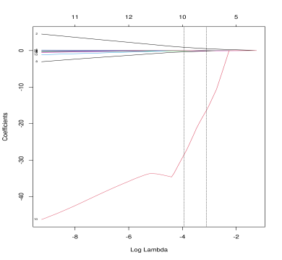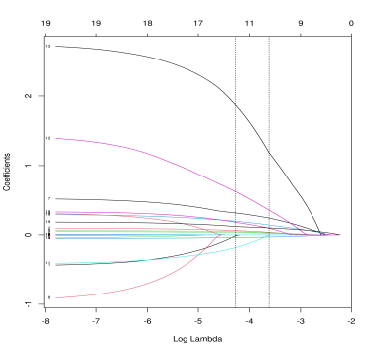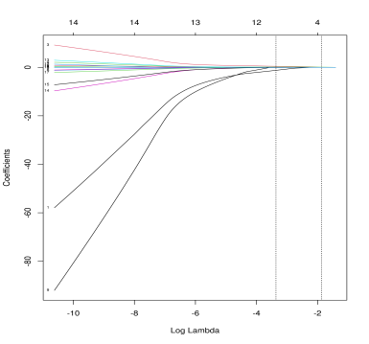
g h i
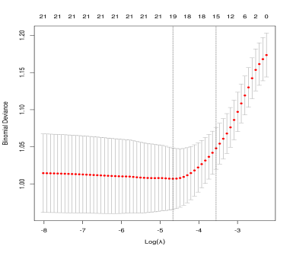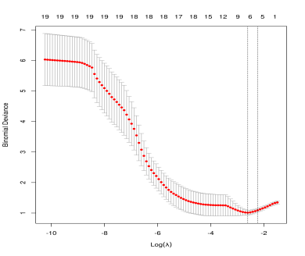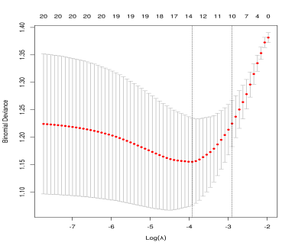
j k l
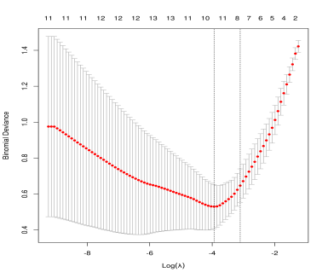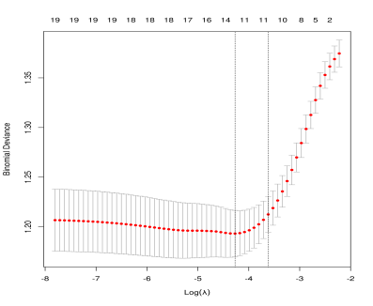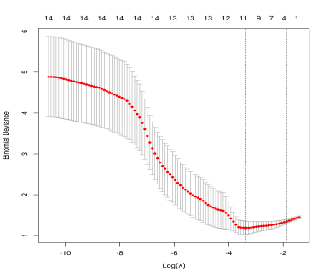
Tuning parameter (λ) selection in the LASSO model used 10-fold cross-validation via minimum criteria. Dotted vertical lines were drawn at the optimal values by using the minimum criteria and the 1 standard error of the minimum criteria (the 1-SE criteria): a)Cohort1 IBD. b) Cohort2 IBD. c) Cohort1 CD.d)Cohort2 CD. e)Cohort1 UC. f)Cohort2 UC. LASSO coefficient profiles of the clinical features. A coefficient profile plot was produced against the log (λ) sequence: g)Cohort1 IBD. h) Cohort2 IBD. i) Cohort1 CD. j)Cohort2 CD. k)Cohort1 UC. l)Cohort2 UC.

Supplementary Figure 2: Performance of Cohort1 ML models in 5-fold cross-validation.

a b c
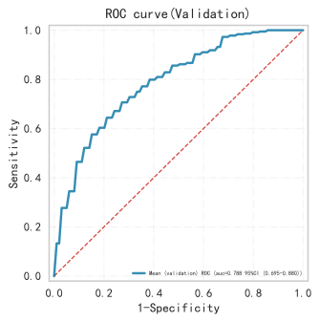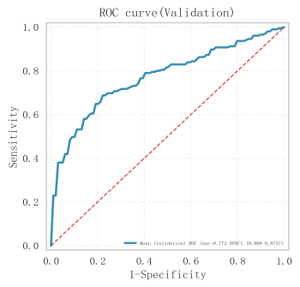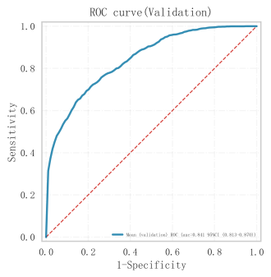

d e f
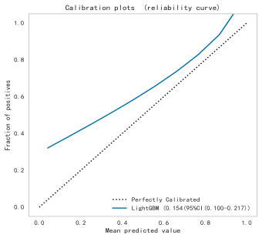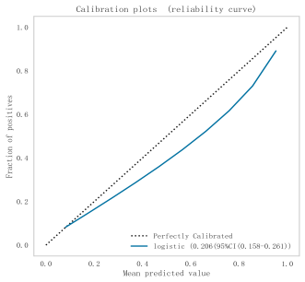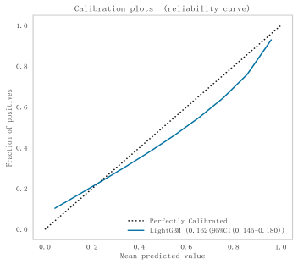

g h i
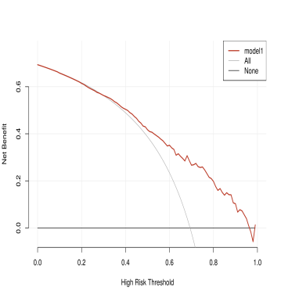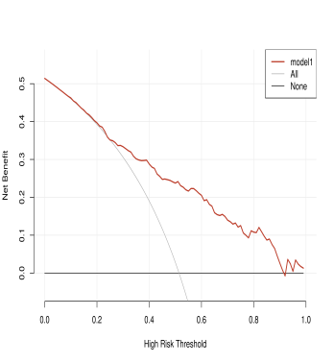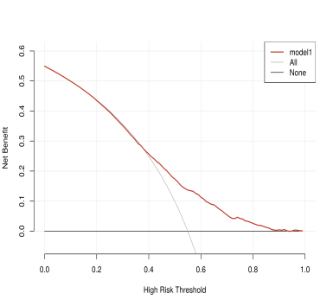
The ROC curve of ML models: a) ML-IBD model. b) ML-CD model. c) ML-UC model. The calibration curve of ML models: d) ML-IBD model. e) ML-CD model. f) ML-UC model. Decision curve analysis of ML models: g) ML-IBD model. h) ML-CD model. c) ML-UC model

Supplementary Figure 3: Performance of Cohort2 ML models in 5-fold cross-validation.
a b c
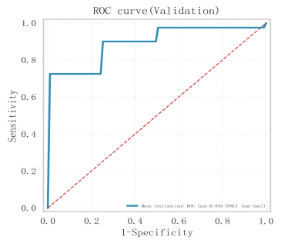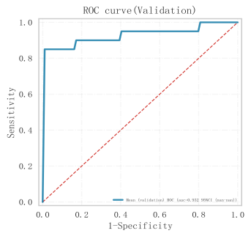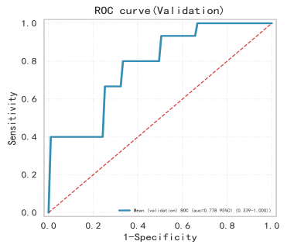

d e f
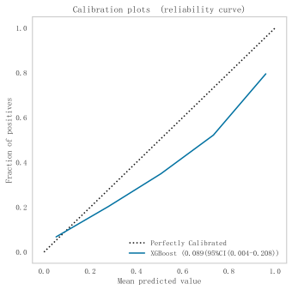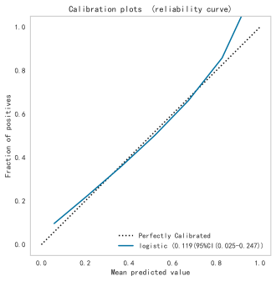

g h i
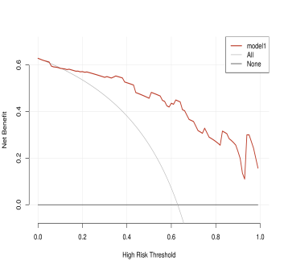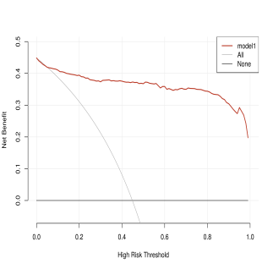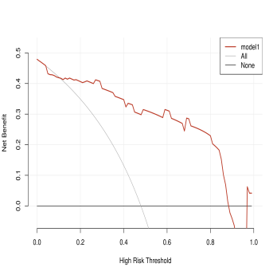
The ROC curve of ML models: a) ML-IBD model. b) ML-CD model. c) ML-UC model. The calibration curve of ML models: d) ML-IBD model. e) ML-CD model. f) ML-UC model. Decision curve analysis of MLmodels: g) ML-IBD model. h) ML-CD model. i) ML-UC model

