SUPPLEMENT 1 – Health state definitions

Non-Fatal Cardiovascular Event (CVE):

- The incidence and distribution of nonfatal myocardial infarctions, nonfatal strokes, coronary revascularizations or unstable anginas were informed by the REDUCE-IT study;
- The median follow-up in REDUCE-IT was 5-year. Therefore, during the initial 5-year period of the model, estimates of risk and benefits versus placebo reflected the REDUCE-IT trial results. After the initial 5-year period, event rates were assumed to equal that of the placebo group.
- After experiencing a non-fatal event, patients were assumed to move into a “post-event” state where they remained until death. Following a CVE, risk of subsequent events is high in following years.(1, 2) A recently published subsequent analysis of the REDUCE-IT patients demonstrate that VASCEPATM substantially reduces the risk of subsequent ischemic events.(3) More precisely, the second occurrence of a primary composite endpoint was reduced with VASCEPATM versus placebo by 32% (HR= 0.68, 95% CI 0.60-0.78, p<0.001). For the initial 5-year period, the incidence and distribution of subsequent fatal cardiovascular events, nonfatal myocardial infarctions, nonfatal strokes, coronary revascularizations or unstable anginas were informed by this sub-analysis of REDUCE-IT.(3) After the trial period, to compensate for the increasing risk of subsequent events and mortality following a CVE, a mortality multiplier associated with the increasing risk of mortality after a CVE has been considered. CV death rates have significantly changed in the last decades.(4) In order to take into account the fact that the data used as mortality multipliers in the model were published in 2000, those were adjusted by a factor of 0.5 (SE=0.01), as per Rawahani et al. (2017).(4)

Fatal Cardiovascular Event (DCV):

- The distribution of cardiovascular death was informed by the REDUCE-IT study;
- The median follow-up of REDUCE-IT was 5-year, therefore during the initial 5-year period of the model, estimates of risk and benefits of fatal cardiovascular events versus placebo reflected the REDUCE-IT trial results. After the initial 5-year period, subsequent event rates were assumed to equal to that of the placebo group;
- Mortality costs associated to in-hospital procedures before death were considered.
Death from other causes:

- Death is the absorbing health state in the model. Patients could transition to death from any of the states included in the model;
- Probability of death was acquired from age- and sex-matched general population mortality rates listed in the most recent life tables from Statistics Canada(5) reflecting the baseline demographic characteristics of patients in the REDUCE-IT trial.

SUPPLEMENT 2 - Proportional hazards assumption for all hazard ratios used in the model

We generated plots of log of negative log of estimated survivor functions from the Cox proportional hazard model for each of the five components of the primary composite endpoint, to check whether curves of the two treatment groups demonstrated parallelism indicative of the proportionality of hazards.

Additionally, we included a time-dependent covariate of treatment by survival time interaction term in the Cox proportional hazard model for testing of the proportional hazard assumption. If the time-dependent covariate resulted in a significant p-value, then these hazard functions were not proportional. On the other hand, if the time-dependent covariate resulted in a non-significant p-value, then the hazard functions were proportional.

Cardiovascular Death

Plot of log of negative log of estimated survivor functions for the cardiovascular death (including undetermined death) endpoint depicted parallel lines for the two treatment groups, which indicated that the proportional hazard assumption holds.

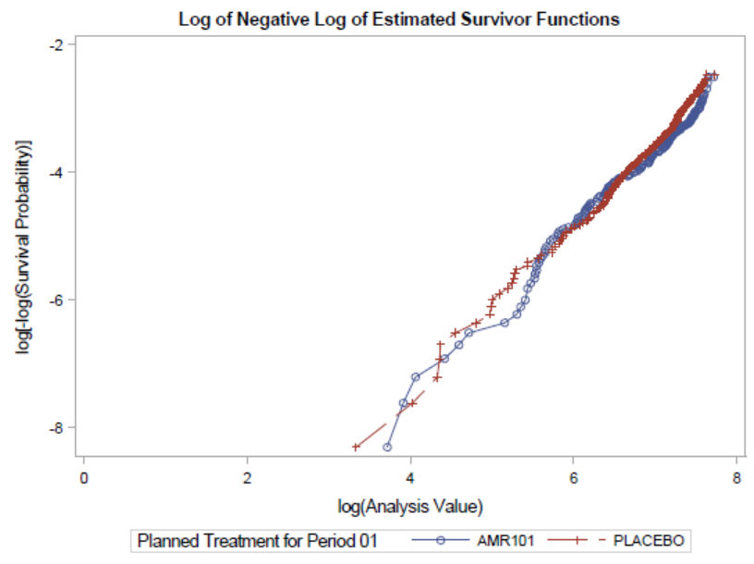

By adding a time-dependent covariate of treatment by survival time interaction term in the Cox proportional hazard model for the cardiovascular death endpoint, a non-significant p-value of 0.3141 resulted for the interaction test which showed that the proportional hazard was a valid assumption for the cardiovascular death endpoint in REDUCE-IT.
Non-Fatal Myocardial Infarction

Plot of log of negative log of estimated survivor functions for the nonfatal myocardial infarction endpoint depicted parallel lines for the two treatment groups, which indicated that the proportional hazard assumption holds.

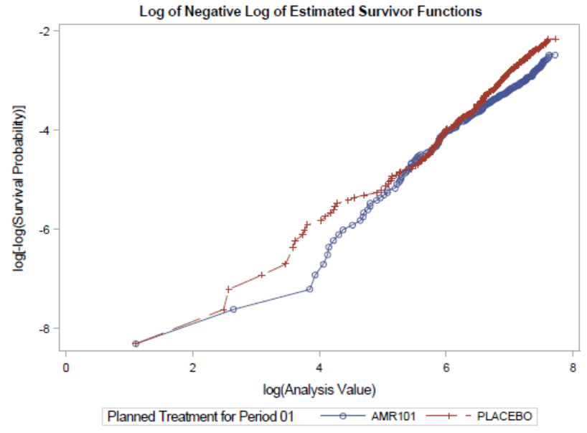

By adding a time-dependent covariate of treatment by survival time interaction term in the Cox proportional hazard model for the nonfatal myocardial infarction endpoint, a non-significant p-value of 0.2179 resulted for the interaction test which showed that the proportional hazard was a valid assumption for the nonfatal myocardial infarction endpoint in REDUCE-IT.
Non-Fatal Stroke

Plot of log of negative log of estimated survivor functions for the non-fatal stroke endpoint depicted parallel lines (except 2 points in the placebo arm that could be outliers) for the two treatment groups, which indicated that the proportional hazard assumption holds.

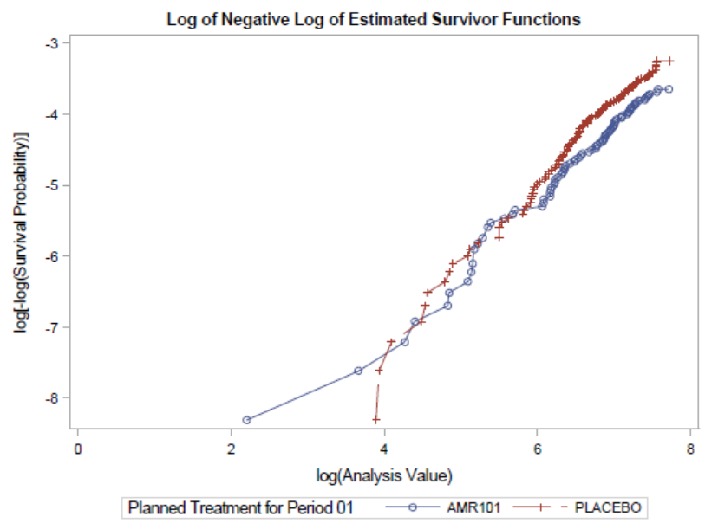

By adding a time-dependent covariate of treatment by survival time interaction term in the Cox proportional hazard model for the non-fatal stroke endpoint, a non-significant p-value of 0.4693 resulted for the interaction test which showed that the proportional hazard was a valid assumption for the non-fatal stroke endpoint in REDUCE-IT.
Coronary Revascularization

Plot of log of negative log of estimated survivor functions for the coronary revascularization endpoint depicted parallel lines (except one outlier in AMR101 arm) for the two treatment groups, which indicated that the proportional hazard assumption holds.

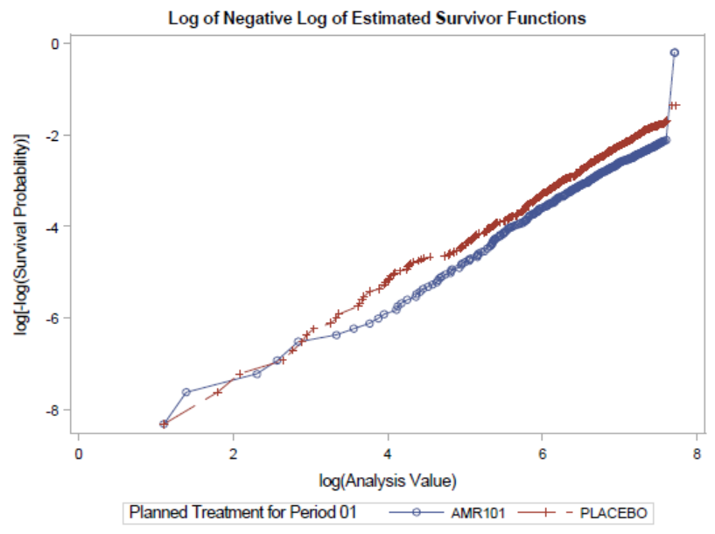

By adding a time-dependent covariate of treatment by survival time interaction term in the Cox proportional hazard model for the coronary revascularization endpoint, a non-significant p-value of 0.5533 resulted for the interaction test which showed that the proportional hazard was a valid assumption for the coronary revascularization endpoint in REDUCE-IT.
Hospitalization of Unstable Angina

Plot of log of negative log of estimated survivor functions for the hospitalization of unstable angina endpoint depicted parallel lines for the two treatment groups, which indicated that the proportional hazard assumption holds.

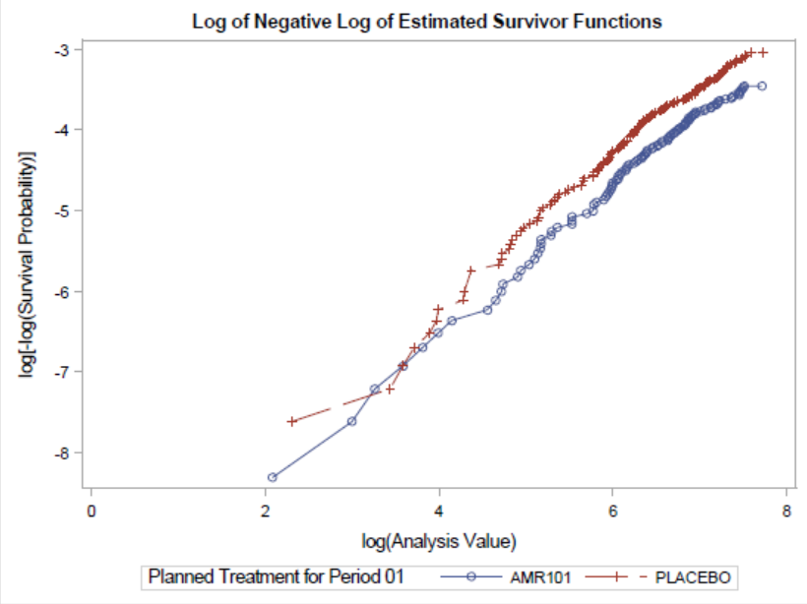

By adding a time-dependent covariate of treatment by survival time interaction term in the Cox proportional hazard model for the hospitalization of unstable angina endpoint, a non-significant p-value of 0.8458 resulted for the interaction test which showed that the proportional hazard was a valid assumption for the hospitalization of unstable angina endpoint in REDUCE-IT.

SUPPLEMENT 3 – Parametric survival models

Cardiovascular Death

For cardiovascular death, the Gompertz distribution provided the lowest AIC and BIC combine score and provided excellent visual fit to the Kaplan Meier curves throughout the trial follow-up; however, at 20 years, approximately 1 patient remained at risk, which we considered implausible. Among the remaining distribution, the Weibull distribution had the second-best AIC/BIC score; however, the Log-Normal distribution provided the most plausible long-term projection despite its statistical fit. Based on these data, we selected the Log-Normal distribution for use in this analysis.

Parametric Distribution Fit to Cardiovascular Death Data and the AIC and BIC
Distribution | Parameter | Estimate | SE | AIC | BIC
Generalized Gamma | Location | 3.361 | 0.136 | 2276.20 | 2277.42
Generalized Gamma | Scale | 0.412 | 0.650 | 2276.20 | 2277.42
Generalized Gamma | Shape | 1.675 | 2.644 | 2276.20 | 2277.42
Weibull | Shape | 1.472 | 0.095 | 2274.67 | 2277.89
Weibull | Scale | 32.634 | 4.336 | 2274.67 | 2277.89
Log Normal | Mean | 4.214 | 0.172 | 2284.69 | 2287.91
Log Normal | SD | 1.680 | 0.097 | 2284.69 | 2287.91
Log Logistic | Shape | 1.494 | 0.096 | 2275.18 | 2278.40
Log Logistic | Scale | 31.101 | 4.058 | 2275.18 | 2278.40
Gompertz | Shape | 0.261 | 0.046 | 2273.44 | 2276.66
Gompertz | Rate | 0.006 | 0.001 | 2273.44 | 2276.66
Exponential | Intercept | 0.012 | 0.001 | 2303.98 | 2309.21

Model-Based Estimation of Cardiovascular Death for VASCEPA and Placebo based on Log-Normal Distribution Fit to REDUCE-IT
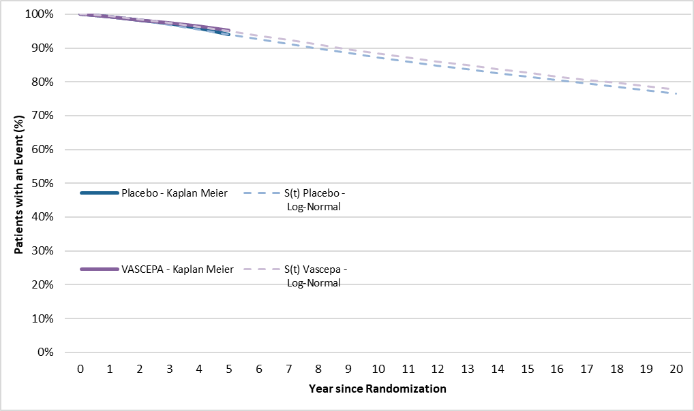
Non-Fatal Myocardial Infarction

For nonfatal myocardial infarction, we selected the Log-Logistic distribution for use in this analysis since it provided the lowest AIC and BIC combine score and provided excellent visual fit to the Kaplan Meier curves throughout the trial follow-up. The long-term projection was the second most favourable projection.

Parametric Distribution Fit to Nonfatal Myocardial Infarction Data and the AIC and BIC
Distribution | Parameter | Estimate | SE | AIC | BIC
Generalized Gamma | Location | 3.685 | 0.249 | 3268.27 | 3269.50
Generalized Gamma | Scale | 0.945 | 0.364 | 3268.27 | 3269.50
Generalized Gamma | Shape | 0.930 | 0.437 | 3268.27 | 3269.50
Weibull | Shape | 1.125 | 0.058 | 3266.30 | 3269.52
Weibull | Scale | 38.568 | 4.676 | 3266.30 | 3269.52
Log Normal | Mean | 4.297 | 0.151 | 3277.83 | 3281.06
Log Normal | SD | 2.040 | 0.094 | 3277.83 | 3281.06
Log Logistic | Shape | 1.153 | 0.059 | 3266.11 | 3269.33
Log Logistic | Scale | 35.110 | 4.137 | 3266.11 | 3269.33
Gompertz | Shape | 0.064 | 0.037 | 3268.20 | 3271.42
Gompertz | Rate | 0.017 | 0.002 | 3268.20 | 3271.42
Exponential | Intercept | 0.020 | 0.001 | 3269.23 | 3274.46

Model-Based Estimation of Nonfatal Myocardial Infarction for VASCEPA and Placebo based on Log-Logistic Distribution Fit to REDUCE-IT
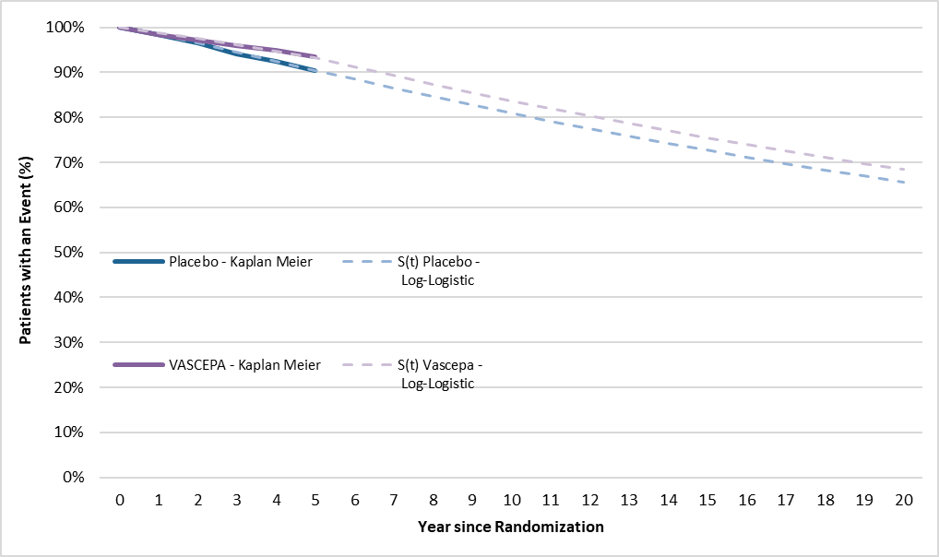

Non-Fatal Stroke

For stroke, the generalized gamma distribution provided the lowest AIC and BIC combine score; however, this distribution did not provide a good visual fit and did not yield stable projection as the survival projection dropped sharply to zero during the model projection period and, therefore, we dropped it from consideration. We selected the Log Normal distribution for use in this analysis since it had the second-best statistical fit, an excellent visual fit and did not yield an implausible long-term projection (most favourable projection).

Parametric Distribution Fit to Nonfatal Stroke Data and the AIC and BIC
Distribution | Parameter | Estimate | SE | AIC | BIC
Generalized Gamma | Location | 2.390 | 0.002 | 519.39 | 522.61
Generalized Gamma | Scale | 0.036 | 0.000 | 519.39 | 522.61
Generalized Gamma | Shape | 47.200 | 4.160 | 519.39 | 522.61
Weibull | Shape | 1.074 | 0.094 | 1414.49 | 1417.72
Weibull | Scale | 114.580 | 33.804 | 1414.49 | 1417.72
Log Normal | Mean | 5.936 | 0.380 | 1411.16 | 1414.38
Log Normal | SD | 2.370 | 0.189 | 1411.16 | 1414.38
Log Logistic | Shape | 1.082 | 0.095 | 1414.30 | 1417.52
Log Logistic | Scale | 110.074 | 32.171 | 1414.30 | 1417.52
Gompertz | Shape | -0.010 | 0.062 | 1415.11 | 1418.34
Gompertz | Rate | 0.007 | 0.001 | 1415.11 | 1418.34
Exponential | Intercept | 0.007 | 0.001 | 1413.14 | 1418.36

Model-Based Estimation of Nonfatal Stroke for VASCEPA and Placebo based on Log-Normal Distribution Fit to REDUCE-IT
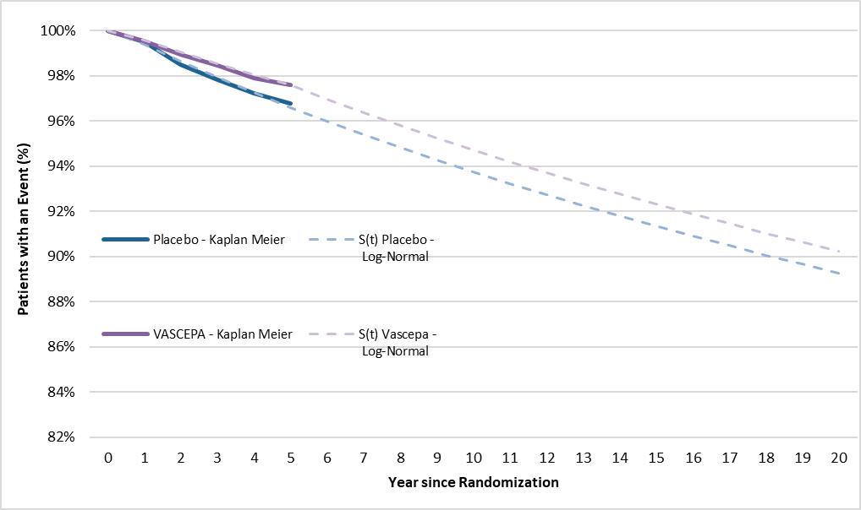
Coronary Revascularization

For coronary revascularization, we selected the Log-Logistic distribution for use in this analysis since it provided the lowest AIC and BIC combine score and provided excellent visual fit to the Kaplan Meier curves throughout the trial follow-up. The long-term projection was the intermediate between the other potential distributions (i.e., the less favourable exponential distribution and the more favourable log-normal distribution).

Parametric Distribution Fit to Coronary Revascularization Data and the AIC and BIC
Distribution | Parameter | Estimate | SE | AIC | BIC
Generalized Gamma | Location | 3.564 | 0.129 | 4781.58 | 4782.81
Generalized Gamma | Scale | 1.411 | 0.237 | 4781.58 | 4782.81
Generalized Gamma | Shape | 0.577 | 0.212 | 4781.58 | 4782.81
Weibull | Shape | 0.993 | 0.040 | 4782.12 | 4785.34
Weibull | Scale | 30.137 | 2.685 | 4782.12 | 4785.34
Log Normal | Mean | 3.755 | 0.106 | 4787.44 | 4790.67
Log Normal | SD | 2.088 | 0.074 | 4787.44 | 4790.67
Log Logistic | Shape | 1.035 | 0.041 | 4779.97 | 4783.19
Log Logistic | Scale | 25.786 | 2.204 | 4779.97 | 4783.19
Gompertz | Shape | -0.037 | 0.029 | 4780.55 | 4783.77
Gompertz | Rate | 0.037 | 0.003 | 4780.55 | 4783.77
Exponential | Intercept | 0.034 | 0.001 | 4780.15 | 4785.37

Model-Based Estimation of Coronary Revascularization for VASCEPA and Placebo based on Log-Logistic Distribution Fit to REDUCE-IT
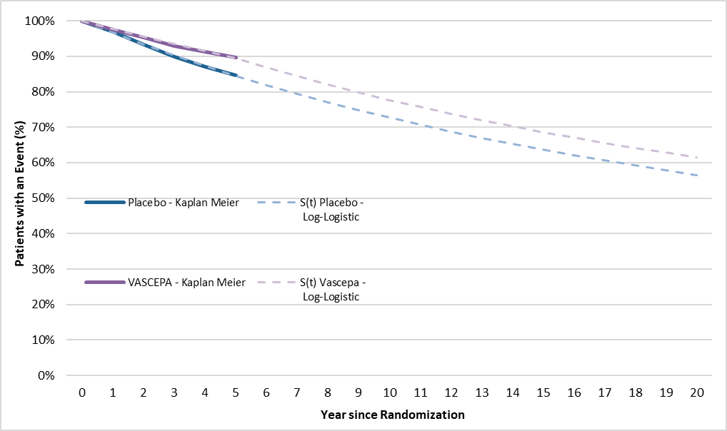
Hospitalization of Unstable Angina

For unstable angina, the generalized gamma distribution provided the lowest AIC and BIC combine score; however, this distribution did not provide a good visual fit and did not yield a stable projection as the survival projection dropped sharply to zero during the model projection period and, therefore, we dropped it from consideration. We selected the Log-Normal distribution for use in this analysis since it had the second-best statistical fit, an excellent visual fit and did not yield implausible long-term projection.

Parametric Distribution Fit to Hospitalization for Unstable Angina Data and the AIC and BIC
Distribution | Parameter | Estimate | SE | AIC | BIC
Generalized Gamma | Location | 1.988 | 0.001 | 578.14 | 579.37
Generalized Gamma | Scale | 0.019 | 0.016 | 578.14 | 579.37
Generalized Gamma | Shape | 89.192 | 74.539 | 578.14 | 579.37
Weibull | Shape | 0.835 | 0.064 | 1783.44 | 1786.66
Weibull | Scale | 203.134 | 62.587 | 1783.44 | 1786.66
Log Normal | Mean | 6.626 | 0.389 | 1778.93 | 1782.15
Log Normal | SD | 2.943 | 0.204 | 1778.93 | 1782.15
Log Logistic | Shape | 0.845 | 0.064 | 1783.11 | 1786.33
Log Logistic | Scale | 189.386 | 57.427 | 1783.11 | 1786.33
Gompertz | Shape | -0.174 | 0.057 | 1779.52 | 1782.75
Gompertz | Rate | 0.013 | 0.002 | 1779.52 | 1782.75
Exponential | Intercept | 0.009 | 0.001 | 1787.33 | 1792.55

Model-Based Estimation of Unstable Angina for VASCEPA and Placebo based on Log-Normal Distribution Fit to REDUCE-IT
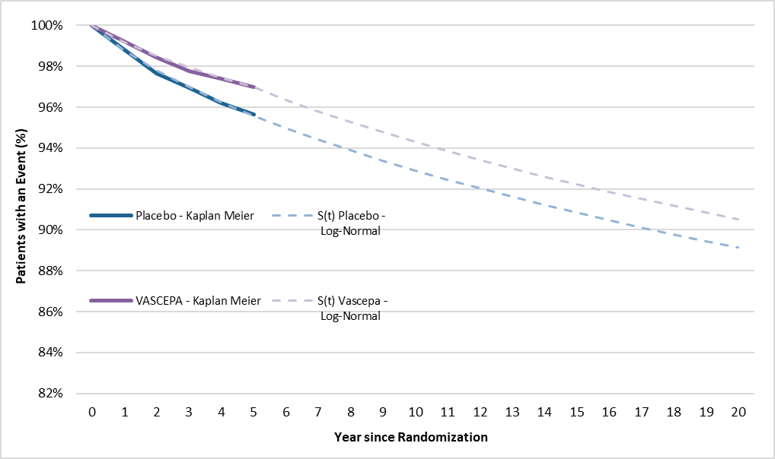

SUPPLEMENT 4 – Detailed cost data for cardiovascular events and follow-up and monitoring

Health Care Costs of Cardiovascular Events
Health Care Cost |  | Value | SE | References
Nonfatal MI | Initial Year | $12,392.82 | $178.41 | R Goeree et al. 2009 (CADTH Clopidrogel)(6, 7)
Nonfatal MI | Subsequent Year | $3,278.32 | $253.14 | R Goeree et al. 2009 (CADTH Clopidrogel)(6, 7)
Nonfatal Stroke | Initial Year | $23,840.28 | $200.47 | R Goeree et al. 2009 (CADTH Clopidrogel)(6, 7)
Nonfatal Stroke | Subsequent Year | $4,806.48 | $123.15 | R Goeree et al. 2009 (CADTH Clopidrogel)(6, 7)
Coronary Revascularization | Initial Year - PCI | $8,895.76 | $91.73 | OCC (1.IJ.50.^^)(8)
Coronary Revascularization | Initial Year - CABG | $25,759.59 | $290.35 | OCC (1.IJ.76.^^)(8)
Coronary Revascularization | Subsequent Year | $3,411.53 | $33.80 | Henk et al. (proportion from Initial Year vs. Subsequent Years)(9)
Unstable Angina | Initial Year | $5,877.19 | $823.79 | R Goeree et al. 2009 (CADTH Clopidrogel) (6, 7)
Unstable Angina | Subsequent Year | $3,463.99 | $55.12 | R Goeree et al. 2009 (CADTH Clopidrogel) (6, 7)
Fatal MI | Hospitalization Without Procedure | $7,917.83 | $1,979.46 | AH Anis et al. ( 2006)(10)
Fatal Stroke | Hospitalization Without Procedure | $7,765.24 | $1,941.31 | AH Anis et al. ( 2006)(10)

Unit Costs Associated with Follow-up and Monitoring Included in the Model
Unit Cost for Appointment and Laboratory | Unit Cost | References
Consultation Visits with a Cardiologist | $157.00 | MoHLTC- Schedule of Benefits Physician Services(11)
Limited Consultation Visits with a Cardiologist | $105.25 | MoHLTC- Schedule of Benefits Physician Services(11)
Consultation Visits with a General Practitioner | $77.00 | MoHLTC- Schedule of Benefits Physician Services(11)
Fasting Lipid Panel (Total Cholesterol, Triglycerides, HDL-C, LDL-C | $19.03 | Schedule of Benefits for Laboratory Services (L151, L700)(12)

SUPPLEMENT 5 – Model assumptions

Assumptions and Data Sources for the Estimation of Medical Costs Associated with Follow-up and Monitoring
Monitoring and Management Frequency by year - First Year | Value | Low | High | References
Assess response to therapy and adverse effects within 4-12 weeks following tx initiation | 1 | - | - | CCS Guideline (2016) and ACA/AHA Guideline (2013)(13, 14)
Visit with a General Practitioner | 80% | 0% | 100% | Assumption Validated by Clinical Experts
Visit with a Cardiologist | 20% | - | - | Assumption Validated by Clinical Experts
Regularly monitor adherence to drug therapy every 3 - 12 months | 2 | 1 | 4 | CCS Guideline (2016) and ACA/AHA Guideline (2013)(13, 14)
Visit with a General Practitioner | 80% | 0% | 100% | Assumption Validated by Clinical Experts
Visit with a Cardiologist | 20% | - | - | Assumption Validated by Clinical Experts
Initial Fasting Lipid Panel (Total Cholesterol, Triglycerides, HDL-C, LDL-C) | 1 | - | - | CCS Guideline (2016) and ACA/AHA Guideline (2013)(13, 14)
Following Fasting Lipid Panel (Total Cholesterol, Triglycerides, HDL-C, LDL-C) | 2 | 1 | 4 | CCS Guideline (2016) and ACA/AHA Guideline (2013)(13, 14)

Monitoring and Management Frequency by year – Subsequent Year | Value | Low | High | References
Regularly monitor adherence to drug therapy every 3 - 12 months | 2 | 1 | 4 | CCS Guideline (2016) and ACA/AHA Guideline (2013)(13, 14)
Visit with a General Practitioner | 80% | 0% | 100% | Assumption Validated by Clinical Experts
Visit with a Cardiologist | 20% | - | - | Assumption Validated by Clinical Experts
Measuring Fasting Lipid Panel | 2 | 1 | 4 | CCS Guideline (2016) and ACA/AHA Guideline (2013)(13, 14)

Summary and Justification of Model Assumptions
Assumption | Justification
Baseline characteristics of patients are in accordance with VASCEPA pivotal study, REDUCE-IT. | Consistent with its intended indication.
The proportion of patients using ezetimibe 10mg was 6.4% and intensity levels of statin was consistent with REDUCE-IT. | Consistent with stratification factors in REDUCE-IT.
The distribution of specific statins within treatment intensity levels was assumed to be evenly distributed between all treatment included in the same intensity levels. | Approximation of distribution of statins could be estimated with real-world data, but this should not significantly influence the results since standard of care is considered in both groups.
20-year time horizon was considered in the base-case analysis. | According to the most recent Canadian HTA reviews of a CUA model for PCSK-9 by CADTH.(15)
Half-cycle correction was applied. | In order to more accurately reflect the continuous nature of the state transition (assumption that transitions occur, on average, half-way through each cycle instead of at the beginning of the cycle).
The median follow-up of REDUCE-IT was 5-years, therefore during the initial 5-year period of the model, estimates of risk and benefits versus placebo for first and subsequent events reflected the REDUCE-IT trial results. After the initial 5-year period, event rates were assumed to equal that of the placebo group. | Since long-term data on treatment effects beyond the end of the trial are not available, this approach was deemed the most conservative.
After the trial period, to compensate for the increasing risk of subsequent events and mortality following a CVE, mortality multipliers associated with the increasing risk of mortality after a CVE have been considered. | This assumption to account for the elevated mortality in patients with stable CVE compared to the general population was also used to in a Canadian cost-effectiveness of Atorvastatin.(16) and was validated by clinical experts. However, CV death rates have significantly changed in the last decades.(4) In order to take into account the fact that the data used as mortality multipliers in the model were published in 2000, those were adjusted by a factor of 0.5 (SE=0.01), as per Rawahani et al. (2017).(4)
Probability of death was acquired from age- and sex-matched general population mortality rates listed in the most recent life tables from Statistics Canada reflecting the baseline demographic characteristics of patients in REDUCE-IT trial. | In absent of all cause mortality data from the clinical study, these values were judged the best estimate possible.
Only AEs that were statistically different (p <0.05) in disadvantage of VASCEPA (higher incidence of AEs for VASCEPA) were taken into account. | This assumption is to avoid considering any AEs related to placebo.
Acute CV event health state disutilities and post-event utilities were applied multiplicatively to baseline utility value. | In line with in the most recent Canadian HTA reviews of a CUA model for PraluentTM by CADTH.(17)
It was assumed that 75% of the revascularization were PCIs and 25% were CABGs. | These proportions are consistent with the recommendation of clinical experts consulted.
Revascularization in Canada performs less frequently in Canada vs the USA (almost 3 times those in Canada). | These proportions are consistent with the recommendation of clinical experts consulted.
80% of the patient's management will be done by a general practitioner | These proportions are consistent with the recommendation of clinical experts consulted.

SUPPLEMENT 6 – Details and results of the sensitivity and scenario analyses

Deterministic sensitivity analyses

We undertook deterministic sensitivity analyses (DSAs) to explore the impact of changing assumptions concerning key model parameter values on the ICER. These sensitivity analyses included both Tornado plots, in which a numerical variable is varied over a specified range in order to measure its impact on cost-effectiveness, and scenario analyses, in which results are evaluated for a particular set of assumptions and parameter estimates. Parameters included in the Tornado plots varied according to the estimated SE, 95% CI, or by +/- 25% in order to assess the relative impact of these parameters on the cost-effectiveness estimates.

Scenario analyses

The model allows for scenario analyses to be performed in which we generate model results for a particular set of assumed parameter estimates. These analyses provided insight into model parameters and model assumptions, and the impact on key model outcomes. The scenarios we tested in this evaluation are listed in the table below. We conducted scenario analyses using the probabilistic model with 1,000 simulations.

Scenario Analyses
Parameter | Base Case Scenario | Alternative Scenario Tested
Discount rates | 1.5% | 0.0%
Discount rates | 1.5% | 3.0%
Time Horizon length | 20 years | 5 years
Time Horizon length | 20 years | Lifetime
Perspective | Publicly Funded Health Care Payer Perspective | Societal Perspective
Survival rates parametric function | Log logistic | Weibull
Survival rates parametric function | Log logistic | Generalized Gamma
Survival rates parametric function | Log logistic | Log normal
Survival rates parametric function | Log logistic | Gompertz
Survival rates parametric function | Log logistic | Exponential
Half Cycle Correction | Considering Half-Cycle Correction | Not Considering Half-Cycle Correction
Data Source for Trial period | Parametric Model | Kaplan Meier

Indirect costs

For the scenario analysis conducted from the societal perspective, we took into account indirect costs associated with CV events by factoring employment rates, hourly wages and fringe benefits for employees. Song and al.(18) have quantified the workplace absenteeism and short-term disability hours associated with CVE in United Stated employees using databases. Productivity losses were consistently greater among patients who experienced CVE compared with those without CVE. The differences were significant in the first month of follow-up, with 56.3 more hours for patients with CVE, and in the first year of follow-up (for a subset of patients with at least one year of follow-up), with 13.5 more hours for patients with CVE. Resulting in a total annual hour lost due to workplace absenteeism and short-term disability of 205.90 hours.(18)

Indirect Costs Associated with CV Events
 | Value | Low | High | References
Employment rates from 60 to 64 years | 53.1% |  |  | Statistics Canada, Table 14-10-0018-01, May 2019(19)
Employment rates from 65 to 69 years | 25.3% |  |  | Statistics Canada, Table 14-10-0018-01, May 2020(19)
Mean Hourly Wage for employee | $28.37 |  |  | Statistics Canada, Table 14-10-0320-01, May 2019(20)
Fringe Benefits worth of Wage for Employee | 22.5% | 0% | 30.0% | MaRS Discovery District(21)

Productivity Lost Associated with CV Events
 | Value | SE | References
Annual Hours Lost due to Workplace Absenteeism and Short-Term Disability - First Year | 205.90 | 170.66 | Song et al. 2015 (18)

Deterministic model results

The cost-effectiveness result based on the deterministic model is presented in the table below. We found that the absolute costs, QALYs, and resulting ICER was very similar to the probabilistic model. The similarity between the probabilistic and deterministic model results provides assurance that conducting a one-way sensitivity analysis (OWSA) using the deterministic model to assess the independent contribution of each model parameter on the overall results would be indicative of the relative results that would be expected with the probabilistic model.

Results of Deterministic Model
Deterministic Model | VASCEPA | Placebo
Total, Discounted
Costs, $ | $54,639 | $41,868
QALYs | 10.10 | 9.78
Difference (VASCEPA vs Placebo)
Costs, $ | $12,771
QALYs | 0.32
ICER Deterministic (VASCEPA vs Placebo)
Costs ($) per QALY Gained | $40,529

One-way sensitivity analyses

Results of the deterministic sensitivity analyses on the ICER, measured in terms of the incremental cost per QALY gained for VASCEPA vs. placebo, is shown in the figure below (only the top 15 are shown).

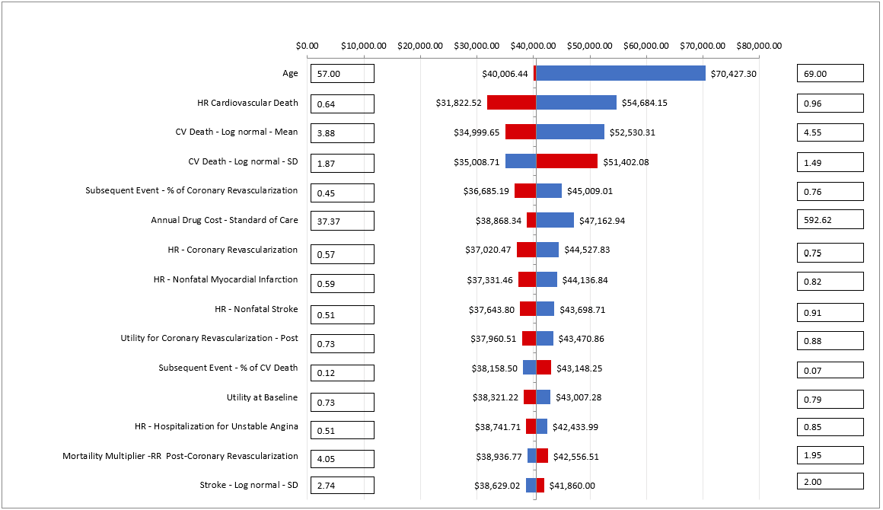
Tornado Diagram – VASCEPA vs. Placebo

Scenario analyses

The results from the various scenario analyses based on the probabilistic model are presented in the table below.

Results of Scenario Analyses
Scenario | Incremental Costs vs Placebo (SD) | Incremental QALYs vs Placebo (SD) | ICER vs Placebo ($/QALY gained) (SD)
Discount Rates
0% | $12,624 ($1,084) | 0.34 (0.08) | $37,433 ($14,113)
3% | $12,553 ($972) | 0.25 (0.06) | $49,860 ($17,761)
Time Horizon Length
5 years | $15,041 ($808) | 0.06 (0.02) | $253,227 ($94,046)
Lifetime (46 years) | $11,943 ($1,521) | 0.36 (0.09) | $32,925 ($12,689)
Perspective
Societal Perspective | $10,926 ($2,338) | 0.29 (0.07) | $37,469 ($16,667)
Half Cycle Correction
Not Considering Half-Cycle Correction | $12,513 ($1,018) | 0.30 (0.08) | $42,108 ($15,272)
Data Source for Trial period
Kaplan Meier | $12,830 ($914) | 0.29 (0.05) | $44,568 ($10,448)

REFERENCES
1. Jernberg T, Hasvold P, Henriksson M, Hjelm H, Thuresson M, Janzon M. Cardiovascular risk in post-myocardial infarction patients: nationwide real world data demonstrate the importance of a long-term perspective. European heart journal. 2015;36(19):1163-70.
2. Kaplan RC, Heckbert SR, Furberg CD, Psaty BM. Predictors of subsequent coronary events, stroke, and death among survivors of first hospitalized myocardial infarction. J Clin Epidemiol. 2002;55(7):654-64.
3. Bhatt DL, Steg PG, Miller M, Brinton EA, Jacobson TA, Ketchum SB, et al. Effects of Icosapent Ethyl on Total Ischemic Events: From REDUCE-IT. Journal of the American College of Cardiology. 2019.
4. Rawshani A, Rawshani A, Franzen S, Eliasson B, Svensson AM, Miftaraj M, et al. Mortality and Cardiovascular Disease in Type 1 and Type 2 Diabetes. The New England journal of medicine. 2017;376(15):1407-18.
5. Statistics Canada. Life Tables, Canada, Provinces and Territories 2014/2016 [Available from: https://www150.statcan.gc.ca/n1/pub/84-537-x/84-537-x2018002-eng.htm.
6. Chen S, Russell E, Banerjee S, Hutton B, Brown A, Asakawa K, et al. Clopidogrel compared with other antiplatelet agents for secondary prevention of vascular events in adults undergoing percutaneous coronary intervention: clinical and cost-effectiveness analyses. CADTH Technol Overv. 2012;2(1):e2103-e.
7. Goeree R, Lim ME, Hopkins R, Blackhouse G, Tarride J-E, Xie F, et al. Prevalence, Total and Excess Costs of Diabetes and Related Complications in Ontario, Canada. Canadian Journal of Diabetes. 2009;33(1):35-45.
8. Ministry of Health and Long Term Care. Ontario Case Costing - Cost Analysis Tool, Health Data Branch Web Portal. 2017 [Available from: http://hsim.health.gov.on.ca/hdbportal/2015. .
9. Henk HJ, Paoli CJ, Gandra SR. A Retrospective Study to Examine Healthcare Costs Related to Cardiovascular Events in Individuals with Hyperlipidemia. Adv Ther. 2015;32(11):1104-16.
10. H Anis A, Sun H, Singh S, Woolcott J, Nosyk B, Brisson M. A Cost-Utility Analysis of Losartan versus Atenolol in the Treatment of??Hypertension with Left Ventricular Hypertrophy2006. 387-400 p.
11. Ministry of Health and Long-Term Care of Ontario. Schedule of Benefits Physician Services Under the Health Insurance Act. [Available from: http://www.health.gov.on.ca/en/pro/programs/ohip/sob/.
12. Ministry of Health and Long-Term Care of Ontario. Schedule of Benefits of Laboratory Services. Effective April 1, 2017 (Updated Nov 7, 2017) 2017 [
13. Anderson TJ, Gregoire J, Pearson GJ, Barry AR, Couture P, Dawes M, et al. 2016 Canadian Cardiovascular Society Guidelines for the Management of Dyslipidemia for the Prevention of Cardiovascular Disease in the Adult. The Canadian journal of cardiology. 2016;32(11):1263-82.
14. Stone Neil J, Robinson Jennifer G, Lichtenstein Alice H, Bairey Merz CN, Blum Conrad B, Eckel Robert H, et al. 2013 ACC/AHA Guideline on the Treatment of Blood Cholesterol to Reduce Atherosclerotic Cardiovascular Risk in Adults. Circulation. 2014;129(25_suppl_2):S1-S45.
15. Lipid modification: cardiovascular risk assessment and the modification of blood lipids for the primary and secondary prevention of cardiovascular disease. London: National Clinical Guideline Centre; 2014. [cited 2016 Mar 22] (NICE clinical guideline CG181) [Available from: https://www.nice.org.uk/guidance/cg181/evidence/lipid‐modification‐update‐appendices‐243786638.
16. Wagner M, Goetghebeur M, Merikle E, Pandya A, Chu P, Taylor DC. Cost-effectiveness of intensive lipid lowering therapy with 80 mg of atorvastatin, versus 10 mg of atorvastatin, for secondary prevention of cardiovascular disease in Canada. Can J Clin Pharmacol. 2009;16(2):e331-45.
17. Canadian Agency for Drugs and Technologies in Health. CDR Pharmacoeconomic review report for Praluent. 2016 July 2016.
18. Song X, Quek RGW, Gandra SR, Cappell KA, Fowler R, Cong Z. Productivity loss and indirect costs associated with cardiovascular events and related clinical procedures. BMC Health Serv Res. 2015;15:245-.
19. Statistics Canada. Labour force characteristics by sex and detailed age group, annual, inactive (Table:14-10-0018-01 ) 2019 [Available from: https://www150.statcan.gc.ca/t1/tbl1/en/tv.action?pid=1410001801&pickMembers%5B0%5D=1.1&pickMembers%5B1%5D=2.10.
20. Statistics Canada. Average usual hours and wages by selected characteristics, monthly, unadjusted for seasonality, last 5 months (Table: 14-10-0320-01 ). 2019 [Available from: https://www150.statcan.gc.ca/t1/tbl1/en/tv.action?pid=1410032001&pickMembers%5B0%5D=3.4.
21. MaRS Discovery District. Employee benefits and benefits packages: What Ontario employers should know. 2019 [Available from: https://learn.marsdd.com/mars-library/employee-benefits-and-benefits-packages-what-ontario-employers-should-know/. .

