Supplementary materials
Supplementary material 1: Sensitivity analysis A using the raw database
EM raw database 2020 (n=118)
All patients (n=118)
Periods | Implementation |  |  |  | Odds ratio
Periods | Estimate | 95% CI |  |  | Estimate | 95% CI |  | p-value
Beforeª | 0.872 | 0.834 |  | 0.903 | NA
During^{b} | 0.869 | 0.826 |  | 0.903 | 0.972 | 0.784 | 1.206 | 0.796
After^{c} | 0.852 | 0.809 |  | 0.886 | 0.840 | 0.693 | 1.017 | 0.074
Patients with cancer (n=10)
Beforeª | 0.950 | 0.838 |  | 0.986 | NA
During^{b} | 0.909 | 0.754 |  | 0.971 | 0.527 | 0.196 | 1.418 | 0.204
After^{c} | 0.847 | 0.706 |  | 0.928 | 0.291 | 0.117 | 0.719 | 0.008^{g}
Patients with diabetic kidney disease (n=25)
Beforeª | 0.926 | 0.867 |  | 0.960 | NA
During^{b} | 0.929 | 0.868 |  | 0.963 | 1.033 | 0.643 | 1.661 | 0.892
After^{c} | 0.899 | 0.804 |  | 0.950 | 0.705 | 0.456 | 1.090 | 0.116
Patients with HIV (n=61)
Beforeª | 0.846 | 0.784 |  | 0.893 | NA
During^{b} | 0.880 | 0.817 |  | 0.923 | 1.334 | 1.060 | 1.678 | 0.014
After^{c} | 0.851 | 0.787 |  | 0.898 | 1.035 | 0.797 | 1.344 | 0.796
Miscellaneous patients (n=22)
Beforeª | 0.855 | 0.755 |  | 0.918 | NA
During^{b} | 0.754 | 0.625 |  | 0.849 | 0.522 | 0.318 | 0.855 | 0.010
After^{c} | 0.795 | 0.674 |  | 0.879 | 0.659 | 0.493 | 0.882 | 0.005
EM raw database 2019 (n=61)
All patients (n=61)
Periods | Implementation |  |  |  | Odds ratio
Periods | Estimate |  | 95% CI |  | Estimate | 95% CI |  | p-value
Winter^{d} | 0.902 |  | 0.862 | 0.931 | NA
Spring^{e} | 0.888 |  | 0.843 | 0.921 | 0.860 | 0.673 | 1.099 | 0.229
Summer^{f} | 0.869 |  | 0.829 | 0.901 | 0.723 | 0.546 | 0.956 | 0.023
NA= Not Applicable (reference period)
ªFrom December 1, 2019 to March 15, 2020; ^{b}From March 16 to June 7, 2020; ^{c}From June 8 to September 30, 2020; ^{d}From December 1, 2018 to March 15, 2019; ^{e}From March 16 to June 7, 2019; ^{f}From June 8 to September 30, 2019; ^{g}This result is not interpretable as only 5/10 (50%) patients with cancer were still using the EM on September 30, 2020.
Supplementary material 2: empirical implementation and GEE modelisations in 2020 (A) and 2019 (B) using the raw database
A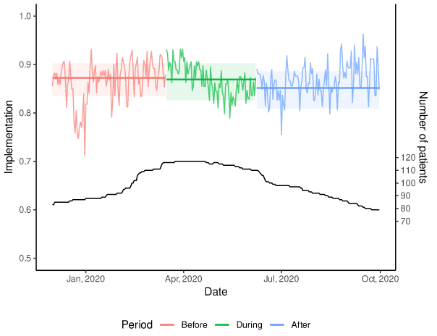 B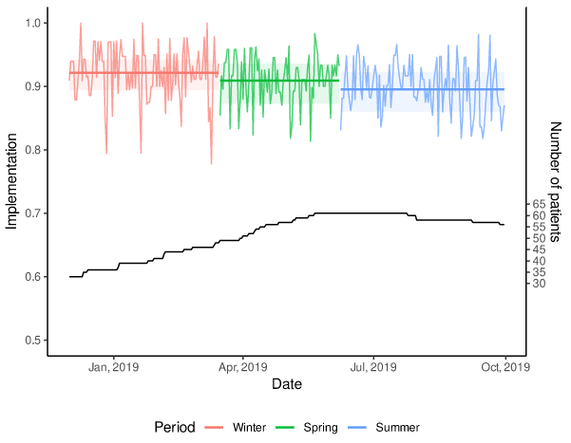
Legend Figure A Supplementary Material 2:
Legend Figure B Supplementary Material 2:

Supplementary material 3: Sensitivity analysis B using the restricted database
EM database 2020 (n=60)
All patients (n=60)
Periods | Implementation |  |  |  | Odds ratio
Periods | Estimate | 95% CI |  |  | Estimate | 95% CI |  | p-value
Beforeª | 0.914 | 0.870 |  | 0.945 | NA
During^{b} | 0.917 | 0.862 |  | 0.951 | 1.035 | 0.837 | 1.281 | 0.751
After^{c} | 0.902 | 0.848 |  | 0.938 | 0.859 | 0.712 | 1.037 | 0.114
Patients with cancer (n=2)
Beforeª | NA^{g}
During^{b}
After^{c}
Patients with diabetic kidney disease (n=11)
Beforeª | 0.986 | 0.973 |  | 0.993 | NA
During^{b} | 0.972 | 0.948 |  | 0.985 | 0.496 | 0.295 | 0.834 | 0.008
After^{c} | 0.972 | 0.952 |  | 0.984 | 0.504 | 0.292 | 0.868 | 0.014
Patients with HIV (n=36)
Beforeª | 0.920 | 0.890 |  | 0.943 | NA
During^{b} | 0.932 | 0.899 |  | 0.955 | 1.188 | 0.901 | 1.566 | 0.222
After^{c} | 0.916 | 0.878 |  | 0.943 | 0.949 | 0.715 | 1.258 | 0.715
Miscellaneous patients (n=11)
Beforeª | 0.892 | 0.743 |  | 0.960 | NA
During^{b} | 0.874 | 0.629 |  | 0.966 | 0.837 | 0.558 | 1.256 | 0.391
After^{c} | 0.854 | 0.637 |  | 0.951 | 0.707 | 0.553 | 0.904 | 0.006
EM database 2019 (n=31)
All patients (n=31)
Periods | Implementation |  |  |  | Odds ratio
Periods | Estimate |  | 95% CI |  | Estimate | 95% CI |  | p-value
Winter^{d} | 0.927 |  | 0.888 | 0.953 | NA
Spring^{e} | 0.907 |  | 0.847 | 0.945 | 0.769 | 0.618 | 0.956 | 0.018
Summer^{f} | 0.906 |  | 0.856 | 0.940 | 0.759 | 0.603 | 0.956 | 0.019
NA= Not Applicable
ªFrom December 1, 2019 to March 15, 2020; ^{b}From March 16 to June 7, 2020; ^{c}From June 8 to September 30, 2020; ^{d}From December 1, 2018 to March 15, 2019; ^{e}From March 16 to June 7, 2019; ^{f}From June 8 to September 30, 2019; ^{g}This result is not interpretable as only 2 patients were included.

Supplementary material 4: empirical implementation and GEE modelisations in 2020 (A) and 2019 (B) using the restricted database
A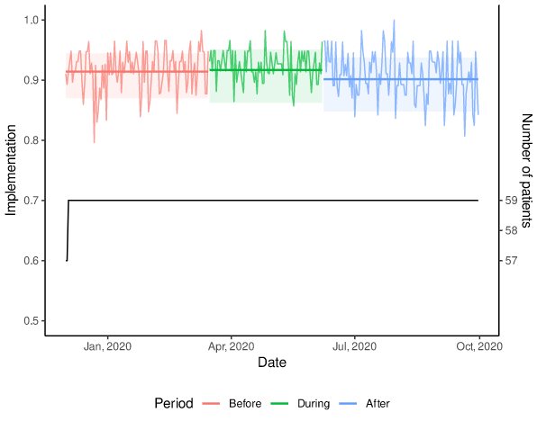B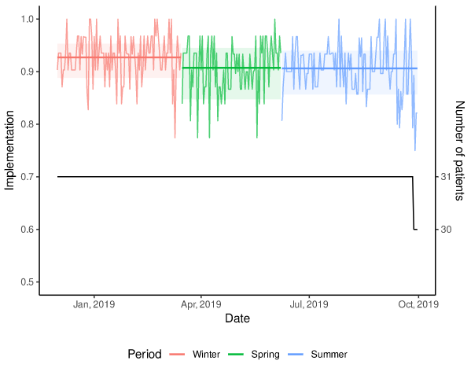
Legend Figure A Supplementary Material 4:
Legend Figure B Supplementary Material 4:

Supplementary material 5: In 2020, medication implementation of the 61 patients who used their EM both in 2019 and 2020 using the clean database
EM database 2020
Patients who used their EM both in 2019 and 2020 (n=61)
Periods | Implementation |  |  | Odds ratio
Periods | Estimate | 95% CI |  | Estimate | 95% CI |  | p-value
Beforeª | 0.876 | 0.821 | 0.916 | NA
During^{b} | 0.866 | 0.803 | 0.911 | 0.916 | 0.758 | 1.105 | 0.359
After^{c} | 0.862 | 0.799 | 0.907 | 0.882 | 0.740 | 1.051 | 0.160

NA= Not Applicable (reference period)
ªFrom December 1, 2019 to March 15, 2020; ^{b}From March 16 to June 7, 2020; ^{c}From June 8 to September 30, 2020
Supplementary material 6: Empirical implementation and GEE modelisations of the 61 patients who used their EM in 2019 (A) and 2020 (B) using the clean database
A 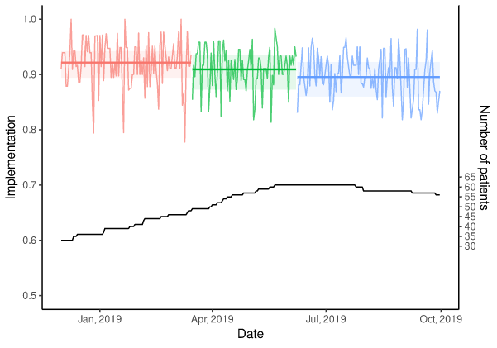B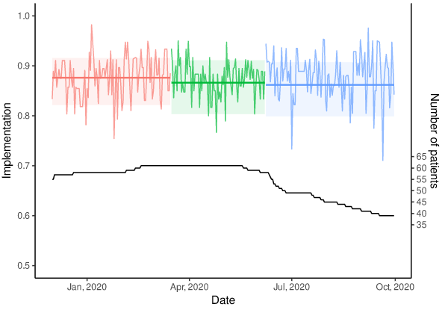
Legend Figure A Supplementary Material 6: Legend Figure B Supplementary Material 6:
NB: If a patient is not monitored at a given day x (e.g., hospitalization), then this patient is not included in the implementation estimates on that day x, leading to a daily variation of patients in the database.

