Supplementary materials:
Detailed information of MRI based-tumor features:
The tumor necrosis of primary tumor or lymph nodes is defined as a focal area of high signal intensity on T2 weighted images or a focal area of low signal intensity on contrast-enhanced T1-weighted images, with or without a surrounding rim of enhancement.
The criteria for diagnosing extranodal extension of retropharyngeal lymph node and cervical lymph node is assessed with four MR sequences in the axial plane, which including a T1-weighted sequence, T2-weighted sequence with fat suppression, and T1-weighted sequence postcontrast with fat suppression. The features of extranodal extension included infiltration into surrounding fat plane, matted nodes or infiltration into adjacent muscle, nerves, or parotid glands.
Nodal grouping is characterized by the presence of three or more contiguous lymph node within one lymph node region.

Detailed information of MRI sequences:
MRI examinations of the head and neck were performed on 1.5 T clinical MRI system (Magnetom Avanto, Siemens, Erlangen, Germany). The MRI protocols consisted of an axial fat-suppressed T2-weighted sequence, an axial T1-weighted spin-echo sequence, and postcontrast-enhanced T1-weighted spin-echo sequence with fat suppression following a bolus injection of gadopentetate dimeglumine (0.2 mL/kg of body weight; Magnevist, Schering, Berlin, Germany). Sequences were obtained using a section thickness of 5 mm with a 1-mm interslice gap for the axial plane, resulting in a matrix size of 256 × 256.
Detailed information of treatment:
IC regimens included two to three cycles of TPF (docetaxel 60 mg/m² and cisplatin 60 mg/m², day 1; fluorouracil 600 mg/m²/d, days 1-5), PF (cisplatin 80 mg/m² day 1; fluorouracil 800 mg/m²/d, days 1-5), TP (docetaxel 75 mg/m² and cisplatin 75 mg/m², day 1), and GP (gemcitabine 1000 mg/m², days 1 and 8; cisplatin 80 mg/m², day 1) at three-week intervals. Concurrent chemotherapy was three-weekly cisplatin (80-100 mg/m²) for 2-3 cycles during IMRT.
IMRT technique was applied to all patients in this study. The primary gross tumor volume (GTVnx) and cervical lymph node tumor volume (GTVnd) included the entire macroscopic tumor defined with the aid of computed tomography (CT), magnetic resonance imaging (MRI) scans, and physical examinations. Two clinical target volumes (CTVs) were delineated according to the tumor invasion pattern. The high-risk clinical target volume (CTV1) included the GTVnx add a margin of 0.5 to 1 cm (forward, both sides, up and down) and a margin of 0.3 to 0.5 cm (back) to encompass the high-risk sites of microscopic extension and the whole nasopharynx. The low-risk clinical target volume (CTV2) was defined as the CTV1 add a margin of 0.5 to 1 cm (forward, both sides, up and down) and a margin of 0.3 to 0.5 cm (back) to encompass the low-risk sites of microscopic extension, the GTVnd, and elective neck area from level IB to V. The total doses were 70-79.5 Gy to the planning target volume (PTV) of the primary gross tumor volume, 60-73.6 Gy to the nodal gross tumor volume.

Supplementary tables:
Supplementary Table 1 Identification of risk factors of OS by multivariate Cox models in the matched cohort.
Characteristics | HR (95% CI) | p-value
Age (> 50 vs. ≤ 50) | 2.123 (1.319-3.417) | 0.002
T stage (T3/4 vs. T2) | 1.706 (1.018-2.857) | 0.042
N stage (N3 vs. N2) | 1.858 (1.150-3.001) | 0.011
EBV DNA (> 6000 vs. ≤ 6000) | 1.647 (1.027-2.641) | 0.038
ALB (> 38.5 vs. ≤ 38.5) | 0.899 (0.537-1.506) | 0.686
NLR (>2.60 vs. ≤2.60) | 0.910 (0.502-1.651) | 0.757
PLR (> 152.5 vs. ≤152.5) | 1.239 (0.738-2.082) | 0.418
LMR (> 3.80 vs. ≤ 3.80) | 0.554 (0.343-0.897) | 0.016
LDH (> 195 vs. ≤ 195) | 1.246 (0.764-2.032) | 0.378
RLN_ necrosis (Yes vs. No) | 1.535 (0.897-2.626) | 0.118
CLN_ necrosis (Yes vs. No) | 1.976 (1.241-3.147) | 0.004
CLN_ ENE (Yes vs. No) | 1.273 (0.654-2.477) | 0.477
NG (Yes vs. No) | 0.833 (0.473-1.467) | 0.527
Treatment (IC+CCRT vs. CCRT) | 0.599 (0.374-0.960) | 0.033
Abbreviations: IC, induction chemotherapy; CCRT, concurrent chemoradiotherapy; WHO, World Health Organization; EBV DNA, Epstein–Barr virus DNA; NLR, neutrophil to lymphocyte ratio; PLR, platelet to lymphocyte ratio; LMR, lymphocyte to monocyte ratio; ALB, albumin; LDH, lactate dehydrogenase; RLN, retropharyngeal lymph node; CLN, cervical lymph node; ENE, extranodal extension; NG, nodal grouping.

Supplementary Table 2 Characteristics of patients group by cohort.
Characteristics | Whole cohort  (n = 624) | Training cohort  (n = 468) | Validation cohort  (n = 156) | p-value
Age (years) |  |  |  | 0.330
≤ 50 | 410 (65.7) | 313 (66.9) | 97 (62.2)
> 50 | 214 (34.3) | 155 (33.1) | 59 (37.8)
Sex |  |  |  | 0.085
Female | 167 (26.8) | 134 (28.6) | 33 (21.2)
Male | 457 (73.2) | 334 (71.4) | 123 (78.8)
Pathological type |  |  |  | 0.045
WHO type I/II | 57 (9.1) | 36 (7.7) | 21 (13.5)
WHO type III | 567 (90.9) | 432 (92.3) | 135 (86.5)
T stage |  |  |  | 0.150
T2 | 242 (38.8) | 188 (40.2) | 54 (34.6)
T3 | 239 (38.3) | 169 (36.1) | 70 (44.9)
T4 | 143 (22.9) | 111 (23.7) | 32 (20.5)
N stage |  |  |  | 0.848
N2 | 394 (63.1) | 297 (63.5) | 97 (62.2)
N3 | 230 (36.9) | 171 (36.5) | 59 (37.8)
Clinical stage |  |  |  | 0.890
III | 295 (47.3) | 220 (47.0) | 75 (48.1)
IVa | 329 (52.7) | 248 (53.0) | 81 (51.9)
BMI (Kg/m²) |  |  |  | 1.000
< 18.5 | 58 (9.3) | 43 (9.2) | 15 (9.6)
≥ 18.5 | 566 (90.7) | 425 (90.8) | 141 (90.4)
Smoke |  |  |  | 0.516
Yes | 193 (30.9) | 141 (30.1) | 52 (33.3)
No | 431 (69.1) | 327 (69.9) | 104 (66.7)
EBV DNA (copies/ml) |  |  |  | 0.553
≤ 6000 | 422 (67.6) | 320 (68.4) | 102 (65.4)
> 6000 | 202 (32.4) | 148 (31.6) | 54 (34.6)
NLR |  |  |  | 1.000
≤ 2.60 | 393 (63.0) | 295 (63.0) | 98 (62.8)
> 2.60 | 231 (37.0) | 173 (37.0) | 58 (37.2)
PLR |  |  |  | 0.046
≤ 152.5 | 331 (53.0) | 237 (50.6) | 94 (60.3)
> 152.5 | 293 (47.0) | 231 (49.4) | 62 (39.7)
LMR |  |  |  | 0.890
≤ 3.80 | 323 (51.8) | 241 (51.5) | 82 (52.6)
> 3.80 | 301 (48.2) | 227 (48.5) | 74 (47.4)
ALB (g/L) |  |  |  | 0.769
≤ 38.5 | 208 (33.3) | 158 (33.8) | 50 (32.1)
> 38.5 | 416 (66.7) | 310 (66.2) | 106 (67.9)
ALP (U/L) |  |  |  | 0.644
≤ 51 | 89 (14.3) | 69 (14.7) | 20 (12.8)
> 51 | 535 (85.7) | 399 (85.3) | 136 (87.2)
LDH (U/L) |  |  |  | 0.739
≤ 195 | 387 (62.0) | 288 (61.5) | 99 (63.5)
> 195 | 237 (38.0) | 180 (38.5) | 57 (36.5)
PT_ necrosis
No | 581 (93.1) | 434 (92.7) | 147 (94.2) | 0.648
Yes | 43 (6.9) | 34 (7.3) | 9 (5.8)
RLN_laterality |  |  |  | 0.707
None | 172 (27.6) | 125 (26.7) | 47 (30.1)
Unilateral | 263 (42.1) | 200 (42.7) | 63 (40.4)
Bilateral | 189 (30.3) | 143 (30.6) | 46 (29.5)
RLN_ necrosis |  |  |  | 0.463
No | 491 (78.7) | 372 (79.5) | 119 (76.3)
Yes | 133 (21.3) | 96 (20.5) | 37 (23.7)
CLN_ necrosis |  |  |  | 0.066
No | 404 (64.7) | 313 (66.9) | 91 (58.3)
Yes | 220 (35.3) | 155 (33.1) | 65 (41.7)
CLN_ ENE |  |  |  | 0.261
No | 117 (18.8) | 93 (19.9) | 24 (15.4)
Yes | 507 (81.2) | 375 (80.1) | 132 (84.6)
NG |  |  |  | 0.880
No | 437 (70.0) | 329 (70.3) | 108 (69.2)
Yes | 187 (30.0) | 139 (29.7) | 48 (30.8)
Treatment |  |  |  | 0.627
CCRT | 216 (34.6) | 159 (34.0) | 57 (36.5)
IC+CCRT | 408 (65.4) | 309 (66.0) | 99 (63.5)
IC regime |  |  |  | 0.544
NA | 216 (34.6) | 159 (34.0) | 57 (36.5)
TPF | 334 (53.5) | 257 (54.9) | 77 (49.4)
TP | 19 (3.0) | 15 (3.2) | 4 (2.6)
PF | 16 (2.6) | 10 (2.1) | 6 (3.8)
GP | 39 (6.2) | 27 (5.8) | 12 (7.7)
IC cycle |  |  |  | 0.832
NA | 216 (34.6) | 159 (34.0) | 57 (36.5)
2 | 80 (12.8) | 60 (12.8) | 20 (12.8)
3 | 328 (52.6) | 249 (53.2) | 79 (50.6)
Note: Data are shown as numbers (percentage).
Abbreviations: IC, induction chemotherapy; CCRT, concurrent chemoradiotherapy; WHO, World Health Organization; EBV DNA, Epstein–Barr virus DNA; NLR, neutrophil to lymphocyte ratio; PLR, platelet to lymphocyte ratio; LMR, lymphocyte to monocyte ratio; ALB, albumin; ALP, alkaline phosphatase; LDH, lactate dehydrogenase; PT, primary tumor; RLN, retropharyngeal lymph node; CLN, cervical lymph node; ENE, extranodal extension; NG, nodal grouping; TPF, docetaxel-cisplatin-5-fluorouracil; TP, docetaxel-cisplatin; PF, cisplatin-5-fluorouracil; GP, gemcitabine-cisplatin.
P-values were calculated by the Chi-square test or Fisher’s exact test.

Supplementary Table 3 The baseline characteristics of the patients treated with IC plus CCRT or CCRT alone in each risk group before matching.
 | High-risk group |  |  | Low-risk group
Characteristics | CCRT  (n = 61) | IC+CCRT  (n = 136) | p-value | CCRT  (n = 155) | IC+CCRT  (n = 272) | p-value
Age (years) |  |  | 0.001 |  |  | 0.036
< 50 | 15 (24.6) | 69 (50.7) |  | 109 (70.3) | 217 (80.0)
≥ 50 | 46 (75.4) | 67 (49.3) |  | 46 (29.7) | 55 (20.0)
T stage |  |  | 0.817 |  |  | 0.038
T2 | 18 (29.5) | 44 (32.4) |  | 76 (49.0) | 104 (38.2)
T3/4 | 43 (70.5) | 92 (67.6) |  | 79 (51.0) | 168 (61.8)
N stage |  |  | 0.008 |  |  | < 0.001
N2 | 36 (59.0) | 51 (37.5) |  | 136 (87.7) | 171 (62.9)
N3 | 25 (41.0) | 85 (62.5) |  | 19 (12.3) | 101 (37.1)
Clinical stage |  |  | 0.004 |  |  | < 0.001
III | 28 (45.9) | 33 (24.3) |  | 122 (78.7) | 112 (41.2)
IVa | 33 (54.1) | 103 (75.7) |  | 33 (21.3) | 160 (58.8)
EBV DNA (copies/ml) |  |  | 0.614 |  |  | 0.423
≤ 6000 | 19 (31.1) | 49 (36.0) |  | 132 (85.2) | 222 (81.6)
> 6000 | 42 (68.9) | 87 (64.0) |  | 23 (14.8) | 50 (18.4)
LMR |  |  | 1.000 |  |  | 0.002
≤ 3.80 | 18 (29.5) | 39 (28.7) |  | 81 (52.3) | 185 (68.0)
> 3.80 | 43 (70.5) | 97 (71.3) |  | 74 (47.7) | 87 (32.0)
RLN_ necrosis |  |  | 0.620 |  |  | 0.563
No | 34 (55.7) | 69 (50.7) |  | 143 (92.3) | 245 (90.1)
Yes | 27 (44.3) | 67 (49.3) |  | 12 (7.7) | 27 (9.9)
CLN_ necrosis |  |  | 0.026 |  |  | 0.398
No | 33 (54.1) | 49 (36.0) |  | 121 (78.1) | 201 (73.9)
Yes | 28 (45.9) | 87 (64.0) |  | 34 (21.9) | 71 (26.1)
Note: Data are shown as numbers (percentage).
Abbreviations: IC, induction chemotherapy; CCRT, concurrent chemoradiotherapy; EBV DNA, Epstein–Barr virus DNA; LMR, lymphocyte to monocyte ratio; RLN, retropharyngeal lymph node; CLN, cervical lymph node.
P-values were calculated by the Chi-square test or Fisher’s exact test.

Supplementary Table 4 The baseline characteristics of the patients treated with IC plus CCRT or CCRT alone in each risk group after matching.
 | High-risk group |  |  | Low-risk group
Characteristics | CCRT  (n = 47) | IC+CCRT  (n = 47) | p-value | CCRT  (n = 128) | IC+CCRT  (n = 128) | p-value
Age (years) |  |  | 0.822 |  |  | 0.887
< 50 | 15 (31.9) | 13 (27.7) |  | 95 (74.2) | 93 (72.7)
≥ 50 | 32 (68.1) | 34 (72.3) |  | 33 (25.8) | 35 (27.3)
T stage |  |  | 0.818 |  |  | 0.382
T2 | 14 (29.8) | 12 (25.5) |  | 61 (47.7) | 69 (53.9)
T3/4 | 33 (70.2) | 35 (74.5) |  | 67 (52.3) | 59 (46.1)
N stage |  |  | 1.000 |  |  | 0.863
N2 | 26 (55.3) | 26 (55.3) |  | 109 (85.2) | 107 (83.6)
N3 | 21 (44.7) | 21 (44.7) |  | 19(14.8) | 21 (16.4)
Clinical stage |  |  | 0.673 |  |  | 1.000
III | 20 (42.6) | 17 (36.2) |  | 96 (75.0) | 96 (75.0)
IVa | 27 (57.4) | 30 (63.8) |  | 32 (25.0) | 32 (25.0)
EBV DNA (copies/ml) |  |  | 0.666 |  |  | 0.263
≤ 6000 | 18 (38.3) | 15 (31.9) |  | 115 (89.8) | 108 (84.4)
> 6000 | 29 (61.7) | 32 (68.1) |  | 13 (10.2) | 20 (15.6)
LMR |  |  | 1.000 |  |  | 0.705
≤ 3.80 | 12 (25.5) | 12 (25.5) |  | 70 (54.7) | 74 (57.8)
> 3.80 | 35 (74.5) | 35 (74.5) |  | 58 (45.3) | 54 (42.2)
RLN_ necrosis |  |  | 1.000 |  |  | 0.807
No | 25 (53.2) | 24 (51.1) |  | 118 (92.2) | 120 (93.8)
Yes | 22 (46.8) | 23 (48.9) |  | 10 (7.8) | 8 (6.2)
CLN_ necrosis |  |  | 1.000 |  |  | 0.123
No | 22 (46.8) | 21 (44.7) |  | 99 (77.3) | 87 (68.0)
Yes | 25 (53.2) | 26 (55.3) |  | 29 (22.7) | 41 (32.0)
Note: Data are shown as numbers (percentage).
Abbreviations: IC, induction chemotherapy; CCRT, concurrent chemoradiotherapy; EBV DNA, Epstein–Barr virus DNA; LMR, lymphocyte to monocyte ratio; RLN, retropharyngeal lymph node; CLN, cervical lymph node.
P-values were calculated by the Chi-square test or Fisher’s exact test.

Supplementary Figures:
a: b:
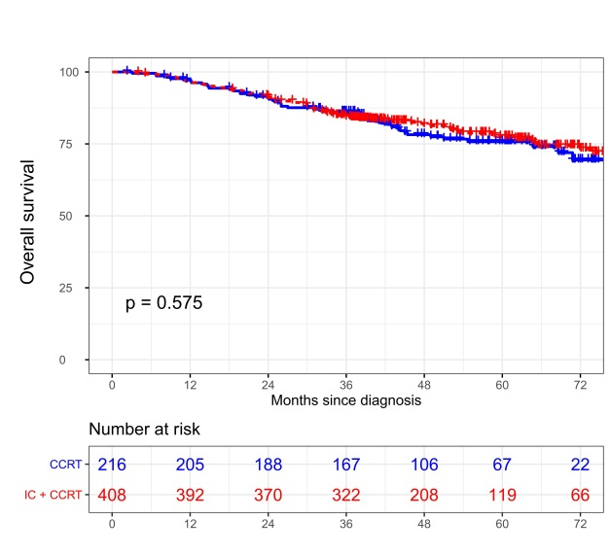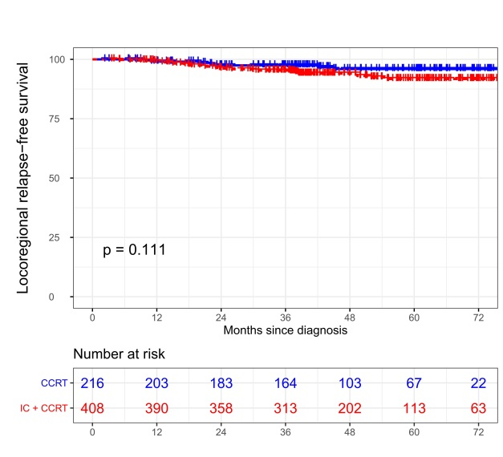

c: d:
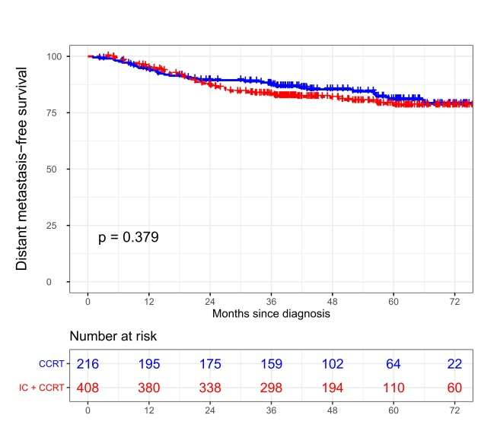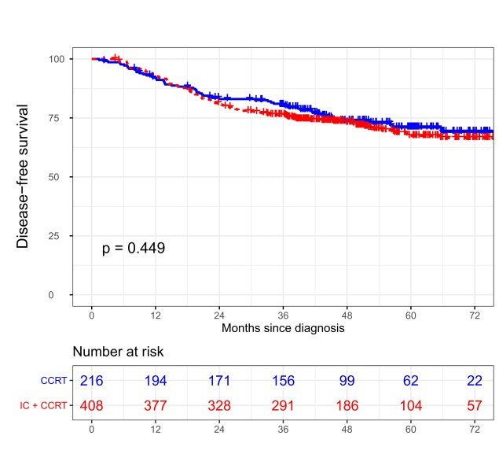
Supplementary Figure 1 Kaplan-Meier survival curves of OS (a), LRRFS (b), DMFS (c), and DFS (d) of patients between IC+CCRT and CCRT alone in the unmatched data set.
Abbreviations: IC, induction chemotherapy; CCRT, concurrent chemoradiotherapy; OS, overall survival; LRRFS, locoregional relapse-free survival; DMFS, distant metastasis-free survival; DFS, disease-free survival.

a: b:
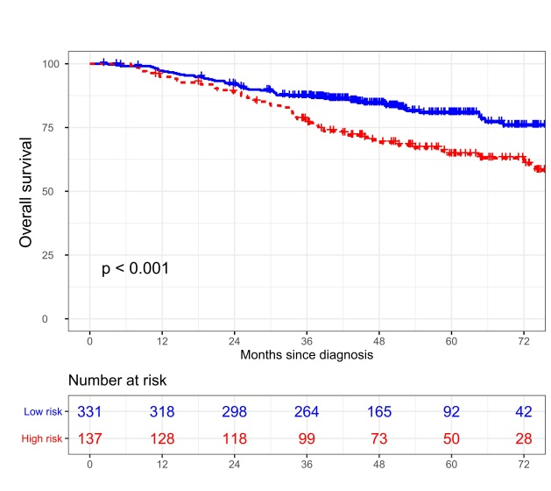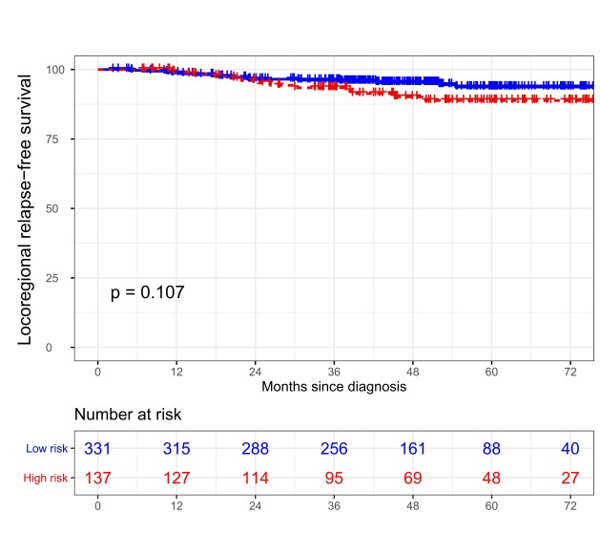

c: d:
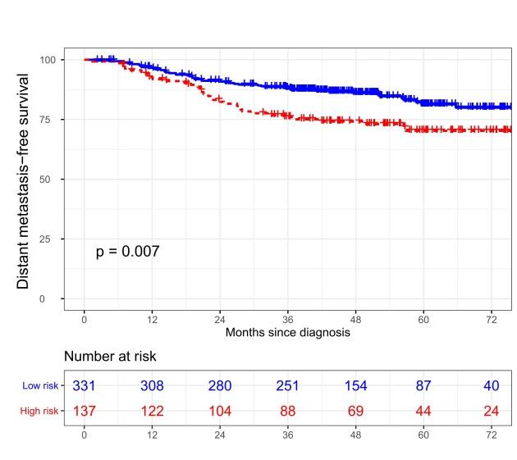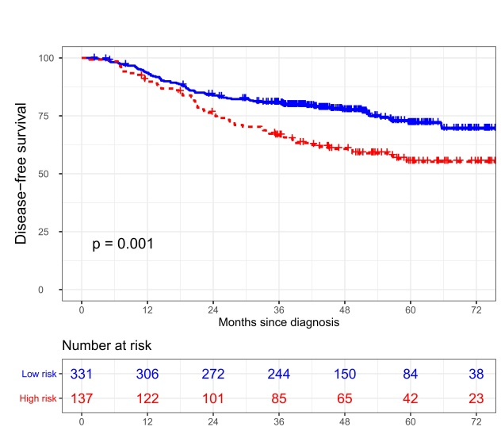
e: f:
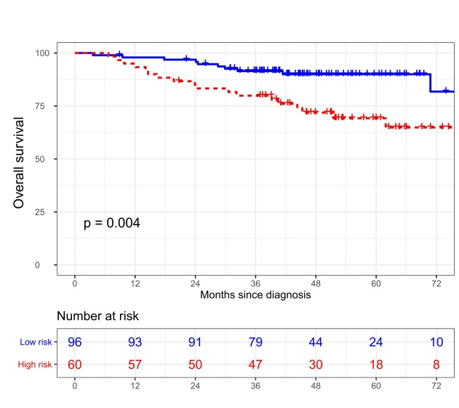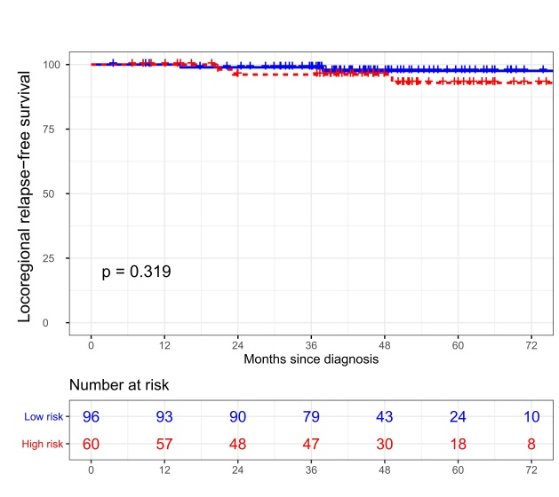
g: h:
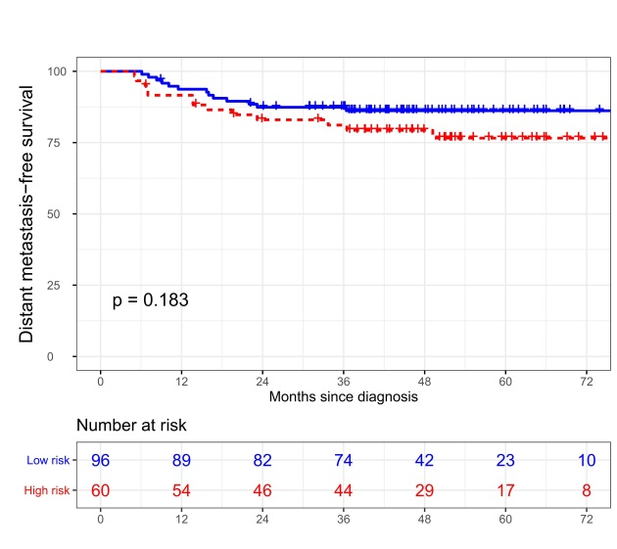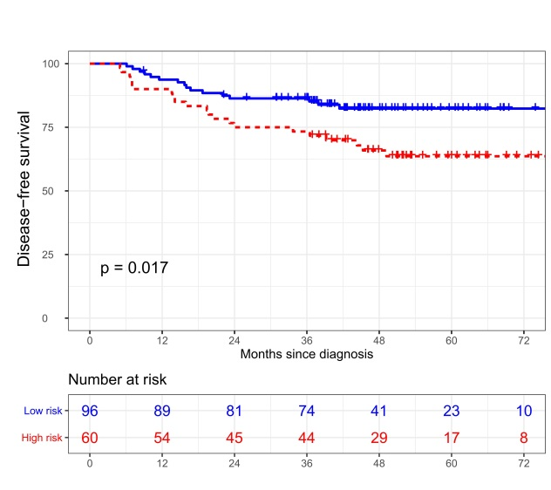
Supplementary Figure 2 Kaplan-Meier survival curves of OS (a, e), LRRFS (b, f), DMFS (c, g), and DFS (d, h) for patients stratified as nomogram-defined high-risk and low-risk groups in training and validation cohorts.
Abbreviations: OS, overall survival; LRRFS, locoregional relapse-free survival; DMFS, distant metastasis-free survival; DFS, disease-free survival.

a: b:
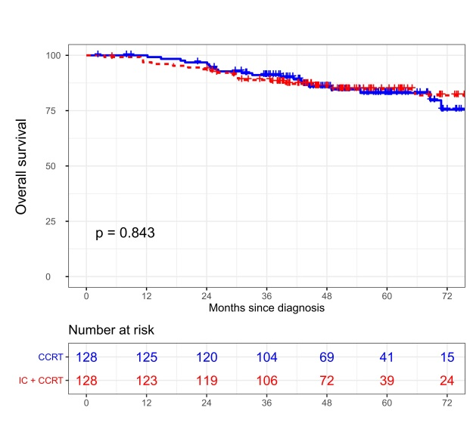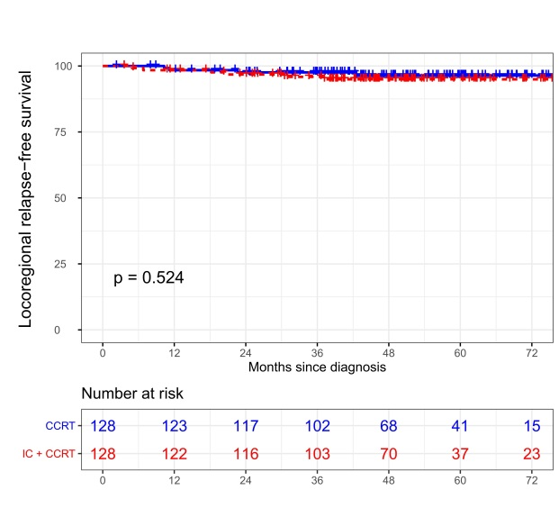
C: d:
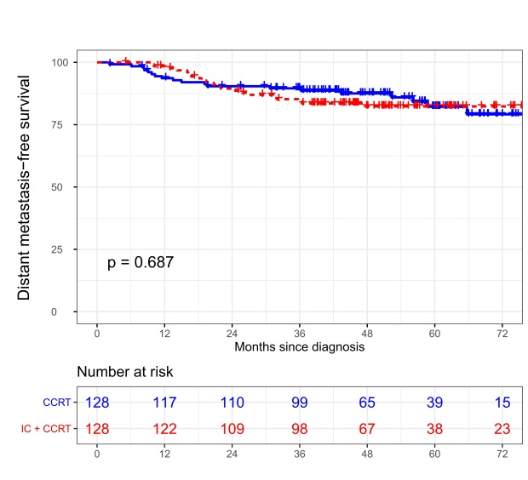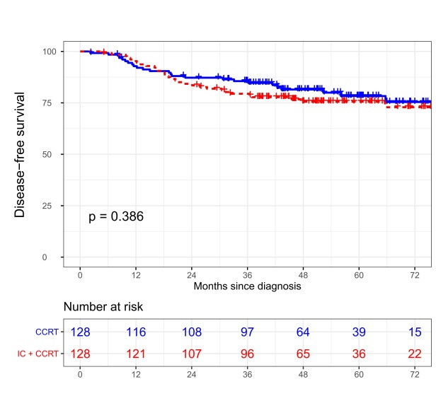
Supplementary Figure 3 Kaplan-Meier survival curves of OS (a), LRRFS (b), DMFS (c), and DFS (d) of patients between IC+CCRT and CCRT alone in the nomogram-defined low-risk group after matching.
Abbreviations: IC, induction chemotherapy; CCRT, concurrent chemoradiotherapy.

