Supporting Information

Rapid identification of bacteria in urinary tract infections via a fluorescence sensor array
Lei Zhang,^{1, *} Bing Wang,^{2, *} Guo Yin,² Jue Wang,² Ming He,³ Yuqi Yang,⁴ Tiejie Wang,² Ting Tang,³ Xie-an Yu,² Jiangwei Tian¹
¹State Key Laboratory of Natural Medicines, Jiangsu Key Laboratory of TCM Evaluation and Translational Research, School of Traditional Chinese Pharmacy, China Pharmaceutical University, Nanjing, Jiangsu Province, 211198, People’s Republic of China; ²NMPA Key Laboratory for Bioequivalence Research of Generic Drug Evaluation, Shenzhen Institute for Drug Control, Shenzhen, Guangdong Province, 518057, People’s Republic of China; ³Dermatology Department, The First Affiliated Hospital of Guizhou University of Traditional Chinese Medicine, Guiyang, Guizhou Province, 550002, People’s Republic of China; ⁴School of Basic Medicine, Guizhou University of Traditional Chinese Medicine, Guiyang, Guizhou Province, 550002, People’s Republic of China
* These authors contributed equally to this work.
Correspondence: Xie-an Yu, Email yuxieanalj@126.com; Jiangwei Tian, Email jwtian@cpu.edu.cn
Content
Fig. S1. The DLS of Ami-AuNPs
Fig. S2. The DLS of Ami-AuNPs-DNAs
Fig. S3. The zeta potential of AuNPs
Fig. S4. The zeta potential of Ami-AuNPs
Fig. S5. The zeta potential of Ami-AuNPs-DNAs
Fig. S6. The stability of size for Ami-AuNPs
Fig. S7. The stability of zeta potential for Ami-AuNPs
Fig. S8. The stability of size for Ami-AuNPs-DNAs
Fig. S9. The stability of zeta potential for Ami-AuNPs-DNAs
Fig. S10. The fluorescence lifetime of DNAs and Ami-AuNPs-DNAs
Fig. S11. 3D canonical score plot for the response patterns of five kinds of bacteria (OD₆₀₀=0.1) by PCA. Each point represents the response pattern for single bacteria species to the sensor.
Fig. S12. Canonical score plot for the response patterns of five kinds of bacteria (OD₆₀₀=0.1) by LDA. Each point represents the response pattern for single bacteria species to the sensor.
Fig. S13. 2D LDA canonical score plots (A) and 3D PCA canonical score plots (B) obtained from the Ami-AuNP-DNAs sensor against Escherichia coli at different concentrations (OD₆₀₀ from 0.005 to 0.1). Each point represents the response pattern for single bacteria to the array.
Fig. S14. 2D LDA canonical score plots (A) and 3D PCA canonical score plots (B) obtained from the Ami-AuNP-DNAs sensor against Enterococcus faecium at different concentrations (OD₆₀₀ from 0.005 to 0.1). Each point represents the response pattern for single bacteria to the array.
Fig. S15. 2D LDA canonical score plots (A) and 3D PCA canonical score plots (B) obtained from the Ami-AuNP-DNAs sensor against Klebsiella pneumoniae at different concentrations (OD₆₀₀ from 0.005 to 0.1). Each point represents the response pattern for single bacteria to the array.
Fig. S16. 2D LDA canonical score plots (A) and 3D PCA canonical score plots (B) obtained from the Ami-AuNP-DNAs sensor against Enterococcus faecalis at different concentrations (OD₆₀₀ from 0.005 to 0.1). Each point represents the response pattern for single bacteria to the array.
Fig. S17. 2D LDA canonical score plots (A) and 3D PCA canonical score plots (B) obtained from the Ami-AuNP-DNAs sensor against Pseudomonas aeruginosa at different concentrations (OD₆₀₀ from 0.005 to 0.1). Each point represents the response pattern for single bacteria to the array.
Fig. S18. 2D canonical score plot for the response patterns of five kinds of bacteria isolated from urine samples of clinical urinary tract infections (OD₆₀₀=0.1) by PCA. Each point represents the response pattern for single bacteria species to the sensor.
Table S1. Zeta potential of bacteria used in this article.
Table S2. The fluorescence response pattern of six DNAs in five kinds of bacteria
Table S3. Classification results and model performance of five kinds of bacteria detection and discrimination
Table S4. Fluorescence response pattern obtained from the Ami-AuNP-DNAs sensor against Escherichia coli at different concentrations (OD₆₀₀ from 0.005 to 0.1).
Table S5. Fluorescence response pattern obtained from the Ami-AuNP-DNAs sensor against Enterococcus Faecium at different concentrations (OD₆₀₀ from 0.005 to 0.1).
Table S6. Fluorescence response pattern obtained from the Ami-AuNP-DNAs sensor against Klebsiella pneumoniae at different concentrations (OD₆₀₀ from 0.005 to 0.1).
Table S7. Fluorescence response pattern obtained from the Ami-AuNP-DNAs sensor against Enterococcus faecalis at different concentrations (OD₆₀₀ from 0.005 to 0.1).
Table S8. Fluorescence response pattern obtained from the Ami-AuNP-DNAs sensor against Pseudomonas aeruginosa at different concentrations (OD₆₀₀ from 0.005 to 0.1).
Table S9. The fluorescence response pattern of six DNAs in bacteria isolated from clinical urine samples
Table S10. Classification results and model performance of five kinds of bacteria isolated from clinical urine samples

Fig. S1. The DLS of Ami-AuNPs

Fig. S2. The DLS of Ami-AuNPs-DNAs

Fig. S3. The zeta potential of AuNPs

Fig. S4. The zeta potential of Ami-AuNPs

Fig. S5. The zeta potential of Ami-AuNPs-DNAs

Fig. S6. The stability of size for Ami-AuNPs

Fig. S7. The stability of zeta potential for Ami-AuNPs

Fig. S8. The stability of size for Ami-AuNPs-DNAs

Fig. S9. The stability of zeta potential for Ami-AuNPs-DNAs

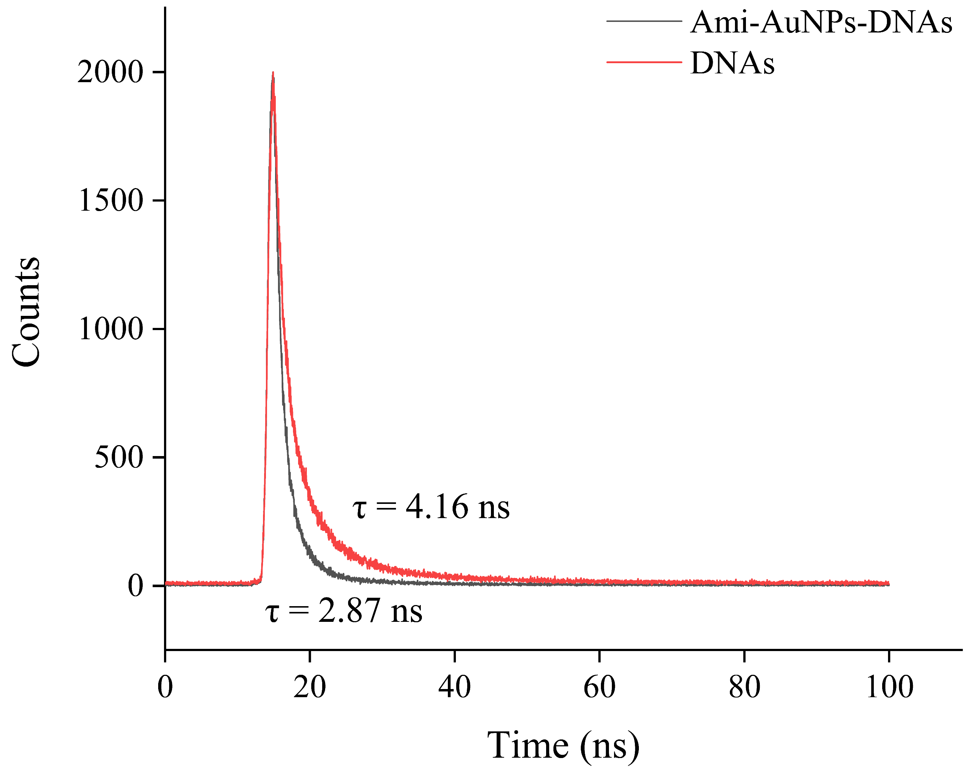
Fig. S10. The fluorescence lifetime of DNAs and Ami-AuNPs-DNAs.

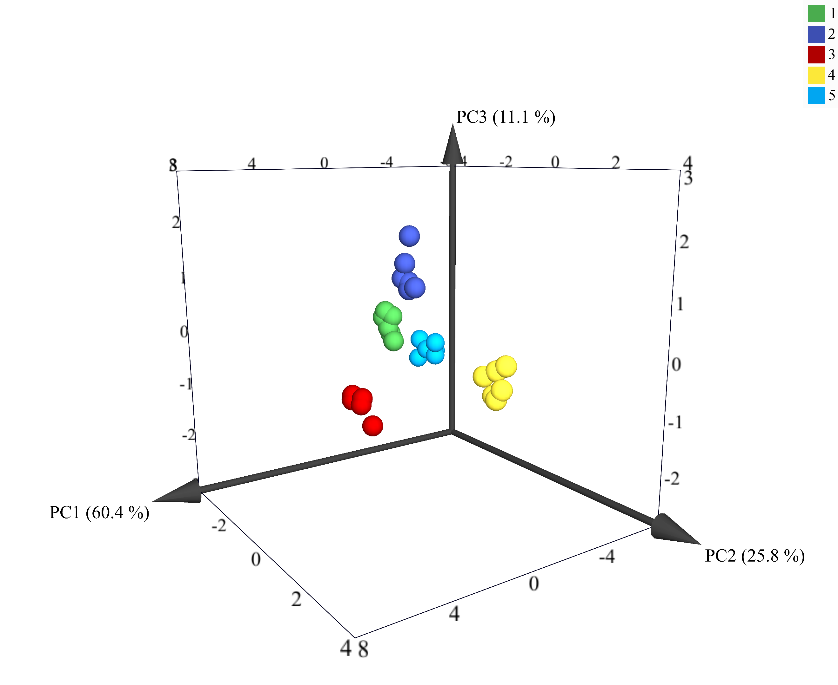
Fig. S11. 3D canonical score plot for the response patterns of five kinds of bacteria (OD₆₀₀=0.1) by PCA. Each point represents the response pattern for single bacteria species to the sensor.

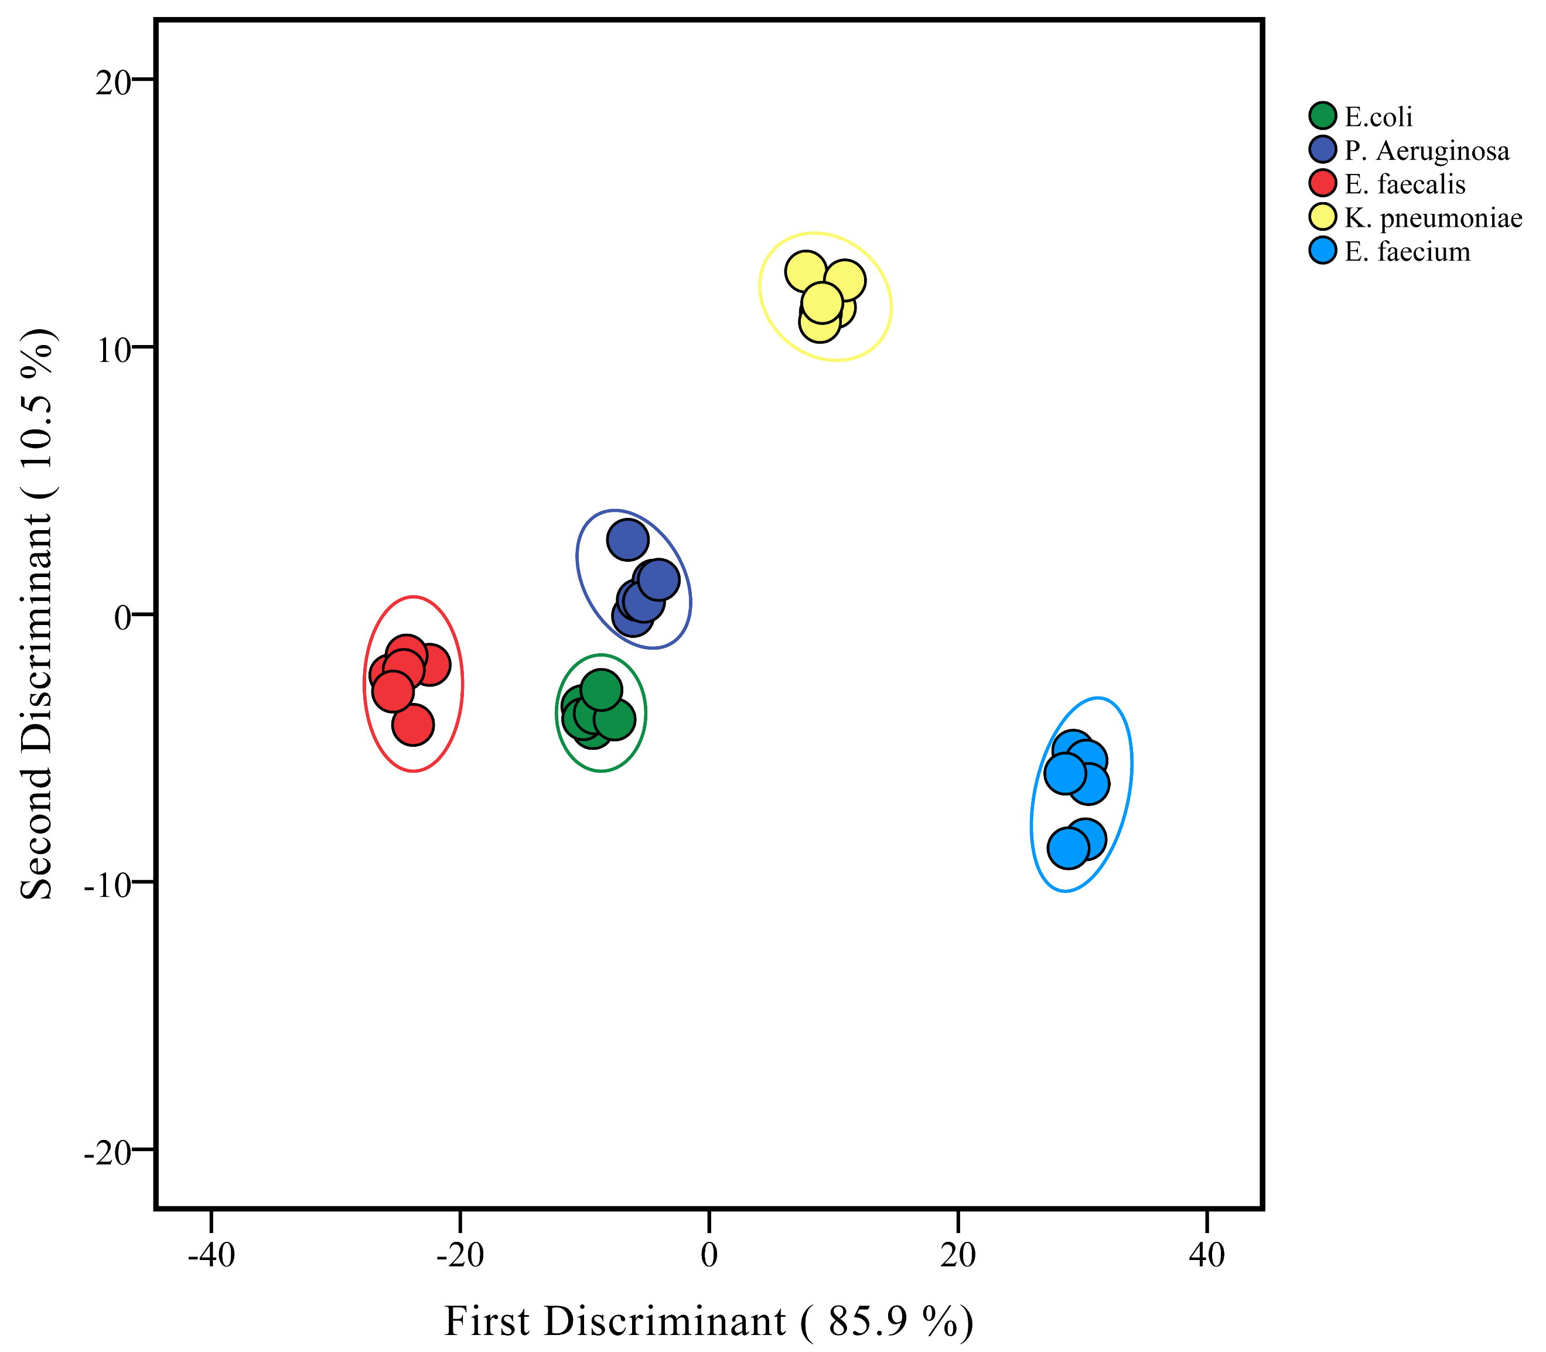
Fig. S12. Canonical score plot for the response patterns of five kinds of bacteria (OD₆₀₀=0.1) by LDA. Each point represents the response pattern for single bacteria species to the sensor.

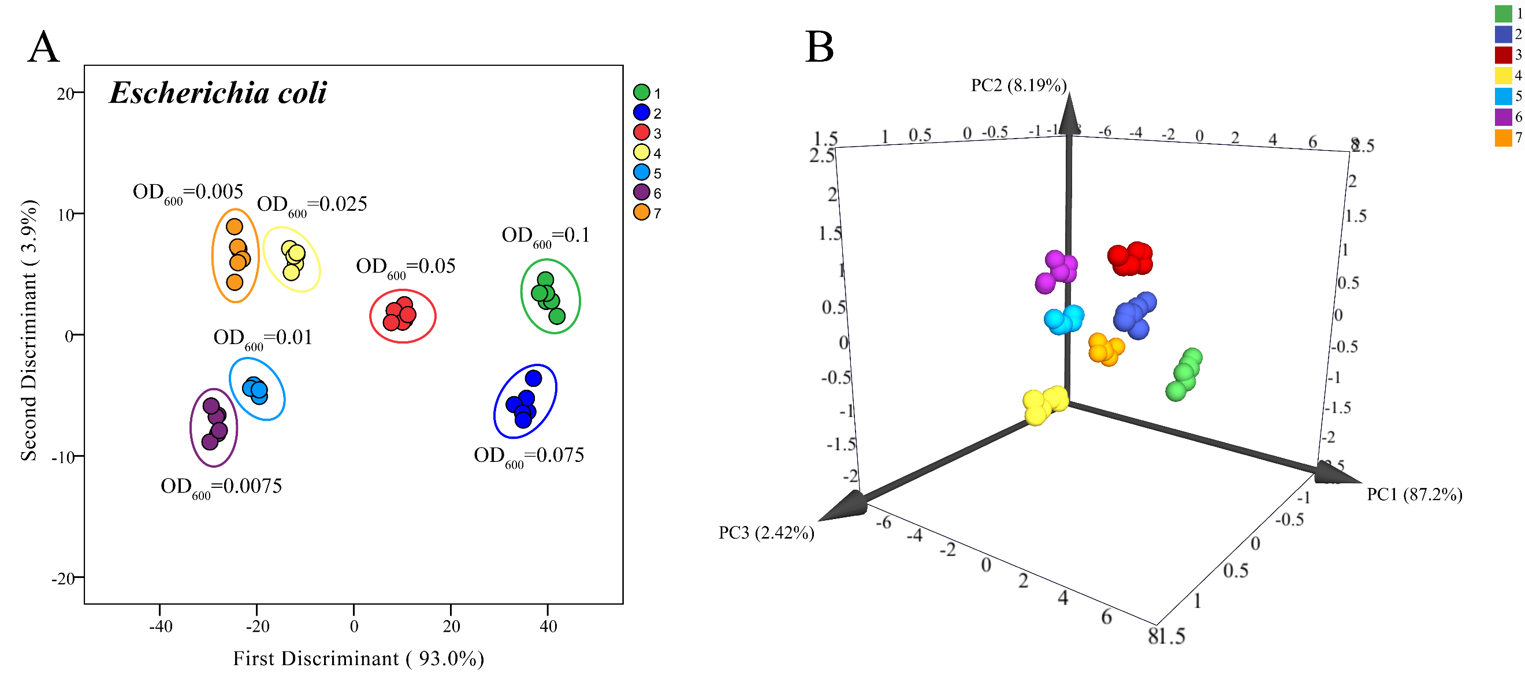
Fig. S13. 2D LDA canonical score plots (A) and 3D PCA canonical score plots (B) obtained from the Ami-AuNP-DNAs sensor against Escherichia coli at different concentrations (OD₆₀₀ from 0.005 to 0.1). Each point represents the response pattern for single bacteria to the array.

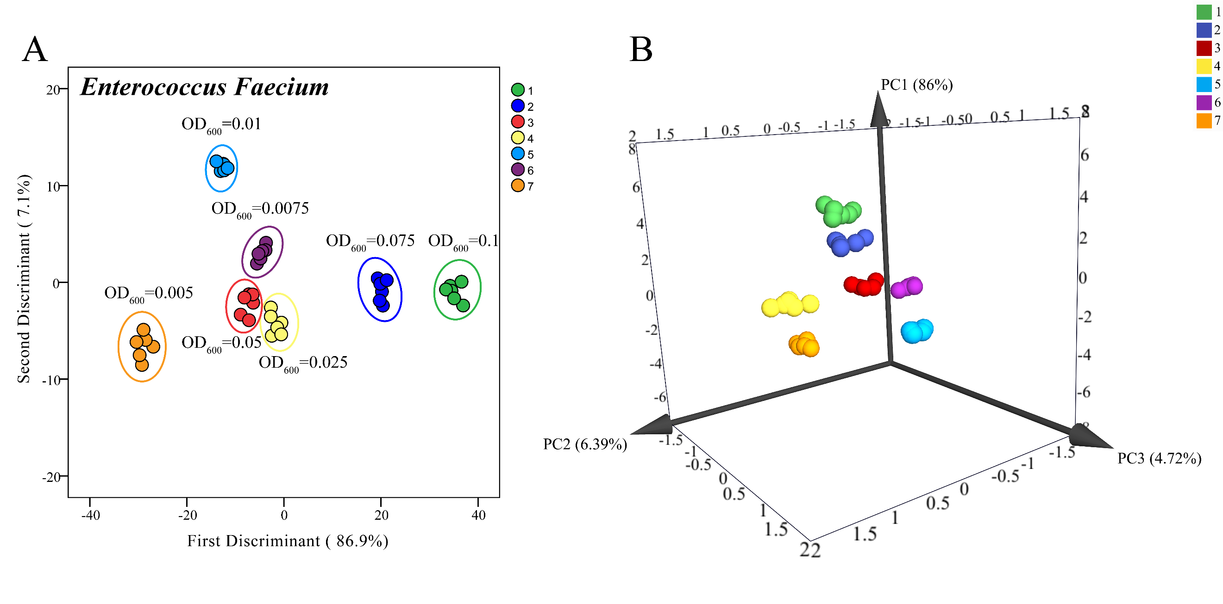
Fig. S14. 2D LDA canonical score plots (A) and 3D PCA canonical score plots (B) obtained from the Ami-AuNP-DNAs sensor against Enterococcus faecium at different concentrations (OD₆₀₀ from 0.005 to 0.1). Each point represents the response pattern for single bacteria to the array.

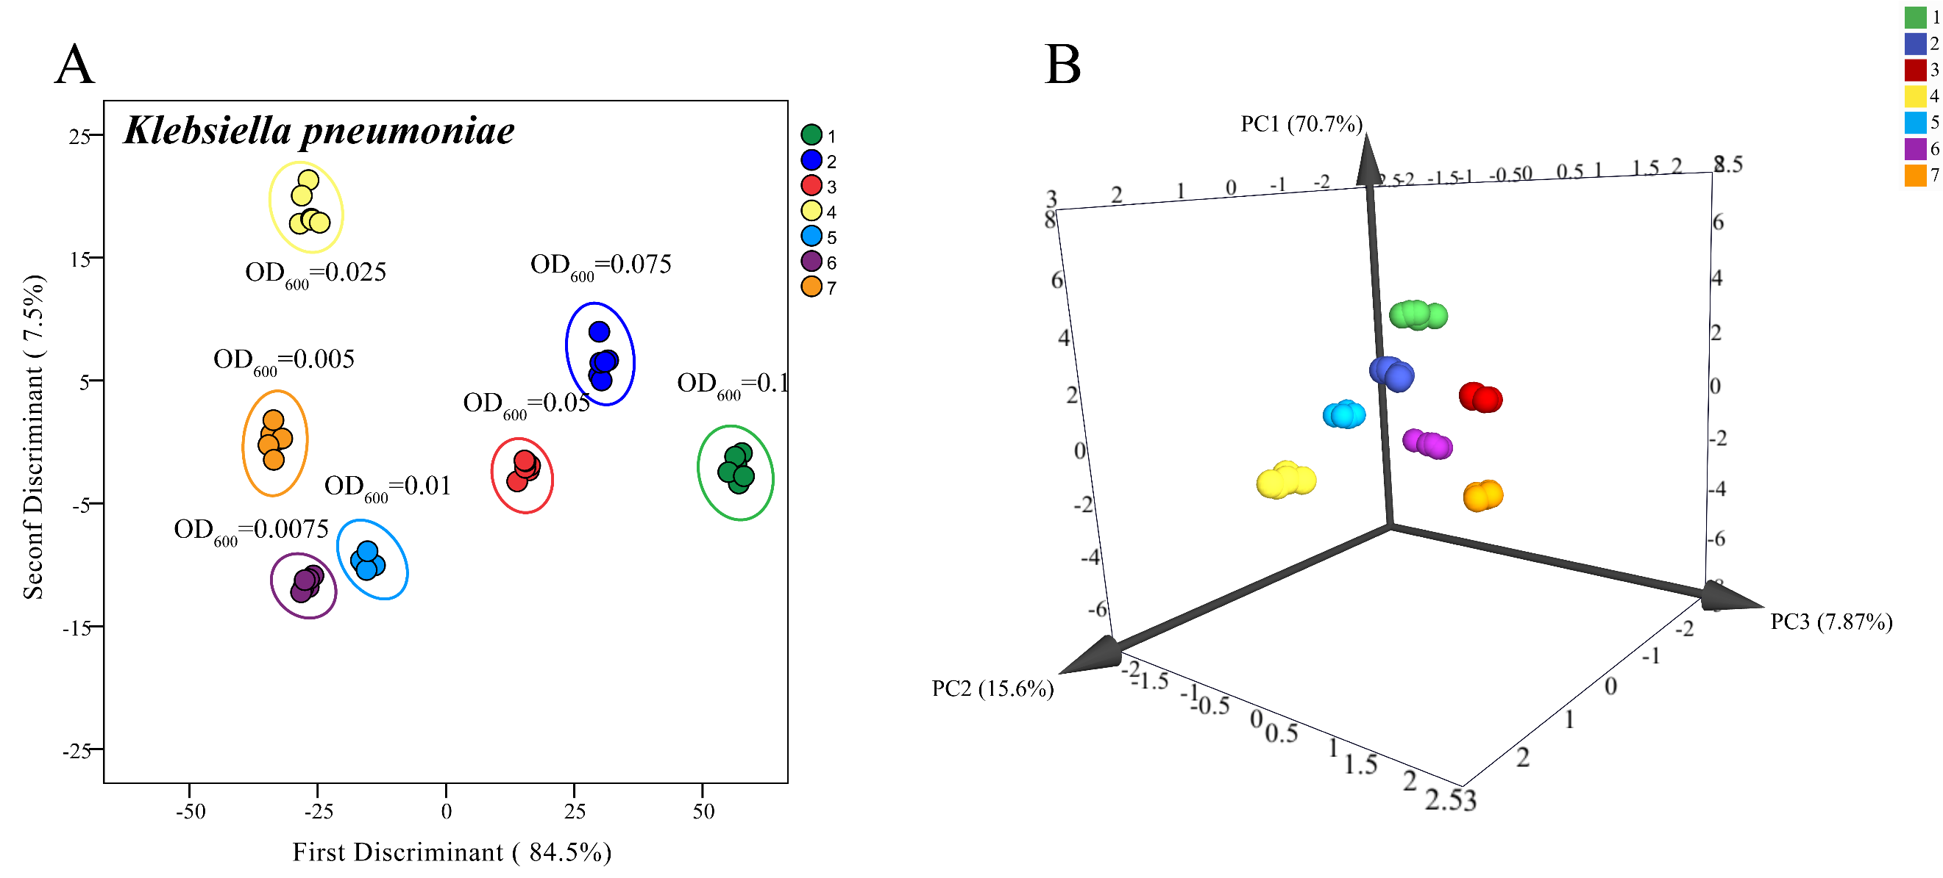
Fig. S15. 2D LDA canonical score plots (A) and 3D PCA canonical score plots (B) obtained from the Ami-AuNP-DNAs sensor against Klebsiella pneumoniae at different concentrations (OD₆₀₀ from 0.005 to 0.1). Each point represents the response pattern for single bacteria to the array.

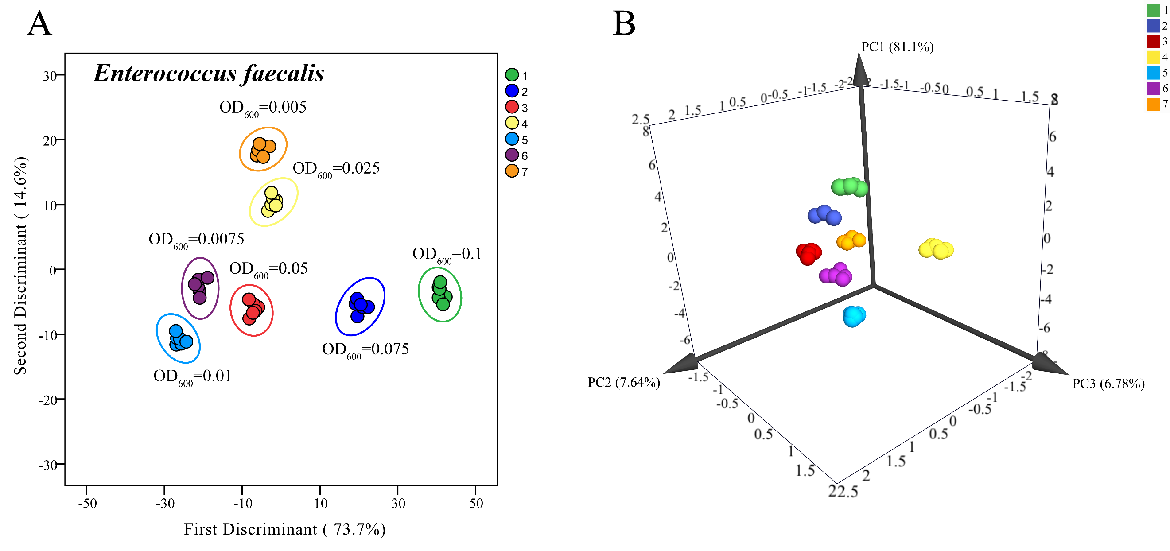
Fig. S16. 2D LDA canonical score plots (A) and 3D PCA canonical score plots (B) obtained from the Ami-AuNP-DNAs sensor against Enterococcus faecalis at different concentrations (OD₆₀₀ from 0.005 to 0.1). Each point represents the response pattern for single bacteria to the array.

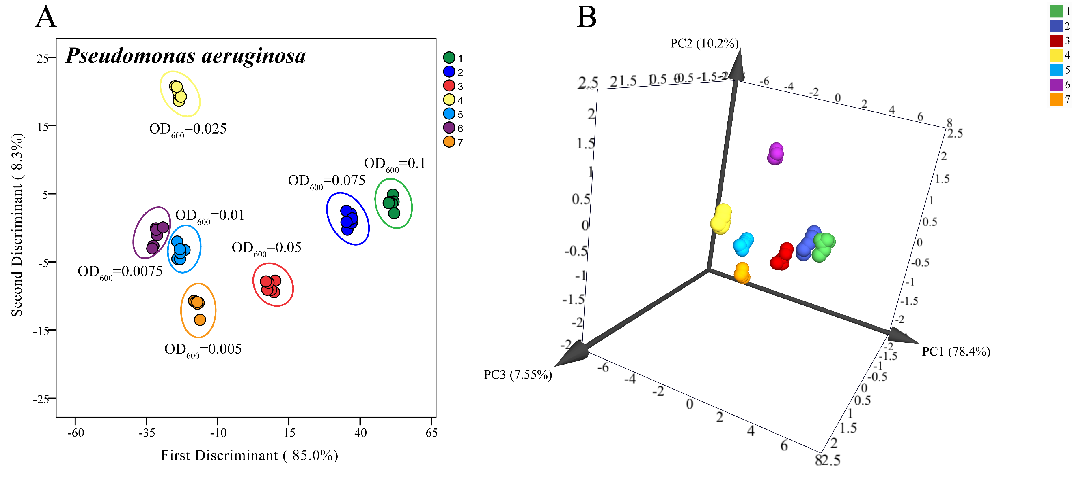
Fig. S17. 2D LDA canonical score plots (A) and 3D PCA canonical score plots (B) obtained from the Ami-AuNP-DNAs sensor against Pseudomonas aeruginosa at different concentrations (OD₆₀₀ from 0.005 to 0.1). Each point represents the response pattern for single bacteria to the array.

Fig. S18. 2D canonical score plot for the response patterns of five kinds of bacteria isolated from urine samples of clinical urinary tract infections (OD₆₀₀=0.1) by PCA. Each point represents the response pattern for single bacteria species to the sensor.

Table S1. Zeta potential of bacteria used in this article.
Bacteria | Zeta potential (mV)
Escherichia coli | -2.54
Enterococcus faecium | -8.64
Klebsiella pneumoniae | -9.83
Enterococcus faecalis | -27.56
Pseudomonas aeruginosa | -10.44

Table S2. The fluorescence response pattern of six DNAs in five kinds of bacteria
Number | 5A-VIC | 10A-TAMRA | 20A-Texas Red |  | 30A-Cy5 | 40A-Cy5.5 | 50A-Cy7
E.coli-1 | 53.2409 | 40.2804 | 41.6227 |  | 20.8322 | 2.5113 | 22.0001
E.coli-2 | 57.2333 | 40.8026 | 40.9677 |  | 20.1737 | 2.5532 | 18.9988
E.coli-3 | 58.3545 | 41.8321 | 41.6227 |  | 20.0274 | 2.4731 | 16.6895
E.coli-4 | 55.5934 | 40.1256 | 41.1284 |  | 20.2883 | 2.0687 | 18.8537
E.coli-5 | 51.4297 | 44.8149 | 42.1840 |  | 22.3977 | 2.7979 | 16.9675
E.coli-6 | 58.5444 | 42.1973 | 43.6065 |  | 21.4454 | 2.3641 | 18.8537
E.faecium-1 | 69.7231 | 59.9756 | 102.2770 |  | 45.4743 | 5.6763 | 37.6088
E.faecium-2 | 62.1178 | 53.0285 | 105.8880 |  | 49.4762 | 5.8777 | 35.1989
E.faecium-3 | 67.3881 | 53.4816 | 101.7790 |  | 48.2038 | 6.1687 | 34.8860
E.faecium-4 | 64.3482 | 59.9387 | 103.6580 |  | 47.8666 | 5.7792 | 36.7909
E.faecium-5 | 68.1654 | 57.7252 | 100.0950 |  | 50.9071 | 5.9233 | 38.8324
E.faecium-6 | 61.2162 | 60.8234 | 100.7010 |  | 49.6337 | 5.8094 | 34.1566
K.pneumoniae-1 | 56.7951 | 82.8433 | 82.9507 |  | 36.6309 | 2.5630 | 49.6867
K.pneumoniae-2 | 62.4834 | 84.0875 | 79.2329 |  | 35.7867 | 2.2198 | 52.3905
K.pneumoniae-3 | 67.6656 | 78.9493 | 81.6153 |  | 37.5403 | 2.3301 | 50.8367
K.pneumoniae-4 | 56.6561 | 84.6223 | 82.9581 |  | 34.0553 | 2.7261 | 44.3559
K.pneumoniae-5 | 68.2963 | 86.5011 | 80.5782 |  | 35.1348 | 2.6996 | 50.6708
K.pneumoniae-6 | 55.9323 | 80.7282 | 83.5823 |  | 33.6205 | 2.5509 | 51.2579
E.faecalis-1 | 17.9221 | 32.3269 | 37.2434 |  | 14.2808 | 1.2034 | 18.3836
E.faecalis-2 | 16.1642 | 36.5366 | 36.4835 |  | 14.2808 | 1.5150 | 21.5984
E.faecalis-3 | 17.1312 | 38.0673 | 37.2434 |  | 14.6178 | 1.2529 | 15.8619
E.faecalis-4 | 13.1073 | 33.6639 | 37.4353 |  | 14.1976 | 1.0836 | 16.0790
E.faecalis-5 | 13.6429 | 32.9963 | 38.1951 |  | 14.8613 | 1.6119 | 12.7944
E.faecalis-6 | 14.7193 | 33.1810 | 37.4327 |  | 15.0384 | 1.3232 | 14.4340
P.aeruginosa-1 | 77.0561 | 53.3235 | 45.8468 |  | 18.8708 | 2.2154 | 15.7796
P.aeruginosa-2 | 70.8467 | 55.6136 | 44.5365 |  | 18.8305 | 2.1630 | 17.3101
P.aeruginosa-3 | 68.6860 | 60.0050 | 45.8468 |  | 18.3270 | 1.8453 | 17.1994
P.aeruginosa-4 | 67.6472 | 57.4007 | 46.7515 |  | 18.6816 | 2.0771 | 15.5449
P.aeruginosa-5 | 71.5575 | 53.5292 | 46.7299 |  | 20.0847 | 2.0331 | 15.6043
P.aeruginosa-6 | 84.4201 | 57.4251 |  | 47.3473 | 19.2578 | 2.0771 | 13.7664

Table S3. Classification results and model performance of five kinds of bacteria detection and discrimination
Actual categories | Prediction results |  |  |  |  | Accuracy | Precision | Sensitivity | Specificity
Actual categories | E.  coli | E.  faecium | K.pneum-oniae | E.  faecalis | P.  aeruginosa
E.coli | 6 | 0 | 0 | 0 | 0 | 100% | 1.00 | 1.00 | 1.00
E.faecium | 0 | 6 | 0 | 0 | 0
K.pneumoniae | 0 | 0 | 6 | 0 | 0
E.faecalis | 0 | 0 | 0 | 6 | 0
P.aeruginosa | 0 | 0 | 0 | 0 | 6

Table S4. Fluorescence response pattern obtained from the Ami-AuNP-DNAs sensor against Escherichia coli at different concentrations (OD₆₀₀ from 0.005 to 0.1).
Concentration | 5A-VIC | 10A-TAMRA | 20A-Texas Red | 30A-Cy5 | 40A-Cy5.5 | 50A-Cy7 | Group
OD₆₀₀=0.1 | 88.1204 | 78.7223 | 49.4034 | 37.7849 | 6.4786 | 43.1015 | 1
OD₆₀₀=0.1 | 87.4550 | 79.4653 | 47.9772 | 34.8912 | 6.4899 | 44.4525 | 1
OD₆₀₀=0.1 | 88.0363 | 79.3630 | 48.9953 | 41.0549 | 6.4935 | 42.3844 | 1
OD₆₀₀=0.1 | 88.4214 | 79.5956 | 47.5021 | 37.1202 | 6.5220 | 43.3917 | 1
OD₆₀₀=0.1 | 88.3931 | 80.0137 | 47.1771 | 36.4102 | 6.4919 | 41.6215 | 1
OD₆₀₀=0.1 | 89.5676 | 78.2782 | 47.9043 | 39.5728 | 6.5130 | 42.8877 | 1
OD₆₀₀=0.075 | 80.0872 | 66.4143 | 62.5434 | 33.1566 | 7.1315 | 39.0793 | 2
OD₆₀₀=0.075 | 77.5831 | 64.4973 | 63.3442 | 30.6140 | 7.0939 | 38.5634 | 2
OD₆₀₀=0.075 | 79.3221 | 64.7370 | 61.9393 | 32.6244 | 7.1949 | 32.5451 | 2
OD₆₀₀=0.075 | 77.8852 | 64.0076 | 57.1671 | 29.1302 | 7.2426 | 37.7486 | 2
OD₆₀₀=0.075 | 77.4425 | 65.1757 | 59.9911 | 30.0757 | 7.2145 | 37.3626 | 2
OD₆₀₀=0.075 | 75.3186 | 66.2252 | 60.8213 | 30.8811 | 7.1970 | 37.1718 | 2
OD₆₀₀=0.05 | 69.2954 | 45.7894 | 38.1574 | 27.8104 | 8.2151 | 30.0867 | 3
OD₆₀₀=0.05 | 70.4197 | 44.4867 | 38.1972 | 25.2425 | 8.1764 | 31.5601 | 3
OD₆₀₀=0.05 | 68.2936 | 44.3564 | 36.4123 | 27.3917 | 8.0349 | 27.0175 | 3
OD₆₀₀=0.05 | 71.7674 | 41.6256 | 39.8721 | 24.8637 | 8.0329 | 28.5297 | 3
OD₆₀₀=0.05 | 66.0971 | 42.0792 | 38.9581 | 26.0938 | 8.1363 | 29.3209 | 3
OD₆₀₀=0.05 | 70.4486 | 47.1088 | 36.7693 | 26.4096 | 8.0209 | 31.6672 | 3
OD₆₀₀=0.025 | 56.0373 | 33.2539 | 26.2213 | 31.6139 | 2.7216 | 21.6273 | 4
OD₆₀₀=0.025 | 58.8017 | 31.5378 | 24.8866 | 29.2983 | 2.7165 | 20.1258 | 4
OD₆₀₀=0.025 | 57.1585 | 31.3714 | 24.4977 | 30.8726 | 2.6887 | 20.1076 | 4
OD₆₀₀=0.025 | 58.9110 | 30.3721 | 25.3929 | 28.7570 | 2.7208 | 22.8242 | 4
OD₆₀₀=0.025 | 56.5925 | 31.0243 | 25.5305 | 30.0316 | 2.8303 | 16.9807 | 4
OD₆₀₀=0.025 | 58.5869 | 33.6678 | 23.0993 | 29.9594 | 2.8025 | 22.3671 | 4
OD₆₀₀=0.01 | 50.9073 | 27.1930 | 14.6275 | 17.4153 | 2.9531 | 14.3650 | 5
OD₆₀₀=0.01 | 52.6032 | 26.0137 | 13.3441 | 16.1594 | 3.0669 | 13.6870 | 5
OD₆₀₀=0.01 | 51.7328 | 26.8395 | 15.4184 | 17.3395 | 2.8336 | 11.8236 | 5
OD₆₀₀=0.01 | 53.0535 | 25.1597 | 13.3472 | 15.8562 | 2.9751 | 13.9262 | 5
OD₆₀₀=0.01 | 50.1716 | 24.5159 | 15.4390 | 17.1999 | 3.0632 | 12.3213 | 5
OD₆₀₀=0.01 | 52.4897 | 27.3013 | 13.8820 | 16.5076 | 2.8467 | 14.8183 | 5
OD₆₀₀=0.0075 | 47.2130 | 16.7602 | 11.2990 | 13.0458 | 3.4733 | 4.7712 | 6
OD₆₀₀=0.0075 | 48.7813 | 15.3825 | 10.2292 | 9.2318 | 3.4915 | 7.6319 | 6
OD₆₀₀=0.0075 | 47.4064 | 16.2386 | 11.1930 | 12.8120 | 3.3257 | 4.2579 | 6
OD₆₀₀=0.0075 | 49.9074 | 13.4151 | 9.8045 | 10.4149 | 3.3262 | 7.3349 | 6
OD₆₀₀=0.0075 | 46.9448 | 13.2483 | 10.7804 | 9.0768 | 3.5481 | 4.8284 | 6
OD₆₀₀=0.0075 | 48.5116 | 16.6261 | 10.1751 | 10.7490 | 3.4515 | 5.5031 | 6
OD₆₀₀=0.005 | 61.3486 | 22.8209 | 6.9239 | 20.7417 | 2.4193 | 18.8716 | 7
OD₆₀₀=0.005 | 63.7802 | 20.3586 | 7.2746 | 18.8817 | 2.1901 | 20.5199 | 7
OD₆₀₀=0.005 | 61.8468 | 22.7053 | 8.3543 | 21.0234 | 2.3783 | 15.9685 | 7
OD₆₀₀=0.005 | 61.1147 | 21.7614 | 7.7193 | 19.5994 | 2.2739 | 18.5767 | 7
OD₆₀₀=0.005 | 60.1024 | 21.5576 | 6.9237 | 18.8435 | 2.3614 | 15.1548 | 7
OD₆₀₀=0.005 | 62.2147 | 22.0114 | 5.8552 | 21.3210 | 2.2945 | 20.4070 | 7

Table S5. Fluorescence response pattern obtained from the Ami-AuNP-DNAs sensor against Enterococcus Faecium at different concentrations (OD₆₀₀ from 0.005 to 0.1).
Concentration | 5A-VIC | 10A-TAMRA | 20A-Texas Red | 30A-Cy5 | 40A-Cy5.5 | 50A-Cy7 | Group
OD₆₀₀=0.1 | 81.6070 | 103.1010 | 121.1000 | 46.6064 | 30.3959 | 57.8335 | 1
OD₆₀₀=0.1 | 84.4263 | 104.0440 | 127.3100 | 49.5039 | 39.5345 | 56.6324 | 1
OD₆₀₀=0.1 | 81.8109 | 109.8800 | 123.6170 | 48.2321 | 37.7163 | 55.9360 | 1
OD₆₀₀=0.1 | 80.1860 | 108.7100 | 126.9540 | 42.9062 | 32.5364 | 54.2326 | 1
OD₆₀₀=0.1 | 82.1860 | 104.2160 | 122.9810 | 46.5802 | 34.4105 | 51.3834 | 1
OD₆₀₀=0.1 | 88.0146 | 102.8660 | 129.8500 | 44.6862 | 30.6979 | 53.2735 | 1
OD₆₀₀=0.075 | 73.5581 | 86.4261 | 105.1490 | 34.8200 | 24.7758 | 49.1209 | 2
OD₆₀₀=0.075 | 74.4375 | 84.9220 | 109.0920 | 38.0878 | 26.5634 | 44.0796 | 2
OD₆₀₀=0.075 | 75.0216 | 88.1205 | 102.2970 | 32.0157 | 27.0657 | 48.0550 | 2
OD₆₀₀=0.075 | 77.1591 | 83.5188 | 106.3700 | 36.7048 | 29.9867 | 44.1882 | 2
OD₆₀₀=0.075 | 79.9054 | 82.8893 | 103.4550 | 39.3438 | 25.1880 | 43.4785 | 2
OD₆₀₀=0.075 | 76.4821 | 89.5252 | 106.7740 | 35.2272 | 23.4043 | 46.9352 | 2
OD₆₀₀=0.05 | 66.3122 | 48.4171 | 73.6301 | 23.2166 | 10.7348 | 20.3395 | 3
OD₆₀₀=0.05 | 69.5766 | 44.8332 | 74.9821 | 24.7186 | 10.7910 | 22.3808 | 3
OD₆₀₀=0.05 | 65.8456 | 41.1563 | 72.9351 | 22.4433 | 11.8528 | 21.8577 | 3
OD₆₀₀=0.05 | 68.8668 | 44.4673 | 70.4321 | 25.9787 | 12.2388 | 24.2991 | 3
OD₆₀₀=0.05 | 66.8755 | 46.0326 | 71.7398 | 21.4425 | 13.2589 | 21.5454 | 3
OD₆₀₀=0.05 | 65.9618 | 43.4305 | 76.1236 | 23.4217 | 14.3417 | 22.6130 | 3
OD₆₀₀=0.025 | 47.7150 | 67.4162 | 86.0265 | 19.7487 | 17.5066 | 33.7497 | 4
OD₆₀₀=0.025 | 43.4757 | 63.2373 | 83.7916 | 18.1115 | 17.2378 | 35.8680 | 4
OD₆₀₀=0.025 | 48.3465 | 64.7133 | 85.8089 | 16.0137 | 15.9607 | 36.9309 | 4
OD₆₀₀=0.025 | 49.6476 | 65.0955 | 81.1645 | 19.0909 | 14.4039 | 31.0423 | 4
OD₆₀₀=0.025 | 49.3814 | 62.9997 | 87.8493 | 17.0376 | 13.9503 | 38.7315 | 4
OD₆₀₀=0.025 | 47.1845 | 65.4909 | 82.6013 | 17.6323 | 15.4773 | 32.4773 | 4
OD₆₀₀=0.01 | 52.5143 | 74.5335 | 45.3526 | 12.3391 | 7.4971 | 17.1382 | 5
OD₆₀₀=0.01 | 53.0101 | 70.0487 | 44.2455 | 12.4372 | 5.8052 | 19.7562 | 5
OD₆₀₀=0.01 | 55.3899 | 73.2775 | 46.9623 | 13.9108 | 6.4144 | 14.3638 | 5
OD₆₀₀=0.01 | 54.0693 | 74.9127 | 49.4556 | 10.4726 | 6.8150 | 15.8287 | 5
OD₆₀₀=0.01 | 52.7074 | 75.4945 | 47.6647 | 13.8952 | 8.4425 | 16.0766 | 5
OD₆₀₀=0.01 | 56.1570 | 71.6520 | 44.2816 | 11.9099 | 7.9338 | 13.3146 | 5
OD₆₀₀=0.0075 | 60.1938 | 53.8615 | 67.0439 | 26.5296 | 0.8037 | 27.8750 | 6
OD₆₀₀=0.0075 | 63.5935 | 57.8696 | 65.5253 | 27.5749 | 0.8404 | 29.2657 | 6
OD₆₀₀=0.0075 | 62.4941 | 55.3828 | 68.3842 | 27.4058 | 0.7263 | 26.0347 | 6
OD₆₀₀=0.0075 | 63.3938 | 56.1124 | 66.5109 | 29.3928 | 0.6407 | 27.9979 | 6
OD₆₀₀=0.0075 | 62.4941 | 54.3522 | 64.3146 | 28.8299 | 0.7953 | 29.6187 | 6
OD₆₀₀=0.0075 | 61.0480 | 52.5164 | 62.6636 | 30.4539 | 0.8256 | 28.6094 | 6
OD₆₀₀=0.005 | 38.2259 | 28.4335 | 58.8834 | 8.1663 | 4.7352 | 7.7451 | 7
OD₆₀₀=0.005 | 36.1146 | 27.7721 | 54.6383 | 6.0782 | 4.0323 | 9.0328 | 7
OD₆₀₀=0.005 | 35.7418 | 29.2749 | 52.5829 | 5.9390 | 3.4703 | 7.8304 | 7
OD₆₀₀=0.005 | 34.7665 | 23.9025 | 51.5420 | 7.8252 | 2.7059 | 6.5949 | 7
OD₆₀₀=0.005 | 34.5092 | 22.0865 | 57.6774 | 6.8051 | 2.1284 | 9.5058 | 7
OD₆₀₀=0.005 | 33.6250 | 24.4539 | 55.8879 | 7.1283 | 2.9895 | 6.8793 | 7

Table S6. Fluorescence response pattern obtained from the Ami-AuNP-DNAs sensor against Klebsiella pneumoniae at different concentrations (OD₆₀₀ from 0.005 to 0.1).
Concentration | 5A-VIC | 10A-TAMRA | 20A-Texas Red | 30A-Cy5 | 40A-Cy5.5 | 50A-Cy7 | Group
OD₆₀₀=0.1 | 111.1850 | 126.6390 | 57.5379 | 45.8495 | 34.1723 | 63.9443 | 1
OD₆₀₀=0.1 | 112.5710 | 125.7500 | 55.6912 | 46.3621 | 32.2838 | 62.1268 | 1
OD₆₀₀=0.1 | 113.9420 | 120.7900 | 54.6774 | 48.4693 | 33.7250 | 64.0121 | 1
OD₆₀₀=0.1 | 115.2890 | 125.2610 | 56.8793 | 43.6477 | 30.6451 | 60.6326 | 1
OD₆₀₀=0.1 | 113.7990 | 127.8540 | 52.3310 | 44.4503 | 31.8862 | 61.8002 | 1
OD₆₀₀=0.1 | 117.3420 | 121.6690 | 55.3880 | 45.9280 | 33.4359 | 65.7961 | 1
OD₆₀₀=0.075 | 95.3795 | 92.9443 | 49.1764 | 38.4935 | 41.0411 | 52.5497 | 2
OD₆₀₀=0.075 | 92.6553 | 95.5660 | 47.9968 | 36.3416 | 40.6576 | 54.9680 | 2
OD₆₀₀=0.075 | 94.3007 | 93.9106 | 48.6109 | 34.1884 | 44.3331 | 50.8278 | 2
OD₆₀₀=0.075 | 93.0436 | 91.9630 | 50.7750 | 37.1830 | 39.1257 | 52.7587 | 2
OD₆₀₀=0.075 | 96.8268 | 94.6435 | 46.7243 | 33.6933 | 42.5751 | 53.4690 | 2
OD₆₀₀=0.075 | 92.7235 | 93.0693 | 50.7739 | 38.3593 | 40.3031 | 51.8685 | 2
OD₆₀₀=0.05 | 86.1192 | 106.4810 | 44.3438 | 16.8527 | 26.8735 | 36.9870 | 3
OD₆₀₀=0.05 | 87.3088 | 105.3360 | 43.5824 | 17.6856 | 27.5133 | 37.3440 | 3
OD₆₀₀=0.05 | 85.2526 | 101.0440 | 45.9198 | 14.7758 | 25.7671 | 35.4748 | 3
OD₆₀₀=0.05 | 89.6377 | 102.1480 | 42.9936 | 15.2712 | 28.1541 | 36.9232 | 3
OD₆₀₀=0.05 | 88.0429 | 104.5140 | 44.1577 | 16.2851 | 26.3849 | 32.5384 | 3
OD₆₀₀=0.05 | 84.1940 | 103.0690 | 46.1493 | 17.1015 | 27.4203 | 36.1366 | 3
OD₆₀₀=0.025 | 45.8276 | 73.2115 | 13.6736 | 24.0121 | 44.0550 | 26.6187 | 4
OD₆₀₀=0.025 | 43.3083 | 75.0948 | 15.6121 | 23.2166 | 49.9198 | 29.8866 | 4
OD₆₀₀=0.025 | 46.3725 | 76.6872 | 14.7173 | 20.7625 | 47.6594 | 31.9813 | 4
OD₆₀₀=0.025 | 47.3199 | 74.1182 | 16.8061 | 21.7126 | 45.3508 | 27.0262 | 4
OD₆₀₀=0.025 | 44.9236 | 72.8007 | 14.0140 | 22.9482 | 48.3906 | 29.2896 | 4
OD₆₀₀=0.025 | 46.2976 | 74.4202 | 17.7770 | 23.6374 | 46.1076 | 30.9923 | 4
OD₆₀₀=0.01 | 65.1719 | 83.5078 | 18.9413 | 27.7273 | 14.3754 | 40.4698 | 5
OD₆₀₀=0.01 | 63.8340 | 85.0440 | 19.6774 | 29.8989 | 13.5112 | 40.3984 | 5
OD₆₀₀=0.01 | 62.2257 | 80.5283 | 20.4469 | 26.4983 | 15.5051 | 42.3424 | 5
OD₆₀₀=0.01 | 61.9127 | 81.1975 | 17.9413 | 29.1799 | 15.4498 | 43.2579 | 5
OD₆₀₀=0.01 | 63.2973 | 82.7872 | 19.1002 | 28.1474 | 14.1458 | 41.7895 | 5
OD₆₀₀=0.01 | 64.4066 | 84.4690 | 16.9437 | 27.8683 | 16.5287 | 42.3955 | 5
OD₆₀₀=0.0075 | 53.1421 | 66.4862 | 30.4190 | 14.3915 | 8.2852 | 24.7746 | 6
OD₆₀₀=0.0075 | 52.7842 | 65.5321 | 31.8667 | 11.9716 | 7.3695 | 21.3463 | 6
OD₆₀₀=0.0075 | 55.7492 | 63.9038 | 32.5403 | 12.2428 | 9.3904 | 22.2542 | 6
OD₆₀₀=0.0075 | 54.0897 | 60.1249 | 33.9424 | 10.0101 | 7.6629 | 20.9867 | 6
OD₆₀₀=0.0075 | 52.6143 | 62.9684 | 34.2650 | 11.6812 | 9.3347 | 23.3929 | 6
OD₆₀₀=0.0075 | 56.2884 | 64.7497 | 30.1465 | 10.6571 | 8.9319 | 21.2274 | 6
OD₆₀₀=0.005 | 77.3366 | 56.5731 | 10.0364 | 4.1991 | 22.8860 | 8.5058 | 7
OD₆₀₀=0.005 | 74.5601 | 54.1829 | 11.2223 | 6.0207 | 22.4656 | 7.5876 | 7
OD₆₀₀=0.005 | 76.9208 | 53.3635 | 9.5975 | 5.5737 | 24.9931 | 8.9881 | 7
OD₆₀₀=0.005 | 78.4863 | 57.7733 | 10.3211 | 3.5457 | 23.7531 | 9.4510 | 7
OD₆₀₀=0.005 | 75.1564 | 53.1398 | 11.5751 | 4.2789 | 21.8577 | 7.4945 | 7
OD₆₀₀=0.005 | 76.7823 | 56.9790 | 10.4531 | 3.9360 | 20.6187 | 8.0221 | 7

Table S7. Fluorescence response pattern obtained from the Ami-AuNP-DNAs sensor against Enterococcus faecalis at different concentrations (OD₆₀₀ from 0.005 to 0.1).
Concentration | 5A-VIC | 10A-TAMRA | 20A-Texas Red | 30A-Cy5 | 40A-Cy5.5 | 50A-Cy7 | Group
OD₆₀₀=0.1 | 89.2568 | 121.8420 | 99.7860 | 48.1065 | 36.1787 | 54.5788 | 1
OD₆₀₀=0.1 | 85.2319 | 120.0400 | 96.5520 | 43.7751 | 35.8835 | 56.9106 | 1
OD₆₀₀=0.1 | 87.2766 | 125.4600 | 95.4692 | 45.9552 | 33.1388 | 53.9106 | 1
OD₆₀₀=0.1 | 86.2835 | 124.5100 | 92.0295 | 46.7635 | 35.7731 | 52.7956 | 1
OD₆₀₀=0.1 | 84.8963 | 123.9610 | 93.0204 | 47.0530 | 37.8354 | 50.5409 | 1
OD₆₀₀=0.1 | 89.8404 | 121.2560 | 97.5015 | 49.2376 | 34.8954 | 54.7802 | 1
OD₆₀₀=0.075 | 74.7518 | 103.1760 | 78.3169 | 31.7482 | 20.9947 | 45.2562 | 2
OD₆₀₀=0.075 | 75.2195 | 100.9680 | 74.2934 | 34.9221 | 20.7195 | 48.7211 | 2
OD₆₀₀=0.075 | 77.2052 | 107.8380 | 78.1957 | 32.4985 | 19.9177 | 46.7246 | 2
OD₆₀₀=0.075 | 76.5818 | 105.0830 | 76.1678 | 35.9625 | 23.2801 | 47.7029 | 2
OD₆₀₀=0.075 | 79.0615 | 106.7700 | 73.3386 | 31.6248 | 20.1358 | 44.7574 | 2
OD₆₀₀=0.075 | 74.4454 | 104.9910 | 77.7196 | 34.4875 | 22.5598 | 43.8020 | 2
OD₆₀₀=0.05 | 67.1962 | 56.2411 | 45.0978 | 23.8010 | 15.7662 | 37.3230 | 3
OD₆₀₀=0.05 | 65.3110 | 56.4398 | 43.5990 | 22.8024 | 15.4936 | 35.7302 | 3
OD₆₀₀=0.05 | 64.2179 | 55.6746 | 44.2816 | 25.1200 | 13.7712 | 33.8293 | 3
OD₆₀₀=0.05 | 66.4475 | 54.4712 | 41.5986 | 20.5779 | 14.8094 | 36.5911 | 3
OD₆₀₀=0.05 | 68.3842 | 58.4884 | 45.7020 | 24.0897 | 14.0732 | 34.3703 | 3
OD₆₀₀=0.05 | 66.9251 | 55.8147 | 42.9293 | 23.4379 | 13.8218 | 37.5211 | 3
OD₆₀₀=0.025 | 58.6220 | 73.2775 | 65.3698 | 6.2767 | 28.0971 | 24.1340 | 4
OD₆₀₀=0.025 | 57.3097 | 72.3138 | 64.0137 | 5.9979 | 25.2419 | 23.7951 | 4
OD₆₀₀=0.025 | 59.9120 | 71.2520 | 68.7375 | 6.2001 | 27.0806 | 21.5454 | 4
OD₆₀₀=0.025 | 54.8298 | 74.9127 | 62.5681 | 6.2471 | 28.1597 | 22.6130 | 4
OD₆₀₀=0.025 | 55.9682 | 70.7233 | 63.3316 | 5.8254 | 29.8671 | 21.9072 | 4
OD₆₀₀=0.025 | 56.2581 | 75.7111 | 66.5456 | 5.1396 | 26.2482 | 25.7584 | 4
OD₆₀₀=0.01 | 39.8996 | 45.0282 | 53.9568 | 17.9096 | 3.3181 | 7.8537 | 5
OD₆₀₀=0.01 | 38.9370 | 46.2192 | 55.1250 | 18.3091 | 4.2836 | 9.0852 | 5
OD₆₀₀=0.01 | 37.5385 | 48.0825 | 51.2109 | 16.8547 | 3.6449 | 7.9446 | 5
OD₆₀₀=0.01 | 40.7089 | 47.3293 | 52.0751 | 17.6216 | 3.9401 | 8.4281 | 5
OD₆₀₀=0.01 | 41.5911 | 49.4028 | 54.9246 | 19.3247 | 4.5425 | 8.2598 | 5
OD₆₀₀=0.01 | 39.7263 | 48.1362 | 51.6247 | 15.1370 | 3.5681 | 7.0611 | 5
OD₆₀₀=0.0075 | 42.3037 | 65.4909 | 26.8687 | 12.3498 | 6.9081 | 33.5280 | 6
OD₆₀₀=0.0075 | 45.4936 | 62.4587 | 27.7605 | 11.8778 | 7.3240 | 31.1956 | 6
OD₆₀₀=0.0075 | 41.3448 | 66.1497 | 28.3779 | 10.4606 | 7.9790 | 32.0043 | 6
OD₆₀₀=0.0075 | 43.2640 | 63.1008 | 29.4093 | 10.8179 | 7.2935 | 33.0433 | 6
OD₆₀₀=0.0075 | 42.2009 | 65.6740 | 26.4414 | 13.6646 | 6.1103 | 34.2556 | 6
OD₆₀₀=0.0075 | 44.9452 | 69.4718 | 30.2983 | 9.7712 | 7.6446 | 31.0109 | 6
OD₆₀₀=0.005 | 50.9019 | 82.5931 | 39.6122 | 3.1752 | 9.0485 | 17.1382 | 7
OD₆₀₀=0.005 | 51.0750 | 81.9858 | 37.8603 | 3.8205 | 10.2769 | 16.8287 | 7
OD₆₀₀=0.005 | 48.3790 | 83.4844 | 35.2498 | 3.0255 | 11.5648 | 15.1812 | 7
OD₆₀₀=0.005 | 52.6701 | 86.8332 | 38.8307 | 3.7358 | 12.6918 | 14.5058 | 7
OD₆₀₀=0.005 | 49.1504 | 80.3814 | 36.6072 | 3.1861 | 11.1529 | 17.8730 | 7
OD₆₀₀=0.005 | 51.3052 | 84.2242 | 39.1512 | 3.5669 | 13.6274 | 18.5685 | 7

Table S8. Fluorescence response pattern obtained from the Ami-AuNP-DNAs sensor against Pseudomonas aeruginosa at different concentrations (OD₆₀₀ from 0.005 to 0.1).
Concentration | 5A-VIC | 10A-TAMRA | 20A-Texas Red | 30A-Cy5 | 40A-Cy5.5 | 50A-Cy7 | Group
OD₆₀₀=0.1 | 135.5100 | 110.4060 | 87.0637 | 55.1059 | 38.8390 | 69.4651 | 1
OD₆₀₀=0.1 | 136.1800 | 115.1550 | 88.8260 | 51.6408 | 39.1194 | 67.3534 | 1
OD₆₀₀=0.1 | 134.9290 | 113.3980 | 86.8089 | 50.9450 | 35.9481 | 68.9434 | 1
OD₆₀₀=0.1 | 132.8470 | 112.7080 | 82.0265 | 56.2968 | 33.8995 | 64.3937 | 1
OD₆₀₀=0.1 | 135.7720 | 117.1260 | 83.7675 | 53.3808 | 39.9935 | 66.2735 | 1
OD₆₀₀=0.1 | 137.4120 | 111.7780 | 86.8185 | 54.4004 | 36.5263 | 63.4596 | 1
OD₆₀₀=0.075 | 125.0420 | 103.2990 | 75.3684 | 42.0818 | 30.1802 | 56.0501 | 2
OD₆₀₀=0.075 | 123.5330 | 104.9560 | 78.1258 | 45.5993 | 33.0090 | 55.0927 | 2
OD₆₀₀=0.075 | 120.6520 | 101.7590 | 77.4766 | 43.2657 | 31.3382 | 57.8335 | 2
OD₆₀₀=0.075 | 122.7820 | 107.6530 | 75.1224 | 45.4769 | 34.4218 | 54.6324 | 2
OD₆₀₀=0.075 | 126.4670 | 102.8490 | 76.6497 | 47.9145 | 33.7534 | 55.2039 | 2
OD₆₀₀=0.075 | 121.9770 | 105.6770 | 74.5099 | 46.0300 | 36.3540 | 52.9360 | 2
OD₆₀₀=0.05 | 108.8165 | 84.9220 | 54.3136 | 19.2695 | 25.0779 | 45.9207 | 3
OD₆₀₀=0.05 | 107.5970 | 85.8741 | 55.5094 | 22.9534 | 26.6287 | 43.5164 | 3
OD₆₀₀=0.05 | 105.0590 | 86.1620 | 52.8843 | 18.8999 | 24.0820 | 44.6987 | 3
OD₆₀₀=0.05 | 109.9410 | 82.4837 | 56.1241 | 19.4409 | 26.4555 | 41.6439 | 3
OD₆₀₀=0.05 | 106.8120 | 81.0855 | 53.6735 | 22.2559 | 27.8582 | 44.4197 | 3
OD₆₀₀=0.05 | 103.9250 | 83.6821 | 54.4627 | 19.1091 | 22.7031 | 42.4505 | 3
OD₆₀₀=0.025 | 46.8874 | 46.8436 | 65.8328 | 24.2331 | 7.3695 | 25.6401 | 4
OD₆₀₀=0.025 | 48.1645 | 45.6285 | 67.0903 | 27.3371 | 8.2852 | 22.3968 | 4
OD₆₀₀=0.025 | 51.3717 | 44.1894 | 66.2652 | 26.3582 | 7.3904 | 23.8044 | 4
OD₆₀₀=0.025 | 44.3015 | 45.8305 | 68.0414 | 24.2117 | 8.2139 | 24.3959 | 4
OD₆₀₀=0.025 | 50.0475 | 44.2605 | 67.2186 | 25.2856 | 7.6629 | 26.8635 | 4
OD₆₀₀=0.025 | 43.8649 | 45.4547 | 64.6847 | 28.1442 | 8.5447 | 23.9772 | 4
OD₆₀₀=0.01 | 75.0509 | 69.7462 | 49.3087 | 11.7791 | 10.7559 | 7.7451 | 5
OD₆₀₀=0.01 | 74.0057 | 66.6665 | 44.7389 | 12.1558 | 11.7438 | 6.6134 | 5
OD₆₀₀=0.01 | 70.4930 | 67.0678 | 48.6267 | 11.4483 | 10.7592 | 7.2343 | 5
OD₆₀₀=0.01 | 75.5712 | 64.7716 | 44.1092 | 13.6229 | 11.4204 | 8.8390 | 5
OD₆₀₀=0.01 | 72.6779 | 69.1508 | 46.2023 | 12.3257 | 12.1389 | 6.8802 | 5
OD₆₀₀=0.01 | 72.4596 | 68.8327 | 47.7322 | 11.7813 | 12.2223 | 7.0169 | 5
OD₆₀₀=0.0075 | 62.6453 | 37.4703 | 21.6443 | 30.5328 | 22.6686 | 15.6124 | 6
OD₆₀₀=0.0075 | 60.9305 | 38.7252 | 24.6009 | 33.9823 | 22.4795 | 13.5117 | 6
OD₆₀₀=0.0075 | 62.7592 | 40.1974 | 25.0365 | 32.4081 | 21.4341 | 12.9916 | 6
OD₆₀₀=0.0075 | 61.6651 | 36.3570 | 22.9375 | 35.2578 | 21.5016 | 14.9910 | 6
OD₆₀₀=0.0075 | 63.7834 | 36.9917 | 20.8992 | 31.4078 | 20.6878 | 13.5188 | 6
OD₆₀₀=0.0075 | 64.9260 | 39.0890 | 26.7318 | 35.4302 | 21.9633 | 15.0250 | 6
OD₆₀₀=0.005 | 88.8474 | 58.6841 | 32.5285 | 6.2801 | 1.7013 | 32.1232 | 7
OD₆₀₀=0.005 | 85.4635 | 55.4422 | 34.4661 | 7.0049 | 1.8189 | 35.0043 | 7
OD₆₀₀=0.005 | 83.9334 | 56.1454 | 33.7393 | 8.5578 | 2.1872 | 30.0136 | 7
OD₆₀₀=0.005 | 87.6055 | 53.9505 | 36.0506 | 7.5494 | 1.4215 | 31.5280 | 7
OD₆₀₀=0.005 | 85.0545 | 55.1941 | 34.0901 | 6.7282 | 2.3663 | 34.9137 | 7
OD₆₀₀=0.005 | 86.8107 | 56.8852 | 35.8271 | 8.1620 | 1.7417 | 30.0915 | 7

Table S9. The fluorescence response pattern of six DNAs in bacteria isolated from clinical urine samples
Number | 5A-VIC | 10A-TAMRA | 20A-Texas Red |  | 30A-Cy5 | 40A-Cy5.5 | 50A-Cy7
E.coli-1 | 18.2117 | 31.5479 | 14.1263 |  | 6.4656 | 0.6624 | 12.2706
E.coli-2 | 19.4688 | 36.3457 | 16.7511 |  | 6.3303 | 0.7260 | 9.7597
E.coli-3 | 26.8622 | 32.2887 | 23.2553 |  | 6.6570 | 0.6074 | 12.8005
E.coli-4 | 19.6383 | 34.3521 | 22.0148 |  | 10.4922 | 0.7856 | 9.8898
E.coli-5 | 23.2031 | 29.2985 | 21.8915 |  | 6.5564 | 0.6943 | 9.9848
E.coli-6 | 20.9084 | 33.5685 | 15.0228 |  | 8.3154 | 0.6901 | 12.6902
E.coli-7 | 25.7742 | 37.1920 | 22.8766 |  | 7.8265 | 0.5988 | 12.4999
E.coli-8 | 23.2987 | 34.0798 | 21.5195 |  | 6.3393 | 0.7775 | 13.7938
E.coli-9 | 22.3037 | 32.8297 | 20.8060 |  | 7.0022 | 0.7697 | 10.1797
E.coli-10 | 21.7119 | 32.7005 | 22.0587 |  | 6.1515 | 0.7549 | 13.4566
E.coli-11 | 24.1798 | 28.8901 | 18.3988 |  | 7.0853 | 0.7601 | 13.7324
E.coli-12 | 26.6620 | 33.6976 | 21.2780 |  | 10.9865 | 0.6919 | 12.2727
E.coli-13 | 18.9184 | 35.6937 | 16.9069 |  | 7.7557 | 0.8410 | 9.5655
E.coli-14 | 20.1450 | 32.6171 | 17.3426 |  | 6.7560 | 0.7590 | 12.4509
E.coli-15 | 23.8343 | 32.1525 | 18.4707 |  | 8.1715 | 0.7188 | 13.2621
E.coli-16 | 21.9553 | 36.9303 | 19.5951 |  | 7.9268 | 0.8288 | 10.1044
E.coli-17 | 18.1443 | 39.5818 | 16.6186 |  | 8.7666 | 0.6292 | 12.6060
E.coli-18 | 22.7331 | 35.7952 | 21.5884 |  | 8.5355 | 0.6860 | 12.4678
E.coli-19 | 23.6293 | 35.2492 | 19.3185 |  | 8.3687 | 0.7528 | 10.9897
E.coli-20 | 22.4430 | 30.1858 | 20.0687 |  | 6.8205 | 0.5784 | 10.3217
E.coli-21 | 21.1938 | 32.6233 | 17.3143 |  | 7.7211 | 0.6052 | 10.8195
E.coli-22 | 25.0649 | 33.0719 | 19.0827 |  | 6.7592 | 0.8371 | 9.5506
E.coli-23 | 25.0585 | 28.0964 | 20.6834 |  | 9.0607 | 0.6157 | 12.8453
E.coli-24 | 21.0187 | 37.8874 | 21.2348 |  | 7.9868 | 0.7342 | 12.4812
E.coli-25 | 26.6938 | 33.6812 | 20.7071 |  | 6.7021 | 0.5610 | 10.4510
E.coli-26 | 24.4033 | 31.7339 | 22.1124 |  | 7.2486 | 0.7261 | 9.6714
E.coli-27 | 20.8033 | 32.7067 | 20.2300 |  | 9.1082 | 0.7492 | 10.1324
E.coli-28 | 24.6242 | 33.0060 | 21.0269 |  | 10.8406 | 0.6119 | 9.8405
E.coli-29 | 25.8953 | 36.9051 | 13.3690 |  | 6.4920 | 0.5787 | 10.7450
E.coli-30 | 24.8777 | 29.7718 |  | 20.0984 | 7.5259 | 0.6484 | 9.7381
E.coli-31 | 20.4411 | 35.1044 | 19.9745 |  | 7.4630 | 0.6554 | 11.3970
E.coli-32 | 27.7925 | 36.3782 | 20.1059 |  | 8.5739 | 0.7091 | 12.3193
E.coli-33 | 18.5258 | 31.1976 | 19.5238 |  | 9.4195 | 0.6944 | 9.9110
E.coli-34 | 24.6997 | 31.0913 | 15.8043 |  | 10.2905 | 0.6832 | 9.7051
E.coli-35 | 19.6866 | 29.0576 | 20.4791 |  | 9.8726 | 0.6620 | 10.0220
E.coli-36 | 18.4001 | 32.2306 | 19.2630 |  | 7.6597 | 0.6355 | 12.8671
E.coli-37 | 15.8067 | 37.8591 | 20.6883 |  | 6.2695 | 0.6252 | 9.4903
E.coli-38 | 20.7730 | 30.3383 | 22.7794 |  | 7.0860 | 0.6050 | 10.3418
E.coli-39 | 26.4874 | 32.4112 | 17.8516 |  | 9.3820 | 0.6777 | 12.8177
E.coli-40 | 22.7083 | 28.5455 | 20.8189 |  | 8.6765 | 0.5906 | 12.7517
E.faecium-1 | 10.6796 | 27.7662 | 25.7555 |  | 10.5413 | 2.1078 | 3.0278
E.faecium-2 | 8.9837 | 27.2548 | 27.2205 |  | 8.7986 | 2.0572 | 2.8282
E.faecium-3 | 8.6036 | 27.5721 | 25.4960 |  | 9.1412 | 1.7921 | 2.6270
E.faecium-4 | 8.0433 | 27.2350 | 27.4302 |  | 6.4454 | 1.9348 | 3.5973
E.faecium-5 | 8.2379 | 25.9283 | 26.9210 |  | 8.5633 | 1.6820 | 2.7493
E.faecium-6 | 9.0902 | 26.9428 | 29.5797 |  | 9.8370 | 2.1922 | 5.0216
E.faecium-7 | 11.1708 | 23.1534 | 26.5404 |  | 6.8835 | 1.9418 | 3.4765
E.faecium-8 | 6.7039 | 28.1332 | 30.0383 |  | 7.4391 | 1.9546 | 2.5759
E.faecium-9 | 7.4236 | 30.7217 | 30.1697 |  | 7.8612 | 2.1256 | 3.3779
E.faecium-10 | 9.4225 | 27.1403 | 28.4595 |  | 6.6190 | 2.3721 | 3.7605
E.faecium-11 | 12.9450 | 36.8954 | 27.3294 |  | 5.9998 | 1.5827 | 3.8986
E.faecium-12 | 8.4599 | 29.8335 | 28.1936 |  | 5.5376 | 1.9408 | 4.6620
E.faecium-13 | 8.6317 | 26.3447 | 28.2719 |  | 9.6274 | 1.9165 | 5.0618
E.faecium-14 | 9.8603 | 31.1682 | 28.4406 |  | 8.5854 | 2.5348 | 4.0603
E.faecium-15 | 10.7433 | 28.1488 | 28.0495 |  | 8.8287 | 2.1191 | 4.9760
E.faecium-16 | 7.2052 | 28.6793 | 29.7487 |  | 6.2499 | 1.8680 | 3.5617
E.faecium-17 | 9.6521 | 26.5049 | 29.8556 |  | 6.9727 | 1.8595 | 3.2904
E.faecium-18 | 7.2342 | 34.4556 | 29.9075 |  | 7.6553 | 1.8974 | 4.2963
E.faecium-19 | 8.6231 | 27.7141 | 29.3146 |  | 9.9138 | 2.1523 | 5.3128
E.faecium-20 | 8.2766 | 25.8376 | 30.7746 |  | 10.9135 | 2.2058 | 3.8089
E.faecium-21 | 7.9299 | 27.0134 | 29.5266 |  | 8.5513 | 2.6230 | 5.5275
E.faecium-22 | 8.6238 | 34.7830 | 26.2626 |  | 7.2394 | 1.6437 | 2.4002
E.faecium-23 | 11.5248 | 26.7162 | 28.2404 |  | 9.2663 | 2.5018 | 3.3780
E.faecium-24 | 9.4367 | 32.4173 | 27.6968 |  | 9.0355 | 2.0258 | 3.7739
E.faecium-25 | 8.6555 | 33.9950 | 26.1552 |  | 8.9229 | 1.7589 | 3.4916
E.faecium-26 | 12.5126 | 25.3373 | 28.8778 |  | 9.7744 | 1.9928 | 5.2702
E.faecium-27 | 12.6560 | 24.8007 | 29.4526 |  | 7.3886 | 1.8939 | 5.5298
E.faecium-28 | 7.2044 | 25.5980 | 30.2506 |  | 6.1679 | 2.0266 | 3.5481
E.faecium-29 | 8.0523 | 27.1809 | 30.8667 |  | 8.5467 | 2.5526 | 4.1364
E.faecium-30 | 8.7936 | 36.0255 | 28.1867 |  | 7.9019 | 1.7526 | 2.9125
E.faecium-31 | 7.3971 | 38.8659 | 27.2493 |  | 6.4366 | 2.1081 | 3.1595
E.faecium-32 | 12.6985 | 32.1327 | 28.6352 |  | 7.9014 | 1.9006 | 5.3011
E.faecium-33 | 7.4025 | 31.8643 | 29.0130 |  | 10.5593 | 2.2641 | 4.3392
E.faecium-34 | 10.1499 | 33.7041 | 27.9158 |  | 7.9853 | 2.3351 | 4.1156
E.faecium-35 | 8.2351 | 27.6910 | 29.9034 |  | 9.5785 | 1.8041 | 4.6679
E.faecium-36 | 9.5405 | 24.0739 | 27.7125 |  | 5.6682 | 2.2661 | 3.7181
E.faecium-37 | 8.3185 | 26.8574 | 26.8247 |  | 7.1182 | 1.9151 | 4.0136
E.faecium-38 | 9.5167 | 30.6240 | 30.2153 |  | 9.9930 | 1.9775 | 4.1829
E.faecium-39 | 9.4028 | 25.2332 | 28.7065 |  | 9.4605 | 2.4056 | 3.9786
E.faecium-40 | 8.3849 | 34.7022 | 27.4468 |  | 7.0773 | 2.1781 | 3.5649
K.pneumoniae-1 | 16.1978 | 13.8038 | 51.7726 |  | 5.8362 | 0.7618 | 17.8187
K.pneumoniae-2 | 18.5827 | 15.7239 | 52.5425 |  | 5.0312 | 0.7002 | 20.2566
K.pneumoniae-3 | 17.0116 | 11.9509 | 59.3670 |  | 4.7031 | 0.8651 | 22.7843
K.pneumoniae-4 | 21.1574 | 12.3066 | 57.4920 |  | 6.5015 | 0.8406 | 19.1843
K.pneumoniae-5 | 19.4937 | 15.8655 | 53.4484 |  | 5.3287 | 0.8200 | 18.0815
K.pneumoniae-6 | 17.1670 | 11.9807 | 60.8278 |  | 3.6305 | 0.8173 | 21.7324
K.pneumoniae-7 | 13.7807 | 11.0121 | 57.6044 |  | 6.7831 | 0.7348 | 20.1232
K.pneumoniae-8 | 14.8792 | 13.0850 | 52.1748 |  | 4.7273 | 0.9181 | 22.1153
K.pneumoniae-9 | 13.6932 | 12.1116 | 56.1480 |  | 5.3024 | 0.8301 | 17.2507
K.pneumoniae-10 | 19.5200 | 16.4146 | 55.7026 |  | 4.4671 | 0.8892 | 21.1933
K.pneumoniae-11 | 16.0509 | 13.0134 | 58.0824 |  | 5.1401 | 0.8085 | 20.9571
K.pneumoniae-12 | 19.1673 | 12.9644 | 55.4451 |  | 4.0134 | 0.8074 | 18.3153
K.pneumoniae-13 | 13.6092 | 13.5104 | 56.7070 |  | 3.7365 | 0.7186 | 19.4867
K.pneumoniae-14 | 19.7271 | 12.5390 | 53.9074 |  | 4.4332 | 0.6662 | 19.0114
K.pneumoniae-15 | 15.7815 | 11.4846 | 55.5620 |  | 6.0084 | 0.8474 | 19.1403
K.pneumoniae-16 | 17.3627 | 10.7395 | 56.0803 |  | 4.4940 | 0.7784 | 22.1102
K.pneumoniae-17 | 21.0568 | 12.5524 | 50.7808 |  | 4.5623 | 0.9309 | 18.7777
K.pneumoniae-18 | 21.3776 | 15.3975 | 55.1346 |  | 4.7097 | 0.7938 | 18.5369
K.pneumoniae-19 | 22.7940 | 12.8081 | 53.6412 |  | 4.5360 | 0.7294 | 18.7549
K.pneumoniae-20 | 18.4121 | 10.7203 | 55.8186 |  | 6.1846 | 0.9378 | 22.8103
K.pneumoniae-21 | 15.6539 | 13.4150 | 50.8867 |  | 5.8741 | 0.7136 | 21.1947
K.pneumoniae-22 | 18.6861 | 11.9508 | 52.2393 |  | 5.8136 | 0.9124 | 19.6305
K.pneumoniae-23 | 17.2556 | 13.7296 | 54.4762 |  | 4.8469 | 0.8998 | 20.9337
K.pneumoniae-24 | 18.4686 | 11.6327 | 51.4550 |  | 6.0630 | 0.7946 | 21.0180
K.pneumoniae-25 | 21.2564 | 13.0440 | 56.3895 |  | 6.0372 | 0.8735 | 21.2818
K.pneumoniae-26 | 15.1313 | 11.5376 | 54.9348 |  | 4.1614 | 0.8107 | 22.5171
K.pneumoniae-27 | 16.0798 | 12.9340 | 54.8387 |  | 4.8803 | 0.7695 | 19.8697
K.pneumoniae-28 | 20.1140 | 12.8717 | 52.6594 |  | 5.6270 | 0.7424 | 22.5265
K.pneumoniae-29 | 22.2702 | 11.7225 | 60.0142 |  | 5.0239 | 0.7949 | 22.5000
K.pneumoniae-30 | 16.2521 | 13.0050 | 56.7642 |  | 6.0879 | 0.8694 | 21.4773
K.pneumoniae-31 | 19.1307 | 13.0851 | 51.6360 |  | 4.4810 | 0.7558 | 21.2048
K.pneumoniae-32 | 14.0864 | 13.1608 | 53.5673 |  | 3.5073 | 0.8755 | 21.6438
K.pneumoniae-33 | 14.0386 | 12.3934 | 56.2438 |  | 5.7584 | 0.8521 | 23.1352
K.pneumoniae-34 | 20.1927 | 15.8541 | 57.5104 |  | 3.6103 | 0.8127 | 19.7855
K.pneumoniae-35 | 22.0321 | 11.2783 | 57.0001 |  | 4.8175 | 0.9227 | 18.8324
K.pneumoniae-36 | 20.4165 | 11.9861 | 58.9871 |  | 4.3078 | 0.8666 | 20.7442
K.pneumoniae-37 | 20.5899 | 11.8277 | 56.7929 |  | 5.6569 | 0.7949 | 19.9228
K.pneumoniae-38 | 19.7203 | 17.8864 | 59.9630 |  | 4.5044 | 0.6885 | 18.6486
K.pneumoniae-39 | 19.1522 | 16.2536 | 59.4095 |  | 4.4490 | 0.8169 | 19.2188
K.pneumoniae-40 | 19.3924 | 14.6902 | 60.3402 |  | 5.9863 | 0.7680 | 21.2196
E.faecalis-1 | 24.4636 | 20.2280 | 8.7407 |  | 23.4527 | 0.2434 | 16.1015
E.faecalis-2 | 36.1833 | 19.7526 | 7.8812 |  | 20.6464 | 0.3014 | 14.2373
E.faecalis-3 | 31.4987 | 17.6240 | 8.1504 |  | 18.7853 | 0.2447 | 17.2021
E.faecalis-4 | 26.4351 | 17.2266 | 8.2923 |  | 17.9843 | 0.2738 | 17.5997
E.faecalis-5 | 24.0047 | 15.9063 | 8.5167 |  | 18.0527 | 0.2438 | 14.9635
E.faecalis-6 | 25.0202 | 17.4608 | 9.7343 |  | 16.9936 | 0.2755 | 15.3630
E.faecalis-7 | 20.7589 | 17.0949 | 8.5977 |  | 18.2632 | 0.2528 | 13.3439
E.faecalis-8 | 35.4394 | 19.3946 | 8.5724 |  | 20.3852 | 0.2201 | 15.8313
E.faecalis-9 | 19.1032 | 16.4548 | 6.8609 |  | 19.3485 | 0.2438 | 17.6521
E.faecalis-10 | 32.6854 | 21.0047 | 7.9635 |  | 20.9152 | 0.2566 | 14.8636
E.faecalis-11 | 34.2174 | 22.4806 | 7.4229 |  | 19.2882 | 0.2327 | 14.0375
E.faecalis-12 | 26.8710 | 16.2381 | 8.4815 |  | 24.2815 | 0.2312 | 17.5874
E.faecalis-13 | 23.3824 | 20.8951 | 8.2599 |  | 20.8719 | 0.2532 | 17.4348
E.faecalis-14 | 31.2909 | 15.5306 | 7.9520 |  | 18.9540 | 0.2069 | 14.0426
E.faecalis-15 | 23.7251 | 21.6847 | 9.2171 |  | 19.5136 | 0.2266 | 14.2913
E.faecalis-16 | 25.6582 | 16.3477 | 7.9227 |  | 25.4014 | 0.2566 | 17.0913
E.faecalis-17 | 23.6290 | 18.5802 | 9.3209 |  | 22.8630 | 0.2625 | 14.8671
E.faecalis-18 | 27.7376 | 21.3784 | 8.7534 |  | 20.1103 | 0.2203 | 16.5966
E.faecalis-19 | 29.1451 | 20.2147 | 7.1639 |  | 21.3408 | 0.2428 | 15.1750
E.faecalis-20 | 20.7835 | 19.4796 | 6.4121 |  | 21.0955 | 0.2219 | 17.2145
E.faecalis-21 | 31.9203 | 16.8204 | 8.0946 |  | 24.8835 | 0.2549 | 14.2126
E.faecalis-22 | 27.2052 | 16.3187 | 7.5605 |  | 19.6525 | 0.2649 | 16.8737
E.faecalis-23 | 28.3670 | 21.9195 | 8.4448 |  | 23.8664 | 0.2070 | 14.5578
E.faecalis-24 | 22.9196 | 19.0156 | 7.5801 |  | 24.7690 | 0.2310 | 13.0047
E.faecalis-25 | 28.8464 | 21.2947 | 8.1896 |  | 23.2411 | 0.2739 | 13.5631
E.faecalis-26 | 30.7697 | 17.9048 | 8.1862 |  | 23.9021 | 0.2474 | 15.6249
E.faecalis-27 | 27.8744 | 17.7849 | 8.9424 |  | 21.6365 | 0.1459 | 13.5047
E.faecalis-28 | 25.6037 | 18.2380 | 7.8117 |  | 22.3083 | 0.2498 | 16.1311
E.faecalis-29 | 24.9818 | 20.0094 | 9.2006 |  | 25.0681 | 0.2334 | 15.2930
E.faecalis-30 | 22.4780 | 20.1849 | 8.2190 |  | 21.5934 | 0.2191 | 17.8632
E.faecalis-31 | 23.0174 | 16.8765 | 7.2832 |  | 19.6969 | 0.2478 | 16.5715
E.faecalis-32 | 29.0054 | 19.6656 | 8.8717 |  | 21.8597 | 0.2839 | 13.7621
E.faecalis-33 | 31.5021 | 23.2694 | 8.9569 |  | 21.1556 | 0.2363 | 17.4334
E.faecalis-34 | 32.0945 | 17.3349 | 8.2642 |  | 23.1688 | 0.2885 | 16.1296
E.faecalis-35 | 36.3484 | 18.1161 | 7.3907 |  | 22.6833 | 0.2445 | 13.4570
E.faecalis-36 | 31.7576 | 19.5108 | 8.6555 |  | 18.9594 | 0.2242 | 13.8648
E.faecalis-37 | 34.1949 | 20.6882 | 9.0371 |  | 23.1366 | 0.2778 | 15.2078
E.faecalis-38 | 28.3317 | 20.1083 | 7.1771 |  | 25.5635 | 0.2517 | 18.1084
E.faecalis-39 | 38.5056 | 17.8492 | 8.8905 |  | 22.9491 | 0.2764 | 15.5523
E.faecalis-40 | 31.2435 | 21.7106 | 9.0044 |  | 22.9288 | 0.2578 | 16.4632
P.aeruginosa-1 | 47.1741 | 67.2487 | 33.0596 |  | 11.1792 | 1.7393 | 17.7514
P.aeruginosa-2 | 46.0115 | 63.5560 | 38.8218 |  | 9.2099 | 1.5238 | 12.5738
P.aeruginosa-3 | 48.5208 | 67.9954 | 37.8235 |  | 9.8213 | 1.5623 | 14.8054
P.aeruginosa-4 | 49.2872 | 70.6246 | 35.0279 |  | 9.4380 | 1.7958 | 11.4644
P.aeruginosa-5 | 43.4537 | 66.6613 | 31.5535 |  | 10.6987 | 1.6978 | 20.1306
P.aeruginosa-6 | 49.5952 | 60.9246 | 33.1366 |  | 7.9624 | 1.8617 | 14.3558
P.aeruginosa-7 | 48.0985 | 71.5126 | 36.8717 |  | 11.5890 | 1.5068 | 17.7066
P.aeruginosa-8 | 49.1553 | 72.8267 | 34.7054 |  | 7.9071 | 1.4923 | 16.4035
P.aeruginosa-9 | 46.8735 | 63.2682 | 36.6842 |  | 8.6117 | 1.4623 | 15.2247
P.aeruginosa-10 | 47.8759 | 69.6881 | 38.1895 |  | 8.7225 | 1.4620 | 10.5974
P.aeruginosa-11 | 53.8756 | 62.4648 | 38.9613 |  | 8.5765 | 1.8832 | 20.0753
P.aeruginosa-12 | 51.9820 | 63.4880 | 30.0736 |  | 9.5083 | 1.6461 | 10.7466
P.aeruginosa-13 | 52.8026 | 59.2295 | 37.0929 |  | 9.7568 | 1.5983 | 13.6526
P.aeruginosa-14 | 46.1475 | 61.7169 | 34.3473 |  | 11.8222 | 1.6634 | 13.9250
P.aeruginosa-15 | 52.6328 | 62.5116 | 35.3669 |  | 11.6656 | 1.7975 | 11.0939
P.aeruginosa-16 | 46.5137 | 67.2529 | 29.4723 |  | 8.2299 | 1.6315 | 10.9629
P.aeruginosa-17 | 46.0974 | 67.9624 | 31.9464 |  | 8.3755 | 1.4237 | 11.0734
P.aeruginosa-18 | 46.8251 | 63.9369 | 29.7908 |  | 8.8405 | 1.8369 | 19.7671
P.aeruginosa-19 | 48.6998 | 68.3242 | 29.7725 |  | 11.4109 | 1.5046 | 14.0823
P.aeruginosa-20 | 50.9515 | 52.2593 | 30.2745 |  | 8.4420 | 1.8436 | 18.3093
P.aeruginosa-21 | 51.4091 | 66.6362 | 34.1330 |  | 10.2884 | 2.0254 | 10.7316
P.aeruginosa-22 | 49.8443 | 59.2641 | 33.7066 |  | 8.4160 | 1.6548 | 14.0335
P.aeruginosa-23 | 50.8424 | 64.1901 | 30.8203 |  | 9.6176 | 1.7753 | 16.7696
P.aeruginosa-24 | 51.1344 | 62.3496 | 37.2594 |  | 12.9678 | 1.9087 | 14.8310
P.aeruginosa-25 | 47.5575 | 61.8242 | 35.4073 |  | 10.5324 | 1.7164 | 19.2422
P.aeruginosa-26 | 46.5360 | 65.2846 | 32.3870 |  | 9.1346 | 1.5245 | 17.4224
P.aeruginosa-27 | 48.4059 | 61.0061 | 33.4727 |  | 11.0884 | 1.7046 | 15.8401
P.aeruginosa-28 | 43.3470 | 60.6523 | 40.8576 |  | 8.6810 | 1.9075 | 19.1304
P.aeruginosa-29 | 47.0315 | 66.8350 | 31.0970 |  | 10.8102 | 1.7569 | 17.0915
P.aeruginosa-30 | 48.2828 | 64.5527 | 36.1072 |  | 11.3452 | 1.8428 | 12.9689
P.aeruginosa-31 | 56.2985 | 60.7224 | 36.0612 |  | 9.3381 | 1.7503 | 12.5855
P.aeruginosa-32 | 52.3166 | 71.1321 | 34.1682 |  | 10.3078 | 1.8782 | 15.7270
P.aeruginosa-33 | 46.6064 | 59.7979 | 38.9076 |  | 9.3676 | 1.5903 | 17.4176
P.aeruginosa-34 | 50.2736 | 60.6715 | 33.4319 |  | 9.7946 | 1.6585 | 18.7892
P.aeruginosa-35 | 47.6405 | 71.7161 | 39.0324 |  | 8.9650 | 1.5233 | 17.0540
P.aeruginosa-36 | 47.5740 | 68.9987 | 38.3031 |  | 9.9510 | 1.9295 | 13.0571
P.aeruginosa-37 | 55.1191 | 61.3950 | 37.1958 |  | 10.4505 | 1.8575 | 12.2664
P.aeruginosa-38 | 47.0333 | 62.4627 | 35.0901 |  | 9.2654 | 1.5338 | 15.1108
P.aeruginosa-39 | 50.7411 | 64.0889 | 30.9429 |  | 9.7446 | 1.8383 | 18.2627
P.aeruginosa-40 | 50.4315 | 61.8811 | 34.3632 |  | 11.0721 | 1.5850 | 16.8914

Table S10. Classification results and model performance of five kinds of bacteria isolated from clinical urine samples
Actual categories | Prediction results |  |  |  |  | Accuracy | Precision | Sensitivity | Specificity
Actual categories | E.  coli | E.  faecium | K.pneum-oniae | E.  faecalis | P.  aeruginosa
E.coli | 40 | 0 | 0 | 0 | 0 | 100% | 1.00 | 1.00 | 1.00
E.faecium | 0 | 40 | 0 | 0 | 0
K.pneumoniae | 0 | 0 | 40 | 0 | 0
E.faecalis | 0 | 0 | 0 | 40 | 0
P.aeruginosa | 0 | 0 | 0 | 0 | 40

