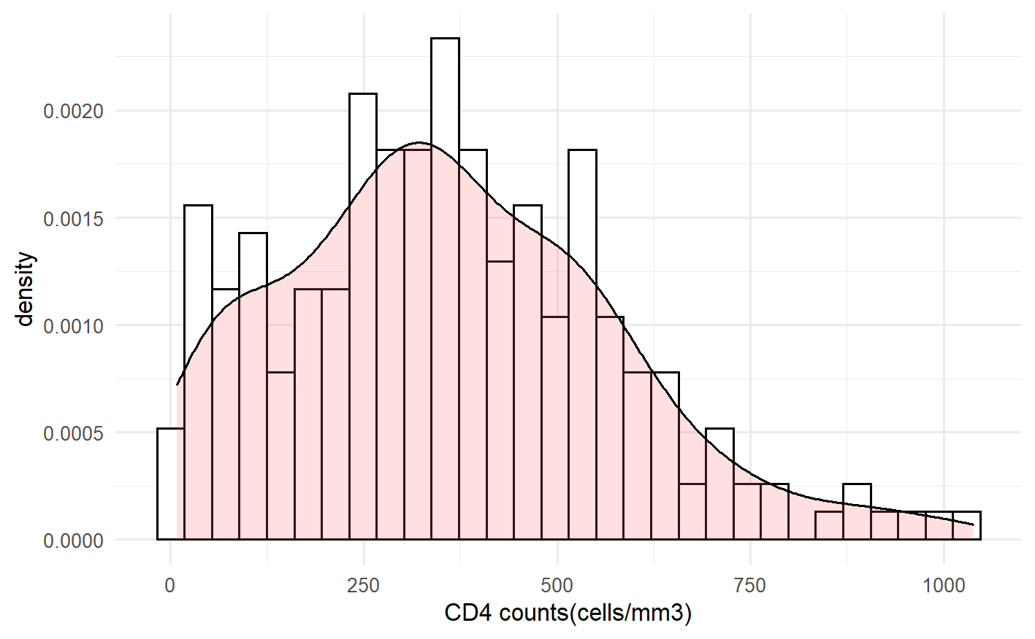

Supplementary Figure 1. The distribution curve of CD4 counts at baseline among persons newly diagnosed with HIV

