Table S1. Codes from DREAM database and which are treated as part of workforce and which are considered permanent detachment. Codes are from DREAM version 46.
Benefit descriptions:
“121”, “122”, “123” (payment received during holiday while currently employed); “412”, “413” (a pause in education but still part of the education); “511”, “521”, “522” (support requires employment); “651”, “652”, “661” (payment received while studying); “740”, “741”, “743”, “744”, “745”, “746”, “747”, “748”(Only available for people receiving “Flex job” benefit); “771”, “774” (benefit available to people with greatly impaired working ability who have work at greatly reduced time); “781” (only available to people with disability retirement); “881” (public support during maternity leave)
Benefits | Part of workforce | Disability retirement
“” = part of the workforce | x
“121” = holiday benefits | x
“122” = holiday benefits | x
“123” = holiday benefits | x
“412” = Leave of absence | x
“413” = Educational leave of absence | x
“511” = service job | x
“521” = Adult apprentice | x
“522” = Rotation substitute | x
“651” = State educational support | x
“652” = State educational support | x
“661” = Adult state educational support | x
“740” = availability benefit |  | x
“741” = availability benefit |  | x
“743” = availability benefit |  | x
“744” = availability benefit |  | x
“745” = availability benefit |  | x
“746” = availability benefit |  | x
“747” = availability benefit |  | x
“748” = availability benefit |  | x
“771” = “Flex Job” |  | x
“774”= “Flex Job” |  | X
“781” = Sheltered job |  | x
“783” = Early retirement |  | x
“881” = Maternity leave | x

Table S2. Table with ICD-10 codes used to define amount of comorbidity and specific comorbidities.
DIAGNOSIS CODES | Charlson (ICD-10) | COTE (ICD-10) | Medication (ATC-code) | GOLD (ICD-10)
AMI | I21-I23, I252
Ischemic heart disease |  | I20, I21, I23-25,
Cardiac insufficiency | I42 (excluding I428B), I43, I50, I099, I110, I130, I132, I255 | I42 (excluding I428B), I43, I50, I099, I110, I130, I132, I255 |  | I42 (excluding I428B), I43, I50, I099, I110, I130, I132, I255
Atrial fibrillation/flutter |  | I48
Peripheral vascular disease | E105, E115, E125, E135, E145, I70-I72, "I731", "I738", "I739", I74, I77, I790, I792, K551, K558, K559, Z958, Z959
Cerebrovascular disease | I60-I69, G45, G46, H340
Dementia | F00-F03, G30, F051, G311
Chronic pulmonary disease (excluding COPD) | J40-J43, J45-J47, J60-J67, J84, I278, I279, J684, J701, J703, J704, J920, J953, J961, J982, J983
Pulmonary fibrosis |  | J84, J631, J633, J635, J628A, J638A, J638B, J701, J703
Bronchitis |  |  |  | J42
Emphysema |  |  |  | J43, J982, J983
Bronchiectasis |  |  |  | J47
Rheumatic disease | M05, M06, M08, M09, M30-M36, D86
Peptic ulcus | K25-K28, K221 | K25-K28, K221
Mild liver disease | K700-K703, K713-K715, K762-K764, K73, K74, B18, K709, K717, K760, K769
Severe liver disease | B150, B160, B162, B190, I850, I859, I864, I982, K704, K711, K721, K729, K765-K767
Liver cirrhosis |  | K703, K717, K74,
Diabetes without comp | E100, E101, E109, E110, E111, E119, E120, E121, E129, E130, E131, E139, E140, E141, E149 |  | A10
Diabetes with comp | E102-E108, E112-E118, E122-128, E132-E138, E142-E148 | E102-E108, E112-E118, E122-128, E132-E138, E142-E148
Hemiplegia/paraplegia | G801, G802, G830-G834, G81-G82, G041, G114, G839
Chronic renal failure | N032-N037, N052-N057, Z490-Z492, N18, N19, N26, I120, I131, I132, N250, Z940, Z992
Cancer without metastasis + lymphoma + leukaemia | C00-C26, C30-C34, C37-C41, C43, C45-C58, C60-C76, C81-C85, C88, C90-C97
Pulmonary cancer |  | C34, C398, C399
Pancreatic cancer |  | C25
Esophageal cancer |  | C15
Mamma cancer |  | C50
Cancer with metastasis | C77-C80
AIDS/HIV | B20 – B24
Anxiety |  | F41 | N05B
Depression |  | F32 | N06A
Gastro esophageal reflux |  |  |  | K21
Sleep apnea |  |  |  | G473
Osteoporosis |  |  |  | M80, M81, M82
Hypertension |  |  | C02, C03, C07, C08, C09

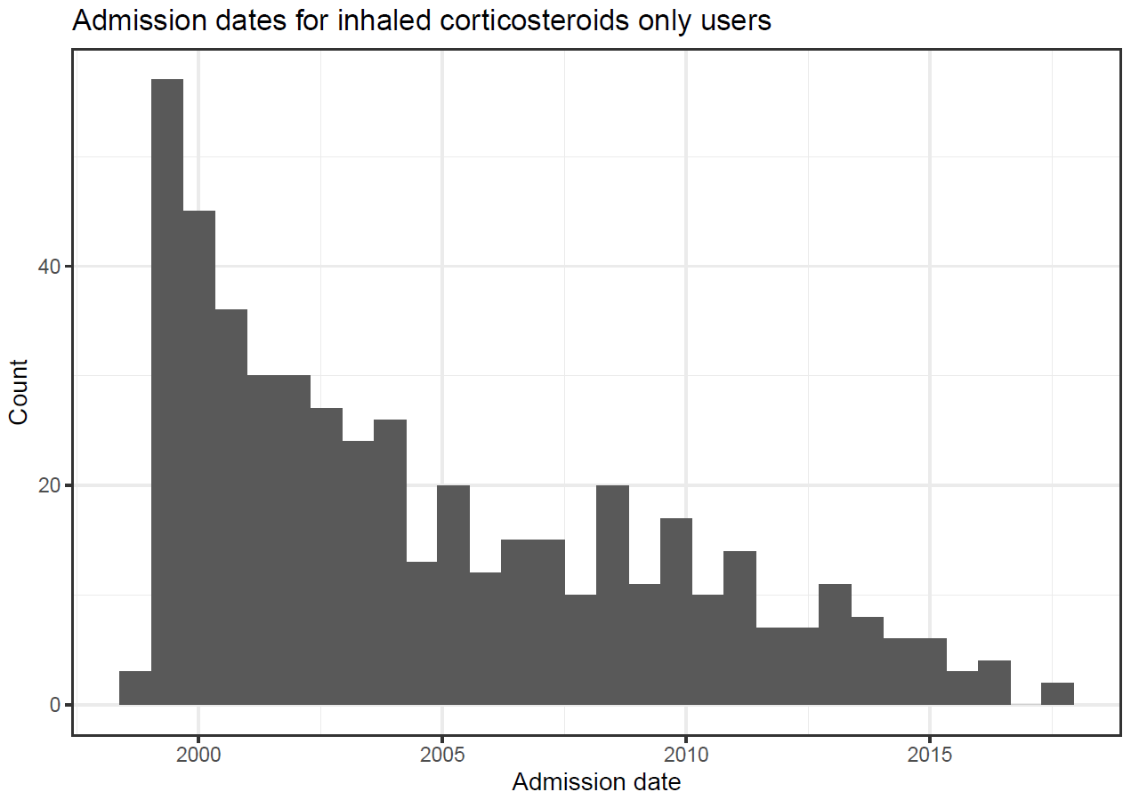

Figure S1. Date of admission for patients only using inhaled corticosteroids

