Supplementary Data
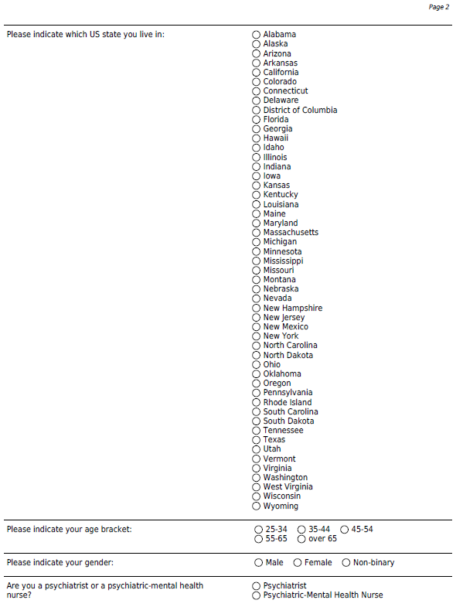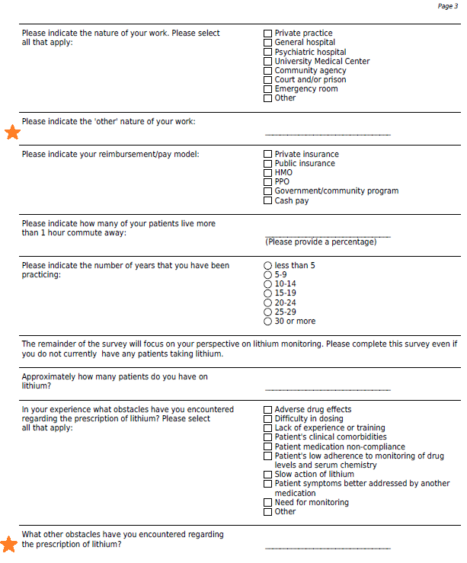
Figure S1. Perspectives on lithium monitoring survey (continued next page)
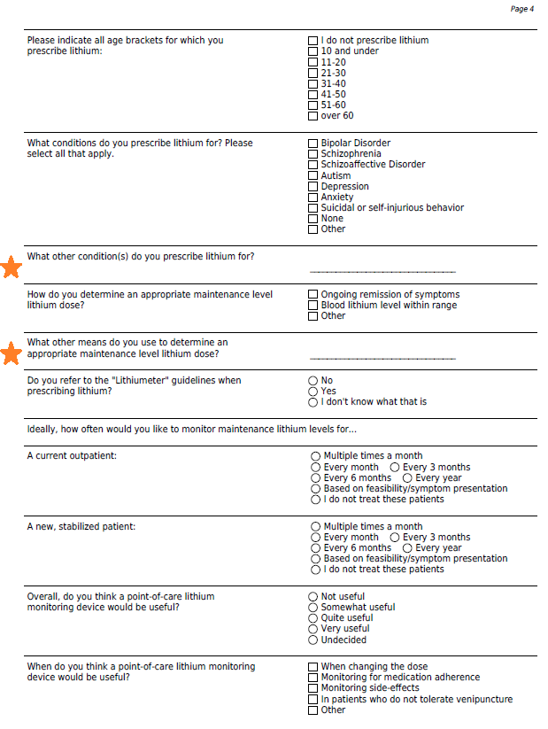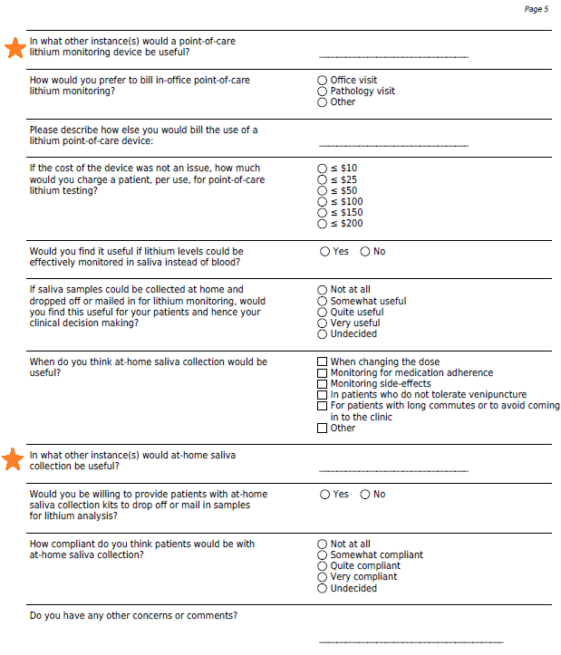
Figure S1. Perspectives on lithium monitoring survey. Questions indicated with an orange star were only presented if the respondent answered ‘Other’ to the preceding question. Questions paired with circle (○) response options allowed for single answers only; questions paired with square (◻) response options allowed for multiple options to be selected.

Table S1. Survey contact and response list
Site | Contacted | Response | Last Received Response type
American Psychiatric Association | 10/19/21
Orange County Psychiatric Society | 10/19/21
Community Psychiatry | 10/19/21
Southern California Psychiatric Society | 10/19/21
Colorado Psychiatric Society | 10/19/21
The Psychiatric Society of Virginia | 10/19/21 |  | Approved
The Arizona Psychiatric Society | 10/19/21
The North Carolina Psychiatric Association | 10/19/21
The New York County Psychiatric Society | 10/19/21 | 10/19/2021 | Approved
Washington State Psychiatric Association | 10/19/21 | 10/20/2021 | Distributed in newsletter and website news section
Michigan Psychiatric Society | 10/20/21
Alabama Psychiatric Physicians Association | 10/20/21
Massachusetts Psychiatric Society | 10/20/21
The Federation of Texas Psychiatry | 10/21/21
The Florida Psychiatric Society | 10/21/21
Alaska Psychiatric Society | 10/21/21
Arkansas Psychiatric Society | 10/21/21
San Diego Psychiatric Society | 10/21/21
North California Psychiatric Society | 10/21/21
Central California Psychiatric Society | 10/21/21
Connecticut Psychiatric Society | 10/21/21
Washington (D.C) Psychiatric Society | 10/21/21
Psychiatric Society of Delaware | 10/21/21
Georgia Psychiatric Physicians Association | 10/21/21
Hawaii Psychiatric Medical Association | 10/21/21
Idaho Psychiatric Association | 10/21/21
Illinois Psychiatric Society | 10/21/21 | 10/25/2021 | Denied request
Indiana Psychiatric Society | 10/21/21
Iowa Psychiatric Physicians Society | 10/25/21
Kansas Psychiatric Society | 10/25/21
Kentucky Psychiatric Medical Association | 10/25/21
Louisiana Psychiatric Medical Association | 10/25/21
Maine Association of Psychiatric Physicians | 10/25/21
Maryland Psychiatric Society | 10/25/21
Minnesota Psychiatric Society | 10/25/21
Mississippi Psychiatric Association | 10/25/21
Missouri Psychiatric Physicians Association | 10/25/21
Montana Psychiatric Association | 10/25/21
Nebraska Psychiatric Society | 10/25/21
Nevada Psychiatric Association | 10/25/21
New Hampshire Psychiatric Society | 10/26/21
New Jersey Psychiatric Association | 10/26/21
Psychiatric Medical Association of New Mexico | 10/26/21
North Dakota Psychiatric Society | 10/26/21
Ohio Psychiatric Physicians Association | 10/26/21 | 10/28/2021 | Denied request

Site | Contacted | Response | Last Received Response type
Oklahoma Psychiatric Physicians Association | 11/2/21
Oregon Psychiatric Physicians Association | 11/2/21
Pennsylvania Psychiatric Society | 11/4/21
Rhode Island Psychiatric Society | 11/4/21
American College of Psychiatrists | 11/5/21
American Academy of Child and Adolescent Psychiatry | 11/5/21
American Association of Chairs of Departments of Psychiatry | 11/5/21
American Board of Psychiatry and Neurology | 11/5/21 | 11/5/2021 | Denied request
American Foundation for Suicide Prevention | 11/5/21
Association of Women Psychiatrists | 11/5/21 | 11/14/2021 | Survey distributed to listserve
World Psychiatric Association | 11/5/21
South Carolina Psychiatric Association | 11/5/21
Tennessee Psychiatric Association | 11/5/21
Utah Psychiatric Association | 11/5/21
Vermont Psychiatric Association | 11/5/21
West Virginia Psychiatric Association | 11/5/21
Wyoming Medical Society | 11/5/21
Wisconsin Psychiatric Association | 11/6/21
South Dakota Psychiatric Association | 11/5/21 | 11/05/2021 | Secretary to check with President
Society of Uniformed Services Psychiatrists | 11/5/21 | 11/05/2021 | Secretary to check with President
American Psychiatric Nurses Association | 12/20/21 | 12/22/2021 | Denied request
Association of Psychiatric Mental Health Nurse Practitioners | 01/18/22
American Association of Directors of Psychiatric Residency Training | 01/18/22
AllHealth Network Psychiatry Services | 01/18/22
Psychiatry Networks | 01/18/22
American Neuro-Psychiatric Network, Inc. | 01/18/22
Progeny Psychiatry Group (Irvine) | 01/18/22
Segal Neuropsychiatry | 01/18/22
American Psychiatric Care | 01/18/22
Association for Academic Psychiatry | 01/18/22
Academy of Organizational and Occupational Psychiatry | 01/18/22
American Academy of Addiction Psychiatry | 01/18/22
American Association for Psychiatric Administration and Leadership | 01/18/22
American Society for Adolescent Psychiatry | 01/18/22
American Society of Hispanic Society | 01/18/22
Association of Directors of Medical Student Education in Psychiatry | 01/18/22
Association of American Medical Colleges | 01/18/22
International Association for Child and Adolescent Psychiatry and Allied Professions | 01/18/22
American Association for Emergency Psychiatry | 01/18/22
American Academy of Clinical Psychiatrists | 01/18/22 | 01/20/22 | Distributed via newsletter
American Neuropsychiatric Association | 01/18/22

Table S2. Respondent perspectives on the billing of point-of-care devices
Query |  |  | n (%)
How would you prefer to bill in-office point-of-care lithium monitoring?
 | Office visit | 46 (70.8)
 | Pathology visit | 9 (13.8)
 | Other (unsure/ not relevant/ not of concern) | 10 (15.4)
If the cost of the device was not an issue, how much would you charge a patient, per use, for the point-of-care device?
 | ≤$10 | 6 (40.0)
 | ≤$25 | 7 (46.7)
 | ≤$50 | 2 (13.3)
 | ≤$100 | 0 (0.0)
 | ≤$150 | 0 (0.0)
 | ≤$200 | 0 (0.0)

Table S3. Free-form concerns/comments
I don't like the idea of the time delay between collecting the saliva and getting the result. I would be far more in favor of a home-based blood POC test, similar to a finger stick. For saliva-based, would still prefer they go to an office or lab. | This is brilliant! Please make it happen | I only do tele psych, I don't see any questions here that seem to enfold that possibility. | clinical picture/symptoms are more important than blood levels, overreliance/overuse of labs/blood levels is a risk. | Would the important 12-hour interval apply to Li concentration in saliva also? I have pts who rarely get it right and need do-overs.
Insurance coverage | I am familiar with previous work that indicated low level of accuracy for saliva. This would be a hard sell. You would need to provide data to overcome years of research. | The main problem with low Lithium prescription numbers is the stigma and wrong information out there in the community. Many recoil at the thought of being offered or taking Lithium. Even health care practitioners discourage patients from taking lithium. | Yes. The cost of a machine for the clinic and the need for OSHA guideline compliance and fear of fines for violating guidelines. And how accurate saliva levels are compared to serum levels. | Thanks for the effort to make follow up less traumatic.
For me it all depends on the cost (!) I will use the cheapest method of drug and testing. | sounds great for higher functioning patients | My concern with a POC lithium saliva assay is merely with ensuring that it has adequate clinical validity comparable to serum lithium levels. One of the current drawbacks I experience which your survey doesn't ask, is the time lag of receiving a serum lithium result. | Hi have fairly high functioning patient population for whom adherence is usually not a problem. This would be a convenience for them but would still need blood draw for TSH BUN CR | would prefer to obtain saliva samples in person / at clinic encounter (rather than at home submission)
For me this was a gold standard at a time labs were better integrated into clinical care. Today, getting labs is a haphazard event in a highly fragmented healthcare system. Some patients have not had the resources, time, or patience to get labs done in a timely manner - if at all. | I feel lithium can be an effective medication but don't have much experience prescribing it as I work with the military population | Note that I staff PGY3-4 residents in a state university hospital clinic. I do not set fees, nor participate in decisions about new testing protocols or methods. | Lithium is highly effective for bipolar d/o and as an augmentation strategy for depression, but it is vastly underprescribed because for the past 30 yrs the drug companies have claimed that atypical antipsychotics were better and safer; this however is not correct. The psychiatric community was sold (and bought) a bill of goods about the dangers of lithium and the desirability of atypicals, which themselves have many undesirable side effects in mood disorder patients. | I have used lithium a lot in the past but currently don't have bipolar patients. I only use it in patients who I expect to have good adherence. Most of those patients would do well with at home monitoring if it was properly structured.
Comments regarding the restriction to high-functioning patients are in orange, comments regarding the validity of the test are in blue, comments regarding the cost are in green.

