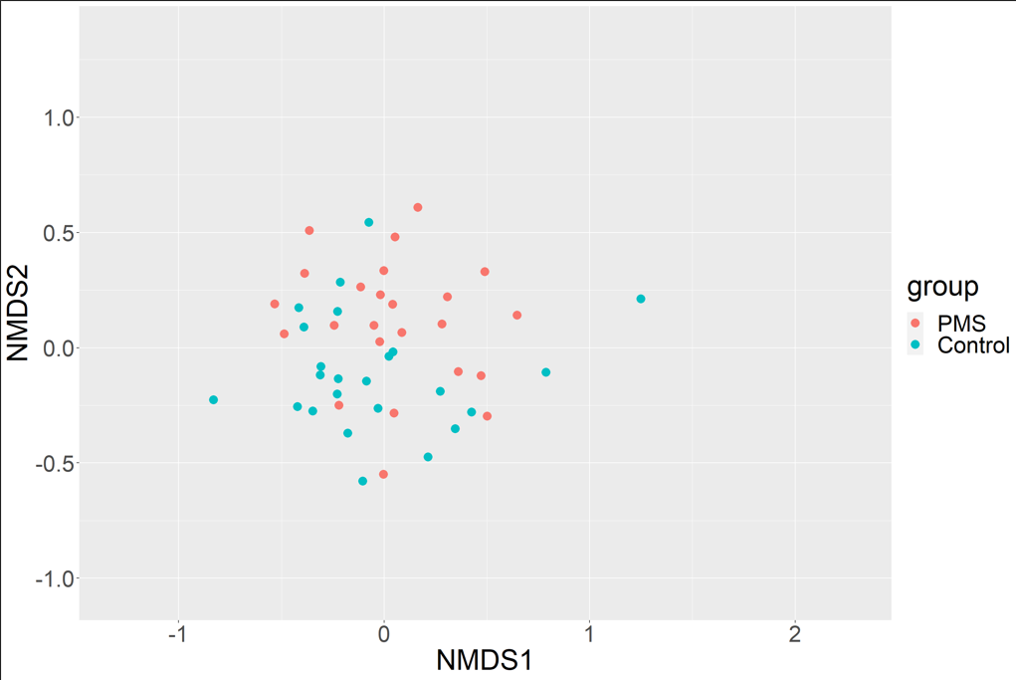
Supplementary Figure 1.
Comparison between the β-diversity of the PMS and control groups. Subjects were randomly selected (PMS: n=24, control: n=24). The distance between the two groups was visualized using the NMDS method (stress=0.211). Distances between samples were calculated using the Bray-Curtis index. A significant difference was observed between the groups at p <0.001 (dispersion=0.838).

Supplementary Table 1 Number of samples by age group in the PMS and control groups.
Age |  | PMS | Control
24–29 | Number of samples | 1 | 15
 | Age | 24.00 (0.00) | 26.73 (1.44)
30–39 | Number of samples | 18 | 52
 | Age | 34.22 (2.55) | 34.75 (2.81)
40–49 | Number of samples | 5 | 77
 | Ages | 44.20 (2.71) | 44.01 (2.71)
30–49 | Number of samples | 23 | 129
 | Age | 36.39 (4.86) | 40.28 (5.31)
Values are mean (SD).

Supplementary Table 2 Comparison of the top 20 genera based on the relative abundance in each group.
PMS |  |  | Control
Genus | Relative abundance (%) |  | Genus | Relative abundance (%)
Phocaeicola† | 16.73 |  | Phocaeicola† | 16.88
Unclassified | 12.81 |  | Unclassified | 14.48
Bifidobacterium | 10.60 |  | Bacteroides | 14.22
Bacteroides | 9.38 |  | Faecalibacterium | 7.56
Faecalibacterium | 6.56 |  | Bifidobacterium | 6.78
Blautia | 5.13 |  | Prevotella | 4.15
Collinsella | 3.96 |  | Blautia | 4.06
Fusicatenibacter | 2.64 |  | Alistipes | 3.31
Parabacteroides | 2.60 |  | Parabacteroides | 3.00
Megamonas | 2.59 |  | Fusicatenibacter | 2.26
Prevotella | 2.52 |  | Lachnospira | 2.03
Streptococcus | 2.03 |  | Megamonas | 1.90
Alistipes | 1.81 |  | Anaerostipes | 1.67
Anaerostipes | 1.34 |  | Agathobacter | 1.23
Fusobacterium | 1.20 |  | Anaerobutyricum | 1.05
Megasphaera | 1.12 |  | Roseburia | 0.98
Agathobacter | 1.04 |  | Ruminococcus | 0.95
Anaerobutyricum | 0.94 |  | Collinsella | 0.88
Ruminococcus | 0.90 |  | Veillonella | 0.74
Dorea | 0.87 |  | Faecalibacillus | 0.70
Others | 13.23 |  | Others | 11.16
Values are presented as means.
†Phocaeicola is a genus reclassified from Bacteroides in 2019.³⁵

Supplementary Table 3 Top 20 genera based on the absolute value of the effect size by age group
Supplementary Table 3 A. Comparison of participants aged 30–39 years belonging to the PMS and control groups in their 30s
Genus | Relative abundance (%) |  | p-value |  | Effect size
Genus | PMS_30s | Control_30s | p-value |  | Effect size
Collinsella | 4.11 | 0.94 | 0.004 | *** | 0.78
Enterocloster | 0.34 | 0.23 | 0.035 | * | 0.64
Sellimonas | 0.31 | 0.06 | 0.056 |  | 0.61
Erysipelatoclostridium | 0.36 | 0.18 | 0.077 |  | 0.52
Dysosmobacter | 0.35 | 0.20 | 0.112 |  | 0.44
Blautia | 5.69 | 4.83 | 0.184 |  | 0.42
Eggerthella | 0.12 | 0.06 | 0.224 |  | 0.41
Bifidobacterium | 9.96 | 7.30 | 0.146 |  | 0.40
Oscillibacter | 0.01 | 0.28 | 0.259 |  | -0.38
Ruminococcus2 | 0.80 | 0.40 | 0.123 |  | 0.36
Phocaeicola | 17.80 | 15.63 | 0.174 |  | 0.34
Faecalimonas | 0.23 | 0.03 | 0.400 |  | 0.33
Holdemania | 0.03 | 0.00 | 0.350 |  | 0.33
Enterococcus | 0.00 | 0.05 | 0.373 |  | -0.31
Ruthenibacterium | 0.12 | 0.05 | 0.401 |  | 0.30
Fusobacterium | 1.58 | 0.17 | 0.458 |  | 0.30
Streptococcus | 2.52 | 0.44 | 0.427 |  | 0.29
Merdimonas | 0.12 | 0.02 | 0.490 |  | 0.29
Flavonifractor | 0.24 | 0.31 | 0.352 |  | 0.29
Dialister | 0.10 | 0.56 | 0.430 |  | -0.28
Supplementary Table 3 B. Comparison of participants aged 40–49 years belonging to the PMS and control groups in their 40s
Genus | Relative abundance (%) |  | p-value |  | Effect size
Genus | PMS_40s | Control_40s | p-value |  | Effect size
Collinsella | 3.86 | 0.87 | 0.16 |  | 1.249
Dorea | 1.55 | 0.68 | 0.40 |  | 0.737
Bifidobacterium | 13.76 | 6.32 | 0.61 |  | 0.714
Megasphaera | 2.84 | 0.46 | 0.76 |  | 0.627
Clostridium_IV | 0.16 | 0.18 | 0.74 |  | 0.561
Unclassified | 24.81 | 14.36 | 0.76 |  | 0.534
Faecalibacillus | 1.72 | 0.78 | 0.80 |  | 0.424
Megamonas | 0.00 | 2.11 | 0.77 |  | -0.421
Turicibacter | 0.00 | 0.12 | 0.81 |  | -0.408
Blautia | 3.24 | 3.43 | 0.79 |  | 0.392
Paraprevotella | 0.00 | 0.40 | 0.80 |  | -0.365
Barnesiella | 0.19 | 0.81 | 0.90 |  | -0.345
Ruthenibacterium | 0.00 | 0.13 | 0.87 |  | -0.318
Ruminococcus2 | 0.10 | 0.32 | 0.88 |  | -0.315
Clostridium_sensu_stricto | 0.00 | 0.12 | 0.84 |  | -0.282
Anaerotignum | 0.02 | 0.15 | 0.88 |  | -0.265
Holdemanella | 0.00 | 0.41 | 0.87 |  | -0.265
Odoribacter | 1.41 | 0.53 | 0.91 |  | -0.259
Neglecta | 0.94 | 0.42 | 0.90 |  | 0.252
Prevotella | 0.03 | 5.38 | 0.91 |  | -0.252
The relative abundance values are presented as means. P-values were calculated using the Wilcoxon rank-sum test with Benjamini-Hochberg FDR correction. *p-value < 0.05 and ***p-value < 0.001. The effect size was calculated using the ALDEx2 pipeline.

