Table S1. Antimicrobial resistance and Hypermucoviscous phenotype of DTR Vs Non-DTR Kp.

 | DTR(n=50) | Non-DTR(n=50) | P value
MDR | 50(100.0%) | 14(28.0%) | 0.000
CR | 50(100.0%) | 2(4.0%) | 0.000
ESCR | 50(100.0%) | 13(26.0%) | 0.000
FQR | 50(100.0%) | 11(22.0%) | 0.000
Piperacillin/tazobactam | 50(100.0%) | 4(8.0%) | 0.000
Cefoperazone/sulbactam | 50(100.0%) | 3(6.0%) | 0.000
Ceftazidime | 50(100.0%) | 10(20.0%) | 0.000
Cefepime | 50(100.0%) | 11(22.0%) | 0.000
Imipenem | 50(100.0%) | 1(2.0%) | 0.000
Meropenem | 50(100.0%) | 2(4.0%) | 0.000
Levofloxacin | 50(100.0%) | 11(22.0%) | 0.000
Amikacin | 35(70.0%) | 2(4.0%) | 0.000
Minocycline | 24(48.0%) | 13(26.0%) | 0.023
Trimethoprim/sulfamethoxazole | 21(42.0%) | 10(20.0%) | 0.017
HvKp | 28(56.0%) | 27(54.0%) | 0.841
Hypermucoviscosity | 26(52.0%) | 32(64.0%) | 0.224
Bold text: P value<0.05.

Figure S1. (A) Sequence type and (B) Capsule serotype distribution distribution of DTR-Kp strains.
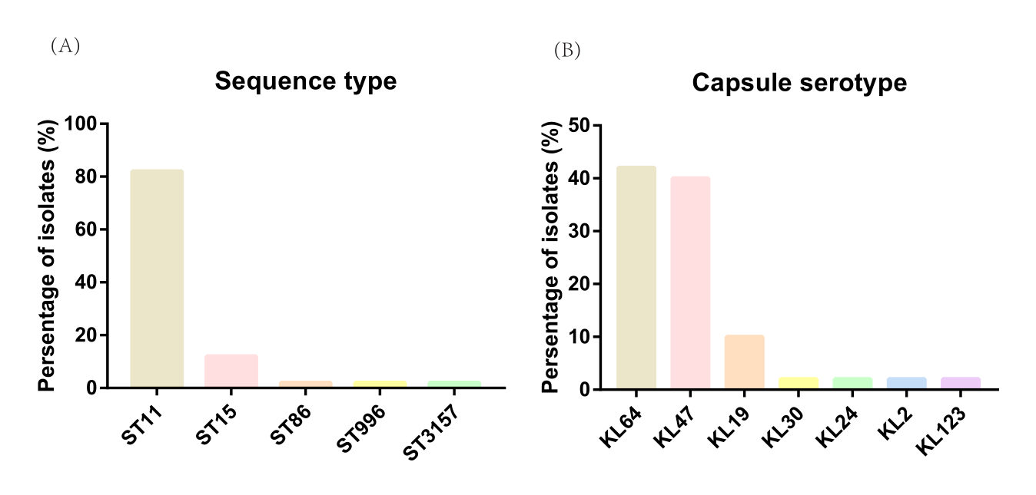
Table S2. Genomic characteristics of DTR Vs Non-DTR Kp.
 | DTR(n=50) | Non-DTR(n=50) | P value
Resistance genes
aadA2 | 28(56.0%) | 5(10.0%) | 0.000
aac(6')-Ib-cr | 12(24.0%) | 7(14.0%) | 0.202
aadA16 | 2(4.0%) | 3(6.0%) | 1.000
fosA3 | 36(72.0%) | 0(0.0%) | 0.000
qnrS1 | 11(22.0%) | 6(12.0%) | 0.183
mphA | 22(44.0%) | 6(12.0%) | 0.000
floR | 3(6.0%) | 4(8.0%) | 1.000
arr-3 | 8(16.0%) | 4(8.0%) | 0.218
sul1 | 9(18.0%) | 9(18.0%) | 1.000
tet(A) | 22(44.0%) | 9(18.0%) | 0.005
dfrA1 | 15(30.0%) | 2(4.0%) | 0.001
blaKPC-2 | 45(90.0%) | 2(4.0%) | 0.000
blaTEM-1D | 40(80.0%) | 6(12.0%) | 0.000
blaOXA-1 | 10(20.0%) | 4(8.0%) | 0.084
CTX-M-65 | 22(44.0%) | 0(0.0%) | 0.000
blaSHV-12 | 7(14.0%) | 0(0.0%) | 0.012
blaSHV-11 | 27(54.0%) | 19(38.0%) | 0.108
Virulence genes
Yersiniabactin
ybtS | 48(96.0%) | 30(60.0%) | 0.000
ybtQ | 48(96.0%) | 30(60.0%) | 0.000
ybtA | 48(96.0%) | 30(60.0%) | 0.000
irp2 | 48(96.0%) | 30(60.0%) | 0.000
irp1 | 48(96.0%) | 30(60.0%) | 0.000
ybtT | 48(96.0%) | 30(60.0%) | 0.000
ybtE | 48(96.0%) | 30(60.0%) | 0.000
Colibactin
clbL | 1(2.0%) | 13(26.0%) | 0.001
Aerobactin
iucA | 28(56.0%) | 23(46.0%) | 0.317
iucB | 28(56.0%) | 23(46.0%) | 0.317
iucC | 28(56.0%) | 23(46.0%) | 0.317
iucD | 28(56.0%) | 23(46.0%) | 0.317
iutA | 28(56.0%) | 23(46.0%) | 0.317
Salmochelin
iroB | 1(2.0%) | 26(52.0%) | 0.000
iroC | 1(2.0%) | 26(52.0%) | 0.000
iroD | 1(2.0%) | 26(52.0%) | 0.000
iroN | 1(2.0%) | 25(50.0%) | 0.000
Other virulence genes
rmpA | 12(24.0%) | 25(50.0%) | 0.007
rmpA2 | 19(38.0%) | 20(40.0%) | 0.838
peg-344 | 12(24.0%) | 25(50.0%) | 0.007
peg-589 | 28(56.0%) | 22(44.0%) | 0.230
Bold text: P value<0.05.

Figure S2. Kaplan–Meier curves for all-cause 30-day mortality in (A) hvKp, (B) cKp subgroup and (C) DTR group.
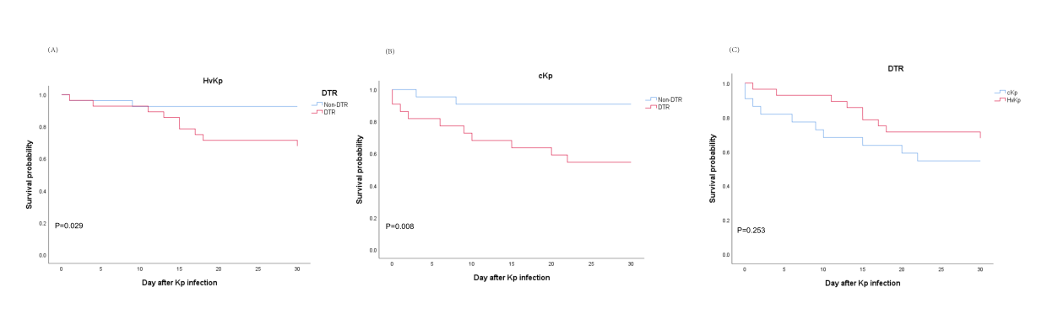

Figure S3. The phylogenetic tree of DTR Kp strains isolated in this study. A. DTR-ST11 Kp strains; B. DTR-Non-ST11 Kp strains.
