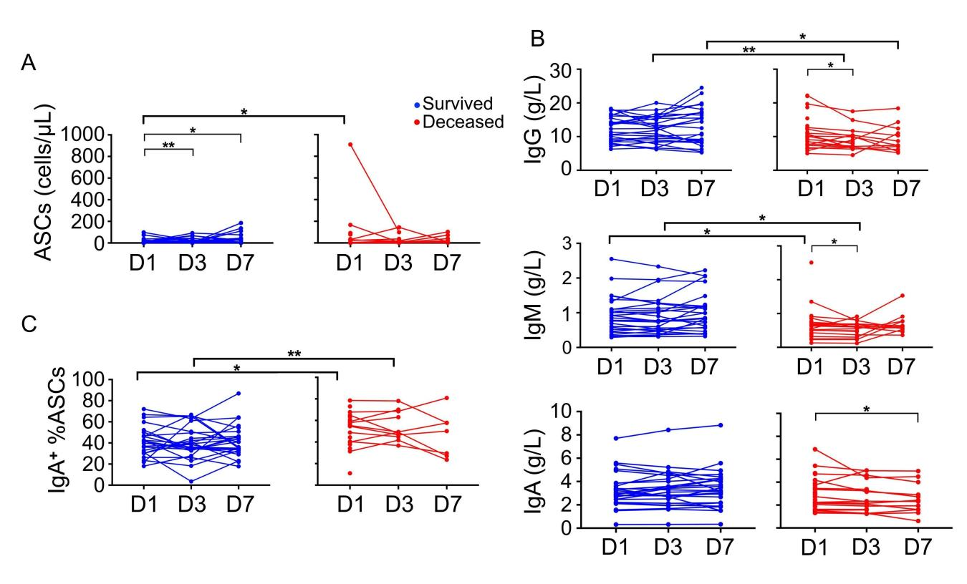
Figure S1. Kinetic analysis of IgA⁺ ASCs and immunoglobulin in sepsis group. (A) The statistical analysis of ASCs in survived and deceased patients at day 1, 3 and 7 after diagnosis of sepsis. For survived patients n = 28, and for deceased patients n = 30 at day 1, n = 18 at day 3 and n = 12 at day 7. (B) The statistical analysis of IgG, IgM, and IgA among different time points. (C) The statistical analysis of IgA⁺ %ASCs in survived and deceased patients at different time points. *, p < 0.05; **, p < 0.01 by Mann-Whitney test and Wilcoxon matched-pairs signed rank test. Red dots represent survived patients, blue dots represent deceased patients.

Table S1. Clinical data and laboratory data in survivors and non-survivors of sepsis group at day1
Variables | Survivors | Non-survivors | p value
Cases | 28 | 30
Age (year) | 80 ± 8 | 81 ± 7 | 0.436
Gender (male/female) | 15 / 13 | 20 / 10 | 0.308
PCT (ng/mL) | 1.9 (0.7, 7.8) | 7.7 (0.9-22.7) | 0.098
CRP (mg/L) | 107.3 (70.8-156.1) | 89.9 (47.4-147.7) | 0.244
Lactate (mmol/L) | 1.3(1.0-2.1) | 1.9 (1.2-3.3) | 0.096
B (cells/μL) | 63.3 (33.5-120.4) | 40.5 (18.1-83.2) | 0.105
ASCs (cells/μL) | 4.8 (0.8-12.1) | 2.7 (0.9-25.7) | 0.856
Abbreviations: PCT procalcitonin, CRP C-reactive protein, ASCs antibody-secreting cells. Numbers are n (%) , means± SEM, or median (interquartile range).

