Supplementary material

Ribociclib plus letrozole in Italian male patients with hormone receptor–positive, human epidermal growth factor receptor 2-negative advanced breast cancer: Case studies of phase 3b CompLEEment-1 trial
Roberta Caputo,^{1*} Alessandra Fabi, ^{2,3} Emanuela Romagnoli, ⁴ Editta Baldini, ⁵ Donatella Grasso, ⁶ Nicola Fenderico, ⁶ Andrea Michelotti⁷

Figure S1. Timeline of tumor marker CA 15-3 levels in case 1.

Figure S2. Timeline of tumor marker CEA levels in case 1.
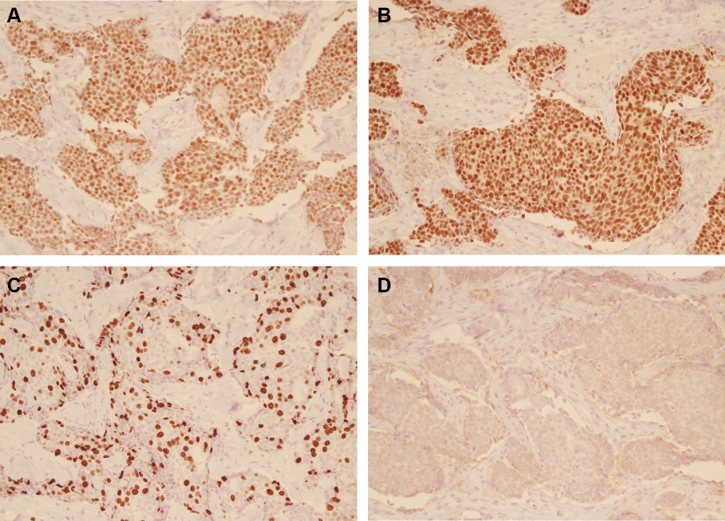
Figure S3. Immunohistochemical staining of (A) ER, (B) PR, (C) Ki-67, and (D) HER2 in tumor tissue of case 5.

Table S1: Details of the approving ethics committees
Ribociclib plus letrozole in Italian male patients with hormone receptor-positive, human epidermal growth factor receptor 2-negative advanced breast cancer: Case studies of phase 3b CompLEEment-1 trial
S.No | Name and address of the approving ethics committees
Ethics Committee
COMITATO ETICO IRCCS Pascale - A.O.R. N. Santobono-Pausilipon
VIA MARIANO SEMMOLA
80131 NAPOLI (NA)
Ethics Committee
COMITATO REGIONE TOSCANA - AREA VASTA NORD OVEST c/o
AZIENDA OSPEDALIERO UNIVERSITARIA PISANA DI PISA
VIA ROMA, 67
56126 PISA (PI)
Ethics Committee
COMITATO ETICO REGIONALE (CER) DELLE MARCHE c/o AZIENDA
OSPEDALIERA UNIVERSITARIA OSPEDALI RIUNITI UMBERTO I-
LANCISI-GM SALESI DI ANCONA
VIA CONCA
60126 ANCONA (AN)
Ethics Committee
COMITATO REGIONE TOSCANA - AREA VASTA NORD OVEST c/o
AZIENDA OSPEDALIERO UNIVERSITARIA PISANA DI PISA
VIA ROMA, 67
56126 PISA (PI)
Ethics Committee
COMITATO ETICO CENTRALE IRCCS LAZIO - Sezione IFO-BIETTI c/o
IRCCS ISTITUTI FISIOTERAPICI OSPITALIERI DI ROMA
VIA ELIO CHIANESI, 53
00144 ROMA (RM)

