Supplementary materials

Table S1. Medication use last 12 months at as assessed at follow-up among those with and without severe asthma according to GINA at follow-up.
 | Other asthma  n=875 |  | Severe asthma  n=131 |  | p-value
Any SABA use | 41.8% |  | 79.4% |  | <0.001
SABA Daily | 6.6% |  | 22.9% |  | <0.001
SABA As needed | 35.2% |  | 56.5% |  | <0.001
Any ICS use* | 35.2% |  | 100.0% |  | <0.001
ICS Daily | 22.4% |  | 100.0% |  | <0.001
ICS As needed | 12.8% |  | 0.0% |  | <0.001
ICS dose (GINA)
Low dose ICS | 24.0% |  | 0.0%
Medium dose ICS | 10.8% |  | 59.5%
High dose ICS | 0.5% |  | 40.5% |  | <0.001
Any LABA use* | 16.6% |  | 100.0% |  | <0.001
LABA Daily | 11.0% |  | 100.0% |  | <0.001
LABA As needed | 5.6% |  | 0.0% |  | 0.005
Any OCS use | 0.5% |  | 10.7% |  | <0.001
OCS Daily | 0.0% |  | 3.1% |  | <0.001
OCS Periodically (during exacerbations) |  | 0.5% |  | 7.6% |  | <0.001
Other
LTRA | 0.8% |  | 13.0% |  | <0.001
Anticholinergic | 1.6% |  | 7.6% |  | <0.001
*Single or in combination, SABA=Short-acting B2-agonist, LABA=Long-acting B2-agonist, ICS=Inhaled corticosteroids, OCS=Oral corticosteroids, LTRA=Leukotriene receptor antagonist, Medium ICS dose according to GINA=Budesonide >400-800mcg or equivalent, High ICS dose according to GINA=Budesonide >800mcg or equivalent. For ERS/ATS severe asthma, medication data have previously been presented elsewhere[4]. Bold font indicates p<0.05.

Table S2. Sensitization patterns for airborne allergens, blood eosinophils and neutrophils, and prevalence (%) of NSAID-related respiratory symptoms and nasal polyps at follow-up in 2012-2014 among those with and without severe asthma according to GINA at follow-up.
 | Other asthma |  | Severe asthma
 | n=875 |  | n=131 | p-value
Sensitization to:
Any airborne allergen | 33.4% |  | 31.3% | 0.634
Any pollen | 23.9% |  | 21.1% | 0.490
Any animal | 22.1 |  | 25.8% | 0.352
Any mite | 4.4% |  | 10.2% | 0.006
Any mould | 2.6% |  | 7.0% | 0.008
Sensitization to specific mites:
D. Pteronyssinus | 4.3% |  | 9.4% | 0.013
D. Farinae | 3.7% |  | 7.8% | 0.030
Sensitization to specific moulds:
Aspergillus fumigatus | 1.8% |  | 6.3% | 0.001
Alternaria alternata | 0.6% |  | 3.9% | 0.001
Cladosporum herbarum | 1.3% |  | 3.1% | 0.120
Multi-sensitization:
Sensitization to ≥4 allergens* | 9.4% |  | 16.4% | 0.015
Sensitization to ≥4 allergens*  but not to mites or moulds | 6.2% |  | 6.4% | 0.974
Cell counts
Blood eosinophils (10⁹/L), mean (SD) | 0.21 (0.16) |  | 0.27 (0.22) | <0.001
Blood neutrophils (10⁹/L), mean (SD) | 3.72 (1.31) |  | 4.15 (1.78) | <0.001
Blood eosinophils ≥ 0.3 x10⁹/L | 25.6% |  | 37.3% | <0.001
Blood neutrophils ≥ 5.0 x10⁹/L | 14.7% |  | 22.0% | 0.039
NSAID-related respiratory symptoms | 3.6% |  | 9.2% | 0.003
Nasal polyps in adulthood | 5.4% |  | 9.2% | 0.085
*Included allergens = Birch, timothy, mugwort, cat, dog, horse, D. pteronyssinus, D. Farinae, aspergillus fumigatus, alternaria alternata, cladosporium herbarum. Sensitization was assessed by ImmunoCap Phadiatop and specific IgE. NSAID = nonsteroidal anti-inflammatory drugs. Bold font indicates p<0.05.
Table S3. Prevalence of allergic sensitization (any positive IgE) and sensitization to Aspergillus fumigatus and D. Pterinyssinus at the 2012-14 in relation to age at asthma onset, in other asthma and severe asthma according to GINA at follow-up.

 | Prevalence of sensitization to  Any allergen (%) |  |  |  |  |  | Prevalence of sensitization to  Aspergillus (%) |  |  |  |  |  | Prevalence of sensitization to  D. Pterinyssinus (%)
 | Other asthma  N=771 |  |  | Severe asthma  N=126 |  |  | Other asthma  N=771 |  |  | Severe asthma  N=118 |  |  | Other asthma  N=771 |  |  | Severe asthma N=126
 | % | p-value |  | % | p-value |  | % | p-value |  | % | p-value |  | % | p-value |  | % | p-value
Among those with age at asthma onset:
≥30 years | 17.9% |  |  | 18.8% |  |  | 1.1% |  |  | 3.8% |  |  | 3.9% |  |  | 1.3%
<30 years | 49.5% | <0.001 |  | 54.3% | <0.001 |  | 2.7% | 0.116 |  | 10.9% | 0.115 |  | 5.1% | 0.415 |  | 23.9% | <0.001
Sensitization was assessed by ImmunoCap Phadiatop and specific IgE. Bold font indicates p<0.05.

Table S4. Prevalence of adult onset asthma, by BMI at study entry and sex, in other asthma and severe asthma according to GINA at follow-up.
 |  |  |  | Prevalence of asthma onset ≥30 years (%)
 |  |  |  | Other asthma  N=780 |  |  |  |  |  | Severe asthma  N=123
 |  |  |  | % |  |  | p-value |  |  | % |  |  | p-value
Normal weight |  |  |  | 48.0% |  |  |  |  |  | 61.5%
Overweight |  |  |  | 64.6% |  |  |  |  |  | 66.7%
Obesity |  |  |  | 52.7% |  |  | 0.015 |  |  | 66.7% |  |  | 0.912
Among men with:
Normal weight |  |  |  | 28.3% |  |  |  |  |  | 65.0%
Overweight |  |  |  | 48.4% |  |  |  |  |  | 42.9%
Obesity |  |  |  | 55.3% |  |  | <0.001 |  |  | 87.5% |  |  | 0.072
Among all with:
Normal weight |  |  |  | 40.3% |  |  |  |  |  | 63.0%
Overweight |  |  |  | 55.2% |  |  |  |  |  | 55.6%
Obesity |  |  |  | 53.9% |  |  | <0.001 |  |  | 73.1% |  |  | 0.338
p-value=chi-square test for difference in prevalence between BMI categories separately among women, men and all in each column. Women and men with underweight were not included due to low numbers. Bold font indicates p<0.05.

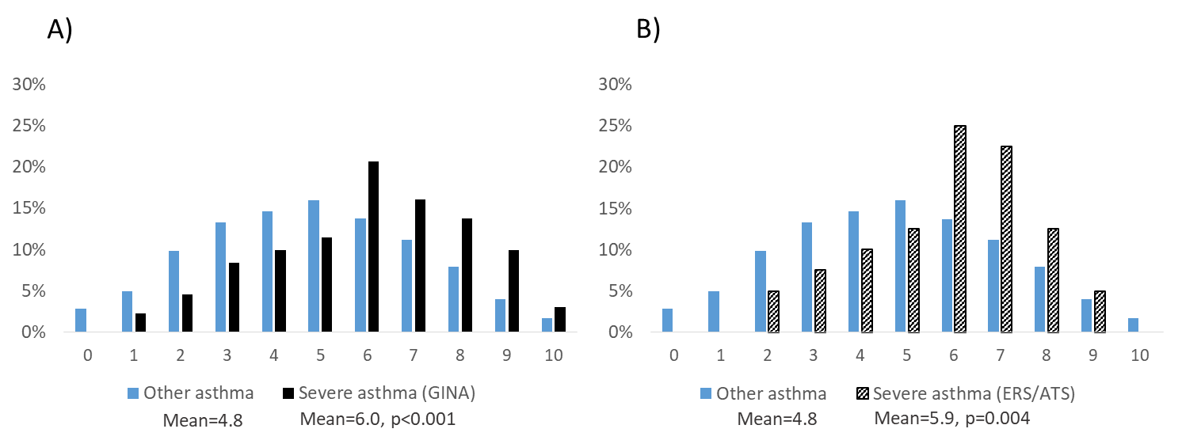

Figure S1. Proportions (%) reporting a total of 0-10 triggers at study entry among those with other asthma and severe asthma at follow-up according to A) GINA and B) ATS/ERS (p from T-test of difference in mean number of triggers).

