Figures and Tables Supporting Materials:

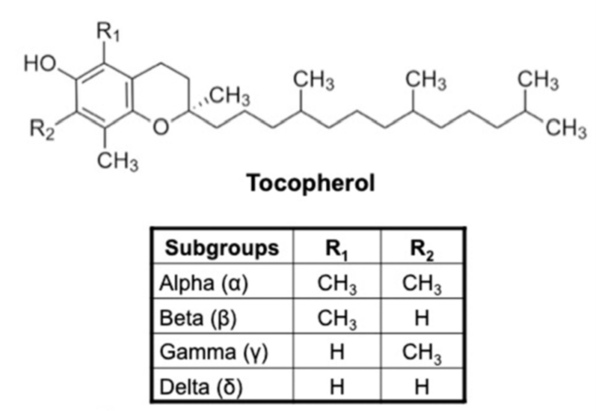
Figure 1S. Vitamin E

Table 1S. Tested Almond Oil formulations (in bold formulation in the homogeneous region, Figure 2S)
Sample | Almond Oil  (g) | Tw80  (g) | Hepes  (g) | Almond oil (% w/w) | Tw80  (% w/w) | Hepes  (% w/w)
A1 | 0.098 | 0.098 | 5.000 | 2.00 | 2.00 | 96.00
A2 | 0.050 | 0.100 | 10.000 | 0.50 | 1.00 | 98.50
A3 | 0.100 | 0.100 | 10.000 | 1.00 | 1.00 | 98.00
A4 | 0.050 | 0.100 | 5.000 | 1.00 | 2.00 | 97.00
A5 | 0.050 | 0.100 | 3.000 | 2.00 | 3.00 | 95.00
A6 | 0.100 | 0.050 | 5.000 | 2.00 | 1.00 | 97.00
A7 | 0.065 | 0.190 | 3.000 | 2.00 | 6.00 | 92.00
A8 | 0.020 | 0.430 | 0.550 | 2.00 | 43.00 | 55.00
A9 | 0.100 | 0.050 | 3.000 | 3.00 | 2.00 | 95.00
A10 | 0.100 | 0.100 | 3.000 | 3.00 | 3.00 | 94.00
A11 | 0.030 | 0.570 | 0.400 | 3.00 | 57.00 | 40.00
A12 | 0.050 | 0.100 | 1.000 | 4.00 | 9.00 | 87.00
A13 | 0.050 | 0.400 | 0.500 | 5.00 | 45.00 | 50.00
A14 | 0.050 | 0.300 | 0.650 | 5.00 | 30.00 | 65.00
A15 | 0.100 | 0.100 | 1.000 | 8.00 | 8.00 | 84.00
A16 | 0.100 | 0.050 | 1.000 | 9.00 | 4.00 | 87.00
A17 | 0.050 | 0.100 | 0.500 | 8.00 | 15.00 | 77.00
A18 | 0.125 | 0.050 | 0.325 | 25.00 | 10.00 | 65.00
A19 | 0.130 | 0.020 | 0.300 | 29.00 | 5.00 | 66.00
A20 | 0.139 | 0.010 | 0.300 | 31.00 | 3.00 | 66.00
A21 | 0.100 | 0.500 | 0.400 | 10.00 | 50.00 | 40.00
A22 | 0.100 | 0.050 | 0.335 | 11.00 | 22.00 | 67.00
A23 | 0.150 | 0.250 | 0.600 | 15.00 | 25.00 | 60.00
A24 | 0.050 | 0.100 | 0.150 | 17.00 | 33.00 | 50.00
A25 | 0.200 | 0.300 | 0.500 | 20.00 | 30.00 | 50.00
A26 | 0.220 | 0.110 | 0.670 | 22.00 | 11.00 | 67.00
A27 | 0.350 | 0.050 | 0.600 | 35.00 | 5.00 | 60.00
A28 | 0.100 | 0.200 | 0.200 | 20.00 | 40.00 | 40.00
A29 | 0.100 | 0.100 | 0.300 | 20.00 | 20.00 | 60.00
A30 | 0.050 | 0.100 | 0.050 | 25.00 | 50.00 | 25.00
A31 | 0.100 | 0.050 | 0.150 | 33.00 | 17.00 | 50.00
A32 | 0.300 | 0.300 | 0.300 | 34.00 | 33.00 | 33.00
A33 | 0.200 | 0.150 | 0.150 | 40.00 | 30.00 | 30.00
A34 | 0.400 | 0.100 | 0.500 | 40.00 | 10.00 | 50.00
A35 | 0.100 | 0.050 | 0.050 | 50.00 | 25.00 | 25.00
A36 | 0.500 | 0.400 | 0.100 | 50.00 | 40.00 | 10.00
A37 | 0.300 | 0.100 | 0.100 | 60.00 | 20.00 | 20.00

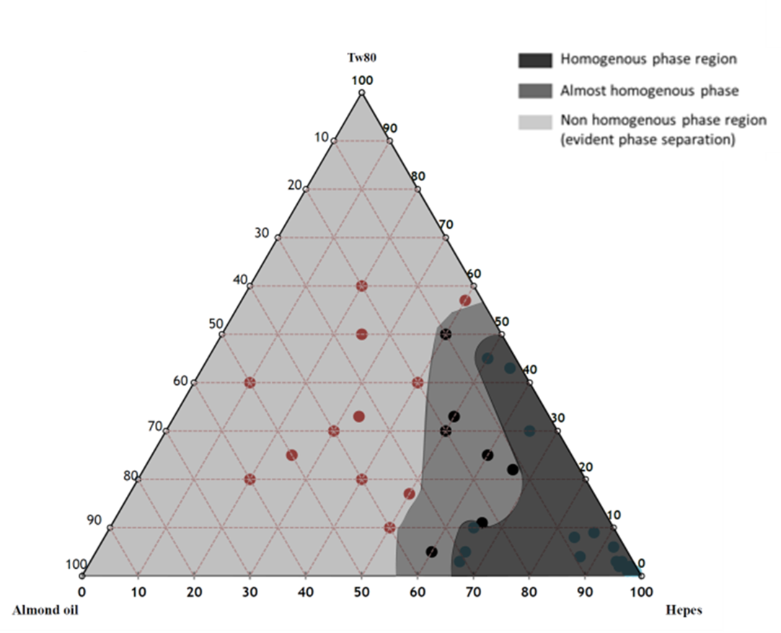

Figure 2S. Pseudo-ternary phase diagram of Almond Oil formulations

Table 2S. Tested Neem Oil formulations (in bold formulation in the homogeneous region, Figure 3S)
Sample | Neem Oil  (g) | Tw80  (g) | Hepes  (g) | Neem oil  (% w/w) | Tw80  (% w/w) | Hepes  (% w/w)
N1 | 0.098 | 0.147 | 5.000 | 2.00 | 3.00 | 95.00
N2 | 0.098 | 0.147 | 0.100 | 28.00 | 43.00 | 29.00
N3 | 0.098 | 0.147 | 0.150 | 25.00 | 37.00 | 38.00
N4 | 0.098 | 0.147 | 0.300 | 18.00 | 27.00 | 55.00
N5 | 0.098 | 0.147 | 0.500 | 13.20 | 19.80 | 67.00
N6 | 0.098 | 0.147 | 1.000 | 8.00 | 12.00 | 80.00
N7 | 0.098 | 0.147 | 2.000 | 4.40 | 6.60 | 89.00
N8 | 0.098 | 0.147 | 3.000 | 3.00 | 4.50 | 92.50
N9 | 0.098 | 0.147 | 4.000 | 2.30 | 3.50 | 94.20
N10 | 0.098 | 0.147 | 0.050 | 33.00 | 50.00 | 17.00
N11 | 0.098 | 0.147 | 10.000 | 1.00 | 1.50 | 97.50
N12 | 0.100 | 0.400 | 0.450 | 10.50 | 42.10 | 47.40
N13 | 0.100 | 0.400 | 1.000 | 7.00 | 27.00 | 66.00
N14 | 0.150 | 0.200 | 0.650 | 15.00 | 20.00 | 65.00
N15 | 0.100 | 0.070 | 3.500 | 2.80 | 1.90 | 95.30
N16 | 0.100 | 0.050 | 3.500 | 2.70 | 1.40 | 95.90
N17 | 0.200 | 0.150 | 0.650 | 20.00 | 15.00 | 65.00
N18 | 0.180 | 0.270 | 0.550 | 18.00 | 27.00 | 55.00
N19 | 0.200 | 0.100 | 2.000 | 8.70 | 4.30 | 87.00
N20 | 0.270 | 0.130 | 0.600 | 27.00 | 13.00 | 60.00
N21 | 0.400 | 0.100 | 0.500 | 40.00 | 10.00 | 50.00
N22 | 0.100 | 0.200 | 0.400 | 14.00 | 29.00 | 57.00
N23 | 0.150 | 0.100 | 0.250 | 30.00 | 20.00 | 50.00
N24 | 0.100 | 0.150 | 0.750 | 10.00 | 15.00 | 75.00
N25 | 0.050 | 0.150 | 0.800 | 5.00 | 15.00 | 80.00
N26 | 0.200 | 0.100 | 0.700 | 20.00 | 10.00 | 70.00
N27 | 0.300 | 0.050 | 0.650 | 30.00 | 5.00 | 65.00
N28 | 0.200 | 0.200 | 0.600 | 20.00 | 20.00 | 60.00
N29 | 0.050 | 0.250 | 0.700 | 5.00 | 25.00 | 70.00
N30 | 0.040 | 0.210 | 0.750 | 4.00 | 21.00 | 75.00
N31 | 0.200 | 0.140 | 0.660 | 20.00 | 14.00 | 66.00
N32 | 0.400 | 0.040 | 0.560 | 40.00 | 4.00 | 56.00
N33 | 0.400 | 0.040 | 0.360 | 50.00 | 5.00 | 45.00
N34 | 0.400 | 0.031 | 0.190 | 65.00 | 5.00 | 30.00
N35 | 0.050 | 0.150 | 0.800 | 5.00 | 15.00 | 80.00

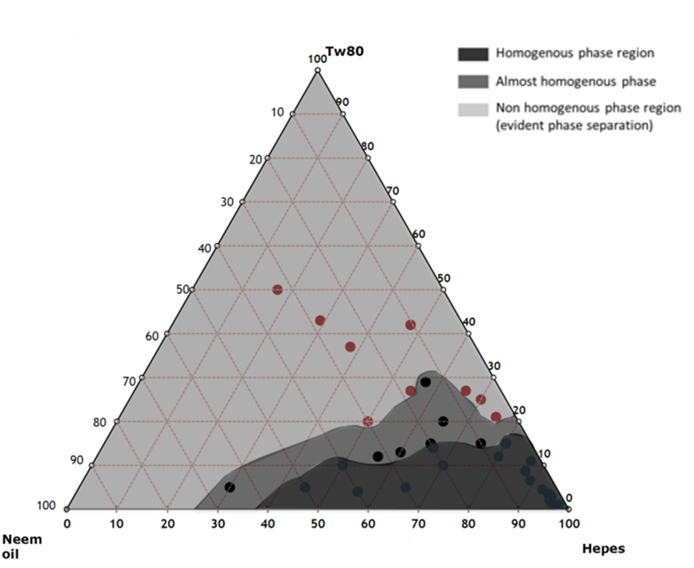
Figure 3S. Pseudo-ternary phase diagram of Neem Oil formulations

Table 3S. Sample features (in bold formulations tested in vitro and in vivo)

Sample | Hydrodynamic diameter (nm) ± SD | ζ-Potential (mV) ± SD | PDI
N | 808.80 ± 11.6 | -32.8 ± 1.0 | 0.3
N1 | 73.4 ± 7.6 | -16.2 ± 0.5 | 0.4
N1E | 174.2 ± 8.4 | -11.1 ± 0.2 | 0.2
N2 | 72.2 ± 9.5 | -14.6 ± 0.7 | 0.4
N2E | 165.6 ± 9.8 | -8.6 ± 0.4 | 0.3
A | 202.0 ± 10.8 | -17.0 ± 0.6 | 0.3
A1 | 114.1 ± 3.8 | -6.8 ± 0.2 | 0.4
A1E | 266.2 ± 7.1 | -10.1 ± 0.5 | 0.2
A2 | 97.3 ± 2.0 | -6.5 ± 1.1 | 0.4
A2E | 206.4 ± 1.9 | -5.7 ± 0.6 | 0.3

Figure 4S. In vitro release study.

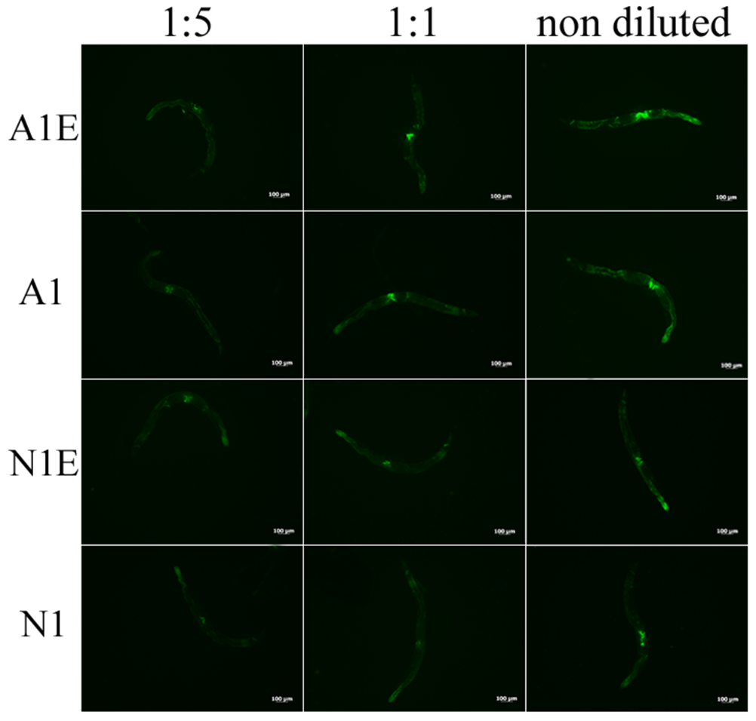

Figure 5S. Analysis of oxidative stress responses in transgenic sod-3::GFP nematodes. Fluorescence microscopy of sod-3::GFP worm strain at the stage of 13 day adult fed heat killed OP50 supplemented with A1E, A1, N1E and N1 nanoemulsions at different dilutions. Scale bar = 100 μm.

