Abstract: 231 words
Full text: 3,043 words
Tables: 2
Figures: 3
Supplementary tables: 1
Supplementary figures: 2

Alleviating excessive worries improves co-occurring depression and pain in adolescent and young adult cancer patients: a network approach

Running head: anxiety, depression and pain in cancer patients

Supplementary Table 1. Edge weight matrix
 | Pain | PHQ1 | PHQ2 | PHQ3 | PHQ4 | PHQ5 | PHQ6 | PHQ7 | PHQ8 | PHQ9 | GAD1 | GAD2 | GAD3 | GAD4 | GAD5 | GAD6 | GAD7
Pain | 0
PHQ1 | 0 | 0
PHQ2 | 0 | 0.2671 | 0
PHQ3 | 0.0326 | 0.0338 | 0 | 0
PHQ4 | 0.0114 | 0.1678 | 0.0649 | 0.2466 | 0
PHQ5 | 0 | 0.1282 | 0.033 | 0 | 0.1901 | 0
PHQ6 | 0.0894 | 0 | 0.1789 | 0 | 0.0574 | 0 | 0
PHQ7 | 0 | 0.0789 | 0.0838 | 0.1005 | 0.0145 | 0 | 0 | 0
PHQ8 | 0.0452 | 0 | 0.125 | 0 | 0.1243 | 0.0113 | 0.1248 | 0.0228 | 0
PHQ9 | 0 | 0 | 0.0637 | 0.031 | 0 | 0 | 0.097 | 0.0699 | 0.167 | 0
GAD1 | 0.0123 | 0.0611 | 0.065 | 0 | 0 | 0.0112 | 0.0877 | 0 | 0.0172 | 0 | 0
GAD2 | 0 | 0.151 | 0.096 | 0.0768 | 0.0095 | 0.1548 | 0.0163 | 0 | 0.0521 | 0.0885 | 0.2676 | 0
GAD3 | 0 | 0 | 0 | 0 | 0.0142 | 0.0721 | 0.0021 | 0 | 0.0098 | 0.0156 | 0.0772 | 0.1227 | 0
GAD4 | 0 | 0 | 0 | 0 | 0 | 0.0791 | 0.0815 | 0 | 0 | 0.0912 | 0.125 | 0.0519 | 0.3031 | 0
GAD5 | 0.0576 | 0 | 0.0618 | 0 | 0 | 0.0128 | 0.0636 | 0.1784 | 0.0013 | 0.038 | 0.1449 | 0 | 0.0359 | 0.2623 | 0
GAD6 | 0 | 0 | 0.0337 | 0.0827 | 0.071 | 0.012 | 0.0074 | 0 | 0.1212 | 0 | 0.1241 | 0.0488 | 0.0971 | 0.188 | 0.0783 | 0
GAD7 | 0 | 0 | 0.0708 | 0.0346 | 0 | 0 | 0.1965 | 0.0175 | 0.0068 | 0.0563 | 0 | 0.0288 | 0.183 | 0 | 0.1144 | 0.1032 | 0
Note: GAD: General Anxiety Disorder Questionnaire; PHQ: Patient Health Questionnaire;

Supplementary Figure 1. Stability of centrality indices
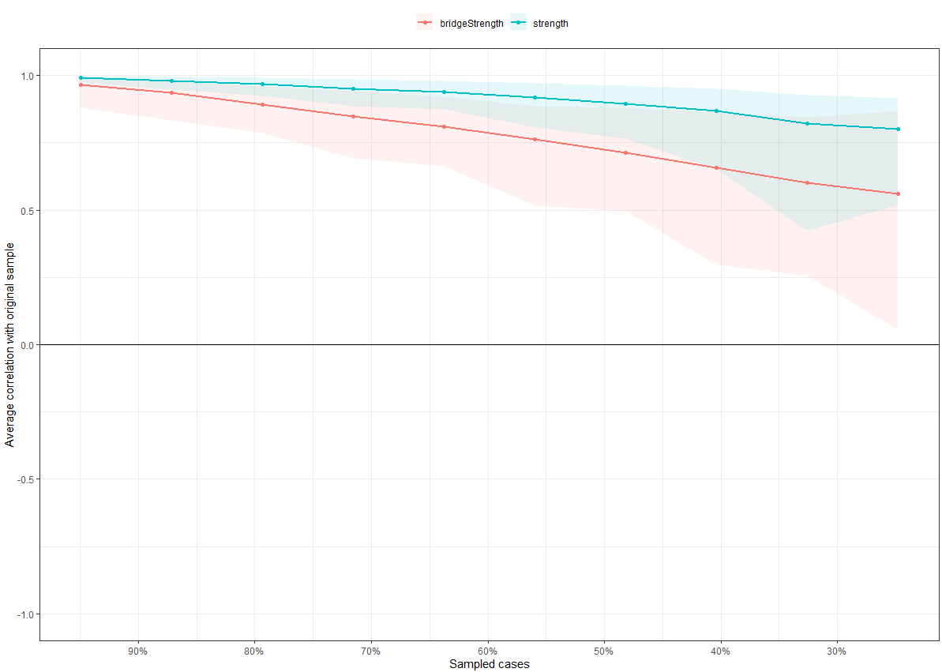

Note: The X-axis represents the proportion of sampled case at each step, while the Y-axis represents the mean correlations between the original indices and the subset indices. Colorful areas represent 95% CI.
Supplementary Figure 2. Bootstrapped 95%CIs of estimated edge weights
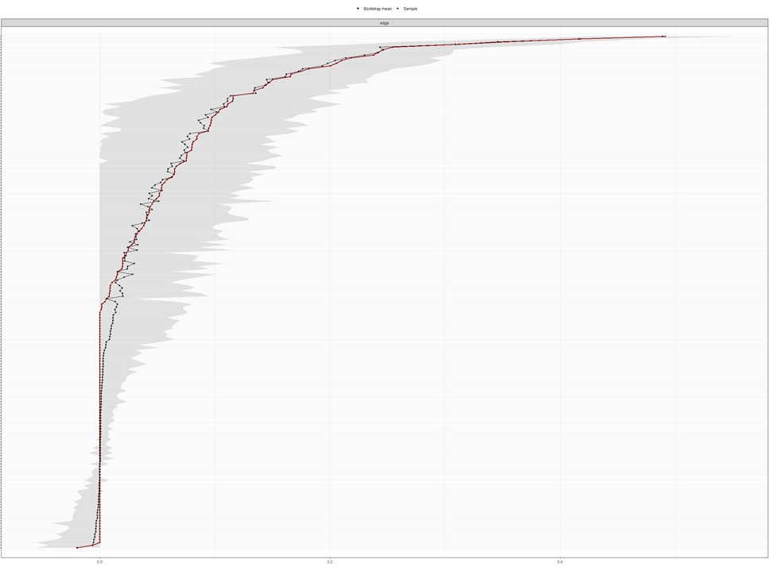

Note: The red dots indicate the values of each edge weight, ordered from the highest to the lowest edge-weight values. The gray area represents the 95% CIs of edge weights, estimated with the non-parametric bootstrap procedure. Wide intervals indicate lower stability and narrow intervals indicate higher stability.

