Supplementary Data

Supplementary Figure 1: Conference Itinerary

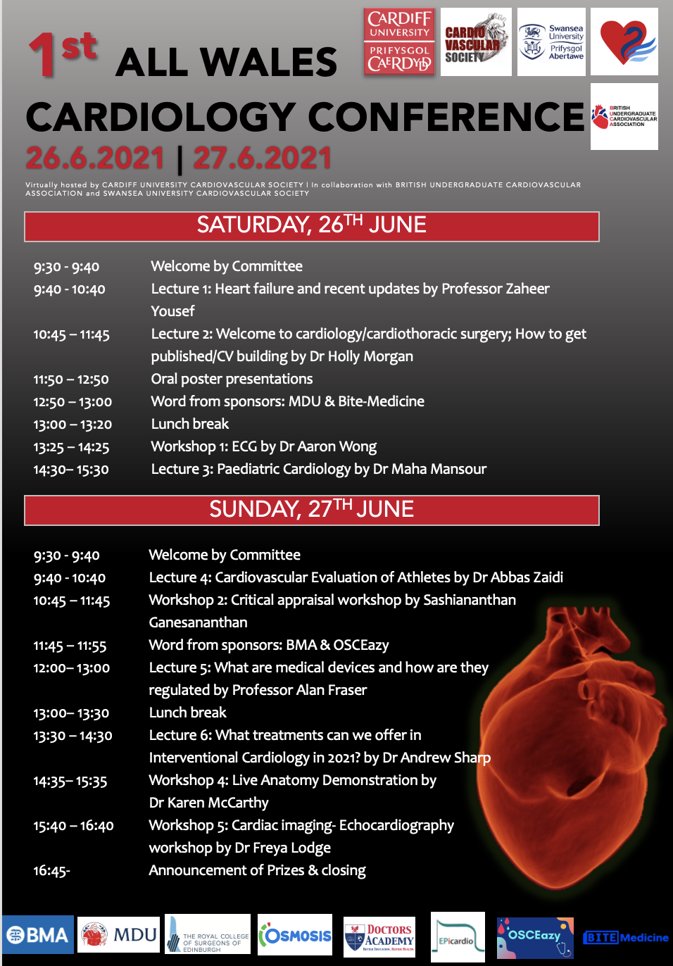
Supplementary Figure 2: Questionnaire

Undergraduate Cardiology Conference
Please fill in our feedback form so that we can evaluate and make appropriate changes onto future online conferences and event.

- Gender
- Male
- Female
- Non-binary
- Prefer not to say

- Age ………………

- Country of Medical School

- Afghanistan
- Akrotiri
- Albania
- Algeria
- American Samoa
- Andorra
- Angola
- Anguilla
- Antarctica
- Antigua and Barbuda
- Argentina
- Armenia
- Aruba
- Ashmore and Cartier Islands
- Australia
- Austria
- Azerbaijan
- Bahamas
- Bahrain
- Bangladesh
- Barbados
- Bassas da India
- Belarus
- Belgium
- Belize
- Benin
- Bermuda
- Bhutan
- Bolivia
- Bosnia and Herzegovina
- Botswana
- Bouvet island
- Brazil
- British Indian Ocean Territory
- British Virgin Islands
- Brunei
- Bulgaria
- Burkina Faso
- Burma
- Burundi
- Cambodia
- Cameroon
- Canada
- Cape Verde
- Cayman Islands
- Central African Republic
- Chad
- Chile
- China
- Christmas Island
- Clipperton Island
- Cocos (Keeling) Islands
- Colombia
- Comoros
- Congo, Democratic Republic of the
- Congo, Republic of the
- Cook Islands
- Coral Sea Islands
- Costa Rica
- Cote d’lvoire
- Croatia
- Cuba
- Cyprus
- Czech Republic
- Denmark
- Dhekelia
- Djibouti
- Dominica
- Dominican Republic
- Ecuador
- Egypt
- El Salvador
- Equatorial Guinea
- Eritrea
- Estonia
- Ethiopia
- Europa Island
- Falkland Islands (Islas Malvinas)
- Faroe Islands
- Fiji
- Finland
- France
- French Guiana
- French Polynesia
- French Southern and Antarctic Lands
- Gabon
- Gambia
- Gaza Strip
- Georgia
- Germany
- Ghana
- Gibraltar
- Glorioso Islands
- Greece
- Greenland
- Grenada
- Guadeloupe
- Guam
- Guatemala
- Guernsey
- Guinea
- Ginea-Bissau
- Guyana
- Haiti
- Heard Island and McDonald Islands
- Holy See (Vatican City)
- Honduras
- Hong Kong
- Hungary
- Iceland
- India
- Indonesia
- Iran
- Iraq
- Ireland
- Isle of Man
- Israel
- Italy
- Jamaica
- Jan Mayen
- Japan
- Jersey
- Jordan
- Juan de Nova Island
- Kazakhstan
- Kenya
- Kiribati
- Korea, North
- Korea, South
- Kuwait
- Kyrgyzstan
- Laos
- Latvia
- Lebanon
- Lesotho
- Liberia
- Libya
- Liechtenstein
- Lithuania
- Luxembourg
- Macau
- Macedonia
- Madagascar
- Malawi
- Malaysia
- Maldives
- Mali
- Malta
- Marshall Islands
- Martinique
- Mauritania
- Mauritius
- Mayotte
- Mexico
- Micronesia, Federated States of
- Moldova
- Monaco
- Mongolia
- Montenegro
- Montserrat
- Morocco
- Mozambique
- Namibia
- Nauru
- Navassa Island
- Nepal
- Netherlands
- Netherlands Antilles
- New Caledonia
- New Zealand
- Nicaragua
- Niger
- Nigeria
- Niue
- Norfolk Island
- Northern Mariana Islands
- Norway
- Oman
- Pakistan
- Palau
- Panama
- Papua New Guinea
- Paracel Islands
- Paraguay
- Peru
- Philippines
- Pitcairn Islands
- Poland
- Portugal
- Puerto Rico
- Qatar
- Reunion
- Romania
- Russia
- Rwanda
- Saint Helena
- Saint Kitts and Nevis
- Saint Lucia
- Saint Pierre and Miquelon
- Saint Vincent and the Grenadines
- Samoa
- San Marino
- Sao Tome and Principe
- Saudi Arabia
- Senegal
- Serbia
- Seychelles
- Sierra Leone
- Singapore
- Slovakia
- Slovania
- Solomon Islands
- Somalia
- South Africa
- South Georgia and the South Sandwich Islands
- Spain
- Spratly Islands
- Sri Lanka
- Sudan
- Suriname
- Svalbard
- Swaziland
- Sweden
- Switzerland
- Syria
- Taiwan
- Tajikistan
- Tanzania
- Thailand
- Timor-Leste
- Togo
- Tokelau
- Tonga
- Trinidad and Tobago
- Tromelin Island
- Tunisia
- Turkey
- Turkmenistan
- Turks and Caicos Islands
- Tuvalu
- Uganda
- Ukraine
- United Arab Emirates
- United Kingdom
- United states
- Uruguay
- Uzbekistan
- Vanuatu
- Venezuela
- Vietnam
- Virgin Islands
- Wake Island
- Wallis and Futuna
- West Bank
- Western Sahara
- Yemen
- Zambia
- Zimbabwe

- Which medical School do you study at? If you are from an non-UK medical school, please write it down in “other”.
- University of Aberdeen School of Medicine
- Anglia Ruskin University School of Medicine
- Aston University Medical School
- Barts and The London School of Medicine and Dentistry
- University of Birmingham College of Medical and Dental Sciences
- Brighton and Sussex Medical School
- University of Bristol Medical School
- University of Buckingham Medical School
- University of Cambridge School of Clinical Medicine
- Cardiff University School of Medicine
- University of Dundee School of Medicine
- Edge Hill University Medical School
- The University of Edinburgh Medical School
- University of Exeter Medical School
- University of Glasgow School of Medicine
- Hull York Medical School
- Imperial College London Faculty of Medicine
- Keele University School of Medicine
- Kent and Medway Medical School
- King’s College London GKT School of Medical Education
- Lancaster University Medical School
- University of Leeds School of Medicine
- University of Leicester Medical School
- University of Liverpool School of Medicine
- London School of Hygiene & Tropical Medicine
- University of Manchester Medical School
- Newcastle University School of Medical Education
- Norwich Medical School
- University of Nottingham School of Medicine
- University of Nottingham-Lincoln Medical School
- University of Oxford Medical Sciences Division
- Plymouth University Peninsula Schools of Medicine and Dentistry
- Queen’s University Belfast School of Medicine
- University of Sheffield Medical School
- University of Southampton School of Medicine
- University of St Andrews School of Medicine
- St George’s, University of London
- University of Sunderland School of Medicine
- Swansea University Medical School
- University of Central Lancashire School of Medicine
- University College London Medical School
- University of Warwick Medical School
- Other:………..

- Have you taken an additional degree?
- BSc
- BmedSci
- MSc
- Mres
- MD
- PhD/Dphil
- BDS
- I do not have an additional degree

- Are you interested in pursuing cardiology in the future?
 | 1 | 2 | 3 | 4 | 5 | 6 | 7 | 8 | 9 | 10
Not interested at all |  |  |  |  |  |  |  |  |  |  | Extremely interested

- Have you ever attended a conference in-person?
- Yes, a cardiology conference +/- other speciality Conferences
- Yes, other (not cardiology) speciality conferences
- Never

- Have you ever attended a virtual conference?
- Yes
- No

- How did you hear about the conference?
- Facebook
- Twitter
- Instagram
- Mailaing list from the society
- Word of mouth
- Other:…………

- To what extent do you agree/disagree with the following statement. “Webinar conferences offer flexibility and convenience eg. not having to spend time and money travelling”
 | 1 | 2 | 3 | 4 | 5
Strongly Disagree |  |  |  |  |  | Strongly Agree

- What type of conferences do you prefer?
- In-person conference
- Virtual conference
- Hybrid conference

- To what extent has the conference improved/increased your knowledge/skill/interest in the following (0 – not at all, 5 – significantly improved/increased)

 | 0 (Not at all) | 1 |  | 2 |  |  | 3 |  | 4 |  | 5 (Very much so)
Interest in cardiology
Likelihood to apply for cardiology

Knowledge about a career in cardiology

Core cardiology Knowledge
Critical analysis skills
Basic echocardiography skills

- Did anything about the virtual conference make it more or less appealing than a traditional conference?
 | More | Less | Unsure | Equal
Opportunity to present

Comfort to present

Appropriate level for me

Student led/organised

Duration of event

Cost

Travel time

Environment/sustainable

Conference surroundings (i.e. your current location and surroundings)

Networking opportunities

Partners/ sponsors

Weekend conference

Learning from other delegates

- Did you enjoy the conference?
 | 1 | 2 | 3 | 4 | 5
Not at all |  |  |  |  |  | Very much so

- How likely are you to recommend this conference to another peer?
 | 1 | 2 | 3 | 4 | 5
Not at all |  |  |  |  |  | Very much so

- How easy was it to use the platform? (Zoom)
 | 1 | 2 | 3 | 4 | 5
Not easy at all |  |  |  |  |  | Very easy

- I find it easy to ask question in a virtual conference?
 | 1 | 2 | 3 | 4 | 5
Not easy at all |  |  |  |  |  | Very easy

- I find it easy to ask questions in an in person conference
 | 1 | 2 | 3 | 4 | 5
Not easy at all |  |  |  |  |  | Very easy

- Do you think virtual conferences has provided students with opportunities that COVID-19 would have otherwise affected?
- Yes
- No
- Maybe

- Any other comments, issues or suggestions regarding the conference (i.e would you have like other types of sessions? Please specify)
……………………………………………………………………………………………………………………………………………………………………………………………………………………………………………………………………………………………………………………………………………………………………………………………………………………………………………….

Supplementary Table 1: Country Data

Country of medical school | N (%)
Albania | 1 (0.2)
Antigua and Barbuda | 1 (0.2)
Armenia | 5 (1.0)
Australia | 3 (0.6)
Bangladesh | 7 (1.4)
Barbados | 1 (0.2)
Belarus | 1 (0.2)
Belgium | 2 (0.4)
Bosnia and Herzegovina | 1 (0.2)
Brazil | 3 (0.6)
Bulgaria | 23 (4.7)
Burma | 9 (1.8)
Cambodia | 31 (6.3)
China | 15 (3.1)
Croatia | 1 (0.2)
Cyprus | 2 (0.4)
Czech Republic | 1 (0.2)
Egypt | 10 (2.0)
Georgia | 17 (3.5)
India | 69 (14.1)
Indonesia | 1 (0.2)
Iraq | 7 (1.4)
Ireland | 1 (0.2)
Jordan | 4 (0.8)
Libya | 2 (0.4)
Macedonia | 6 (1.2)
Malaysia | 69 (14.1)
Malta | 4 (0.8)
Mauritius | 2 (0.4)
Mexico | 1 (0.2)
Morocco | 1 (0.2)
Nepal | 6 (1.2)
Nigeria | 1 (0.2)
Pakistan | 15 (3.1)
Peru | 2 (0.4)
Philippines | 26 (5.3)
Poland | 5 (1.0)
Romania | 21 (4.3)
Russia | 7 (1.4)
Serbia | 2 (0.4)
Singapore | 1 (0.2)
Slovakia | 1 (0.2)
South Africa | 1 (0.2)
Sri Lanka | 4 (0.8)
Sudan | 2 (0.4)
Sweden | 1 (0.2)
Taiwan | 1 (0.2)
Tunisia | 1 (0.2)
Turkey | 2 (0.4)
Ukraine | 18 (3.7)
United Kingdom | 63 (12.9)
United States | 2 (0.4)
Uzbekistan | 1 (0.2)
Vietnam | 5 (1.0)
Yemen | 1 (0.2)

Supplementary Figure 3



Supplementary Figure 3 shows the Word cloud analysis of participants' free text responses regarding any other comments, issues or suggestions regarding the conference

