Electronic Supplementary Material

A selective reduction of osteosarcoma by mitochondrial apoptosis using hydroxyapatite nanoparticles

Hongfeng Wu^{1,3}, Shuo Liu^{1,3}, Siyu Chen^{1,3}, Yuchen Hua^{1,3}, Xiangfeng Li^{1,3}, Qin Zeng^{2,3*}, Yong Zhou⁴, Xiao Yang^{1,3}, Xiangdong Zhu^{1,3*}, Chongqi Tu⁴, Xingdong Zhang^{1,2,3}

¹National Engineering Research Center for Biomaterials, Sichuan University, Chengdu, China, 610064
²NMPA Key Laboratory for Quality Research and Control of Tissue Regenerative Biomaterials & Institute of Regulatory Science for Medical Devices & NMPA Research Base of Regulatory Science for Medical Devices, Sichuan University, Chengdu, China, 610064
³College of Biomedical Engineering, Sichuan University, Chengdu, China, 610064
⁴Department of Orthopedics, West China Hospital, Sichuan University, Chengdu, China, 610041

*Corresponding authors: E-mail: qzeng8156@scu.edu.cn; zhu_xd1973@scu.edu.cn
National Engineering Research Center for Biomaterials, Sichuan University, NO. 29 Wangjiang Road, Chengdu, 610064, People’s Republic of China

Figure S1 Six HANPs with different morphologies and particle sizes were synthesized and characterized. Schematic diagram of the process to prepare the six HANPs (a). XRD patterns of the six HANPs (b). Representative TEM images of the six HANPs (c).

Figure S2 The cell viabilities of MC3T3-E1 cells after the cells were treated with six HANPs at the different concentration of 100, 200, 400 and 800 μg/mL for 1, 2 and 3 days (n=3; vs 0 μg/mL, *P<0.05, **P<0.01; vs 400 μg/mL, #P<0.05, ##P<0.01).

Figure S3 The typical Edu images (red) (a, c, e) and Edu incorporation rates (b, d, f) of MC3T3-E1 cells after the cells were treated with six HANPs at the concentration of 400 μg/mL for 1 (a, b), 2 (c, d) and 3 (e, f) days (n=3; vs Control, *P<0.05, **P<0.01).

Figure S4 HANPs at the concentration of 400 μg/mL selectively inhibited the growth of 143B and UMR106 cells, but not that of MC3T3-E1 cells. The typical CLSM images of 143B (a), UMR106 (b) and MC3T3-E1 (c) cells stained with FDA (green) and PI (red) after the cells were treated with six HANPs at the concentration of 400 μg/mL for 1, 2 and 3 days (n=3).

Figure S5 Endocytosis efficiency of HANPs into MC3T3-E1 cells. The representative flow cytometer histograms (a) and mean fluorescence intensity (b) of MC3T3-E1 cells after the cells treated with the six FITC-HANPs at the concentration of 400 μg/mL for 4 h (n=3, vs Control, **P<0.01).

Figure S6 The levels of intracellular Ca²⁺ and mitochrondiral membrane potentials in tumor cells or MC3T3-E1 cells. The relative Ca²⁺ fluorescence intensity of MC3T3-E1 cells after the cells treated with six HANPs at the concentration of 400 μg/mL for 1, 2 and 3 days (n=3, vs Control, *P<0.05, **P<0.01) (a). The Δψm fluorescence intensity ratio (Red/Green) of 143B (b), UMR106 (c) and MC3T3-E1 (d) cells after the cells were treated with six HANPs at a concentration of 400 μg/mL for 1, 2 and 3 days (n=3; for 143B cells: vs Control, *P<0.05, **P<0.01; for UMR106 cells: vs Control, *P<0.05, **P<0.01; vs N-HANPs-1, ⁺⁺P<0.01; vs N-HANPs-2, &&P<0.01). The representative CLSM images of 143B (e), UMR106 (f) and MC3T3-E1 (g) cells by staining JC-1 after the cells were treated with six HANPs at the concentration of 400 μg/mL for 1 and 3 days (n=3; after HANPs treatment, the corresponding red fluorescence (JC-1 aggregates) decreased, while the corresponding green fluorescence (JC-1 monomers) increased, indicating that mitochondrial depolarization occurred in tumor cells after HANPs treatment).

Figure S7 HANPs did not up-regulated the level of intracellular ROS in MC3T3-E1 cells. The relative ROS fluorescence intensity of MC3T3-E1 cells after the cells were treated with six HANPs at the concentration of 400 μg/mL for 1, 2 and 3 days (n=3; vs Control, **P<0.01).

Figure S8 HANPs induced apoptosis of 143B and UMR106 cells, not that of MC3T3-E1 cells. The typical CLSM images of 143B (a), UMR106 (b) and MC3T3-E1 (c) cells stained with nuclei (blue) after the cells were treated with six HANPs at the concentration of 400 μg/mL for 1, 2 and 3 days (n=3; white triangle: the nucleus shrinkage or fragmentation).

Figure S9 HANPs induced apoptosis of 143B and UMR106 cells. The density maps obtained by double-staining with Annexin V-FITC/PI of 143B (a) and UMR106 (b) cells after the cells treated with six HANPs at the concentration of 400 μg/mL for 1 and 3 days (n=3).

Figure S10 HANPs did not up-regulated the level of mitochondria-related gene expression in MC3T3-E1 cells. The mitochondria-related apoptotic gene expressions in MC3T3-E1 cells after the cells were treated with six HANPs at the concentration of 400 μg/mL for 1, 2 and 3 days (n=3; vs Control, *P<0.05, **P<0.01).

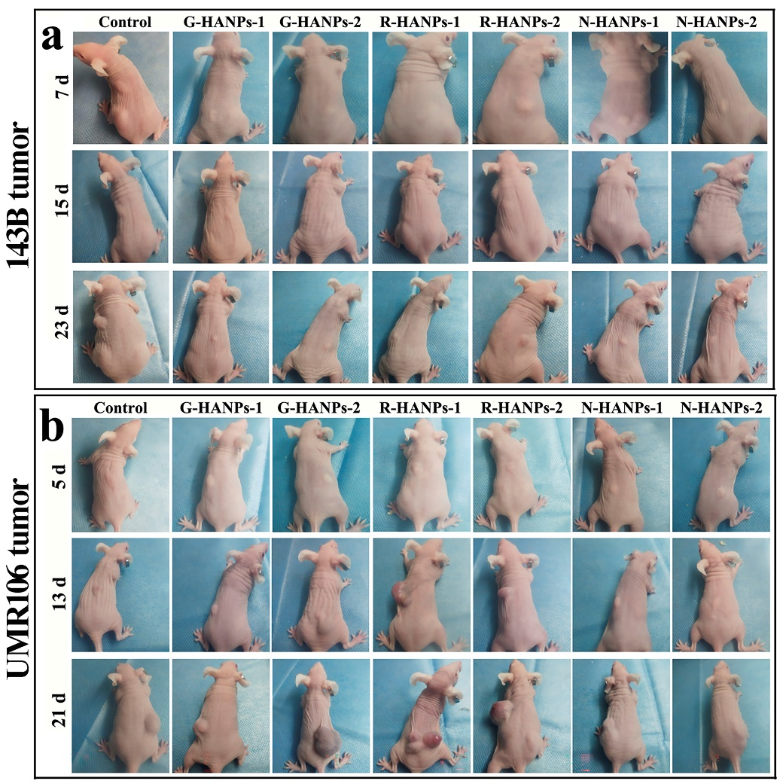
Figure S11 All the six HANPs inhibited the growth of 143B tumor tissues, while only N-HANPs inhibited the growth of UMR106 tumor tissues. Macroscopic observation for the formed of tumor tissue in 143B (a) and UMR106 (b) OS-bearing mice (n=5).

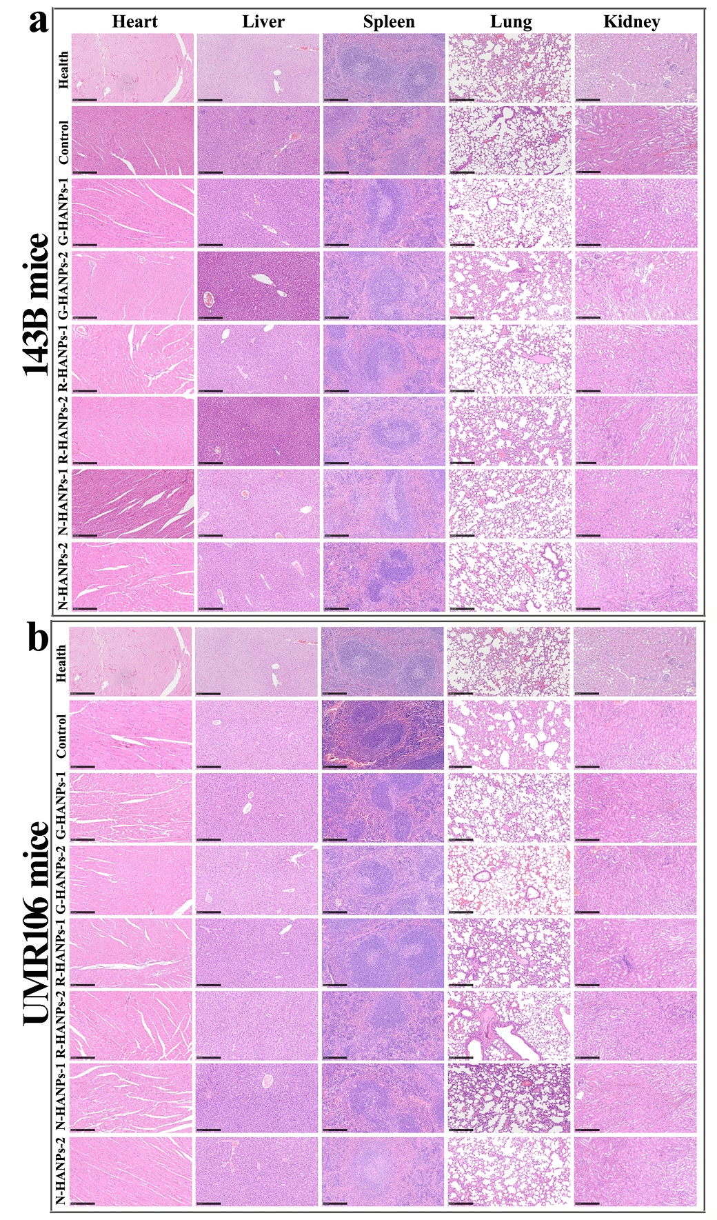
Figure S12 H&E staining of heart, liver, spleen, lung and kidney in 143B (a) and UMR106 (b) OS-bearing mice at day 28 and 21, respectively (scale bar: 250 μm).

Figure S13 The biochemical analysis of blood in 143B (a) and UMR106 (b) OS-bearing mice at day 28 and 21, respectively (n=5).

Table S1 The primer sequences for target genes
Gene | Primer (5′ to 3′)
Human-GAPDH | F: GCCAAGGCTGTGGGCAAGGT  R: AGGTGGAGGAGTGGGTGTCG
Human-Caspase-3 | F: ATAAGGAAAGCAATAAATGAATGG  R: CAGTGCGTATGGAGAAATGGG
Human-Caspase-8 | F: TTTTATTCAGGCTTGTCAGGG  R: CTGGCAAAGTGACTGGATGTA
Human-Caspase-9 | F: TGGTTCTGGAGGATTTGGTGA  R: CGACGCCGCAACTTCTCACA
Human-Bcl-2 | F: TGCGTCCTACAGATACCACAA  R: ATGATGCCGTCTTCAAACTCC
Human-Bax | F: GCCTCCTCTCCTACTTTGGG  R: AAAACACAGTCCAAGGCAGC
Human-p53 | F: TGTGCCTTGCCAGTGGGATTC  R: AGGATTTTCACGGGGTTGCCA
Rat-GAPDH | F: GAAGGTCGGTGTGAACGGAT  R: CCCATTTGATGTTAGCGGGAT
Rat-Caspase-3 | F: CGGACCTGTGGACCTGAAAA  R: TAACCGGGTGCGGTAGAGTA
Rat-Caspase-8 | F: GAGAGAAGCAGCCTATGCCAC  R: AGAGGGAGGAGAAAGGCAACT
Rat-Caspase-9 | F: CAAGAAGAGCGGTTCCTGGT  R: CAGAAACAGCATTGGCGACC
Rat-Bcl-2 | F: ACTCTTCAGGGATGGGGTGA  R: TGACATCTCCCTGTTGACGC
Rat-Bax | F: GCCTCCTTTCCTACTTCGGG  R: GGTTTATTGGCACCTCCCCC
Rat-p53 | F: CCCCTGAAGACTGGATAACTGT  R: CAACTCTGCAACATCCTGGG
Mouse-GAPDH | F: TATGTATGGGGAGAGCTGGG  R: CCCTCAGATGCCTGCTTCAC
Mouse-Caspase-3 | F: AGCAAGTCAGTGGACTCTGG  R: CATCCGTACCAGAGCGAGAT
Mouse-Caspase-8 | F: CAGGAGACCATCGAGGATGC  R: CCCACCGACTGATGTGGAAA
Mouse-Caspase-9 | F: CTAGTGAGCGAGCTGCAAGT  R: CCAGATCCTGCCTGCTGAATA
Mouse-Bcl-2 | F: AAGCAGACGTAGAAGTGGGC  R: ACATCTCAAGCCTTCACGCA
Mouse-Bax | F: CACTAAAGTGCCCGAGCTGA  R: GGTCCCGAAGTAGGAGAGGA
Mouse-p53 | F: TTCATTGGGACCATCCTGGC  R: GGCAGTCATCCAGTCTTCGG

Table S2 The effect of HANPs on blood routine parameters of 143B OS-bearing mice (n=5)
parameters | Control | G-HANPs-1 | G-HANPs-2 | R-HANPs-1 | R-HANPs-2 | N-HANPs-1 | N-HANPs-2
WBC (10⁹/L) | 2.28±1.01 | 1.77±0.55 | 1.98±0.68 | 1.42±0.33 | 2.20±0.59 | 1.60±1.07 | 2.03±0.94
Lymph (10⁹/L) | 1.91±0.66 | 1.54±0.30 | 1.40±0.46 | 1.00±0.21 | 1.70±0.56 | 1.32±0.89 | 1.40±0.60
Mon (10⁹/L) | 0.13±0.10 | 0.10±0.09 | 0.18±0.10 | 0.12±0.04 | 0.13±0.08 | 0.12±0.12 | 0.17±0.08
Gran (10⁹/L) | 0.48±0.42 | 0.28±0.10 | 0.40±0.14 | 0.28±0.12 | 0.37±0.18 | 0.28±0.15 | 0.47±0.26
Lymph (%) | 74.13±6.68 | 77.93±7.97 | 70.43±2.48 | 68.62±5.99 | 76.62±10.02 | 74.67±6.61 | 70.40±5.36
Gran (%) | 17.80±4.67 | 17.02±4.04 | 20.10±2.27 | 22.58±4.57 | 16.97±6.29 | 17.17±4.70 | 20.72±3.97
RBC (10¹²/L) | 8.64±0.37 | 7.64±0.57 | 7.98±0.55 | 8.24±0.51 | 8.01±0.60 | 7.77±0.84 | 7.91±0.96
HGB (g/L) | 131.00±9.40 | 117.40±6.73 | 133.00±5.34 | 129.00±9.54 | 128.67±8.80 | 123.33±13.13 | 127.00±4.97
HCT (%) | 40.86±2.63 | 36.63±1.79 | 40.00±3.16 | 40.14±3.42 | 39.98±2.47 | 39.00±3.74 | 39.57±1.00
MCV (fL) | 50.15±1.17 | 42.75±16.05 | 51.25±1.60 | 49.50±0.91 | 49.97±1.53 | 50.32±0.96 | 51.18±0.63
MCH (pg) | 16.06±0.28 | 16.33±0.40 | 16.20±0.26 | 15.95±0.21 | 16.00±0.20 | 16.10±0.30 | 16.15±0.19
MCHC (g/L) | 320.33±6.10 | 323.50±4.32 | 314.17±5.49 | 321.17±5.91 | 321.33±8.07 | 315.67±6.53 | 314.20±3.03
RDW (%) | 14.34±1.22 | 14.12±0.30 | 13.37±0.40 | 14.15±0.62 | 14.30±0.64 | 13.40±0.19 | 13.70±0.70
PLT (10⁹/L) | 1118.00±221.67 | 1117.83±200.03 | 1143.67±218.33 | 937.50±215.89 | 818.83±299.43 | 1006.80±225.09 | 952.00±288.72
MPV (fL) | 5.42±0.38 | 5.35±0.22 | 5.13±0.37 | 5.47±0.44 | 5.26±0.33 | 5.25±0.41 | 5.32±0.26
PDW | 16.62±0.49 | 16.78±0.34 | 16.75±0.44 | 16.82±0.45 | 16.80±0.53 | 16.53±0.38 | 16.85±0.47
PCT (%) | 0.55±0.08 | 0.60±0.10 | 0.55±0.06 | 0.41±0.19 | 0.43±0.14 | 0.44±0.20 | 0.47±0.12

Table S3 The effect of HANPs on blood routine parameters of UMR106 OS-bearing mice (n=5)
parameters | Control | G-HANPs-1 | G-HANPs-2 | R-HANPs-1 | R-HANPs-2 | N-HANPs-1 | N-HANPs-2
WBC (10⁹/L) | 1.40±0.87 | 1.34±1.18 | 1.40±0.17 | 1.67±0.31 | 1.87±0.45 | 1.90±0.82 | 2.07±0.81
Lymph (10⁹/L) | 1.80±0.00 | 1.60±0.10 | 1.20±0.26 | 1.30±0.30 | 1.47±0.47 | 1.30±0.60 | 1.43±0.32
Mon (10⁹/L) | 0.13±0.06 | 0.10±0.10 | 0.03±0.06 | 0.10±0.00 | 0.10±0.10 | 0.17±0.06 | 0.17±0.12
Gran (10⁹/L) | 0.27±0.12 | 0.30±0.17 | 0.17±0.06 | 0.27±0.06 | 0.30±0.10 | 0.43±0.21 | 0.47±0.38
Lymph (%) | 70.37±5.92 | 79.63±7.75 | 84.93±4.42 | 76.07±8.55 | 77.23±9.06 | 67.13±4.16 | 70.07±10.11
Gran (%) | 20.20±5.06 | 13.90±5.14 | 12.00±2.81 | 17.67±6.10 | 16.67±6.34 | 22.97±4.00 | 20.17±8.21
RBC (10¹²/L) | 8.84±0.71 | 8.29±0.42 | 7.60±0.97 | 6.96±0.81 | 7.71±0.33 | 8.35±0.54 | 7.39±0.17
HGB (g/L) | 136.50±0.71 | 135.00±8.48 | 133.00±5.57 | 123.50±0.71 | 127.00±7.07 | 133.67±9.29 | 122.67±5.69
HCT (%) | 41.60±0.71 | 42.10±2.12 | 41.35±1.91 | 36.95±2.47 | 40.40±1.56 | 41.60±3.54 | 39.07±0.86
MCV (fL) | 50.30±0.44 | 50.30±0.95 | 52.77±3.02 | 55.03±3.29 | 53.73±3.10 | 50.63±1.63 | 53.97±1.86
MCH (pg) | 17.03±1.53 | 16.83±1.02 | 16.63±1.04 | 17.43±1.03 | 16.47±0.11 | 15.93±0.15 | 16.77±0.81
MCHC (g/L) | 323.67±2.52 | 319.67±3.06 | 315.67±2.31 | 312.33±5.03 | 313.33±6.66 | 314.33±5.51 | 311.67±7.57
RDW (%) | 14.20±1.04 | 14.60±0.85 | 14.30±0.78 | 14.95±2.05 | 15.03±1.19 | 13.20±0.10 | 14.00±0.42
PLT (10⁹/L) | 773.67±160.85 | 750.00±254.98 | 717.33±77.20 | 586.00±13.45 | 886.33±347.63 | 699.67±231.36 | 712.33±185.41
MPV (fL) | 5.23±0.11 | 5.23±0.42 | 5.20±0.10 | 5.33±0.25 | 5.60±0.42 | 5.50±0.40 | 5.00±0.57
PDW | 17.90±1.04 | 17.20±0.98 | 16.73±0.06 | 17.93±0.29 | 17.47±0.71 | 17.13±0.40 | 17.10±0.75
PCT (%) | 0.28±0.23 | 0.35±0.18 | 0.37±0.05 | 0.34±0.05 | 0.25±0.08 | 0.39±0.16 | 0.38±0.07

