Supplemental Information
Perception and Satisfaction of Undergraduate Medical Students of the Mini Clinical Evaluation Exercise Implementation in Orthopedic Outpatient Setting
Abdulaziz Z Alomar
Department of Orthopaedic Surgery, College of Medicine, King Saud University, Riyadh, Kingdom of Saudi Arabia

Correspondence:
Abdulaziz Z Alomar, MBBS, MSc, FRCSC
Associate Professor of Orthopaedic Surgery
Head, Division of Arthroscopy & Sports Medicine
Department of Orthopaedic Surgery, College of Medicine, King Saud University, Riyadh, KSA
Phone No.: +966554655665
Mail Address: P.O. BOX 7805, Riyadh 11472
Email: dr_abdulaziz@yahoo.com
ORCiD: 0000-0001-5948-8221

Supplementary file 1: A sample mini-CEX assessment sheet used in our institute.

MINI-CLINICAL EVALUATION EXERCISE
(MINI-CEX)

Assessor’s Name
Student’s Name
Date

Patient Problem:
Patient | □ Age:__ | □ Sex:__ | □ New | □ Follow-up
Setting | □ Out-patient | □ In -patient | □ ED
Case Complexity | □ Low | □ Moderate | □ High
Focus of assessment | □ Data gathering | □ Diagnosis | □ Management | □ Counselling

Please assess the following competencies: |  | Unsatisfactory |  |  | Satisfactory |  |  | Superior
1. | Medical Interviewing Skills  □ Not observed or applicable | □ 1 | □ 2 | □ 3 | □ 4 | □ 5 | □ 6 | □ 7 | □ 8 | □ 9
2. | Physical Examination Skills  □ Not observed or applicable | □ 1 | □ 2 | □ 3 | □ 4 | □ 5 | □ 6 | □ 7 | □ 8 | □ 9
3. | Consideration for patient/ Humanistic qualities/ professionalism  □ Not observed or applicable | □ 1 | □ 2 | □ 3 | □ 4 | □ 5 | □ 6 | □ 7 | □ 8 | □ 9
4. | Clinical Judgement and Management Plan  □ Not observed or applicable | □ 1 | □ 2 | □ 3 | □ 4 | □ 5 | □ 6 | □ 7 | □ 8 | □ 9
5. | Counseling and Communication Skills  □ Not observed or applicable | □ 1 | □ 2 | □ 3 | □ 4 | □ 5 | □ 6 | □ 7 | □ 8 | □ 9
6. | Organization / Efficiency  □ Not observed or applicable | □ 1 | □ 2 | □ 3 | □ 4 | □ 5 | □ 6 | □ 7 | □ 8 | □ 9
7. | OVERALL CLINICAL COMPETENCE | □ 1 | □ 2 | □ 3 | □ 4 | □ 5 | □ 6 | □ 7 | □ 8 | □ 9

Comment: (Please you must justify each score of 1-3.)

Student’s signature:_____________________

Assessor’s signature:____________________

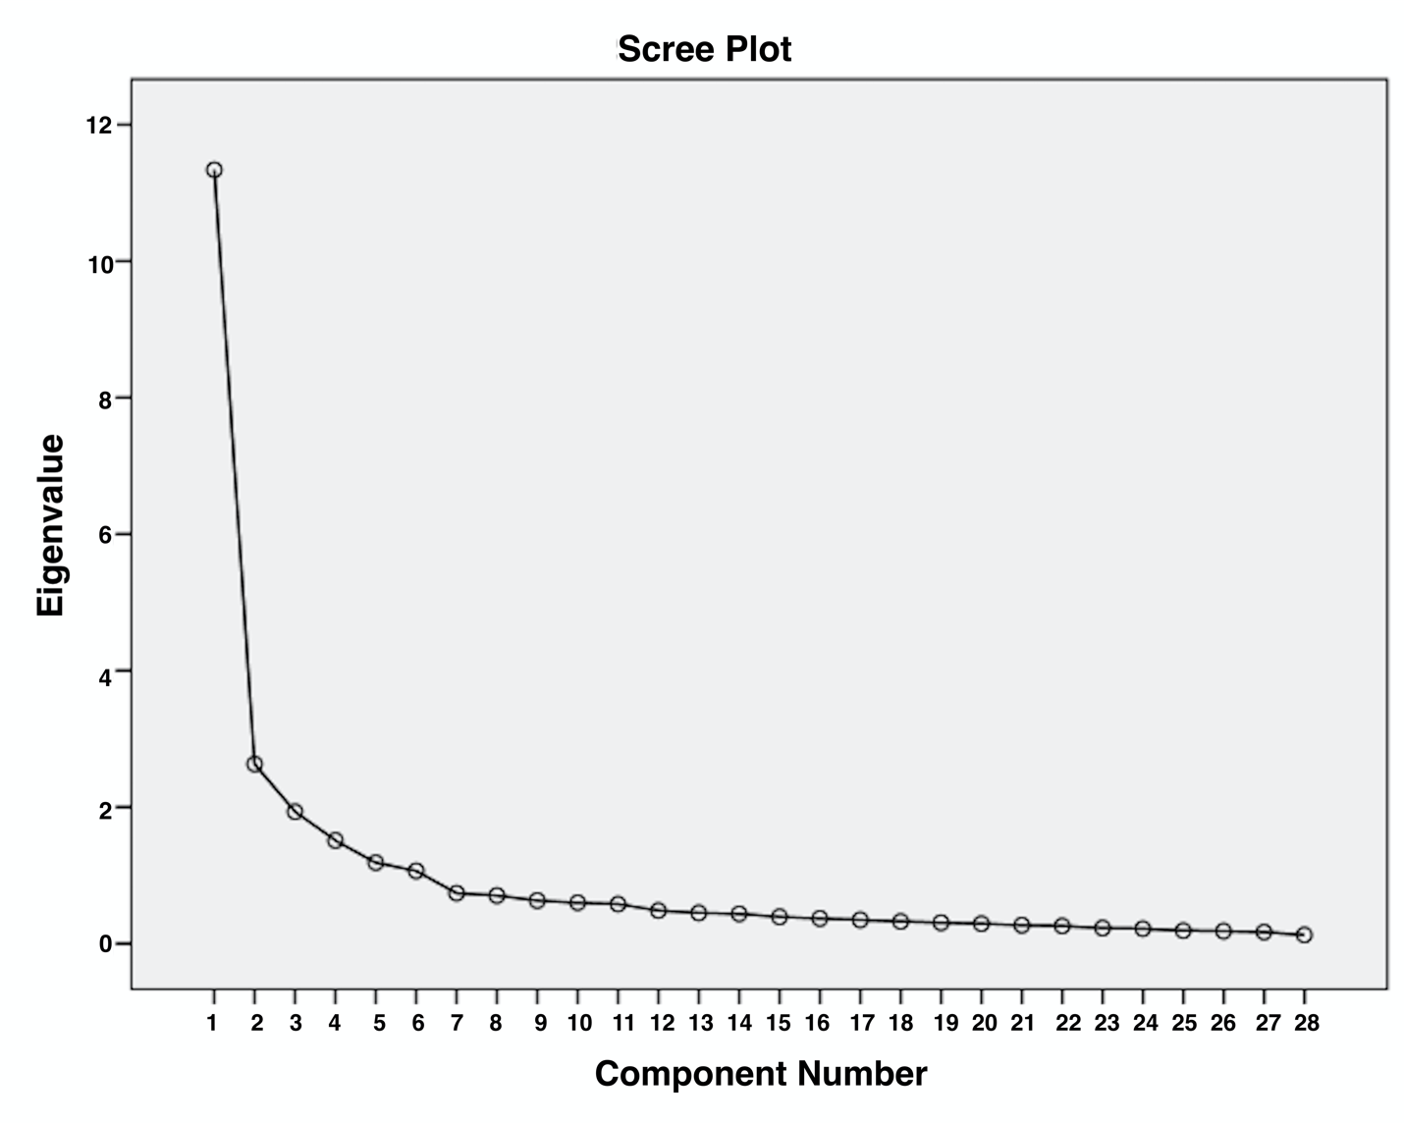

Supplementary file 2: Scree plot of the questionnaire for evaluation of the perception of orthopedic mini-CEX among undergraduate medical students.

Supplementary File 3: Extracted factors through principal component analysis with varimax rotation along with the loadings of all items.

Component | Factors
Component | Skills development | Teacher’s support | Basic understanding of the mini-CEX | Overall satisfaction | Professional development | Personality development
Were the details of mini-CEX methodology communicated to you prior to the assessment? |  |  | 0.85
Were the objectives of each mini-CEX encounter explained to you clearly? |  |  | 0.84
Were your queries regarding mini-CEX activities well addressed? |  |  | 0.72
Did mini-CEX contents cover all essential clinical skills? |  |  | 0.88
Mini-CEX evaluates a wide variety of clinical skills. |  |  | 0.80
Mini-CEX provides opportunity for constructive feedback. |  |  | 0.54
Did the teachers provide you constructive feedback? |  | 0.69
Were the teachers fully committed to the mini-CEX activities? |  | 0.76
Did teachers show interest in conducting mini-CEX? |  | 0.79
Did teachers explain the mini-CEX activities well? |  | 0.76
Did teachers help you during the mini-CEX activities? |  | 0.75
Did teachers directly observe you while doing the mini-CEX? |  | 0.68
Mini-CEX helps me communicate better with patients. | 0.78
Does mini-CEX help in improving your clinical judgment skills? | 0.72
Did the feedback help you in improving your overall clinical examination skills? | 0.80
Does mini-CEX Help in better preparation of clinical exams? | 0.75
Mini-CEX improves my performance in OSCE. | 0.73
How will you rate your overall satisfaction with mini-CEX based assessment? |  |  |  | 0.65
Do mini-CEX scores reflect your clinical performance appropriately? |  |  |  | 0.42
Do you think mini-CEX is effective for formative assessment? |  |  |  | 0.78
Do you feel that mini-CEX assessment is better than traditional clinical case presentation-based assessment? |  |  |  | 0.72
Do you think that the number of mini-CEX encounters should be increased? |  |  |  | 0.74
Has mini-CEX Improved your doctor-patient interviewing skills? |  |  |  |  | 0.76
Does mini-CEX make you confident in a real-life clinical scenario? |  |  |  |  | 0.72
Does mini-CEX help in your overall development as a clinician? |  |  |  |  | 0.66
Does mini-CEX help in development of counseling and communication skills? |  |  |  |  |  | 0.82
Does mini-CEX provide better organization of your patient evaluation skills? |  |  |  |  |  | 0.80
Does mini-CEX compel you to practice important skills more? |  |  |  |  |  | 0.53

