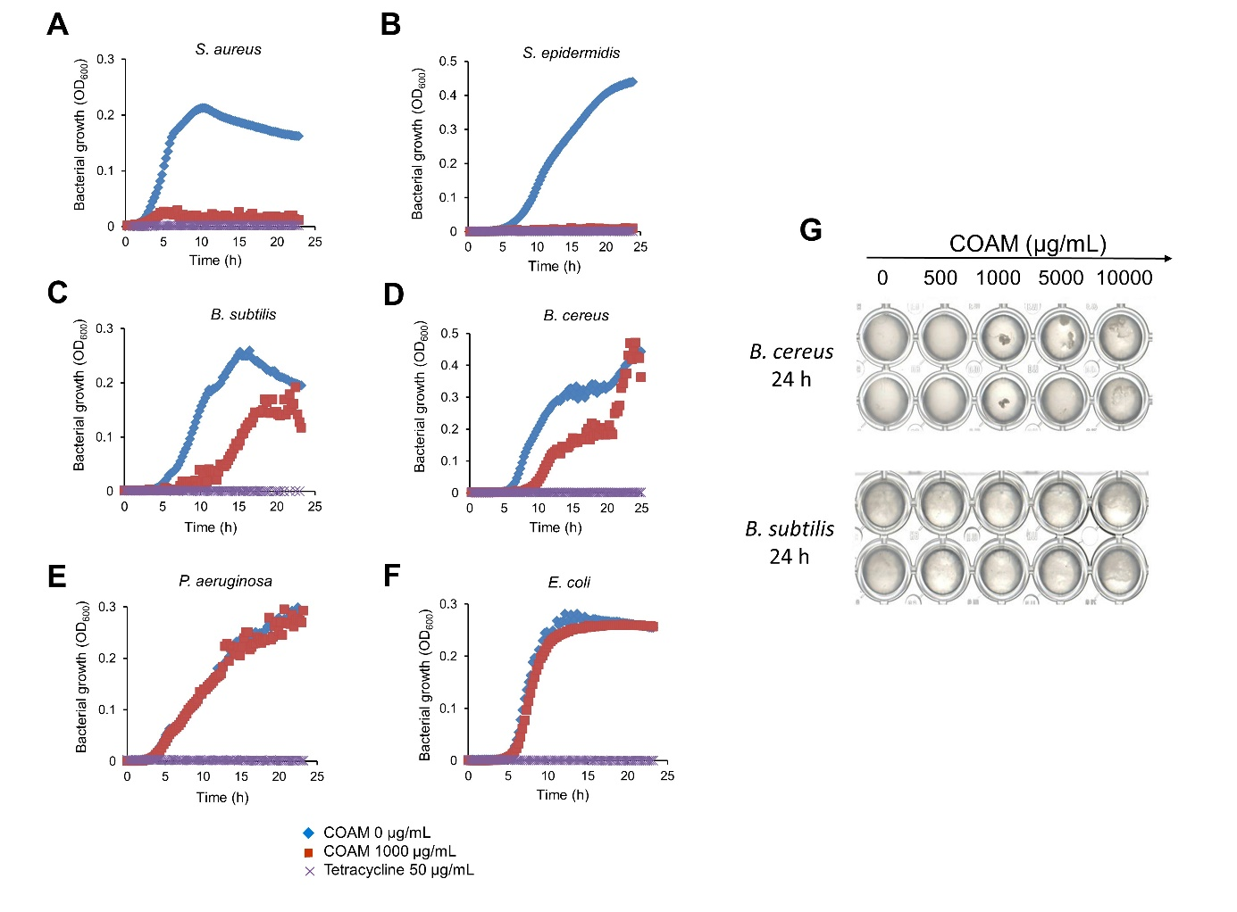
Supplementary Figure 1. Inhibition assay of bacterial growth to investigate antimicrobial activity of COAM. Growth of (A) S. aureus (ATCC 6538), (B) S. epidermidis (ATCC 12228), (C) B. subtilis (EEUT VIL), (D) B. cereus (ATCC 11778), (E) P. aeruginosa PAO1 (ATCC 15692) and (F) E. coli (EEUT EY) in MH broth. Blue lines represent the bacterial growth in the absence of inhibitor and treament (control), the red lines represent the bacterial growth in the presence of COAM (1000 µg/mL) and the purple lines represent the bacterial growth in the presence of tetracycline (50 µg/mL), used as an antibiotic control. (G) Aggregation of B. cereus and B. subtilis cells after 24 h of incubation with different concentrations of COAM.

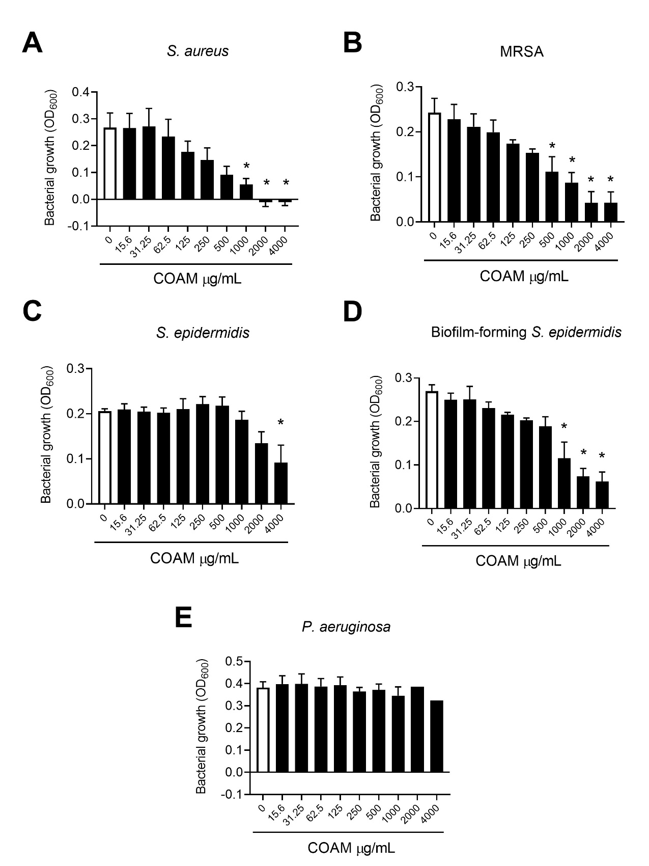Supplementary Figure 2. Antimicrobial activity of COAM. Growth of (A) S. aureus (ATCC 6538P), (B) MRSA (UZ Gasthuisberg collection), (C) S. epidermidis (ATCC 12228), (D) biofilm-forming S. epidermidis (ATCC 35984) and (E) P. aeruginosa (ATCC BAA-47) in LB broth incubated with increasing concentrations of COAM. 3 independent experiments performed in triplicates (n=3). Data are the mean ± SEM. *p < 0.05 vs control group without COAM.
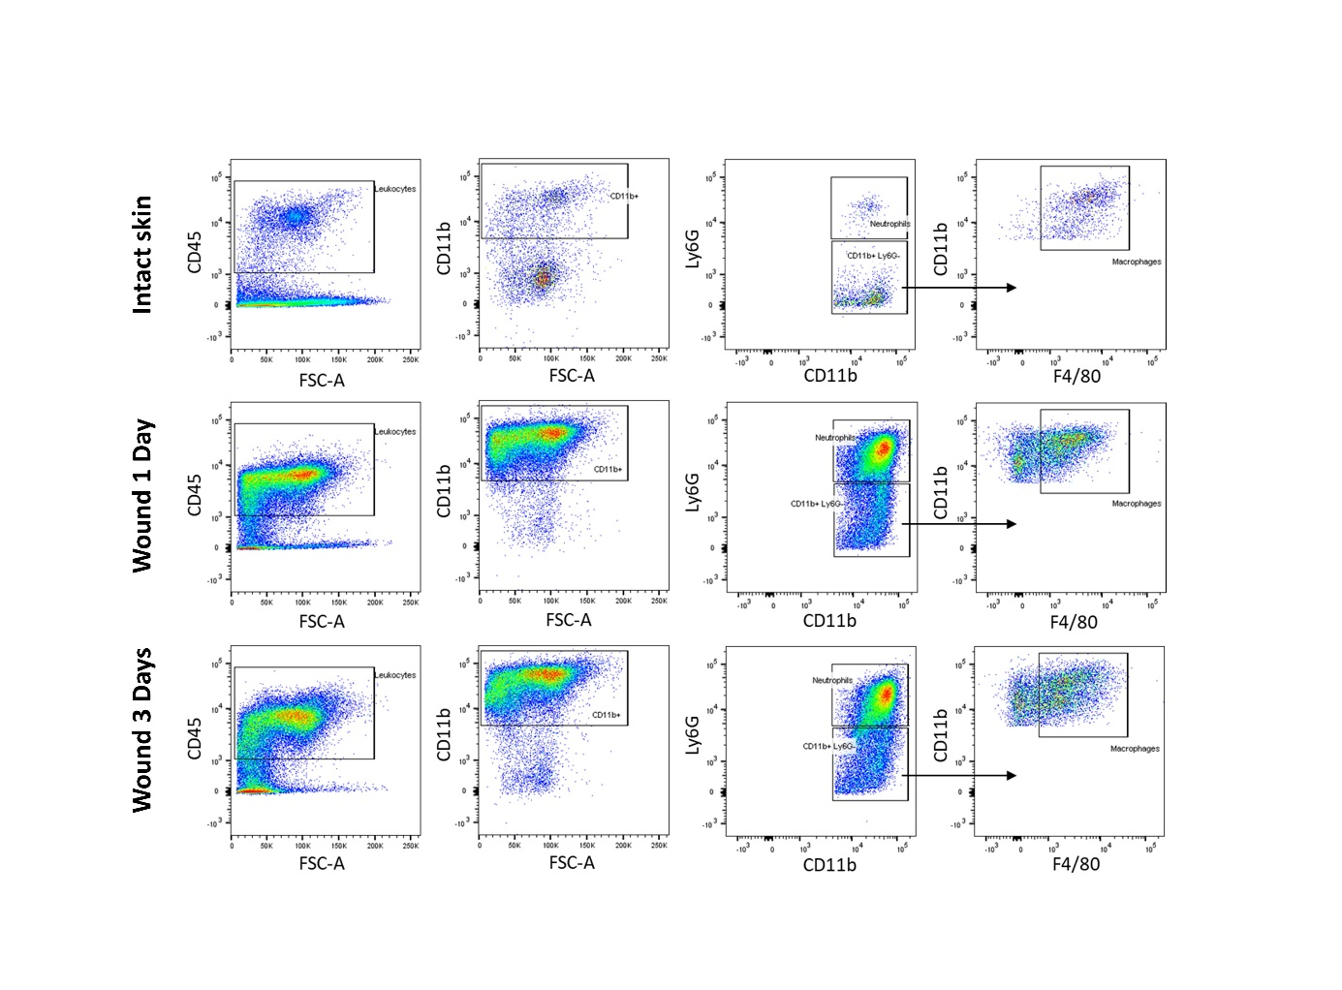
Supplementary Figure 3. Gating strategy for analysis of leukocyte influx into skin wounds. Skin wounds were harvested at day 1 and day 3 postinjury. Leukocyte infiltrations in the 2 mm rims of the full thickness wound edges were analyzed by flow cytometry. Gating strategy used to analyze leukocytes (CD45⁺), neutrophils (CD45⁺, CD11b⁺ and Ly6G⁺) and macrophages (CD45⁺, CD11b⁺, Ly6G⁻, F4/80⁺) after selection of single and live cells (not shown).

