Supporting information
An acid response IR780-based targeted nanoparticle for intraoperative near-infrared fluorescence imaging of ovarian cancer
Jiao Song*, Huixia Ye*, Senwei Jiang, Yuebo Yang, Xiaomao Li
Gynaecology Department, The Third Affiliated Hospital of Sun Yat-sen University, Guangzhou, 510630, P.R. China

Correspondence: Yuebo Yang
Gynaecology Department, The Third Affiliated Hospital of Sun Yat-sen University, Guangzhou, 510630, P.R. China;
Tel/Fax: 020-85252259
Email: yangyueb@mail.sysu.edu.cn

Correspondence: Xiaomao Li
Gynaecology Department, The Third Affiliated Hospital of Sun Yat-sen University, Guangzhou, 510630, P.R. China;
Tel/Fax: 020-85253289
Email: Lixmao@mail.sysu.edu.cn
*The two authors contributed equally to this work.

Methods
Synthesis of FA-IR780-PFOB-SNPs with different doses of PFOB
FA-IR780&PFOB-SNPs were generated by dissolving FA-PEG4000-PLGA10000, PLGA10000-PEOz, and IR780 at a weight ratio of 12mg:12mg: 2mg in 2 mL of dichloromethane in a tube. Then, different doses of PFOB (50μL, 100μL, 150μL, 200μL, 300μL, 400μL )were added to the mixture and emulsified in an ice-water bath with an ultrasonic probe (Sonics and Materials, Inc., USA) with an amplitude of 40% for 4 min (5 s on and 5 s off). Next, PVA solution (5 mL, 1% w/v) was added to the emulsion and emulsified in an ice-water bath with an amplitude of 40% for 4 min (5 s on and 5 s off). The final emulsion was stirred for 4 h with a magnetic stirrer (85-2A, Yuexin, Changzhou, China) to extract the dichloromethane. Next, FA-IR780&PFOB-SNPs were isolated from microsized NPs by differential centrifugation (Beckman Avanti J-26 XP, Beckman, USA) at 1000 rpm for 5 min and 10000 rpm for 10 min.

Results
We tried to add different doses of PFOB to the system. As shown in FigureS1, when adding PFOB of 50μL and 100μL, the nanoparticles precipitate after centrifugation was significantly lower than that of adding PFOB of 200μL; while adding PFOB of 400μL, it can be seen that there was transparent excess PFOB at the bottom of the collected nanoparticles. Our study used FA-IR780&PFOB-SNPs with an initial PFOB dosage of 200μL to perform the subsequent experiments.
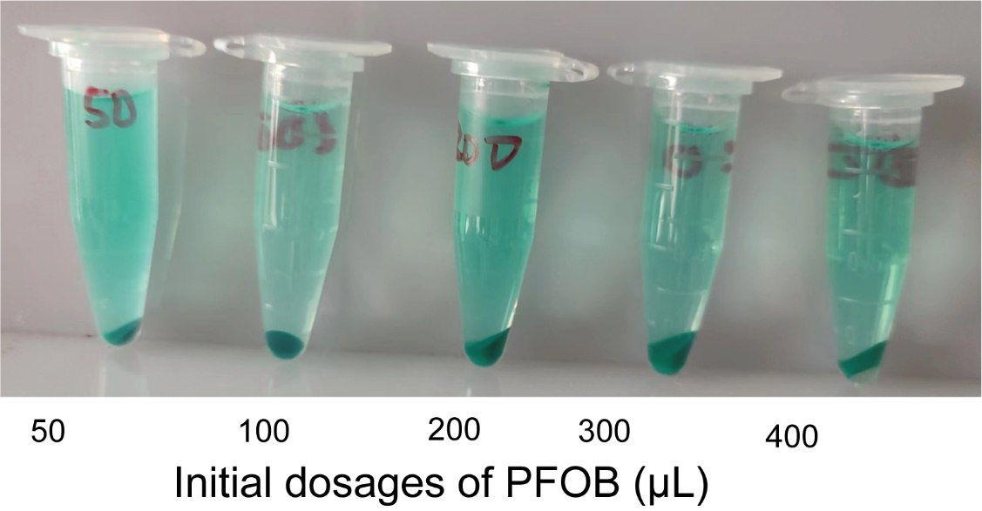
Figure S1 White light images of FA-IR780&PFOB-SNPs precipitate with different dosages of PFOB (50μL，100μL， 200μL，300μL，400μL).

Free IR780 exhibited an absorbance peak at 795nm(Figure S1A)，and the absorbance peak intensity increased linearly with increased concentrations(Figure S1B). The absorption spectra were scanned with a multifunctional microplate reader and exhibited an absorption peak at 795 nm (Figure 2C) which indicated the IR780 was successfully loaded into nanoparticles. According to the calibration curve（Y=0.0789x+0.0768） for IR780, the dye loading of IR780 was calculated to be approximately 3.46±0.03% when the initial IR780 dosage was 2 mg(Figure S1C). At the same time, it was also observed that the drug loading of IR780 was not significantly improved when the initial dosage was increased from 2 mg to 3 mg.

Figure S2 A) Absorbance spectra of IR780 at elevated concentrations in DMSO; B) Linear relationship between absorbance peak intensity and IR780 concentrations; C) Absorbance spectra of FA-IR780&PFOB-SNPs (450μg/mL) contain different dosage IR780 in DMSO (1mg, 2mg, 3mg) and Absorbance spectra of DMSO.

