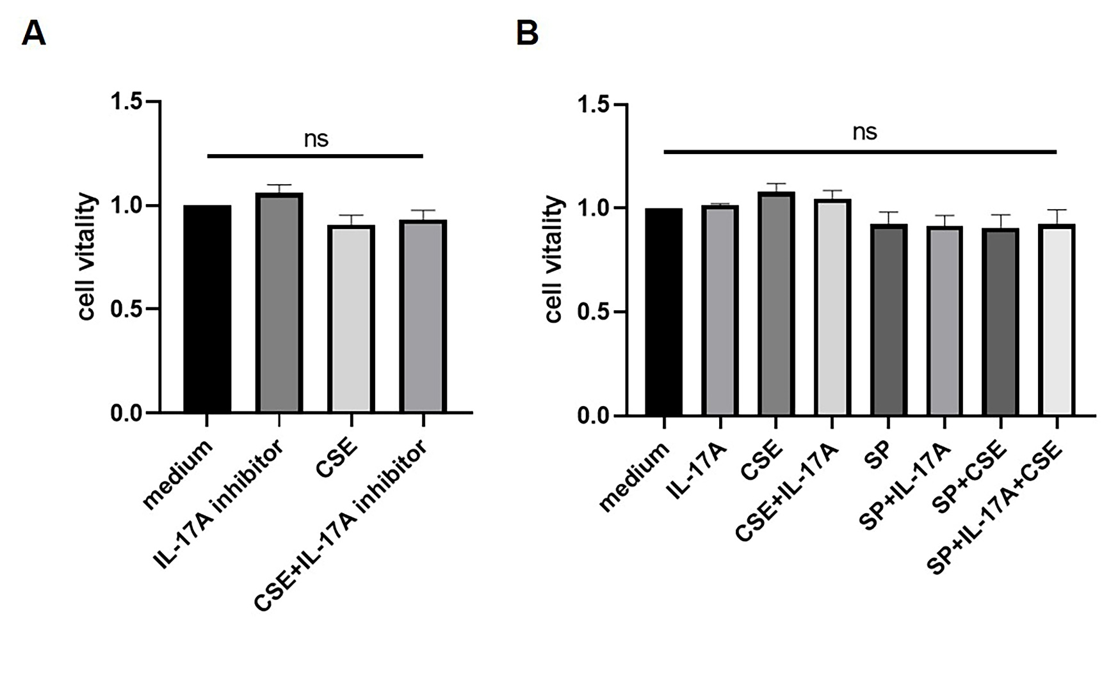
Figure S1: Cell cytotoxicity of different drugs to human bronchial epithelial (HBE) cells. (A) The cytotoxicity of IL-17A neutralizing antibody with or without cigarette smoker extract (CSE) to HBE cells was measured by CCK-8 assay (n = 3). (B) The cytotoxicity of SP600125(SP), IL-17A and CSE was tested in HBE cells. ns, no significant difference (n = 3).

