Table S1 The FASTQ output from tape stripping showed the mean number of raw reads of healthy control, normal skin and lesional skin of patients with psoriasis before and after NUVB treatment.
Group | raw reads |  | filtered reads
Group | mean | sd | mean | sd
Tape control | 54,044.33 | 10,446.73 | 39,249.33 | 7,546.81
Tape lesion after | 47,702.11 | 15,081.33 | 39,147.89 | 15,103.66
Tape lesion before | 54,548.14 | 21,007.81 | 46,039.43 | 20,714.25
Tape normal after | 115,165.22 | 204,333.39 | 86,682.00 | 154,158.36
Tape normal before | 89,185.79 | 156,614.47 | 67,755.21 | 117,677.75

Table S2 The FASTQ output from skin biopsy showed the mean number of raw reads of healthy control, normal skin and lesional skin of patients with psoriasis before and after NUVB treatment.
Group | raw reads |  | filtered reads
Group | mean | sd | mean | sd
Biopsy lesion after | 72,734.50 | 15,968.01 | 68,237.83 | 16,990.58
Biopsy lesion before | 79,126.27 | 16,952.26 | 75,695.55 | 16,242.44
Biopsy normal after | 76,362.60 | 11,613.31 | 71,795.40 | 11,302.70
Biopsy normal before | 86,665.73 | 40,165.59 | 83,587.00 | 39,443.80

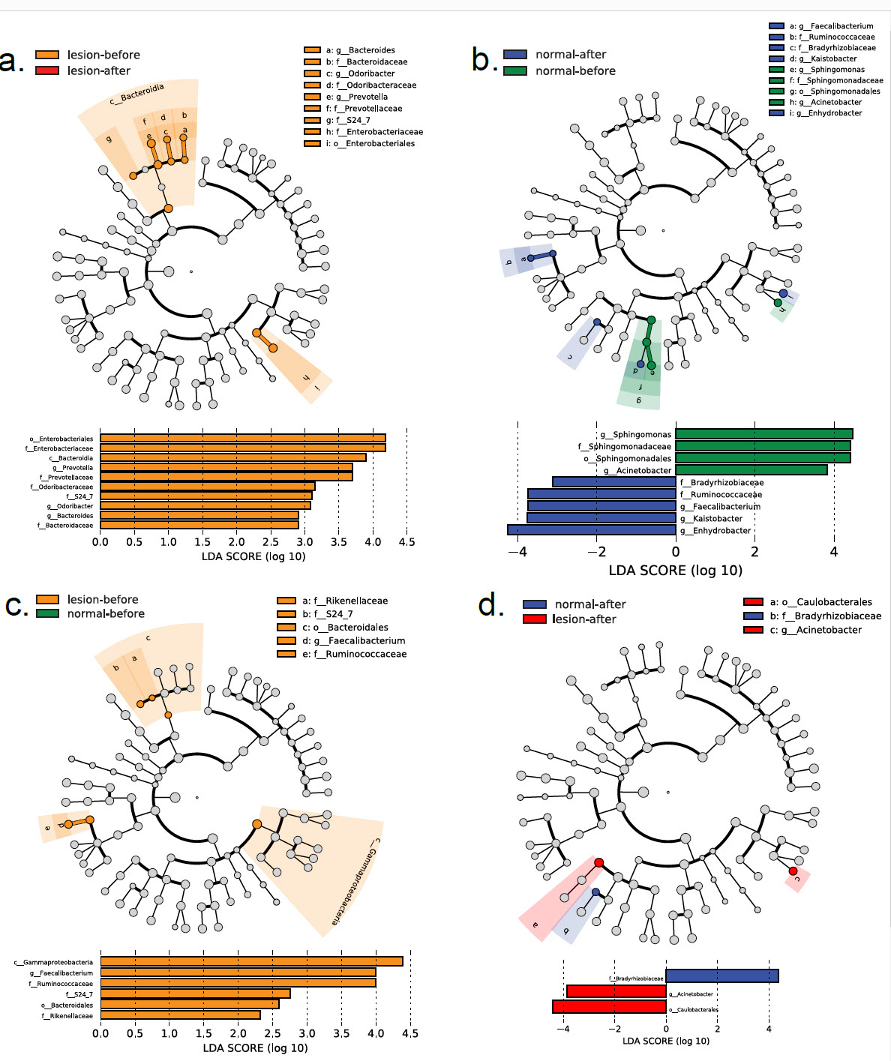
Figure S1. Plot of LEfSe analysis from skin biopsy indicating enriched bacterial classes among patients with psoriasis before and after NUVB treatment. Cladogram showing the differences in relative abundance. The length of the bar column represents the Linear Discriminant Analysis (LDA) score (a) between psoriasis lesional skin before (orange) and after NUVB treatment (red) (b) between psoriasis normal skin before (green) and after NUVB treatment (blue), (c) between psoriasis lesional skin before (orange) and psoriasis normal skin before treatment (green), and (d) between psoriasis normal skin (blue) and psoriasis lesional skin NUVB (red). (p < 0.05; LDA score 2.5).

Table S3. Relative abundance of microbiota from skin biopsy and tape stripping (a) phylum relative abundance from skin biopsy (b) genus relative abundance from skin biopsy (c) phylum relative abundance from tape stripping (d) genus relative abundancefrom tape stripping.
(a) phylum relative abundance from skin biopsy
Phylum | BLA |  | BLB |  | BNA |  | BNB
Phylum | Mean | SD | Mean | SD | Mean | SD | Mean | SD
Proteobacteria | 50.41267 | 18.75491 | 58.76238 | 11.34309 | 61.9289 | 9.598046 | 53.68404 | 9.026283
Actinobacteria | 16.24235 | 13.44271 | 12.11967 | 7.287763 | 11.47801 | 6.607536 | 15.23577 | 12.54272
Bacteroidetes | 14.27552 | 6.175031 | 16.48328 | 6.925551 | 22.01637 | 8.033659 | 21.29845 | 7.07019
Firmicutes | 13.12328 | 13.91184 | 12.04492 | 10.79045 | 4.481037 | 2.901429 | 9.144556 | 7.905291
Cyanobacteria | 5.533065 | 13.35349 | 0.546846 | 1.224307 | 0.056709 | 0.069379 | 0.482321 | 0.885869
Chloroflexi | 0.404676 | 0.99125 | 0.008218 | 0.018336 | 0.025366 | 0.042441 | 0.128768 | 0.265944
Deferribacteres | 0.00844 | 0.013402 | 0.034678 | 0.051635 | 0.013605 | 0.018973 | 0.026092 | 0.046985

(b) genus relative abundancefrom skin biopsy
Genus | BNB |  | BNA |  | BLB |  | BLA
Genus | mean | SD | mean | SD | mean | SD | mean | SD
Sediminibacterium | 18.98328 | 7.354567 | 21.79308 | 8.05613 | 13.81861 | 6.219823 | 13.38477 | 6.623507
order Rhizobiales | 13.93725 | 7.440009 | 20.42506 | 5.727237 | 14.59049 | 7.951405 | 11.73091 | 9.642848
Corynebacterium | 6.622855 | 5.031859 | 5.201848 | 6.244568 | 6.387907 | 4.957195 | 11.01667 | 13.59304
Staphylococcus | 5.895609 | 6.865708 | 2.932963 | 3.199936 | 3.957373 | 6.257517 | 10.84296 | 13.56023
Paracoccus | 2.462582 | 3.16426 | 7.312234 | 10.42692 | 5.538214 | 5.548306 | 7.848414 | 4.391211
Sphingomonas | 5.813009 | 5.684644 | 0.243657 | 0.531537 | 6.491308 | 6.812125 | 2.789492 | 3.565498
Bradyrhizobium | 3.123998 | 3.488059 | 4.21199 | 4.247882 | 4.809476 | 4.044993 | 3.485553 | 2.531939
Stenotrophomonas | 2.375307 | 2.670813 | 4.714129 | 5.420829 | 4.26467 | 4.50211 | 2.424039 | 2.581793
Enhydrobacter | 1.471074 | 2.478886 | 4.97328 | 2.551115 | 4.367406 | 6.702742 | 3.299662 | 5.922084
Achromobacter | 5.278064 | 6.338804 | 4.235567 | 4.665348 | 1.224489 | 1.929127 | 1.284901 | 1.998059
family Comamonadaceae | 4.843786 | 4.860589 | 2.157606 | 2.127036 | 1.995863 | 2.224961 | 1.889922 | 1.845995
Delftia | 1.305543 | 2.407869 | 4.904374 | 5.682038 | 2.337274 | 3.345886 | 2.943473 | 4.740067
Pseudomonas | 2.37818 | 2.433833 | 1.309951 | 0.863601 | 2.317232 | 4.144848 | 1.31253 | 1.959058
family Caulobacteraceae | 1.676266 | 2.089723 | 0.515341 | 1.038816 | 2.487411 | 2.49234 | 2.5786 | 2.667343
Propionibacterium | 4.157387 | 10.54882 | 0.498962 | 0.421169 | 0.749559 | 0.848382 | 0.494252 | 0.658533
others | 19.67581 | 8.62605 | 14.56995 | 9.499669 | 24.66271 | 8.852638 | 22.67387 | 19.8122
BNB- biopsy from psoriasis non-lesional skin before NUVB, BNA- biopsy from psoriasis non-lesional skin after NUVB, BLB- biopsy from psoriasis lesional skin before NUVB, BLA- biopsy from psoriasis lesional skin after NUVB.
(c) phylum relative abundance from tape stripping
Phylum | TC (n=9) | TNB (n=14) | TNA (n=9) | TLB (n=14) | TLA (n=9) | p-value
Actinobacteria | 38.27 ± 20.95 | 49.15 ± 16.08 | 46.11 ± 13.57 | 43.83 ± 18.79 | 41.16 ± 21.3 | 0.674
Proteobacteria | 45.66 ± 24.32 | 35.15 ± 14.69 | 35.89 ± 11.98 | 34.63 ± 17.65 | 37.51 ± 17.11 | 0.614
Firmicutes | 7.14 ± 5.57 | 8.73 ± 5.94 | 10.67 ± 7.2 | 13.64 ± 13.24 | 10.29 ± 10.04 | 0.508
Bacteroidetes | 6.32 ± 6.32 | 4.79 ± 4.2 | 4.69 ± 2.24 | 5.16 ± 4.84 | 6.99 ± 4.5 | 0.751
Cyanobacteria | 1.39 ± 1.37 | 0.35 ± 0.25 | 0.95 ± 1.25 | 0.9 ± 1.71 | 2.54 ± 5.93 | 0.411
others | 1.23 ± 1.09 | 1.83 ± 2.15 | 1.69 ± 1.17 | 1.84 ± 2 | 1.53 ± 0.98 | 0.914
ANOVA test. *p-value <0.05 by the Bonferroni post-hoc test
(d) genus relative abundancefrom tape stripping.
Bacterial taxa | TC (n=9) | TNB (n=14) | TNA (n=9) | TLB (n=14) | TLA (n=9) | p-value
Corynebacterium | 18.84 ± 15.55 | 27.96 ± 16.15 | 21.63 ± 11.22 | 25.16 ± 13.56 | 18.83 ± 11.24 | 0.446
Paracoccus | 6.65 ± 6.69 | 9.01 ± 9.73 | 6.82 ± 5.27 | 6.23 ± 6.28 | 4.91 ± 2.95 | 0.701
Kocuria | 1.47 ± 1.37 | 4.95 ± 6.56 | 9.81 ± 15.69 | 4.31 ± 6.95 | 11.45 ± 18.08 | 0.255
Enhydrobacter | 5.2 ± 3.85 | 5.5 ± 7.05 | 6.94 ± 5.51 | 6.12 ± 6.54 | 6.61 ± 7.37 | 0.971
Micrococcus | 4 ± 5.4 | 7.34 ± 7.95 | 4.45 ± 3.78 | 5.33 ± 5.79 | 3.51 ± 2.73 | 0.524
family Caulobacteraceae | 3.72 ± 3.17 | 3.39 ± 2.92 | 3.36 ± 2.93 | 4.81 ± 5.96 | 5.01 ± 5.82 | 0.844
Staphylococcus | 0.87 ± 1 | 3.2 ± 2.86 | 1.95 ± 3.46 | 6.73 ± 13.13 | 1.39 ± 1.37 | 0.264
Sediminibacterium | 2.98 ± 3.4 | 1.95 ± 1.82 | 1.83 ± 1.34 | 2.11 ± 2.52 | 3.27 ± 3.99 | 0.680
Propionibacterium | 6.38 ± 9.57^{b,c,d,e} | 0.63 ± 0.71^{b} | 2.14 ± 3.65^{c} | 1.58 ± 4.31^{d} | 0.4 ± 0.53e | 0.048*
family Neisseriaceae | 2.3 ± 3.72 | 2.36 ± 5.31 | 2.12 ± 3.87 | 2.18 ± 3.49 | 2.12 ± 4.56 | 1.000
Pseudomonas | 6.17 ± 13.83 | 0.9 ± 0.67 | 1.18 ± 1.18 | 0.76 ± 0.71 | 1.54 ± 1.67 | 0.187
Acinetobacter | 1.86 ± 1.85 | 2.48 ± 4.74 | 1.87 ± 1.5 | 2.27 ± 3.5 | 1.33 ± 1.51 | 0.933
Bradyrhizobium | 1.78 ± 1.83 | 1.68 ± 1.87 | 1.28 ± 1.02 | 1.6 ± 1.64 | 3.11 ± 4.63 | 0.529
Prevotella | 1.63 ± 3.18 | 1.76 ± 3.59 | 0.81 ± 0.88 | 1.94 ± 3.44 | 1.2 ± 1.87 | 0.907
Brevibacterium | 1.18 ± 1.14 | 1.07 ± 0.87 | 1.15 ± 0.81 | 1.9 ± 2.5 | 2.11 ± 1.34 | 0.386
Anaerococcus | 1.26 ± 1.45 | 1.38 ± 3.19 | 1.21 ± 2.78 | 0.9 ± 1.31 | 0.9 ± 2.21 | 0.981
Veillonella | 0.75 ± 1.15 | 0.69 ± 1.58 | 2.16 ± 3.09 | 0.85 ± 1.54 | 1.57 ± 1.8 | 0.341
Finegoldia | 1.13 ± 1.02 | 0.92 ± 0.81 | 1.12 ± 1.14 | 1.41 ± 1.63 | 0.88 ± 0.76 | 0.798
Agrobacterium | 0.88 ± 0.59 | 0.71 ± 0.7 | 0.87 ± 0.92 | 0.89 ± 0.58 | 2.17 ± 3.49 | 0.225
order Streptophyta | 1.37 ± 1.37 | 0.28 ± 0.25 | 0.68 ± 1.1 | 0.87 ± 1.61 | 2.54 ± 5.93 | 0.351
order Rhizobiales | 2.1 ± 3.24 | 0.73 ± 0.66 | 0.63 ± 0.65 | 0.79 ± 0.75 | 0.93 ± 0.91 | 0.183
Sphingomonas | 0.63 ± 0.44 | 0.96 ± 0.62 | 1.16 ± 1.34 | 1.08 ± 1.27 | 0.87 ± 0.87 | 0.803
Streptococcus | 0.86 ± 1.03 | 0.69 ± 0.66 | 0.88 ± 0.6 | 0.71 ± 0.57 | 1.89 ± 2.97 | 0.269
Peptoniphilus | 1.03 ± 1.14 | 0.48 ± 0.71 | 0.81 ± 1.7 | 1.04 ± 1.36 | 1.02 ± 2.4 | 0.849
Deinococcus | 0.31 ± 0.8 | 1.1 ± 2.08 | 0.71 ± 0.88 | 0.88 ± 1.85 | 0.48 ± 0.53 | 0.748
Gordonia | 0.41 ± 0.56 | 0.97 ± 1.79 | 0.92 ± 0.96 | 0.59 ± 1.13 | 0.8 ± 0.92 | 0.812
Janibacter | 0.8 ± 1.11 | 1.05 ± 2.1 | 0.74 ± 1 | 0.54 ± 0.74 | 0.47 ± 0.69 | 0.826
Mycobacterium | 0.98 ± 1.23 | 0.65 ± 0.49 | 1.18 ± 1.2 | 0.45 ± 0.54 | 0.5 ± 0.6 | 0.217
Phyllobacterium | 0.55 ± 0.54 | 0.51 ± 0.73 | 0.7 ± 1.04 | 0.63 ± 1.41 | 0.91 ± 1.04 | 0.913
Chryseobacterium | 0.43 ± 0.65 | 0.47 ± 0.29 | 0.8 ± 1.02 | 0.5 ± 0.84 | 0.77 ± 0.92 | 0.699
Ralstonia | 0.94 ± 1.91 | 0.34 ± 0.42 | 0.67 ± 0.77 | 0.44 ± 0.43 | 0.64 ± 0.6 | 0.589
Brachybacterium | 0.45 ± 0.75 | 0.51 ± 0.43 | 0.84 ± 0.95 | 0.48 ± 0.88 | 0.6 ± 0.61 | 0.772
ANOVA test. * p-value <0.05 by the Bonferroni post-hoc test
TC-tape stripping from healthy control, TNB-tape stripping from psoriasis non-lesional skin before NUVB, TNA- tape stripping from psoriasis non-lesional skin after NUVB, TLB- tape stripping from psoriasis lesional skin before NUVB, TLA- tape stripping from psoriasis lesional skin after NUVB.

