Supplementary Table 1. Details of S. pneumoniae, H. influenzae and M. catarrhalis strains collected by different hospitals in different regions during different study periods.
Region | City | Hospital | Year |  |  |  |  |  | Count
Region | City | Hospital | 2010 | 2013 | 2014 | 2016 | 2018 |  | Spnª | Hin^{b} | Bca^{c}
East | Hangzhou | Sir Run Run Shaw Hospital affiliated with the Zhejiang University School of Medicine |  |  | 33 |  |  |  | 9 | 19 | 5
East | Hangzhou | The First Affiliated Hospital of Medical School of Zhejiang University | 77 |  | 52 |  |  |  | 76 | 42 | 11
East | Hangzhou | The First Affiliated Hospital of Sun Yat-sen University |  |  |  |  | 28 |  | 1 | 22 | 5
East | Hangzhou | The Second Affiliated Hospital of Medical School of Zhejiang University | 97 | 68 | 68 | 33 |  |  | 124 | 104 | 38
East | Hefei | The First Affiliated Hospital of Anhui Medical University |  |  | 12 |  |  |  | 12
East | Shanghai | Ruijin Hospital, Shanghai Jiao Tong University School of Medicine | 95 |  |  | 17 |  |  | 47 | 55 | 10
East | Shanghai | Zhongshan Hospital, Fudan University | 74 | 19 | 58 | 57 |  |  | 96 | 98 | 14
Middle | Changsha | Central South University Xiangya Hospital |  |  |  | 14 | 28 |  | 12 | 24 | 6
Middle | Wuhan | Tongji Hospital, Tongji Medical College, Huazhong University of Science & Technology | 59 |  |  |  |  |  | 25 | 24 | 10
Middle | Wuhan | Wuhan Puai Hospital |  |  |  | 28 |  |  | 13 | 14 | 1
Middle | Xian | Xijing Hosital |  | 86 | 89 |  |  |  | 109 | 33 | 33
Middle | Zhengzhou | The First Affiliated Hospital of Zhengzhou University |  |  | 53 |  |  |  | 37 | 7 | 9
North | Beijing | Beijing Chao-Yang Hospital, Capital Medical University | 71 | 94 | 60 |  |  |  | 172 | 39 | 14
North | Beijing | Beijing Hospital of the Ministry of Health | 110 | 65 | 68 |  |  |  | 121 | 92 | 30
North | Beijing | Beijing Tsinghua Chang Gung Memorial Hospital |  |  |  | 21 | 77 |  | 44 | 12 | 42
North | Beijing | Peking Union Medical College Hospital | 98 | 71 | 67 |  |  |  | 130 | 70 | 36
North | Beijing | Peking University People's Hospital |  | 75 | 70 | 71 | 150 |  | 207 | 94 | 65
North | Beijing | Sino-Japanese Friendship Hospital |  |  |  | 18 | 85 |  | 38 | 46 | 19
North | Hohhot | Inner Mongolia Medical University Affiliated Hospital |  |  |  | 46 |  |  | 19 | 16 | 11
North | Jinan | Shandong Provincial Hospital |  |  |  | 61 |  |  | 29 | 23 | 9
North | Tianjin | Tianjin General Hospital |  |  |  | 14 |  |  | 12 | 2
Northeast | Changchun | Jilin University Sino-Japanese Friendship Hospital |  |  | 26 | 52 | 17 |  | 56 | 21 | 18
Northeast | Harbin | The First Affiliated Hospital of Harbin Medical University |  |  | 62 |  |  |  | 32 | 20 | 10
Northeast | Shenyang | The First Hospital of China Medical University | 49 | 23 | 26 |  |  |  | 72 | 18 | 8
Northeast | Shenyang | The Second Hospital of China Medical University | 65 |  |  |  |  |  | 39 | 18 | 8
Northwest | Urumchi | The First Affiliated Hospital of Xinjiang Med-ical University |  |  | 35 | 53 |  |  | 77 | 9 | 2
Northwest | Yinchuan | Ningxia Medical University General Hospital |  |  |  | 75 | 119 |  | 81 | 82 | 31
South | Guangzhou | Guangzhou Institute of Respiratory Disease | 94 |  | 79 |  | 6 |  | 89 | 69 | 21
South | Guangzhou | The First Affiliated Hospital of Guangzhou Medical University |  | 54 |  | 23 |  |  | 32 | 25 | 20
South | Nanchang | The First Affiliated Hospital of Nanchang University |  |  | 36 |  |  |  | 18 | 8 | 10
Southwest | Chengdu | West China Hospital of Sichuan University |  |  |  |  | 69 |  | 22 | 45 | 2
Southwest | Chongqing | Southwest Hospital |  | 66 | 113 |  |  |  | 102 | 55 | 22
Southwest | Kunming | First Affiliated Hospital of Kunming Medical University |  | 24 | 39 |  |  |  | 55 | 8
Southwest | Nanning | The First Affiliated Hospital of Guangxi Medical University |  |  |  | 8 |  |  | 7 | 1
ªSpn: S. pneumoniae
^{b}Hin: H. influenzae
^{c}Bca: M. catarrhalis

Supplementary Table 2. Multi-drug resistance profile of 2015 S. pneumoniae isolates.
Organism | Resistance profile | n | percent
S. pneumoniae | MLS, Sulfonamides, Tetracycline, β-lactams | 651 | 32.30%
S. pneumoniae | MLS | 244 | 12.10%
S. pneumoniae | MLS, Sulfonamides, Tetracycline | 218 | 10.80%
S. pneumoniae | MLS, β-lactams | 211 | 10.50%
S. pneumoniae | MLS, Tetracycline | 182 | 9.00%
S. pneumoniae | MLS, Tetracycline, β-lactams | 126 | 6.30%
S. pneumoniae | All sensitive | 86 | 4.30%
S. pneumoniae | Amphenicols, MLS, Sulfonamides, Tetracycline | 59 | 2.90%
S. pneumoniae | Amphenicols, MLS, Tetracycline | 54 | 2.70%
S. pneumoniae | Amphenicols, MLS, Sulfonamides, Tetracycline, β-lactams | 39 | 1.90%
S. pneumoniae | Tetracycline | 31 | 1.50%
S. pneumoniae | MLS, Sulfonamides, β-lactams | 20 | 1.00%
S. pneumoniae | MLS, Sulfonamides, Tetracycline, Topoisomerase inhibitors, β-lactams | 12 | 0.60%
S. pneumoniae | Amphenicols, MLS, Tetracycline, β-lactams | 11 | 0.50%
S. pneumoniae | MLS, Sulfonamides | 8 | 0.40%
S. pneumoniae | MLS, Topoisomerase inhibitors, β-lactams | 8 | 0.40%
S. pneumoniae | MLS, Tetracycline, Topoisomerase inhibitors, β-lactams | 6 | 0.30%
S. pneumoniae | β-lactams | 5 | 0.20%
S. pneumoniae | Amphenicols, MLS, Sulfonamides | 4 | 0.20%
S. pneumoniae | Amphenicols, MLS, Sulfonamides, β-lactams | 3 | 0.10%
S. pneumoniae | Amphenicols, MLS, Tetracycline, Topoisomerase inhibitors | 3 | 0.10%
S. pneumoniae | Amphenicols, Tetracycline | 3 | 0.10%
S. pneumoniae | MLS, Tetracycline, Topoisomerase inhibitors | 3 | 0.10%
S. pneumoniae | MLS, Topoisomerase inhibitors | 3 | 0.10%
S. pneumoniae | Sulfonamides, Tetracycline | 3 | 0.10%
S. pneumoniae | Amphenicols | 2 | 0.10%
S. pneumoniae | Amphenicols, MLS | 2 | 0.10%
S. pneumoniae | Amphenicols, MLS, Sulfonamides, Tetracycline, Topoisomerase inhibitors | 2 | 0.10%
S. pneumoniae | Amphenicols, MLS, Sulfonamides, Tetracycline, Topoisomerase inhibitors, β-lactams | 2 | 0.10%
S. pneumoniae | Amphenicols, Sulfonamides, Tetracycline | 2 | 0.10%
S. pneumoniae | MLS, Sulfonamides, Tetracycline, Topoisomerase inhibitors | 2 | 0.10%
S. pneumoniae | Sulfonamides, β-lactams | 2 | 0.10%
S. pneumoniae | Tetracycline, β-lactams | 2 | 0.10%
S. pneumoniae | Topoisomerase inhibitors, β-lactams | 2 | 0.10%
S. pneumoniae | Amphenicols, Tetracycline, β-lactams | 1 | 0.00%
S. pneumoniae | Sulfonamides | 1 | 0.00%
S. pneumoniae | Sulfonamides, Tetracycline, β-lactams | 1 | 0.00%
S. pneumoniae | Topoisomerase inhibitors | 1 | 0.00%

Supplementary Table 3. Multi-drug resistance profile of 1215 H. influenzae isolates.
Organism | Resistance profile | n | percent
H. influenzae | All sensitive | 501 | 41.20%
H. influenzae | Sulfonamides, β-lactams | 213 | 17.50%
H. influenzae | β-lactams | 197 | 16.20%
H. influenzae | Sulfonamides | 123 | 10.10%
H. influenzae | MLS, Sulfonamides, β-lactams | 50 | 4.10%
H. influenzae | Amphenicols, Sulfonamides, β-lactams | 20 | 1.60%
H. influenzae | Amphenicols, Sulfonamides, Tetracycline, β-lactams | 17 | 1.40%
H. influenzae | Sulfonamides, Tetracycline, β-lactams | 17 | 1.40%
H. influenzae | MLS, β-lactams | 15 | 1.20%
H. influenzae | MLS, Sulfonamides, Tetracycline, β-lactams | 11 | 0.90%
H. influenzae | Tetracycline | 10 | 0.80%
H. influenzae | Tetracycline, β-lactams | 9 | 0.70%
H. influenzae | Amphenicols, Sulfonamides | 6 | 0.50%
H. influenzae | MLS | 6 | 0.50%
H. influenzae | Sulfonamides, Tetracycline | 5 | 0.40%
H. influenzae | Amphenicols | 4 | 0.30%
H. influenzae | MLS, Sulfonamides | 3 | 0.20%
H. influenzae | Amphenicols, MLS, Sulfonamides, Tetracycline, β-lactams | 2 | 0.20%
H. influenzae | Amphenicols, Tetracycline, β-lactams | 2 | 0.20%
H. influenzae | MLS, Tetracycline, β-lactams | 2 | 0.20%
H. influenzae | Amphenicols, β-lactams | 1 | 0.10%
H. influenzae | MLS, Sulfonamides, Tetracycline | 1 | 0.10%

Supplementary Table 4. Multi-drug resistance profile of 520 H. influenzae isolates.
Organism | Resistance profile | n | percent
M. catarrhalis | All sensitive | 362 | 69.60%
M. catarrhalis | MLS | 51 | 9.80%
M. catarrhalis | MLS, β-lactams | 32 | 6.20%
M. catarrhalis | Tetracycline | 21 | 4.00%
M. catarrhalis | Sulfonamides | 14 | 2.70%
M. catarrhalis | β-lactams | 7 | 1.30%
M. catarrhalis | Amphenicols | 6 | 1.20%
M. catarrhalis | MLS, Tetracycline | 5 | 1.00%
M. catarrhalis | Tetracycline, β-lactams | 5 | 1.00%
M. catarrhalis | Amphenicols, Sulfonamides | 4 | 0.80%
M. catarrhalis | MLS, Sulfonamides, β-lactams | 4 | 0.80%
M. catarrhalis | MLS, Sulfonamides | 2 | 0.40%
M. catarrhalis | MLS, Tetracycline, β-lactams | 2 | 0.40%
M. catarrhalis | Amphenicols, MLS, Tetracycline | 1 | 0.20%
M. catarrhalis | Amphenicols, Tetracycline | 1 | 0.20%
M. catarrhalis | Amphenicols, Tetracycline, β-lactams | 1 | 0.20%
M. catarrhalis | Sulfonamides, Tetracycline | 1 | 0.20%
M. catarrhalis | Sulfonamides, Tetracycline, β-lactams | 1 | 0.20%

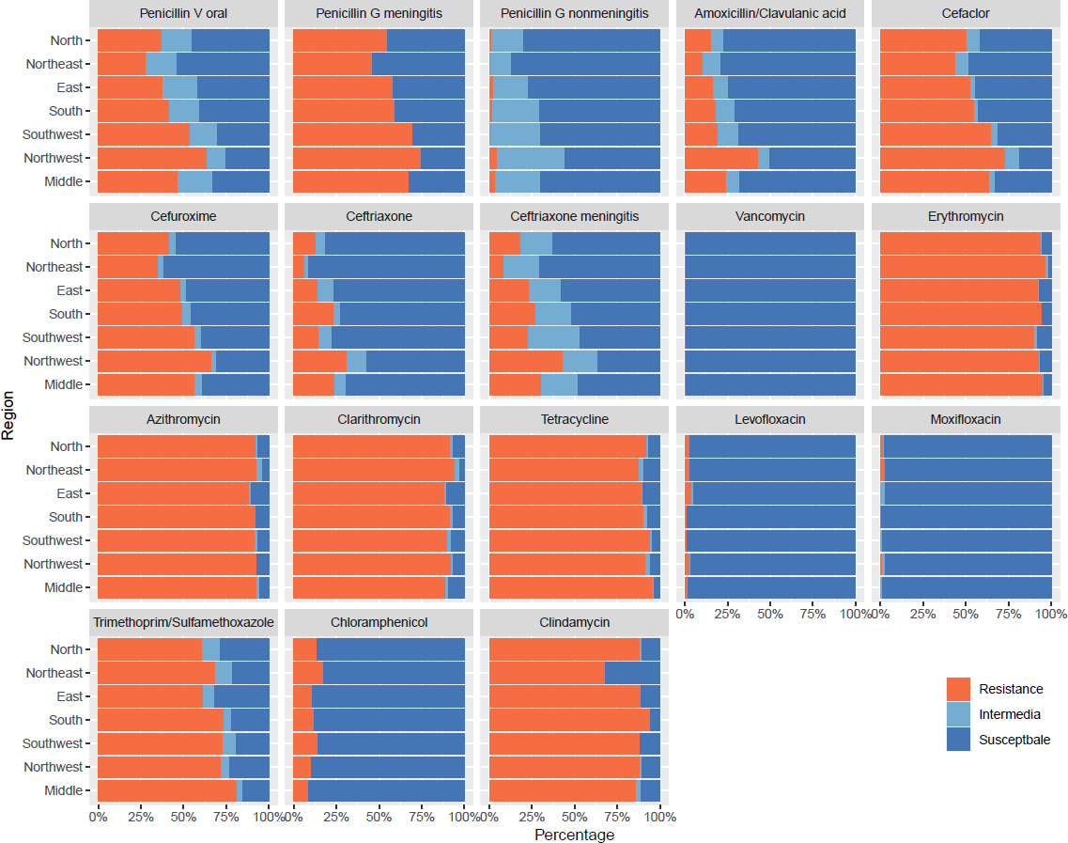

Supplementary Figure 1. Resistance rates of S. pneumoniae to major antimicrobials in different regions.

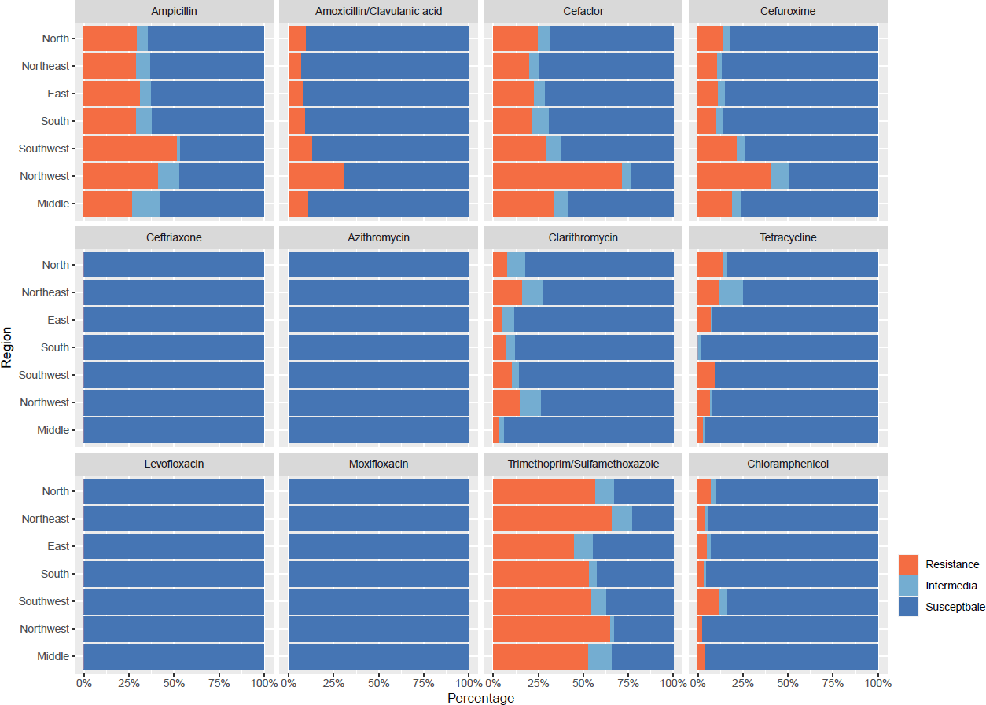

Supplementary Figure 2. Resistance rates of H. influenzae to major antimicrobials in different regions.

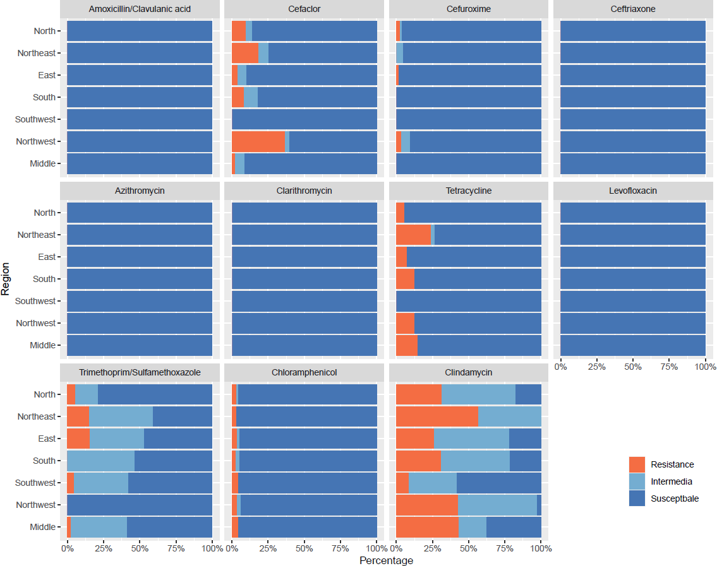

Supplementary Figure 3. Resistance rates of M. catarrhalis to major antimicrobials in different regions.

