Supplementary materials
Figure S1
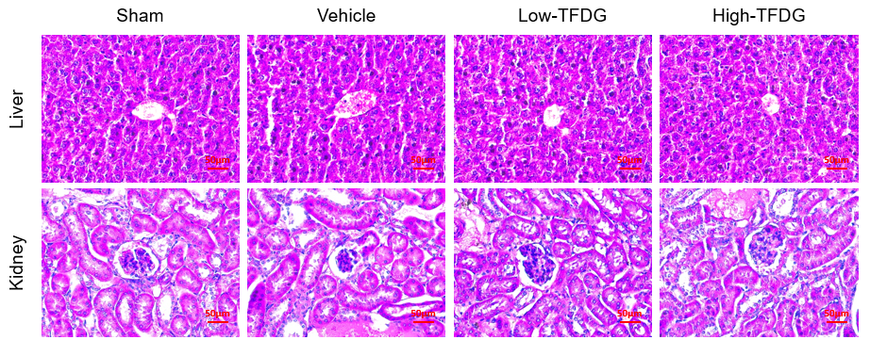
Figure S1 H&E staining of liver and kidney.
Figure S2
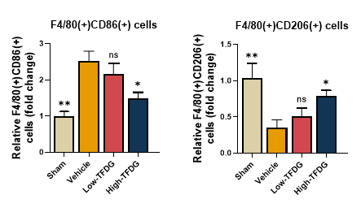
Figure S2 Semiquantitative analysis of joint immunofluorescence staining. (Scale bar: 100μm and 50μm, *p<0.05 and **p<0.01 compared with the TNF-α group; ns: no statistically significant.)
Figure S3
Figure S3 Protein–ligand docking prediction. (A) Ⅰ: apoptosis regulator Bcl-2 crystal structure; Ⅱ, Ⅲ: Bcl-2/Beclin-1 complex crystal structure of different direction (red: Beclin-1, cyan: Bcl-2). (B) TFDG binding site were similar to Beclin-1 binding site and combination of TFDG affected the Beclin-1 binding site. (yellow: TFDG)
Figure S4
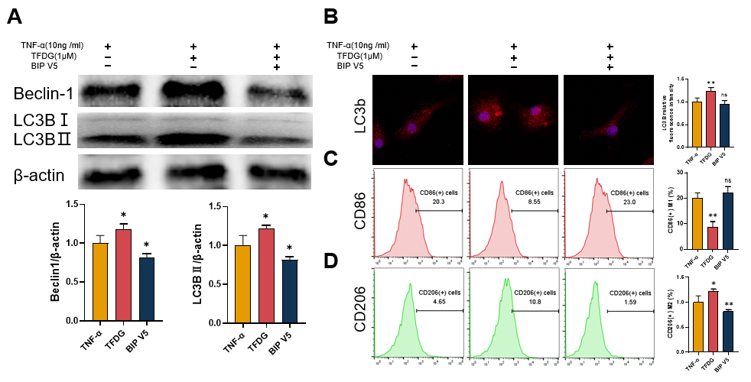
Figure S4 TFDG regulated cell autophagy and M2 polarization via inhibition of BCL2. Before 10ng/ml TNF-α treatment for 4h, BMMs were pretreated with 1.0μM TFDG and BIP V5. (A) The western blot analysis of Beclin-1, LC3B and β-actin (internal reference). (B) Immunofluorescence of the LC3B in BMMs. (C, D) CD86(+) and CD206(+) macrophages were analyzed. (* p<0.05 and ** p<0.01 compared with the TNF-α group, n=3 each group; ns: no statistically significant.)

