Supplementary Material S1. Interview format
“We are now interviewing subject ID *no*. Today is *day*, *date*.
To make sure all the data here is transparent and traceable, we would like to record this interview. We will transcribe all the interview answers and provide them to you, for your approval. If the interview is in Dutch, we will also translate it to English and provide it to you.
Do we have your permission to record the interview? (yes/no)
You have been using the smart blister package for 4 weeks. How was your experience using the blister package?
- Were you on holiday during the study period? How was your experience using the blister package during the holiday?
Did you ever open the blister package without taking any pill out? (yes/no)
Would you prefer to use the smart blister system over standard blister packaging? (yes/no)
- Reasons for using the smart blister system vs. standard blister packaging?
Would you see as an extra patient burden if this package is used in a clinical trial with patients? (yes/no)
- Reasons for patient burden?
What would you like to change in this system?
Do you have any ideas to improve this system? (yes/no)
- Ideas to improve this system?
What is your feedback for the "Instructions for the patients" sheet?
Thank you for your active participation and your time. We will now turn off the recording”

Supplementary Table S1. Additional questions for the use of smart blister package
No. | Questions | Strongly disagree | Disagree | Neutral | Agree | Strongly agree
1 | The smart blister package was simple to use | O | O | O | O | O
2 | The instructions on the blister package are clear | O | O | O | O | O
3 | The smart blister package was easy to carry around | O | O | O | O | O
4 | Dispensing is easier than standard packaging | O | O | O | O | O
5 | It was easy to change the re-usable electronic module | O | O | O | O | O
6 | It was clear when to change the re-usable electronic module | O | O | O | O | O
7 | It was useful seeing intake moments on both sides of the package | O | O | O | O | O
8 | I find remembering to take my medicine at the correct time difficult | O | O | O | O | O
9 | I would like help for taking my medicines on time | O | O | O | O | O
10 | I would like to get feedback on my medication intake behavior | O | O | O | O | O

Supplementary Figure S1. The difference between two different definitions of EDP adherence level
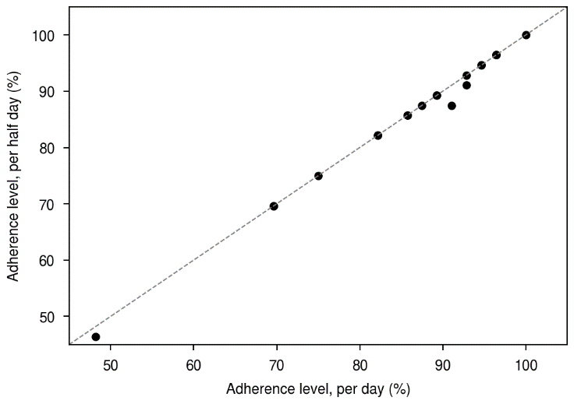

In the definition used for this study, a tablet is considered to have been taken on schedule if it is taken at some point between 3:00 a.m. and 3 a.m. the next day. This measure is thus insensitive to whether two tablets were both taken in the evening (cf. the 2nd day in Figure 5B) or if the two tablets were taken one in the morning and one in the evening, as prescribed. This definition is shown on the horizontal axis above. A somewhat more precise definition of adherence level is that the morning tablet is considered to have been taken on schedule if it is taken between 3:00 a.m. and 3:00 p.m. and the evening tablet is considered to have been taken on schedule if it is taken between 3:00 p.m. and 3:00 a.m. the next day. With this definition if two tablets were both taken in the evening (cf. the 2nd day in Figure 5B) then only one tablet is considered to have been taken on schedule. This definition is shown on the vertical axis above.

The results above show the adherence levels using these two different measures for all participants of this study (note that some participants exhibit the same adherence level and hence overlap). The dashed line above represents the two definitions giving the same results. Clearly for the majority of subjects that participated in this study, the two different definitions give the same adherence level. Furthermore, for the few (3 out of 20) participants where the adherence levels differed, the difference was small. For the rest of the study, we thus used the simpler definition (horizontal axis) that did not take into account when during the day the tablet was taken, as this is the definition implemented in the MEMS® Adherence Software v4.

Supplementary Figure S2. Differences in dose-taking adherence levels

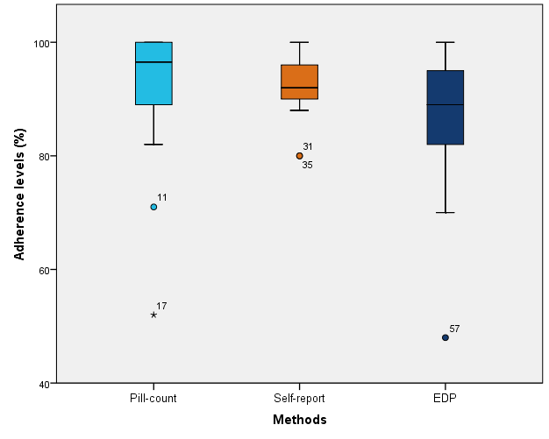

This figure shows boxplot of dose-taking adherence levels as measured by the electronic Dosepak® (EDP) records, manual pills count, and self-report. These dose-taking adherence levels differed significantly (p<0.05).

