Supplemental Material

Supplemental Figures

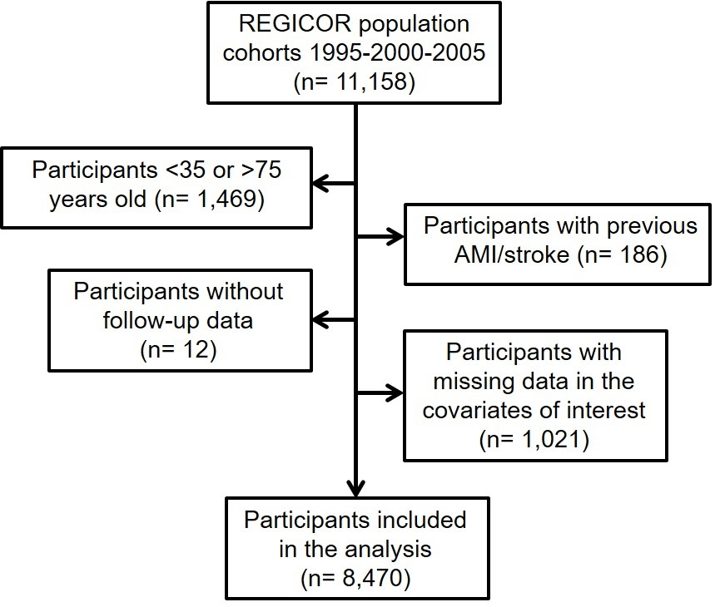
Supplemental Figure 1. Flowchart of the participants included in the study from the REGICOR population cohorts. AMI: acute myocardial infarction; REGICOR: Registre Gironí del Cor

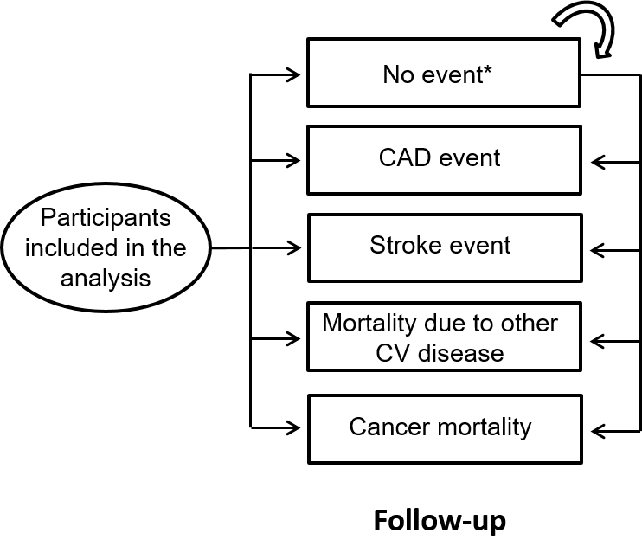

Supplemental Figure 2. Structure of the multi-state Markov model. CAD: coronary artery disease; CV: cardiovascular. *No event means that the participant did not have an acute myocardial infarction, angina, stroke, or died due to other cardiovascular causes or due cancer during the follow-up.

Supplemental Figure 3. Cumulative incidence of events during the follow-up by sex. CV: cardiovascular. Incidence units are 1/100 inhabitants.

Panel A. Women
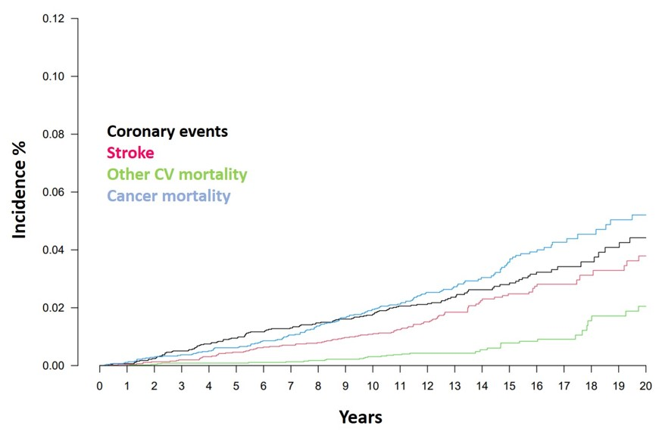
Panel B: Men
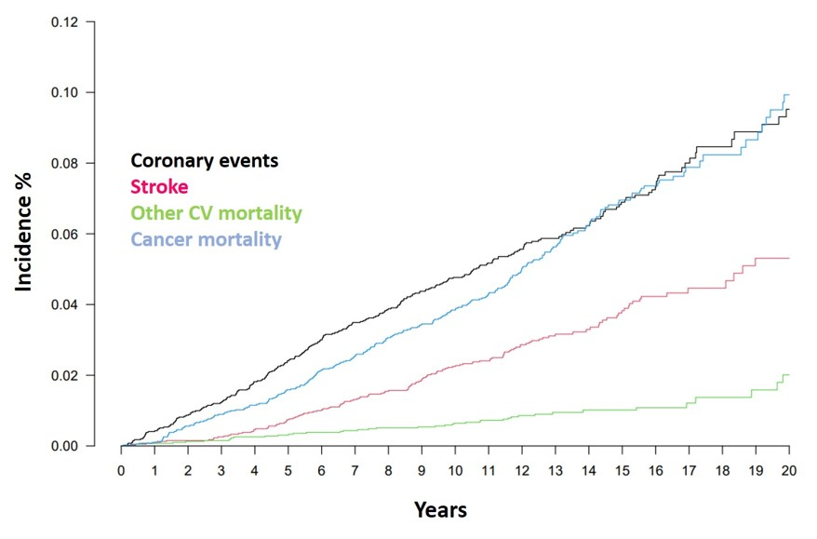

Supplemental Figure 4. Plots to assess calibration of models predicting coronary events with a significant p-value in the Hosmer-Lemeshow test. Expected and observed coronary events are presented by deciles of risk (d1-d6). A-C and D-F are models with and without competing risks, respectively. A and D models include the basal measurement of the classical risk factors of the REGICOR model (age, sex, total cholesterol, high-density lipoprotein cholesterol, diabetes, smoking, systolic blood pressure, diastolic blood pressure), B model includes 2 measurements of the classical risk factors, C and F models include 2 measurements of classical risk factors and treatments, and E model includes the basal measurement of classical risk factors and treatments.
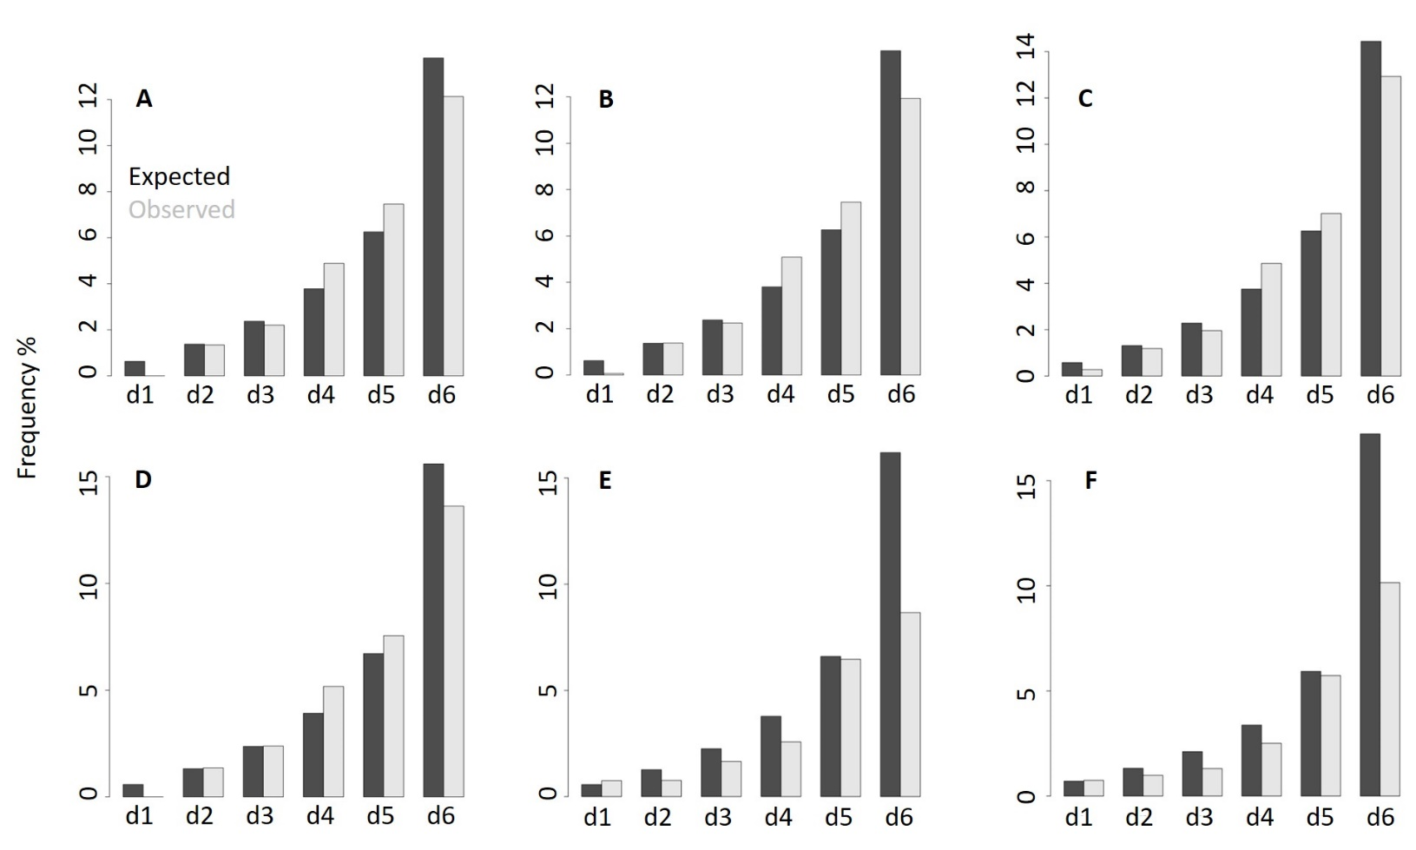

Supplemental Tables

Supplemental Table 1. Demographic characteristics and cardiovascular risk factors of the included participants at re-examination by groups depending on the event that occurred in the follow-up.
 | No event  N=5382 | CAD event  N=206 | Stroke event  N=137 | Other CV death  N=20 | Cancer death  N=118 | p-value
Age, years | 59.0 [51.0;67.0] | 70.0 [62.2;76.0] | 72.0 [62.0;77.0] | 74.5 [70.0;79.2] | 71.0 [60.2;75.0] | <0.001
Total cholesterol, mg/dL | 207 [184;232] | 183 [158;218] | 200 [165;230] | 196 [168;218] | 204 [175;237] | <0.001
HDL cholesterol, mg/dL | 52.5 [45.3;61.0] | 45.7 [39.5;53.6] | 49.5 [41.0;56.4] | 54.8 [38.9;60.5] | 51.4 [43.6;58.4] | <0.001
LDL cholesterol, mg/dL | 134 [114;155] | 116 [94.2;142] | 127 [97.5;152] | 122 [98.5;145] | 136 [107;153] | <0.001
Triglycerides, mg/dL | 86.0 [64.0;118] | 100 [75.5;131] | 101 [72.0;132] | 86.5 [69.0;123] | 91.0 [72.0;119] | <0.001
Systolic blood pressure, mmHg | 128 [115;141] | 138 [124;151] | 139 [124;151] | 140 [124;158] | 134 [124;146] | <0.001
Diastolic blood pressure, mmHg | 77.0 [71.0;84.0] | 76.5 [70.0;82.0] | 78.0 [71.0;84.0] | 73.5 [64.8;80.2] | 78.0 [70.0;85.0] | 0.187
Diabetes | 658 (12.3%) | 63 (30.7%) | 44 (32.1%) | 6 (30.0%) | 33 (28.4%) | <0.001
Smoking | 896 (16.8%) | 29 (14.2%) | 15 (11.0%) | 2 (10.0%) | 16 (13.6%) | 0.263
BMI, km/m² | 26.9 [24.1;29.8] | 28.4 [26.1;31.1] | 27.4 [25.2;30.8] | 28.4 [26.5;32.6] | 27.6 [25.6;29.8] | <0.001
Cholesterol treatment | 919 (17.1%) | 110 (53.9%) | 44 (32.4%) | 5 (25.0%) | 22 (18.6%) | <0.001
Blood pressure treatment | 1377 (25.6%) | 131 (63.9%) | 81 (59.1%) | 11 (55.0%) | 47 (39.8%) | <0.001
Diabetes treatment | 344 (6.40%) | 49 (23.8%) | 33 (24.3%) | 5 (25.0%) | 21 (17.9%) | <0.001
BMI: body mass index; CAD: coronary artery disease; CV: cardiovascular; HDL: high-density lipoprotein cholesterol; LDL: low-density lipoprotein cholesterol. Categorical variables are summarized with absolute (N) and relative frequencies (%), continuous variables with the median and interquartile range.

Supplemental Table 2. Variable estimates in the models with best discrimination by sex.

Panel A. Women

 | Model with competing risks |  | Model without competing risks
 | REGICOR + treatments |  | REGICOR model
 | HR (95% CI) | p-value | HR (95% CI) | p-value
Age (x10years) | 2.40 (1.61, 2.58) | <0.001 | 2.43 (1.92, 3.08) | <0.001
Total cholesterol (x10mg/dL) | 1.04 (1.00, 1.08) | 0.037 | 1.03 (0.99, 1.07) | 0.113
HDL cholesterol (x10mg/dL) | 0.88 (0.75, 1.03) | 0.110 | 0.87 (0.76, 1.00) | 0.047
Systolic blood pressure (x10mmHg) | 1.15 (1.04, 1.28) | 0.009 | 1.18 (1.07, 1.31) | 0.001
Diastolic blood pressure (x10mmHg) | 1.03 (0.84, 1.26) | 0.780 | 1.04 (0.85, 1.27) | 0.689
Diabetes | 1.29 (0.85, 1.97) | 0.230 | 1.58 (1.05, 2.38) | 0.029
Current smoker | 2.92 (1.70, 5.02) | <0.001 | 2.91 (1.66, 5.11) | <0.001
Cholesterol treatment | 2.31 (1.54, 3.47) | <0.001 | --- | ---
Blood pressure treatment | 1.56 (1.06, 2.31) | 0.026 | --- | ---
CI: confidence interval; HDL: high-density lipoprotein cholesterol; HR: hazard ratio.

Panel B. Men

 | Model with competing risks |  | Model without competing risks
 | REGICOR + treatments |  | REGICOR model
 | HR (95% CI) | p-value | HR (95% CI) | p-value
Age (x10years) | 1.59 (1.38, 1.82) | <0.001 | 1.77 (1.53, 2.04) | <0.001
Total cholesterol (x10mg/dL) | 1.08 (1.05, 1.11) | <0.001 | 1.08 (1.05, 1.11) | <0.001
HDL cholesterol (x10mg/dL) | 0.76 (0.66, 0.87) | <0.001 | 0.76 (0.67, 0.85) | <0.001
Systolic blood pressure (x10mmHg) | 1.11 (1.03, 1.21) | 0.010 | 1.13 (1.04, 1.24) | 0.004
Diastolic blood pressure (x10mmHg) | 0.99 (0.84, 1.17) | 0.900 | 0.98 (0.84, 1.14) | 0.781
Diabetes | 1.37 (1.02, 1.83) | 0.037 | 1.48 (1.11, 1.96) | 0.007
Current smoker | 1.47 (1.13, 1.91) | 0.004 | 1.50 (1.15, 1.95) | 0.003
Cholesterol treatment | 1.86 (1.33, 2.60) | <0.001 | --- | ---
Blood pressure treatment | 1.17 (0.85, 1.60) | 0.330 | --- | ---
CI: confidence interval; HDL: high-density lipoprotein cholesterol; HR: hazard ratio.

Supplemental Table 3. Calibration of the models with and without treatments, time-dependent covariates and competing risks, using the Hosmer-Lemeshow test.

 | H-L | p-value
Models including competing risks
REGICOR model | 19.6 | 0.002
REGICOR + time-dependent covariates | 20.8 | 0.001
REGICOR + treatments | 10.0 | 0.075
REGICOR + time-dependent covariates + treatments | 11.5 | 0.043
Models not including competing risks
REGICOR model | 18.9 | 0.002
REGICOR + time-dependent covariates | 8.9 | 0.115
REGICOR + treatments | 70.1 | <0.001
REGICOR + time-dependent covariates + treatments | 58.0 | <0.001
H-L: hosmer-lemeshow statistic

