Supplementary materials

Supplementary Figure 1 Measurement of multifrequency bioimpedance spectroscopy.
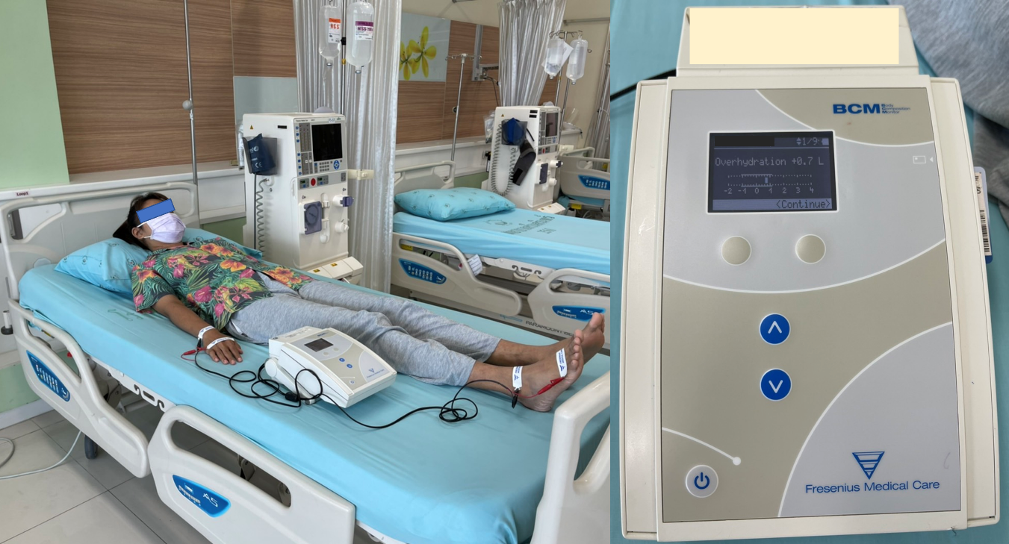

Supplementary Table 1 Descriptive statistics of mean and median LUS scores and BIA parameters at baseline and week 8 combined data

Parameters | Combined baseline and week 8 (n =40)
Parameters | Mean ± SD | Median (IQR)
WG (L) | 2.90 ± 1.19 | 2.90 (2.35-3.55)
TLUSS (scores) | 24.5 ± 6.66 | 26.0 (21.0-29.0)
BIA parameters  Pre-HD BW (kg)  NHW (kg)  TBW (L)  ECW (L)  ICW (L)  AFO (L)  RFO (%)  LTM (kg)  relLTM (%)  ATM (kg)  RelATM (%)  Fat mass (kg)  relFAT (%) | 62.1 ± 10.5  57.3 ± 9.45  33.9 ± 6.00  16.9 ± 2.70  16.9 ± 3.73  3.34 ± 1.53  20.2 ± 7.82  36.1 ± 9.91  59.8 ± 16.0  21.3 ± 10.0  34.2 ± 14.2  15.6 ± 7.36  25.3 ± 10.6 | 63.8 (55.1-69.0)  60.4 (52.0-64.5)  35.9 (28.3-38.9)  17.4 (15.2-18.5)  18.0 (14.2-19.6)  3.15 (2.20-3.80)  19.0 (14.6-22.3)  37.4 (27.1-42.1)  58.9 (49.7-69.9)  20.7 (16.5-29.5)  32.5 (27.3-44.7)  15.2 (12.1-21.7)  24.0 (20.1-33.1)

Abbreviations: SD, standard deviation; IQR, interquartile range (25th-75th percentile); kg, kilograms; L, liter; IDWG, interdialytic weight gain; LUS, lung ultrasound; BIA, bioimpedance analysis; Pre-HD BW, Pre-hemodialysis body weight; NHW, normal hydration weight (=Pre-HD BW- AFO); TBW, total body water; ECW, extracellular water; ICW, intracellular water; AFO, absolute fluid overload; RFO, relative fluid overload (=100 x AFO/ECW); LTM, lean tissue mass; relLTM, relative lean tissue mass (=100 X LTM/ Pre-HD BW); ATM, adipose tissue mass (=Pre-HD BW – LTM - AFO); relATM, relative adipose tissue mass (=100 x ATM/ Pre-HD BW); relFAT, relative fat mass (=100 X fat mass/ Pre-HD BW)

Supplementary Table 2 Relevance of clinical signs of volume overload with amount of weight gains and total lung ultrasound
scores
Clinical signs | Weight gains (L) (n=166) |  |  |  | TLUSS (scores) (n=166) |  | Severities of pulmonary congestion by TLUSS, n (%)
Clinical signs | Mean ± SD | p-value | Median (IQR) | p-value | Mean ± SD | p-value | Absent or mild  TLUSS ≤15  (n=16) | Moderate  TLUSS 16-30  (n=106) | Severe  TLUSS >30  (n=44) | p-value
Leg edema  Grade 0 (n=88)  Grade 1+ (n=62)  Grade 2+ (n=16) | 2.5 ± 1.0  3.2 ± 1.1  5.0 ± 1.7 | <0.001 | 2.5 (1.95-3.2)  3.25 (2.5-3.9)  5.05 (4.0-6.4) | <0.001 | 23.6 ± 6.2  26.0 ± 6.8  33.8 ± 7.4 | <0.001 | 12 (75)  4 (25)  0 (0) | 63 (59.4)  39 (36.8)  4 (3.8) | 13 (29.5)  19 (43.2)  12 (27.3) | <0.001
Puffy eyelids  Absent (n=131)  Present (n=35) | 2.9 ±1.4  3.5 ±1.0 | 0.029 | 2.7 (2.1-3.6)  3.5 (2.7-4.0) | 0.003 | 24.9 ± 7.0  27.6 ± 7.2 | 0.048 | 14 (87.5)  2 (12.5) | 87 (82.1)  19 (17.9) | 30 (68.2)  14 (31.8) | 0.12
Lung crepitation  Absent (n=140)  Present (n=26) | 3.0 ± 1.3  3.5 ± 1.2 | 0.076 | 2.9 (2.1-3.65)  3.55 (2.6-4.3) | 0.023 | 25.0 ± 7.1  28.1 ± 6.5 | 0.045 | 15 (93.8)  1 (6.2) | 89 (84.0)  17 (16.0) | 36 (81.8)  8 (18.2) | 0.61

Abbreviations: L, litre; n, number; TLUSS, total lung ultrasound score; SD, standard deviation

Supplementary Table 3 Predictions for pulmonary congestion by clinical signs of volume overload

Clinical signs | Edema | Puffy eyelids | Lung crepitation
Prediction for pulmonary congestion (moderate and severe degrees)  Sensitivity (%), 95% CI  Specificity (%), 95% CI  Positive predictive value (%), 95% CI  Negative predictive value (%), 95% CI | 49.3 (41.7-56.9)  75.0 (68.4-81.6)  94.9 (91.5-98.2)  13.6 (8.4-18.9) | 22.0 (15.7-28.3)  87.5 (82.5-92.5)  94.3 (90.8-97.8)  10.7 (6.0-15.4) | 16.7 (11.0-22.3)  93.8 (90.1-97.4)  96.2 (93.2-99.1)  10.7 (6.0-15.4)
Prediction for severe pulmonary congestion  Sensitivity (%), 95% CI  Specificity (%), 95% CI  Positive predictive value (%), 95% CI  Negative predictive value (%), 95% CI | 70.5 (63.5-77.4)  61.5 (54.1-68.9)  39.7 (32.3-47.2)  85.2 (79.8-90.6) | 31.8 (24.7-38.9)  82.8 (77.0-88.5)  40.0 (32.6-47.5)  77.1 (70.7-83.5) | 18.2 (12.3-24.1)  85.3 (79.9-90.6)  30.8 (23.8-37.8)  74.3 (67.6-80.9)

Abbreviations: CI, confidence interval

