APPENDIX A
Participating clinical sites:
- Eye Research Foundation, Newport Beach, CA 92663
- Piedmont Eye Center, Lynchburg, VA 24502
- Vita Eye Clinic, Shelby, NC 28150
- Vision Institute, Colorado Springs, CO 80907
- The Eye Care Institute, Louisville, KY 40206
- Midwest Cornea Associates, LLC, Carmel, IN 46290
- Andover Eye Associates, Andover, MA 01810
- Total Eye Care, P.A., Memphis, TN 38119

APPENDIX B
Collarette grading scale (non-linear)
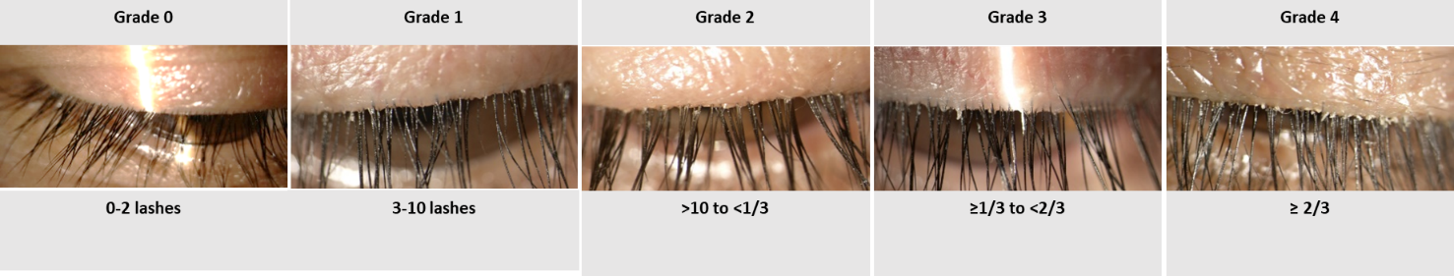

Lid Margin erythema grading scale (non-linear)
