Supplementary materials
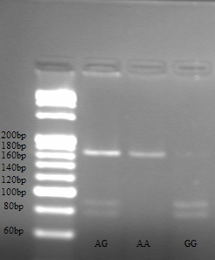
Figure S1. The representative gel image for CTLA-4+49A/G detection. After digestion by restriction endonuclease BbvⅠ, mutation of A-G at site 49 of exon 1 of CTLA-4 gene will form the enzymatic site of BbvⅠ enzyme, and enzymatic cleavage can occur. If the site is not mutated, enzymatic cleavage will not occur. When the sample genotype is wild type A/A, only one fragment of 162bp is observed; when the genotype is heterozygous A/G, three fragments of 162bp, 88bp and 74bp can be observed; when the genotype is pure mutation G/G, two fragments of 88bp and 74bp are observed.

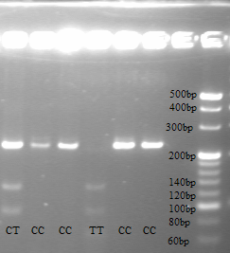
Figure S2. After digestion by restriction endonuclease Mse I, the mutation of C-T at the -318 site of the CTLA-4 gene promoter will form an enzymatic site for Mse I enzyme, and enzymatic cleavage can occur; if the site is not mutated, no enzymatic cleavage will occur. When the sample genotype is wild type C/C, two fragments of 226bp and 21bp should be observed; when the genotype is heterozygous C/T, four fragments of 226bp, 130bp, 96bp and 21bp should be observed; when the genotype is pure mutant T/T, three fragments of 130bp, 96bp and 21bp will be formed. However, due to the small molecular weight of the 21bp fragment, the gel image could not show that band.

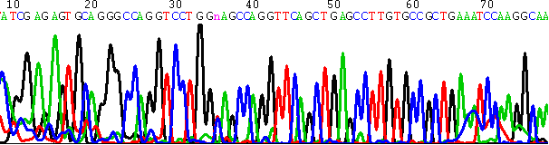
Figure S3. Representative sequencing result of the AG genotype of the CTLA-4+49A/G locus. The sequence of the CTLA-4+49A/G locus is ATCGAGAGTGCAGGGCCAGGTCCTGG [A/G]AGCCAGGTTCAGCTGAGCCTTGTGCCG. The sequencing result shows that the genotype of the sample tested is AG, which is consistent with the enzyme digestion results.

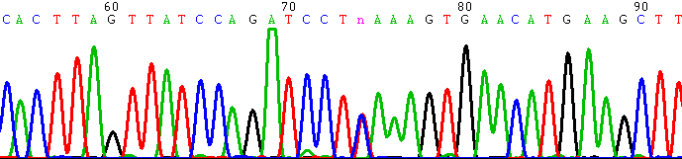
Figure S4. Representative sequencing result of the AG genotype of the CTLA-4-318C/T CT locus. The sequence of the locus is GTCTCCACTTAGTTTTATCCAGATCCT[C/T]AAAGTGAACATGAAGCTTCAGTTTC. The sequencing results showed that the genotype of the sample tested was CT type, which was consistent with the enzyme digestion results.

