Supplementary file

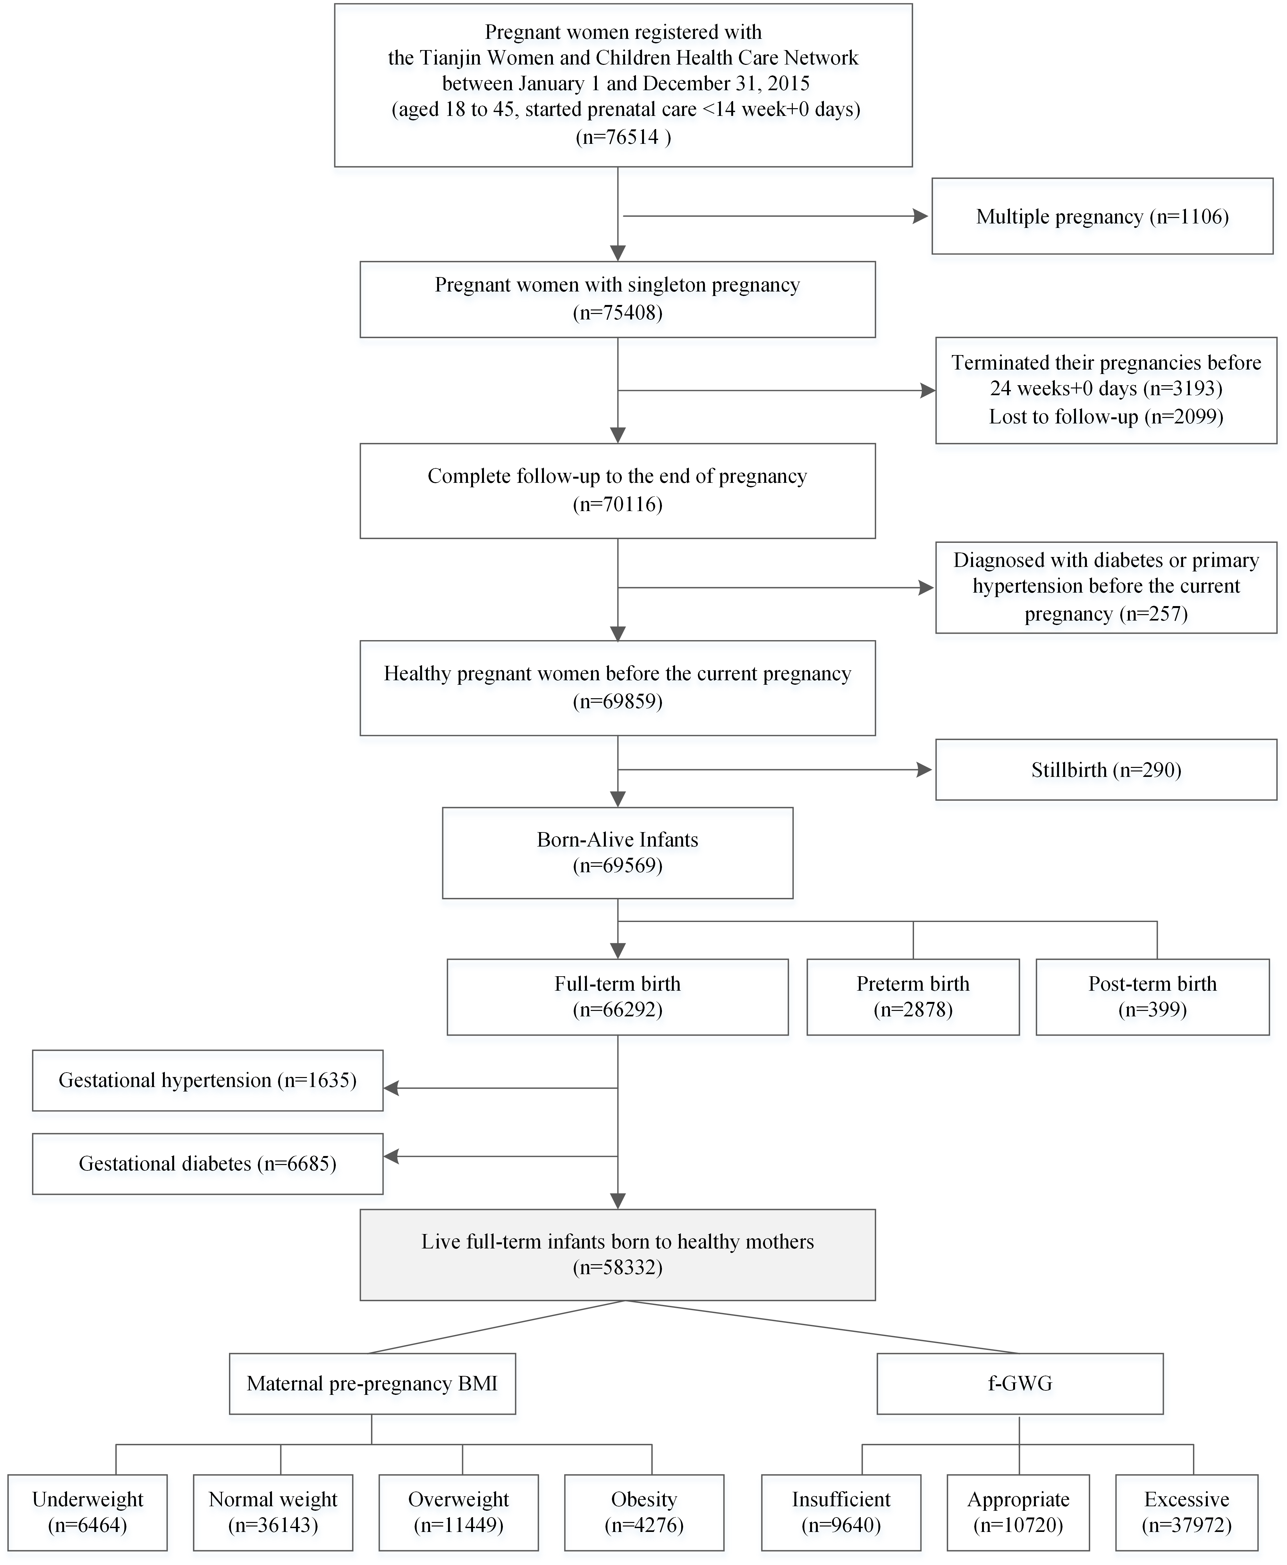
Figure S1 Study flow chart.
Abbreviations: BMI, body mass index; f-GWG, weight gain during the first half of pregnancy.

Table S1 Prevalence of offspring adiposity from 0.5 to 5 years of age
Prepregnancy | f-GWG | Prevalence of adiposity
BMI group | category | 0.5 years | 1 year | 1.5 years | 2 years | 2.5 years | 3 years | 4 years | 5 years
Underweight | Insufficient | 107 (10.0%) | 69 (6.8%) | 57 (5.5%) | 50 (4.9%) | 22 (2.3%) | 24 (2.5%) | 12 (3.4%) | 7 (3.5%)
 | Appropriate | 155 (12.0%) | 115 (9.4%) | 84 (6.7%) | 67 (5.4%) | 32 (2.9%) | 28 (2.5%) | 12 (3.1%) | 13 (5.2%)
 | Excessive | 364 (11.4%) | 307 (10.3%) | 220 (7.2%) | 191 (6.4%) | 99 (3.7%) | 104 (3.7%) | 30 (3.0%) | 23 (3.8%)
 | P-value | 0.301 | 0.004 | 0.148 | 0.180 | 0.113 | 0.050 | 0.924 | 0.579
Normal weight | Insufficient | 779 (15.7%) | 567 (12.0%) | 485 (10.1%) | 361 (7.6%) | 254 (6.1%) | 217 (5.0%) | 115 (7.0%) | 84 (8.6%)
 | Appropriate | 1071 (16.9%) | 753 (12.5%) | 663 (10.8%) | 561 (9.3%) | 308 (5.6%) | 320 (5.8%) | 137 (7.1%) | 78 (6.4%)
 | Excessive | 3419 (17.6%) | 2574 (13.9%) | 2249 (11.9%) | 1942 (10.4%) | 1075 (6.5%) | 1100 (6.4%) | 428 (7.4%) | 312 (8.8%)
 | P-value | 0.006 | <0.001 | <0.001 | <0.001 | 0.069 | 0.001 | 0.800 | 0.027
Overweight | Insufficient | 262 (19.1%) | 198 (15.3%) | 186 (13.9%) | 140 (10.7%) | 97 (8.3%) | 101 (8.3%) | 54 (11.3%) | 33 (13.0%)
 | Appropriate | 216 (20.8%) | 146 (14.6%) | 131 (13.0%) | 133 (13.3%) | 74 (8.4%) | 81 (8.9%) | 41 (11.0%) | 41 (18.8%)
 | Excessive | 1713 (23.0%) | 1329 (18.7%) | 1224 (16.9%) | 1084 (15.2%) | 691 (10.8%) | 761 (11.6%) | 345 (13.9%) | 258 (16.6%)
 | P-value | 0.003 | <0.001 | 0.001 | <0.001 | 0.006 | <0.001 | 0.125 | 0.209
Obesity | Insufficient | 215 (26.4%) | 163 (21.3%) | 148 (19.0%) | 133 (16.9%) | 95 (13.5%) | 105 (14.3%) | 48 (15.4%) | 40 (22.9%)
 | Appropriate | 103 (23.4%) | 71 (17.1%) | 76 (17.2%) | 74 (17.4%) | 56 (14.7%) | 44 (11.0%) | 32 (17.3%) | 20 (21.7%)
 | Excessive | 630 (25.6%) | 512 (22.1%) | 502 (20.6%) | 484 (20.3%) | 327 (15.5%) | 373 (16.7%) | 193 (20.4%) | 135 (24.6%)
 | P-value | 0.492 | 0.079 | 0.187 | 0.073 | 0.458 | 0.009 | 0.124 | 0.785
Notes: Values represent the prevalence of offspring adiposity for each body mass index and weight gain category. P-value refers to trend from comparison among three f-GWG categories: Insufficient, Appropriate, and Excessive. The total study sample size was 58332 at birth, and 49824 (85.4%), 47388 (81.2%), 48401 (83.0%), 47709 (81.8%), 42604 (73.0%), 43948 (75.3%), 15896 (27.3%), and 9661 (16.6%) at 0.5, 1, 1.5, 2, 2.5, 3, 4, and 5 years of age. Prepregnancy BMI groups were commented the Chinese BMI criteria: underweight (BMI <18.5 kg/m²), normal weight (BMI 18.5−23.9 kg/m²), overweight (BMI 24.0−28.0 kg/m²), and obesity (BMI ≥ 28.0 kg/m²). According to the IOM guidelines, participants were divided into three categories based on maternal weight gain during the first half of gestation.
Abbreviations: BMI, body mass index; f-GWG, weight gain during the first half of pregnancy.

