Table S1. MOOSE checklist
Section/Topic | MOOSE checklist Item(s) | Reported on Page #
BACKGROUND
Reporting of background should include | Problem definition. Hypothesis statement. Description of study outcome(s). Type of exposure or intervention used. Type of study designs used. Study population. | 1-2
SEARCH
Reporting of search strategy should include | Search strategy, including time period included in the synthesis and keywords. Effort to include all available studies. Databases and registries searched. Use of hand searching (eg, reference lists of obtained articles). List of citations located and those excluded, including justification. Method of addressing articles published in languages other than English. | 2
METHODS
Reporting of methods should include | Description of relevance or appropriateness of studies assembled for assessing the hypothesis to be tested. Rationale for the selection and coding of data (eg, sound clinical principles or convenience). Documentation of how data were classified and coded (eg, multiple raters, blinding, and interrater reliability). Assessment of confounding (eg, comparability of cases and controls in studies where appropriate). Assessment of study quality, including blinding of quality assessors; stratification or regression on possible predictors of study results. Assessment of heterogeneity. Description of statistical methods (eg, complete description of fixed or random effects models, justification of whether the chosen models account for predictors of study results, dose-response models, or cumulative meta-analysis) in sufficient detail to be replicated. Provision of appropriate tables and graphics. | 2-3
RESULTS
Reporting of results should include | Graphic summarizing individual study estimates and overall estimate. Table giving descriptive information for each study included. Results of sensitivity testing (eg, subgroup analysis). Indication of statistical uncertainty of findings. | 3-4, Table 1, Table S2, Table S3, Figure 1, Figure S1, Figure S2
DISCUSSION
Reporting of discussion should include | Quantitative assessment of bias (eg, publication bias). Justification for exclusion (eg, exclusion of non–English-language citations). Assessment of quality of included studies. | 4-6
CONCLUSIONS
Reporting of conclusions should include | Consideration of alternative explanations for observed results. Generalization of the conclusions (ie, appropriate for the data presented and within the domain of the literature review). Guidelines for future research. Disclosure of funding source. | 6
Stroup DF, Berlin JA, Morton SC, et al. Meta-analysis of observational studies in epidemiology: a proposal for reporting. Meta-analysis Of Observational Studies in Epidemiology (MOOSE) group. JAMA. 2000;283(15):2008-2012.
Table S2. Characteristics of the included studies and data of each indicator.
Study | Size | Age | M/F | BMI (kg/m²) | Smoking history  (pack-years) | PB-FEV₁% | DLCO% | FeNO  (ppb) | Serum  total IgE  (IU/mL, pg/mL) | Blood eosinophil  (cell/μL) | Sputum  eosinophil (%) | Sputum  neutrophil (%) | Circulating  YKL-40  (ng/ml) | Circulating  periostin  (ng/ml) | Circulating  NGAL  (ng/ml) | Study Design | Score
Fu et al. 2014¹⁸ | 42ª  21^{b}  16^{c} | 67.9±7.3  69.9±7.4  66.1±7.5 | 21/21  8/13  6/10 | 29.2±6.7  27.9±8.6  30.3±6.4 | 40.6±36.1  29.0±23.8  7.9±15.0 | 54.6±19.5  52.1±14.0  83.7±8.1 | / | / | / | / | 2.22±3.38  1.5±2.15  3.17±3.33 | 63.84±31.09  66.17±25.6  32.79±31.54 | / | / | / | CS | 8
Fu et al. 2014⁷ | 55ª  36^{b}  8^{c} | 68.6±7.6  70.1±7.7  66.1±6.6 | 27/28  12/24  3/5 | 28.8±6.4  28.6±7.1  30.3±6.5 | 34.9±27.9  34.4±26.3  12.6±22.3 | 54.6±18.2  55.9±16.2  81.6±6.8 | / | / | / | 135.4±76.1  171.1±154.4  200.0±178.7 | 2.33±3.43  1.11±1.31  2.46±4.2 | 61.35±27.03  72.18±28.57  46.35±37.97 | / | / | / | CO | 6
Lee et al. 2014¹⁹ | 97ª  159^{c} | 63.0±8.9  57.6±8.8 | 36/61  29/130 | 23.7±3.0  24.1±3.8 | 29.5±18.8  25.8±48.6 | 58.0±11.82  69.4±15.13 | 91.7±20.0  90.8±16.2 | / | 332.1±347.1  199.8±247.7 | 267.8±211.9  477.5±682.1 | / | / | / | / | / | CS | 6
Carpagnano et al. 2016²⁰ | 23ª  13^{b}  14^{c} | 63.8±6.9  71±4.58  60.8±12.4 | / | 29±5.2  29.5±4.3  28.8±5.8 | /  68.6±32.3  / | 71.94±23.21  46.76±10.66  88.67±17.72 | / | 25.43±14.25  17.69±4.12  21.61±11.40 | / | / | 3.29±2.71  0.55±1.34  47.34±26.55 | 81.84±10.82  88.26±10.70  24.26±20.14 | / | / | / | CS | 6
Cosio et al. 2016²¹ | 125ª  706^{b} | 66.5±8.7  67.8±8.9 | 102/23  588/118 | 29.1±5.5  27.8±5.5 | 53.2±26.2  56.6±28.7 | 61.2±18.1  59.3±20.7 | 78±22  73.8±24.1 | / | 206.6±232  115.7±273 | / | / | / | / | / | / | CO | 6
Gao et al. 2016²² | 18ª  20^{b}  24^{c} | 61.8±6.5  59.3±7.0  58.3±8.3 | 12/6  12/8  9/15 | 28.2±6.5 24.6±4.0  26.0±4.5 | 42.5±17.7  37.2±17.3  13.0±16.0 | 51.6±13.7  58.3±19.1  78.8±14.0 | 67.9±18.7  53.2±20.2  82.2±17.8 | / | / | / | 6.8±9.8  2.4±4.9  5.1±9.2 | 64.8±15.5  62.8±20.3  53.6±23.4 | / | / | / | CS | 6
Gao et al. 2016²² | 17ª  35^{b}  21^{c} | 65.9±8.9  72.2±8.1  42.0±15.4 | 14/3  34/1  4/17 | 24.2±3.2  23.5±3.0  24.6±5.4 | 40.7±16.6  47.6±21.9  4.3±12.5 | / | / | / | / | / | 9.2±17.1  3.2±8.7  12.0±17.4 | 66.1±24.8  72.4±17.4  46.2±26.0 | / | / | / | CS | 7
Goto et al. 2016²³ | 48ª  149^{b} | 56±9.7  58±13.4 | / | / | 32±22.9  36±26.9 | 63±6.11  63.35±5.24 | / | / | / | 272±304.8  236±158.7 | / | / | / | / | / | CS | 6
Kalinina et al. 2016²⁴ | 12ª  44^{b}  39^{c} | 64.3±5.3  60.1±10.4  42.6±14.9 | 6/6  32/12  16/23 | 26.9±7.1  21.2±8.5  28.9±20.2 | 16.3±19.9  26.0±33.9  0.4±1.3 | 81.72±24.2  85.44±22.72  95.56±47.6 | / | / | 562±100.6  197.4±56.5  511.0±110.8 | / | / | / | / | / | / | CS | 8
Bai et al. 2017²⁵ | 65ª  65^{b} | 62.6±8.7  64.7±9.5 | 62/3  62/3 | 22.8±5.4  21.0±4.6 | 48.1±50.4  47.8±30.5 | 36.1±13.4  36.8±15.4 | 70.7±24.8  55.9±24.9 | / | 368.8±605.8  208.7±302.0 | / | / | / | / | / | / | CS | 7
Gao et al. 2017²⁶ | 72ª  160^{b}  142^{c} | 59.5±15.8  71.8±8.5  46.2±16.5 | 53/19  132/28  56/86 | 22.4±3.2  20.5±3.5  23.2±3.8 | / | 61.97±15.33  42.39±18.90  85.55±12.83 | / | / | / | / | 8.64±13.23  1.99±2.72  8.98±15.08 | 77.43±22.62  91.15±8.03  68.09±35.83 | / | / | / | CS | 7
Inoue et al. 2017⁸ | 93ª  915^{b} | 69.2±9.8  73.9±8.0 | 84/9  853/62 | 22.8±3.4  22.2±3.5 | 46.0±27.7  58.1±31.5 | 64.2±18.2  56.0±21.2 | / | 33.1±17.5  26.4±21.7 | / | 368.3±362.8  226.1±213.6 | / | / | / | / | / | CS | 7
Kawamatawong et al. 2017⁹ | 44ª  24^{b}  24^{c} | 69.4±34.5  71.4±33.1  59.7±29.9 | 23/21  18/6  4/20 | 28.2±18.7  22.4±13.6  28.6±13.3 | 28.6±53.7  11.8±23.6  51.8±94.6 | 67.2±18.0  65.6±20.2  68.3±11.8 | / | 52.54±29.04  72.22±30.21  53.94±23.51 | 747.2±1,243.6  471.6 ± 641.6  442.4 ± 432.4 | 271.4±159.5  255.5 ± 240.0  311.4±199.2 | / | / | / | / | / | CS | 6
Kodama et al. 2017²⁷ | 21ª  39^{b}  15^{c} | 66.8±8.4  72.7±6.9  56.4±13.7 | 9/12  34/5  3/12 | 22.8±6.5  22.0±0.5  24.8±3.3 | 16.1±24.5  66.8±33  10.1±14 | 68.7±19.1  55.6±19.0  96.0±13.3 | 70.2±17.7  43.1±14.5  74.4±13.8 | / | / | / | / | / | / | / | / | CO | 6
Kurashima et al. 2017²⁸ | 256ª  537^{b} | 66.5±8.3  69.4±7.8 | 223/33  516/21 | 22.0±4.0  21.1±3.5 | 52.1±28.4  66.9±34.3 | 59.4±22.6  60.5±24.2 | / | / | / | / | / | / | / | / | / | CS | 6
Lacedonia et al. 2017²⁹ | 8ª  31^{b}  13^{c} | 63.3±9.0  70.3±8.0  52.5±13.2 | / | 27.7±3.0  28.5±5.0  29.2±7.67 | / | 67.00±16.83  52.68±19.40  75.77±22.45 | / | / | / | / | / | / | / | / | / | CS | 8
Boulet et al. 2018³⁰ | 75ª  40^{c} | 61±10  64±9 | 28/47  25/15 | 29±6  28±5 | 36±13  3±2 | 56±13  61±11 | 75±19  89±22 | 17.9±12.7  24.5±19.0 | 127.38±171.63  163.91±178.39 | 230±170  260±230 | 3.43±5.2  9.77±17.78 | 56.18±29.29  51.81±37.22 | / | / | / | CS | 8
de Llano et al. 2018³¹ | 109ª  89^{b}  94^{c} | 63.3±10.6  67.9±8.6  61.8±12.3 | 71/38  67/22  42/52 | 28.6±6  28.4±4.9  28.6±4.7 | 45.1±24  48.7±22.5  3.4±5.8 | 58.9±17  55.1±18.5  69.5±18.9 | 66.6±19.1  63.6±25.9  83.4±18.7 | 22.5±21  17.3±9.6  36.0±24.1 | 907.5±1875.2  826.9±1730.9  1062.0±2187.2 | 440.7±751.3  100.0±150.7  1620.3±3275.2 | / | / | / | 35.67±12.1  37.23±16.73  37.75±17.02 | / | CS | 8
Duong-Quy et al. 2018³² | 59ª  74^{b}  76^{c} | 52±14  59±13  41±22 | 45/14  66/8  36/40 | 21.7±2.8  20.3±3.5  22.4±4.1 | 31±16  37±12  9±4 | 54±14  64±17  80±22 | 68±14  73±11  90±12 | 34±12  15±8  46±28 | / | / | / | / | / | / | / | CS | 8
Ekerljung et al. 2018³³ | 181ª  89^{b}  651^{c} | 59±12.5  62.4±11.2  45.9±15.3 | 83/98  52/37  242/409 | 27.1±4.6  25.4±4.0  27.4±5.0 | 24.5±16.4  23.9±16.2  14.5±13.9 | 76.2±18.1  86.8±15.6  100.4±12.8 | / | 24.5±24.8  19.8±11.6  26.9±23.6 | / | 270±270  190±140  230±160 | / | / | / | / | / | CC | 6
Guo et al. 2018³⁴ | 53ª  53^{b} | 68.7±12.2  70.3±7.6 | 44/9  47/6 | / | 19.7±30.5  43.5±22.9 | 57.14±14.19  45.07±16.96 | / | 38.24±21.72  20.0±6.86 | / | / | 8.45±12.48  0.5±0.78 | 73.45±23.6  81.79±13.31 | / | / | / | CO | 7
Jo et al. 2018³⁵ | 77ª  60^{b} | 72.5±7.4  74.0±8.1 | 56/21  50/10 | 24.3±3.4  22.2±3.1 | 27.4±20.7  26.7±22.0 | 77.6±16.6  71.1±15.8 | / | / | / | 230.9±361.8  188.7±286.2 | / | / | / | / | 15.6±6.6  15.9±7.9 | CO | 7
Oh et al. 2018³⁶ | 37ª  38^{b}  32^{c} | 64.2±11.2  67.7±10.0  56.9±15.4 | 33/4  37/1  12/20 | 24.4±4.6  22.3±2.5  23.9±4.2 | 33.1±18.9  43.1±16.2  0 | 61.62±17.35  59.08±31.2  90.68±19.01 | 85.03±23.91  72.09±39.52  99.53±15.91 | 22.17±19.67  18.36±10.79  24.85±13.97 | / | / | / | / | / | / | / | CS | 8
Ojanguren et al. 2018³⁷ | 42ª  262^{c} | 52.0±9.0  39.5±10.7 | 32  175 | 27.9±5.5  28.2±5.7 | 28.6±15.8  6.5± 10.6 | 62.2±15.1  92.4±15.9 | / | / | / | 20±20  30±30 | / | / | / | / | / | CO | 6
Park et al. 2018³⁸ | 47ª  192^{b} | 64.7±6.6  66.6±7.5 | 45/2  188/4 | 23.9±3.1  23.2±3.2 | 45.0±29.2  48.5±26.8 | 58.3±15.4  53.1±15.3 | / | / | / | / | / | / | / | / | / | CS | 5
Shi et al. 2018³⁹ | 19ª  25^{b}  16^{c} | 64.8±6.5  65.4±7.0  62.2±5.9 | 13/6  21/4  11/5 | 22.9±1.9  23.0±3.7  24.0±2.0 | / | 58.82±9.41  56.58±16.75  97.44±24.40 | / | 37.7±16.5  21.9±10.3  36.3±17.7 | / | 245.8±145.2  120.8±97.9  182.5±97.4 | / | / | / | / | / | CS | 6
Takayama et al. 2018⁴⁰ | 56ª  65^{b} | 72.3±7.8  72.3±9.8 | 42/14  54/11 | 22.6±5.6  23.0±3.7 | 46.4±30.0  56.0±31.6 | 64.9±17.6  69.7±21.1 | / | 26.09±19.4  16.0±6.07 | / | 224.98±138.87  145.59±89.08 | / | / | / | / | / | CC | 6
Wang et al. 2018⁴¹ | 102ª  147^{b}  124^{c} | 62.5±92  67.6±111  48.5±136 | 40/62  99/48  55/69 | 25.6±12.2  22.4±18.9  24.4±18.6 | 46.5±159  39.3±174  13.6±156 | 70.85±56.8  58.95±109.7  73.67±61.6 | / | / | / | 305±878.7  275±1576.2  345±846.3 | / | / | 11.4±3.77  16.13±6.3  10.44±2.54 | / | 113.27±54.34  138.85±79.53  84.76±17.63 | CS | 8
Cai et al. 2019⁴² | 29ª  27^{b} | 58.8±7.1  60.9±4.2 | 25/4  22/5 | 23.8±3.2  21.8±2.3 | / | 40.62±8.53  40.22±6.44 | / | 18.14±6.97  17.63±5.88 | / | / | / | / | / | / | / | CS | 7
Chen et al. 2019⁴³ | 43ª  135^{b} | 61.6±9.9  66.9±8.7 | 30/13  112/23 | 22.2±3.1  21.2±3.6 | / | 36.88±9.62  35.53±9.51 | 46.58±13.39  41.50±13.30 | 26.13±14.91  20.99±9.16 | 151.17±43.45  199.16±30.79 | 230.37±215.24  232.53±206.91 |  |  |  |  |  | CO | 6
Kyogoku et al. 2019⁴⁴ | 23ª  33^{c} | 71.2±6.4  65.7±11.5 | 21/2  16/17 | / | 49.1±22.8  13.5±18.5 | 64.2±19.1  99.1±15.7 | / | 30.6±16.1  33.2±22.6 | 594.55±766.86  253.03±282.08 | 281.3±176.6  301.6±222.0 | / | / | / | / | / | CO | 7
Park et al. 2019⁴⁵ | 228ª  731^{c} | 57.6±13.3  46.2±15.8 | 143/85  271/460 | 24.1±3.1  24.0±3.6 | 19.7±25.5  4.6±10.3 | 71.02±19.02  87.72±19.53 | / | / | 367.73±548.46  389.09±617.78 | 343.93±383.27  383.29±400.66 | 15.15±21.30  13.52±16.94 | 24.37±24.58  28.64±28.95 | / | / | / | CS | 5
Sevimli et al. 2019⁴⁶ | 40ª  298^{c} | 63.8±10.2  53.9±13 | 13/27  234/64 | / | 23±11.6  2.6±17.5 | 70.44±15.94  101.83±98.03 | / | / | / | / | / | / | / | / | / | CS | 8
Shirai et al. 2019¹⁰ | 115ª  61^{b}  177^{c} | 69.3±9.0  73.7±6.8  56.9±20.9 | 91/24  49/12  52/125 | 23±3  21±3  23.4±3.7 | 28.6±27  47.8±34.9  0.4±0.8 | 68.84±25  67.43±27.87  91.42±17.86 | / | 27.21±22.52  13.74±9.26  27.06±20.18 | 462.02±582.6  58.66±67.58  236.96±275.06 | 317.5±212.47  153.64±76.69  286.31±232.45 | / | / | 89.85±92.12  120.36±128  39.2±32.29 | 61.66±21.7  53.86±14.88  59.39±15.77 | / | CS | 8
Backer et al. 2020⁴⁷ | 126ª  271^{b}  859^{c} | 64.0±12.0  68.0±8.9  44.0±21.5 | 51/75  116/155  379/480 | 27.9±6  26.2±6  26.2±5 | 31.4±18  38.3±18.6  10.8±11.9 | 67.45±19.5  55.97±22.36  90.65±15.59 | 66.2±17.6  53.5±20.6  87.8±15 | 17.05±11.25  13.2±9.69  20.1±14.85 | 80.97±104.32  72.32±112.54  104.47±146.28 | 200±150.0  200±149.1  200±148.5 | 2.59±4.12  1.45±2.61  2.47±3.92 | 44.84±34.35  62.38±30.56  39.65±36.39 | / | / | / | CS | 5
Ding et al. 2020⁴⁸ | 21ª  69^{c} | 55.7±19.4  55.7±19.2 | 12/9  23/46 | / | 14.2±3.2  11.2±9.3 | / | / | / | 1431.0±2904.3  414.3±761.0 | 250±1191.5  280±2408.9 | / | / | / | / | / | CS | 5
Gava et al. 2020⁴⁹ | 24ª  53^{b} | 67.2±8.4  66.0±8.9 | 19/5  37/16 | / | 48.6±28.9  54.1±33.6 | 45.8±17.3  45.1±15.7 | / | / | / | 400±200  100±80 | / | / | / | / | / | CS | 6
Ghosh et al. 2020⁵⁰ | 35ª  30^{b}  34^{c} | 54.0±5.9  55.0±6.1  51.9±7.2 | 35/0  30/0  34/0 | 21.0±1.7  20.8±1.6  21.4±1.6 | 29.9±5.7  35.0±5.6  16.8±4.9 | 59.1±9.8  57.6±10.2  70.4±11.3 | / | / | / | 628.7±1159.5  147.1±233.5  1464.1±2971.9 | / | / | 76.88±9.09  112.75 ±20.87  55.07 ±13.04 | 0.599±0.133  0.381±0.115  0.612±0.137 | 0.039±0.0036  0.034±0.0038  0.032±0.0038 | CS | 8
Kang et al. 2020⁵¹ | 749ª  971^{b}  283^{c} | 60.4±9.7  65.8±8.6  55.1±9.2 | 483/266  805/166  133/150 | 23.4±3.5  22.4±3.7  24.1±3.4 | 39.1±27.1  42.9±28.8  28.8±23.7 | 55.57±17.87  49.85±20.18  65.20±19.24 | 77.66±28.56  0.12±0.11  0.26±0.207 | 38.1±31.91  25.7±20.61  59.9±53.69 | 331.62±538.38  200.05±424.75  269.64±421.01 | 270±270  190±170  310±320 | 11.43±14.74  2.97±2.95  13.73±13.18 | 45.62±29.91  63.81±19.35  38.19±14.48 | / | / | / | CS | 6
Kobayashi et al. 2020⁵² | 41ª  346^{b} | 71.4±6.6  74.9±7.4 | 36/5  318/28 | 24.9±4.4  23.3±3.7 | 47.5±28.7  58.3±29.7 | 67.1±21.4  61.6±21.2 | / | 33.4±20.8  21.8±13.3 | 708±1228  218±376 | 252±150  197±153 | / | / | / | / | / | CS | 7
Kubysheva et al. 2020⁵³ | 57ª  58^{b}  32^{c} | 61.8±8.6  63.1±9.6  58.0±7.9 | 23/34  50/8  5/27 | / | 36±17.9  36±18  / | 60.8±0.5  55.3±21.2  75.2±18.8 | / | / | / | / | / | / | / | / | / | CS | 6
Li et al. 2020⁵⁴ | 48ª  134^{b} | 61.1±9.4  67.7±8.6 | 26/22  91/43 | 23.0±3.5  22.6±3.2 | / | 41.30±15.28  39.76±17.24 | / | 40.60±28.85  24.94±12.55 | / | 242.5±290.4  117.6±127.4 | / | / | / | / | / | CO | 6
Lim et al. 2020⁵⁵ | 178ª  935^{b} | 68.8±8.5  69.4±7.7 | 152/26  860/75 | 23.7±3.0  23.1±3.3 | 40.4±24.2  42.1±25.0 | 71.3±21.6  64.0±20.3 | 78.4±20.6  73.4±22.8 | / | 276.2±542.2  307.2±544.8 | / | / | / | / | / | / | CS | 6
Queiroz et al. 2020⁵⁶ | 37ª  6^{b} | 62.1±9.6  65.9±6.3 | / | 26.7±6.3  24.8±5.2 | 47.6±33.3  44.1±26.3 | 45.6±16.2  47.3±18.5 | / | / | 363.7±525.9  58.2±81.6 | 281.5±174.5  293.6±532.8 | / | / | / | / | / | CS | 6
Chen et al. 2021⁵⁷ | 75ª  153^{b} | 69.2±10.6  68.8±10 | / | 24.2±5.3  24.2±4.3 | 50.5±31.9  55.7±36.7 | 61.5±18.4  62.1±19.4 | / | / | / | 312±273  213±492 | / | / | / | / | / | CS | 8
Shi et al. 2021⁵⁸ | 129ª  103^{c} | 56±8  42±14 | 56/58  52/65 | 23.7±3.0  24.1±3.7 | 10.3±18.7  1.2±2.5 | 69.7±21.2  93.5±19.9 | / | 41.98±30.36  52.07±49.32 | / | 305.5±374.8  300.0±300.8 | 3.52±5.32  3.45±5.71 | 4.52±8.62  2.05±3.91 | / | / | / | CS | 6
Toyota et al. 2021⁵⁹ | 34ª  42^{b} | 72.5±7.6  74.3±7.8 | 28/6  34/8 | 24.1±3.5  22.3±3.9 | 55.7±33.8  62.0±33.7 | 72.9±23.9  79.6±24.0 | / | 33.8±14.9  20.7±14.9 | 375±482.5  258±486.1 | 248±166.6  218±168.5 | / | / | / | / | / | CS | 8
Lei et al  2022⁶⁰ | 338ª  3920^{b} | 66.5±10.4  70.5±9.2 | 232/106  3132/788 | 23.2±3.8  21.8±3.5 | / | 50.0±20.9  40.8±21.5 | / |  |  | 194.9±223.4  110.5±140.9 |  |  |  |  |  | CO | 7
Tamura et al  2022⁶¹ | 40ª  41^{b}  49^{c} | 73.9±10.8  74.9±8.5  63.6±13.8 | 35/5  36/5  19/30 | 22.3±3.7  22.5±3.5  23.8±4.9 | 43.5±20.8  49.7±20.7  4.3±9.2 | 60.1±21.5  70.1±28.8  77.4±18.2 | / | 41.78±34.99  23.97±10.37  41.67±36.89 | 260.68±296.81  132.25±186.68  355.88±533.87 | 264.7±273.0  161.6±104.5  200.9±258.9 | 2.61±4.08  0.28±0.61  4.03±7.56 | 92.50±8.92  97.97±3.46  92.26±9.17 |  |  |  | CC | 6
Notes: ªACO, ^{b}COPD, ^{c}Asthma. Data were presented with mean ± SD. “/”: not reported.
Abbreviations: ACO, asthma-COPD overlap; BMI, body mass index; COPD, chronic obstructive pulmonary disease; CO, cohort; CC, case-control; CS, cross-section; DLCO%, diffusion lung capacity for carbon monoxide as a percentage of predicted value; FeNO, fractional exhaled nitric oxide; IgE, Immunoglobulin E; M/F, male/female; NGAL, neutrophil gelatinase-associated lipocalin; PB-FEV1%, post-bronchodilator forced expiratory volume in the first second as a percentage of predicted value.

Table S3. Results of linkage bias analyses for the population of the included studies linked to our research.
Studies that provide File Aª | Is File A expected contain patients not represented in File B^{b}? | Is File B expected contain patients not represented in File A? | Linkage structure^{c} | What are the implications of the linkage bias?
Fu et al. 2014¹⁸ | No | Yes | Nested | Potential misclassification or measurement error
Fu et al. 2014⁷ | No | Yes | Nested | Potential misclassification or measurement error
Lee et al. 2014¹⁹ | Yes | No | Nested | Potential misclassification or measurement error
Carpagnano et al. 2016²⁰ | Yes | Yes | Imperfect nest^{d} | Potential misclassification or measurement error
Cosio et al. 2016²¹ | Yes | Yes | Imperfect nest | Potential misclassification or measurement error
Gao et al. 2016²² | No | Yes | Nested | Potential misclassification or measurement error
Goto et al. 2016²³ | Yes | Yes | Imperfect nest | Potential misclassification or measurement error
Kalinina et al. 2016²⁴ | No | Yes | Nested | Potential misclassification or measurement error
Bai et al. 2017²⁵ | No | Yes | Nested | Potential misclassification or measurement error
Gao et al. 2017²⁶ | No | Yes | Nested | Potential misclassification or measurement error
Inoue et al. 2017⁸ | Yes | Yes | Imperfect nest | Potential misclassification or measurement error
Kawamatawong et al. 2017⁹ | Yes | Yes | Imperfect nest | Potential misclassification or measurement error
Kodama et al. 2017²⁷ | No | Yes | Nested | Potential misclassification or measurement error
Kurashima et al. 2017²⁸ | Yes | Yes | Imperfect nest | Potential misclassification or measurement error
Lacedonia et al. 2017²⁹ | Yes | Yes | Imperfect nest | Potential misclassification or measurement error
Boulet et al. 2018³⁰ | Yes | No | Nested | Potential misclassification or measurement error
de Llano et al. 2018³¹ | Yes | Yes | Imperfect nest | Potential misclassification or measurement error
Duong-Quy et al. 2018³² | Yes | No | Nested | Potential misclassification or measurement error
Ekerljung et al. 2018³³ | Yes | Yes | Imperfect nest | Potential misclassification or measurement error
Guo et al. 2018³⁴ | Yes | Yes | Imperfect nest | Potential misclassification or measurement error
Jo et al. 2018³⁵ | No | Yes | Nested | Potential misclassification or measurement error
Oh et al. 2018³⁶ | Yes | Yes | Imperfect nest | Potential misclassification or measurement error
Ojanguren et al. 2018³⁷ | Yes | Yes | Imperfect nest | Potential misclassification or measurement error
Park et al. 2018³⁸ | Yes | Yes | Imperfect nest | Potential misclassification or measurement error
Shi et al. 2018³⁹ | No | Yes | Nested | Potential misclassification or measurement error
Takayama et al. 2018⁴⁰ | No | Yes | Nested | Potential misclassification or measurement error
Wang et al. 2018⁴¹ | No | Yes | Nested | Potential misclassification or measurement error
Cai et al. 2019⁴² | No | Yes | Nested | Potential misclassification or measurement error
Chen et al. 2019⁴³ | No | Yes | Nested | Potential misclassification or measurement error
Kyogoku et al. 2019⁴⁴ | Yes | Yes | Imperfect nest | Potential misclassification or measurement error
Park et al. 2019⁴⁵ | No | Yes | Nested | Potential misclassification or measurement error
Sevimli et al. 2019⁴⁶ | Yes | Yes | Imperfect nest | Potential misclassification or measurement error
Shirai et al. 2019¹⁰ | Yes | Yes | Imperfect nest | Potential misclassification or measurement error
Backer et al. 2020⁴⁷ | No | Yes | Nested | Potential misclassification or measurement error
Ding et al. 2020⁴⁸ | No | Yes | Nested | Potential misclassification or measurement error
Gava et al. 2020⁴⁹ | Yes | Yes | Imperfect nest | Potential misclassification or measurement error
Ghosh et al. 2020⁵⁰ | Yes | Yes | Imperfect nest | Potential misclassification or measurement error
Kang et al. 2020⁵¹ | No | Yes | Nested | Potential misclassification or measurement error
Kobayashi et al. 2020⁵² | No | Yes | Nested | Potential misclassification or measurement error
Kubysheva et al. 2020⁵³ | No | Yes | Nested | Potential misclassification or measurement error
Li et al. 2020⁵⁴ | No | Yes | Nested | Potential misclassification or measurement error
Lim et al. 2020⁵⁵ | No | Yes | Nested | Potential misclassification or measurement error
Queiroz et al. 2020⁵⁶ | Yes | Yes | Imperfect nest | Potential misclassification or measurement error
Chen et al. 2021⁵⁷ | Yes | Yes | Imperfect nest | Potential misclassification or measurement error
Shi et al. 2021⁵⁸ | No | Yes | Nested | Potential misclassification or measurement error
Toyota et al. 2021⁵⁹ | Yes | Yes | Imperfect nest | Potential misclassification or measurement error
Lei et al. 2022⁶⁰ | No | Yes | Nested | Potential misclassification or measurement error
Tamura et al. 2022⁶¹ | Yes | No | Nested | Potential misclassification or measurement error
Notes: ªFile A refers to the actual group of patients with asthma-chronic obstructive pulmonary disease overlap (ACO) identified by the criteria of the original study; ^{b}File B refers to the expected group of ACO patients identified by our criteria among the population in the corresponding study; ^{c}Only File A will be included in the study regardless of File B. ^{d}Linkage cannot be meaningfully interpreted due to detailed records of each patient was not provided by the included studies.

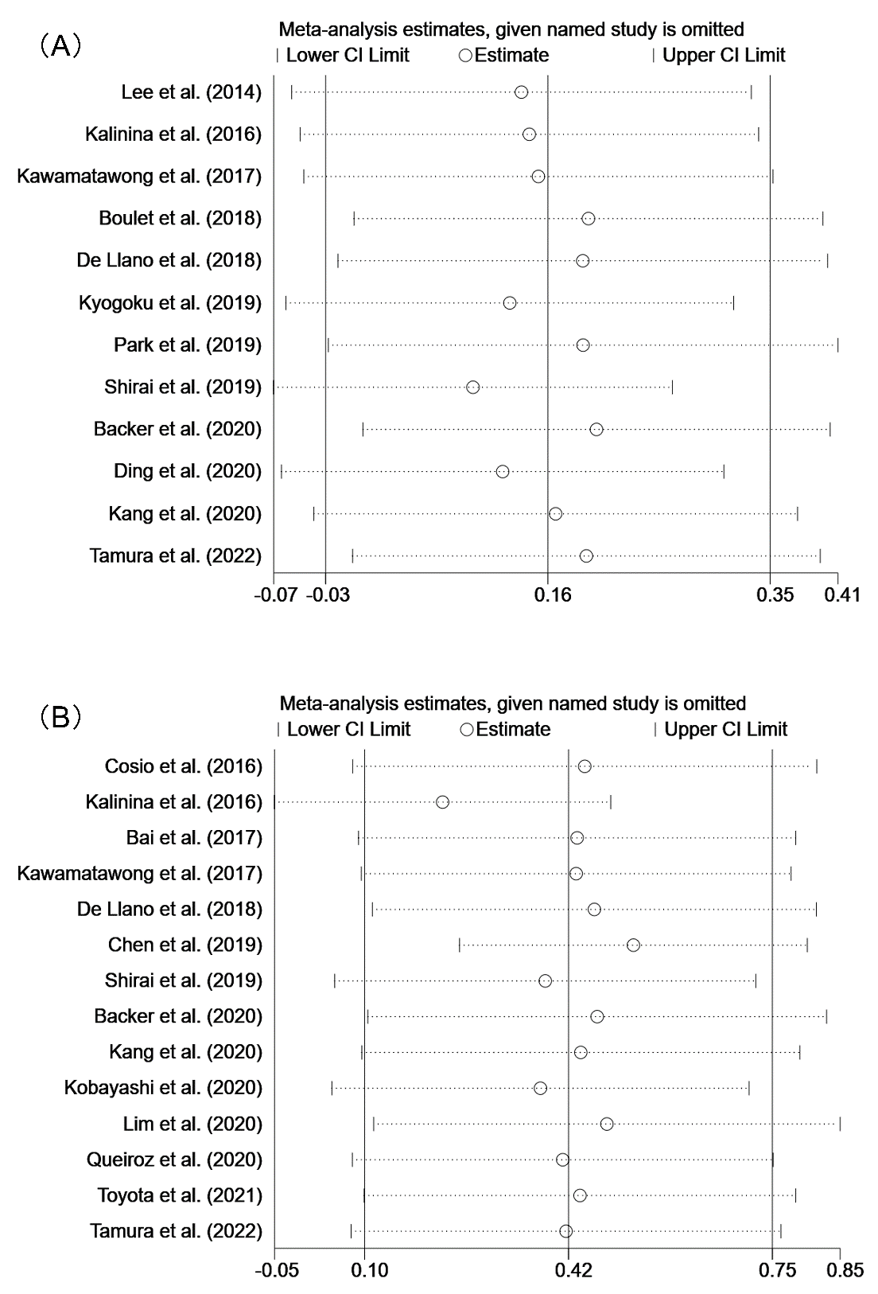
Figure S1. The sensitivity analysis on the pooled results of serum total immunoglobulin E. (A) Asthma-COPD overlap (ACO) vs pure asthma; (B) ACO vs pure chronic obstructive pulmonary disease (COPD).
Abbreviations: CI, confidence interval.
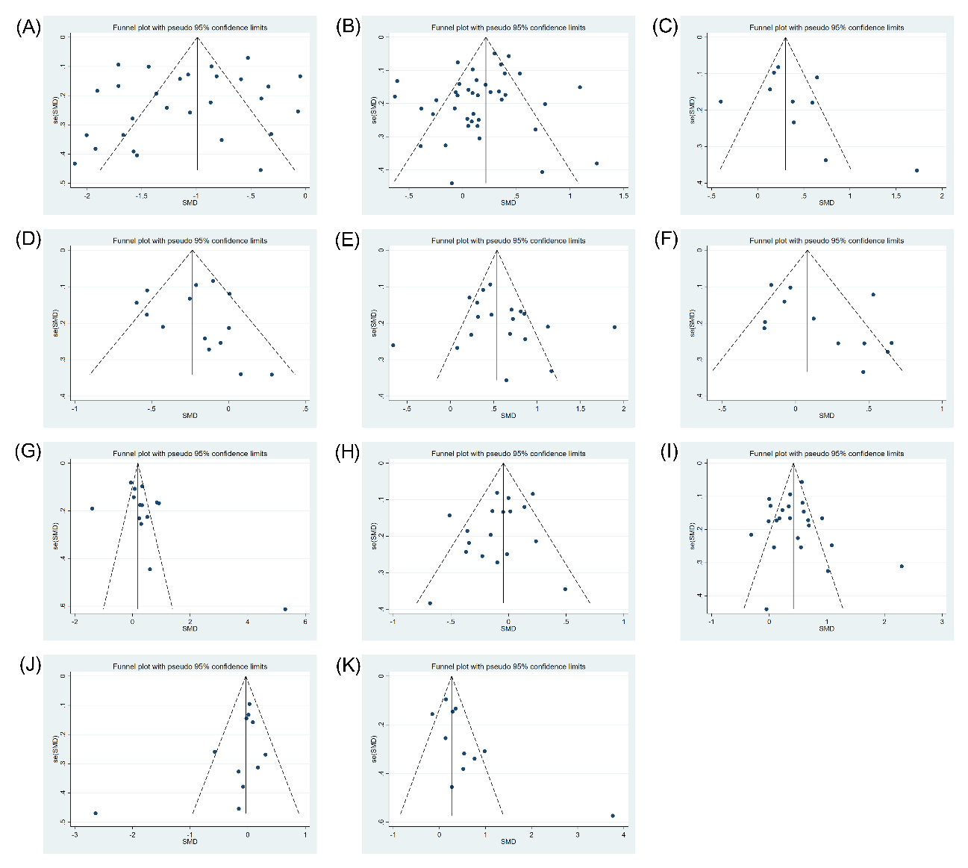
Figure S2. The funnel plots of the pooled results of each indicator. (A) Forced expiratory volume in the first second (FEV₁)% predicted (pred), asthma-COPD overlap (ACO) vs pure asthma; (B) FEV₁% pred, ACO vs pure chronic obstructive pulmonary disease (COPD); (C) Diffusing capacity of the lungs for carbon monoxide (DLCO)% pred, ACO vs pure COPD; (D) Fractional exhaled nitric oxide (FeNO), ACO vs pure asthma; (E) FeNO, ACO vs pure COPD; (F) Serum total immunoglobulin (Ig) E, ACO vs pure asthma; (G) Serum total IgE, ACO vs pure COPD; (H) Blood eosinophil counts, ACO vs pure asthma; (I) Blood eosinophil counts, ACO vs pure COPD; (J) Induced sputum eosinophils, ACO vs pure asthma; (K) Induced sputum neutrophils, ACO vs pure asthma.
Abbreviations: SMD, standardized mean difference.

