Supplementary material
Tables
Table S1. Detailed comorbidities according to the fixed ratio (FEV1/FVC <0.7)
 | TOTAL  n=164 | COPD  n=56 | Non-COPD  n=108 | P-value
Previous myocardial infarction | 66 (40.2%) | 25 (15.2%) | 41 (38%) | 0.50
Heart failure | 41 (25%) | 18 (30.4%) | 24 (22.2%) | 0.26
Peripheral artery disease | 24 (14.6%) | 13 (23.2%) | 11 (10.2%) | 0.03
Diabetes mellitus | 66 (40.2%) | 24 (42.9%) | 42 (38.9%) | 0.74
Arterial hypertension | 111 (68 %) | 35 (62.5%) | 76 (70.4%) | 0.23
Dyslipidemia | 113 (68.9%) | 43 (76.8%) | 70 (64.8%) | 0.16
Arrhythmia | 20 (12.2%) | 12 (21.4%) | 8 (7.4%) | 0.01
Mood disorders | 50 (30.5%) | 17 (30.4%) | 33 (30.6%) | 1
Previous angina | 77 (47%) | 25 (44.6%) | 52 (48.1%) | 0.74
Previous PCI | 59 (36%) | 21 (37.5%) | 38 (35,2%) | 0.86
Anemia | 18 (11.1%) | 8 (14.5%) | 10 (9.3%) | 0.43
PCI=percutaneous coronary intervention. ** Described through median and interquartile range (IQR) 25-75%.

Table S2
Table S4.
Detailed differences in variables between cluster groups.

Figures
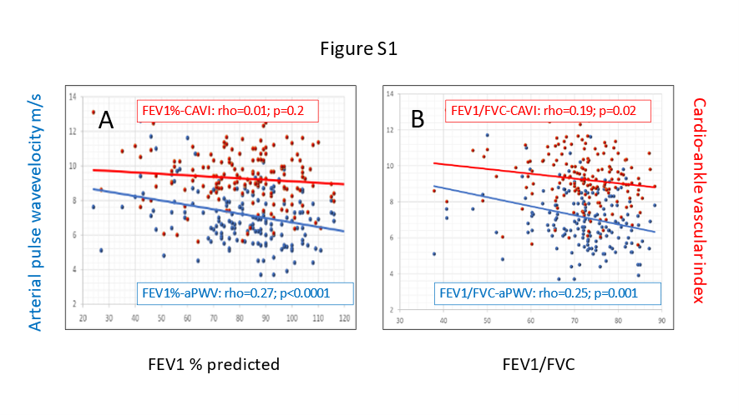
Figure S1. Scatter diagram of arterial pulse wave velocity (aPWV; blue) and cardio-ankle vascular index (CAVI; red) with FEV1% (A) and FEV1/FVC

