Supplementary Materials

Figure S1. TEM images for AgNPs-EPI (several photos for the same sample).
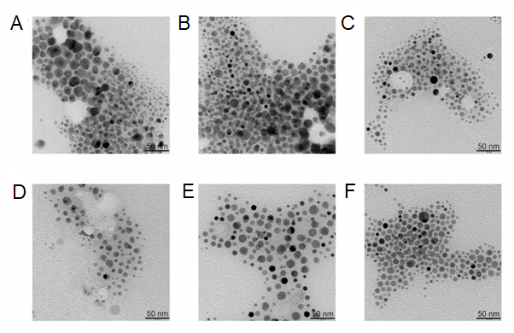
Table S1. Effect of platelets activation by collagen on respiration states of mitochondria under AgNPs-EPI and EPI coincubation.

Respiration  (pmol O₂∙s⁻¹∙mL) | Control | Collagen | AgNPs-EPI | AgNPs-EPI  + collagen | EPI | EPI  + collagen
state CI | 40.67 ± 8.70 | 46.14 ± 4.73 | 40.45 ± 6.85 | 49.06 ± 4.41 | 36.45 ± 7.98 | 46.96 ± 8.20
state CI + CII | 92.73 ± 10.37 | 95.05 ± 14.32 | 90.52 ± 16.98 | 101.29 ± 13.15 | 76.67 ± 19.93 | 91.90 ± 18.69
state E | 101.71 ± 4.68 | 102.37 ± 19.97 | 100.29 ± 16.87 | 107.01 ± 15.60 | 81.39 ± 20.67 | 101.41 ± 25.62
state R | 64.39 ± 3.41 | 58.37 ± 10.20 | 63.87 ± 14.14 | 61.17 ± 6.47 | 50.03 ± 13.38 | 57.97 ± 11.77

OXPHOS capacity of complex I (state CI), maximal OXPHOS capacity with convergent input through both complex I and complex II (state CI + CII), electron transfer system (ETS) capacity (state E) and electron flow specific to complex II (state R) were measured in platelets treatment without (control) or in presence of collagen, AgNPs-EPI + collagen, EPI + collagen or AgNPs-EPI and EPI alone. Results are presented as the mean ± SD.

Figure S2. Parameters related with the coagulation system: PT (Prothrombin time), APTT (Activated partial thromboplastin time), APTT ratio (the ratio of a patient's APTT to the normal laboratory reference, TT (Thrombin time), INR (the ratio of the patient's protrombin time to the control protrombin time standardized for the potency of the thromboplastin reagent), plasma fibrinogen, D-dimers.
