 | TMP | PM₁₀ | PM_{2.5} | CO | NO | NO₂ | NO_{X} | PM_{CO} | SO₂
Fraxinus sp. | 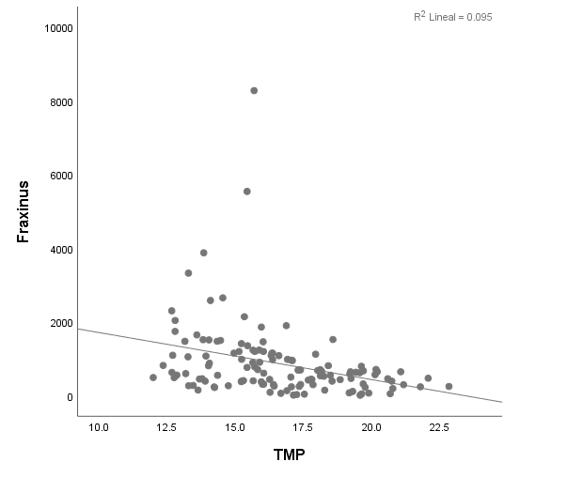  p<0.001  r=-0.308 | 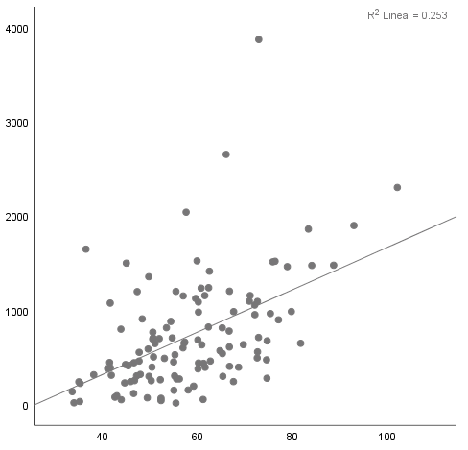  p<0.001  r=0.503 | 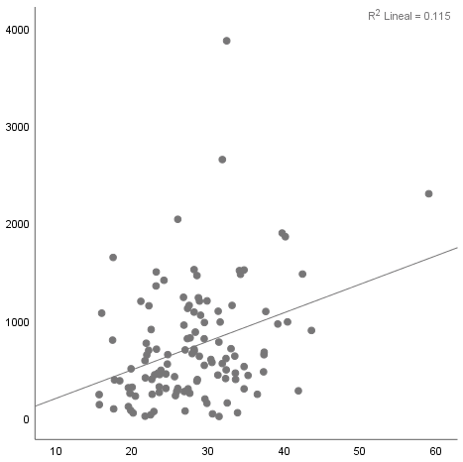  p=0<0.001  r=0.339 | 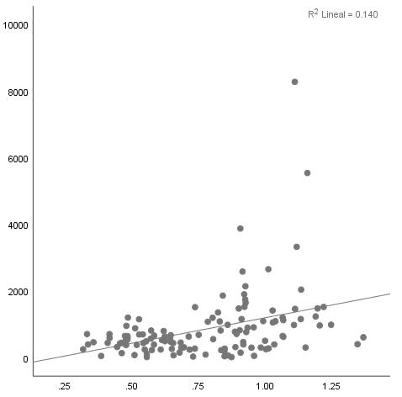  p<0.001  r=0.374 | 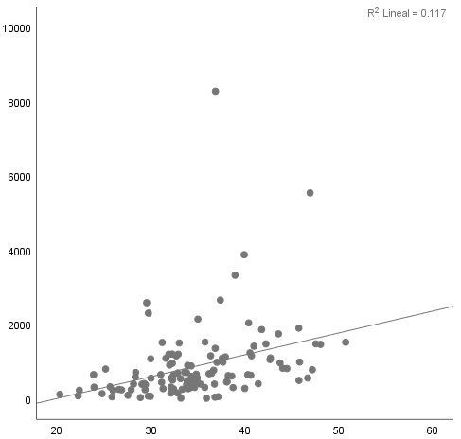  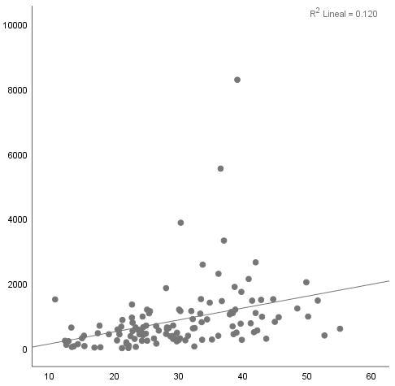  p<0.001  r=0.346 | p<0.001  r=0.343 | 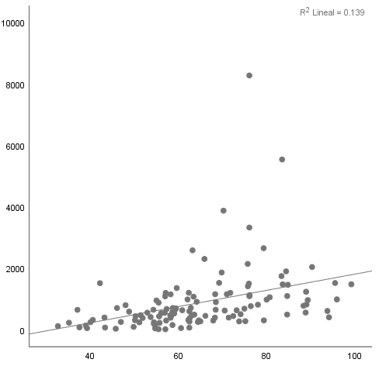  p<0.001  r=0.373 | 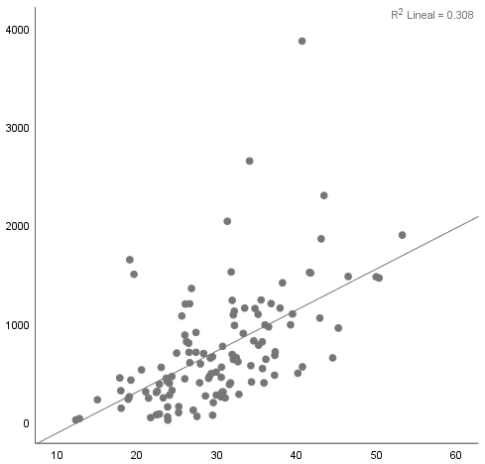  p=0.001  r=0.555 | 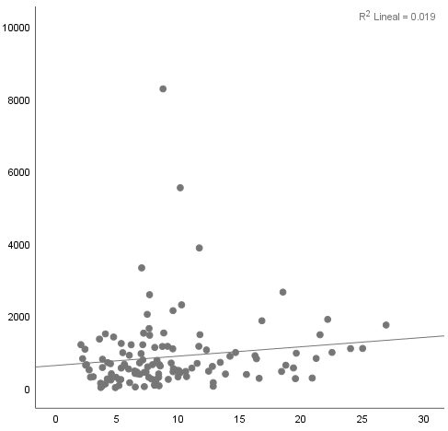  p=0.13  r=0.136
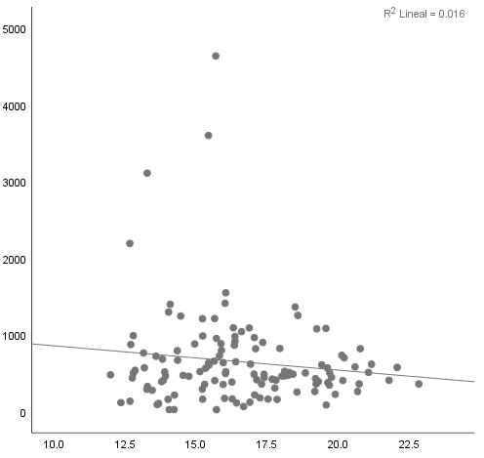  Cupressaceae | p=0.15  r=-0.127 | 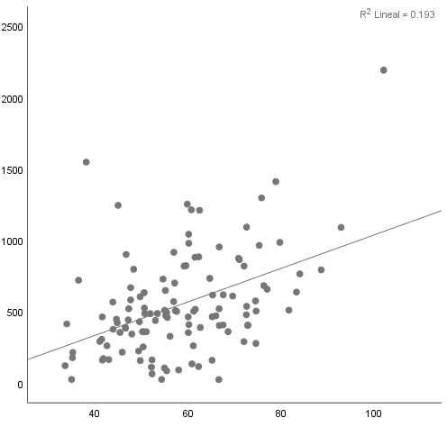  p<0.001  r=0.44 | 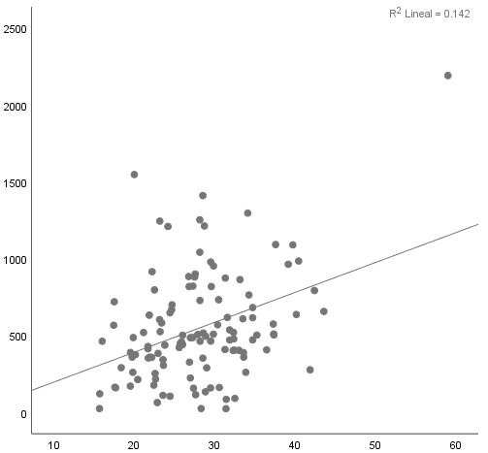  p<0.001  r=0.377 | 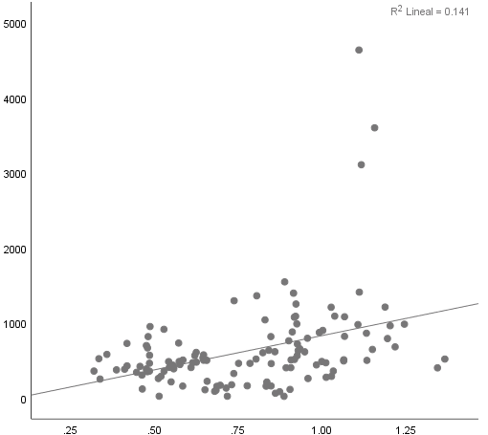  p<0.001  r=0.376 | 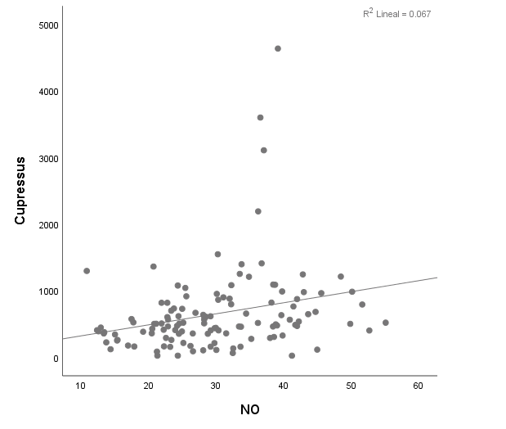  p=0.004  r=0.259 | 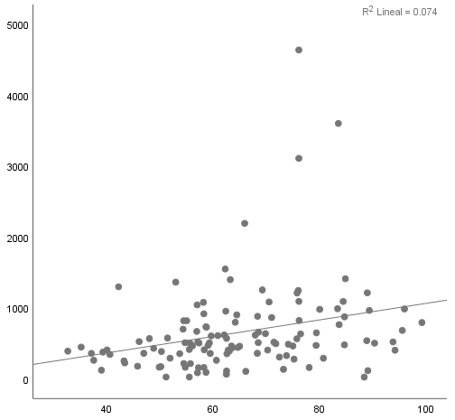  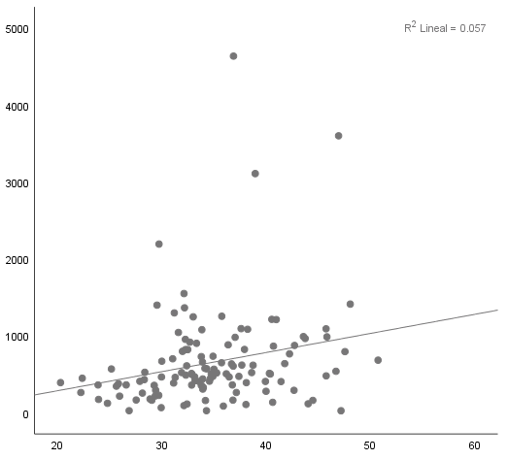  p=0.008  r=0.239 | p=0.003  r=0.272 | 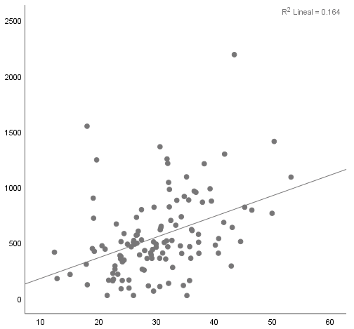  p<0.001  r=0.405 | 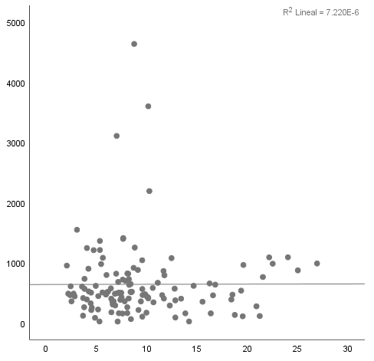  p=0.97  r=0.003
Alnus sp. | 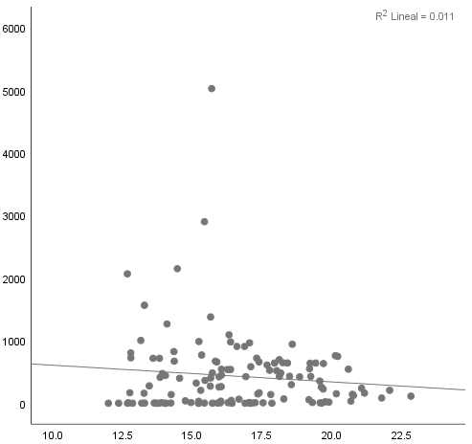  p=0.23  r=-0.106 | 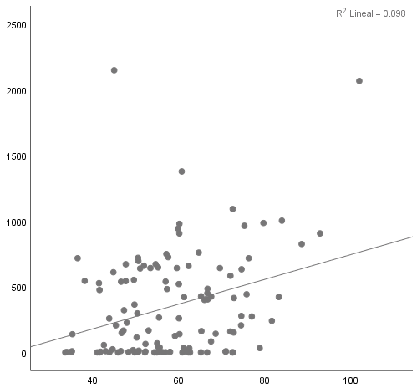  p=0.001  r=0.313 | 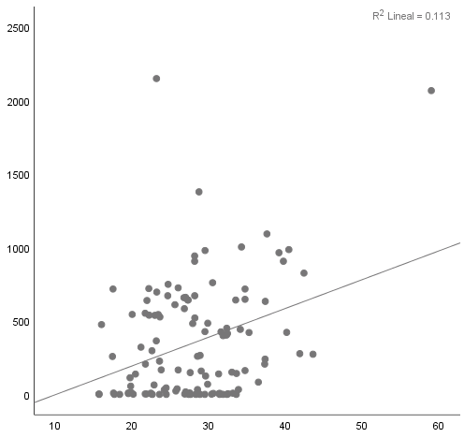  p<0.001  r=0.336 | 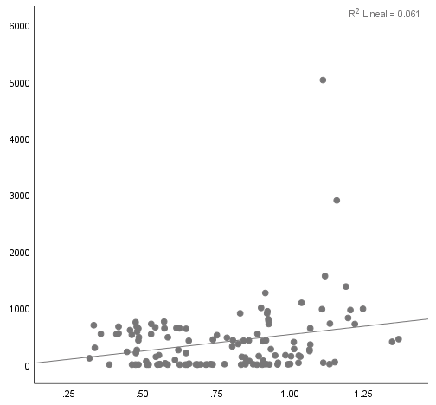  p=0.006  r=0.247 | 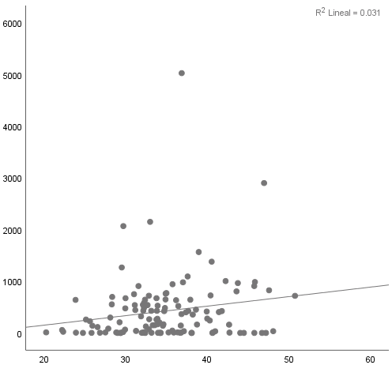  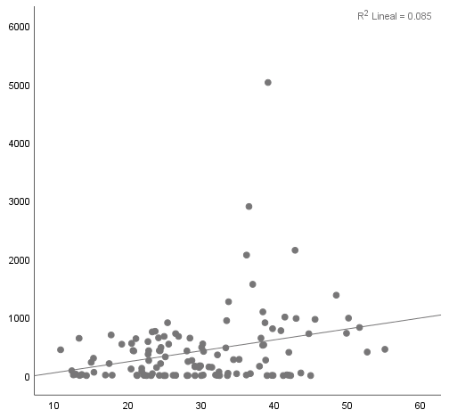  p=0.001  r=0.291 | p=0.05  r=0.176 | 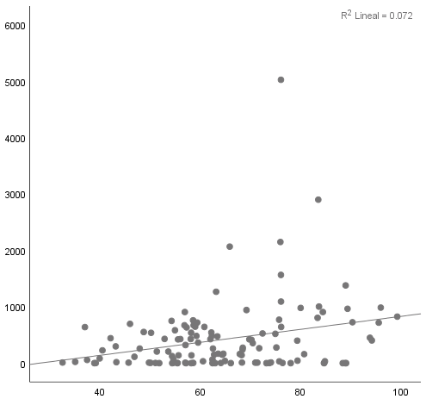  p=0.003  r=0.268 | 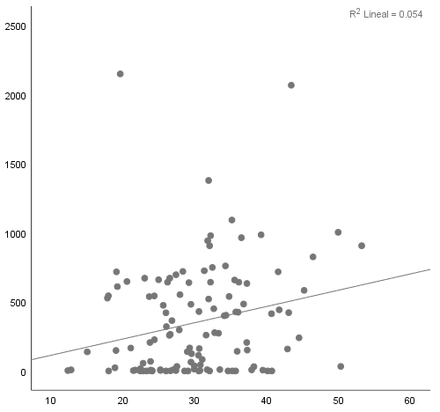  p=0.01  r=0.233 | 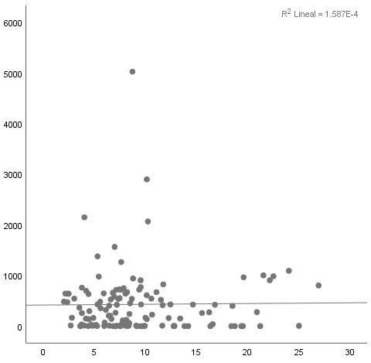  p=0.88  r=0.013
Quercus sp. | 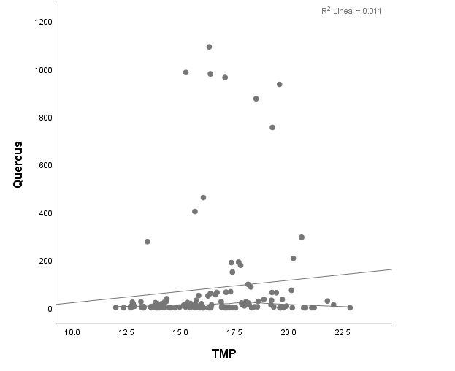  p=0.24  r=0.105 | 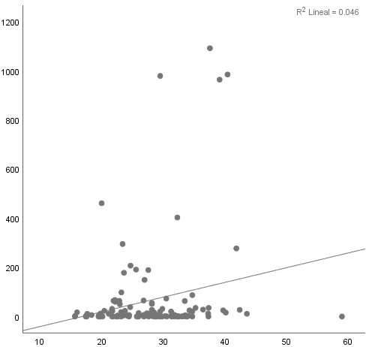  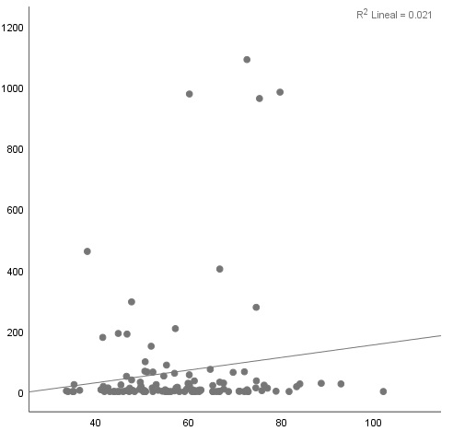  p=0.12  r=0.144 | p=0.02  r=0.214 | 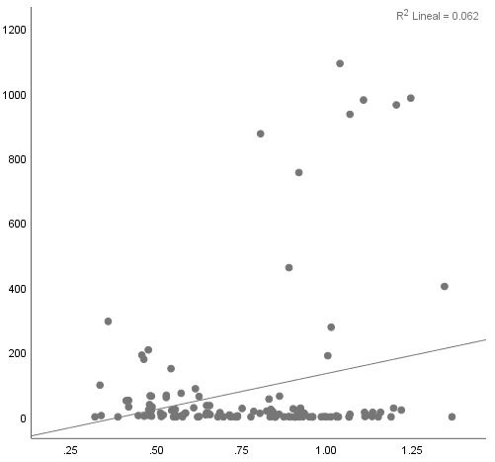  p=0.01  r=0.249 | 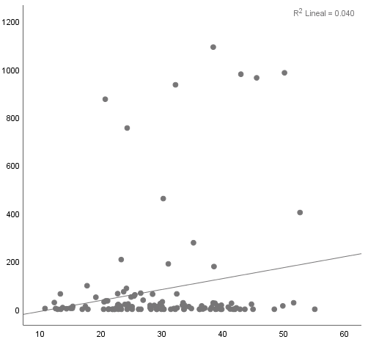  p=0.03  r=0.02 | 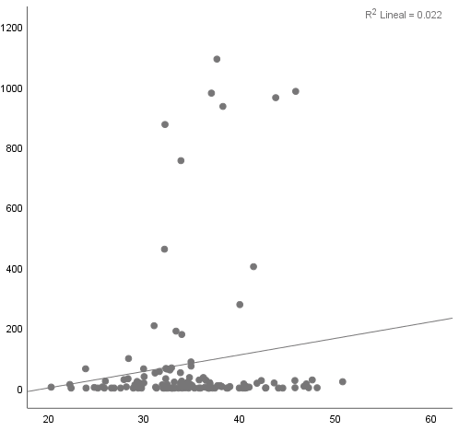  p=0.11  r=0.148 | 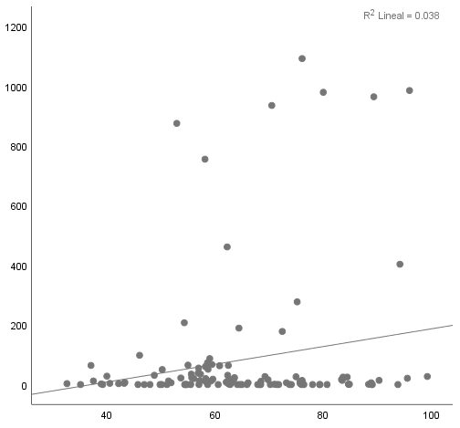  p=0.03  r=0.195 | 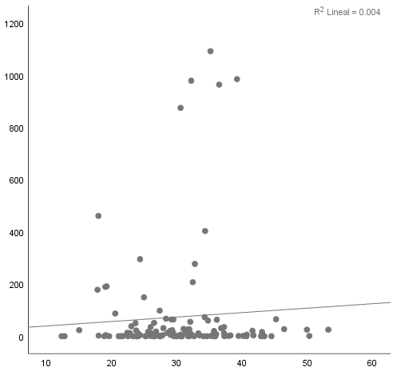  p=0.48  r=0.065 | 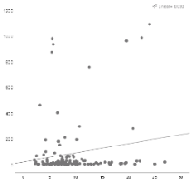  p=0.05  r=0.172  p=0.05  r=0.172

Supplementary Figure 1. Global correlations between meteorological variables/pollutants with pollen.
Abbreviations: CO, carbon monoxide; NO, nitrogen monoxide; NO₂, nitrogen dioxide; NO_{X}, nitrogen oxides; O₃, ozone; PM_{CO}, coarse fraction of PM₁₀ and PM_{2.5} particles; SO₂, sulfur dioxide; TMP, temperature; WSP, wind speed; RH, relative humidity; PM₁₀, particulate matter of 10 micrometers or less; PM_{2.5}, particulate matter of 2.5 micrometers or less.

 | TMP | PM₁₀ | PM_{2.5} | NO | NO₂ | NO_{X} | PM_{CO} | O₃ | SO₂
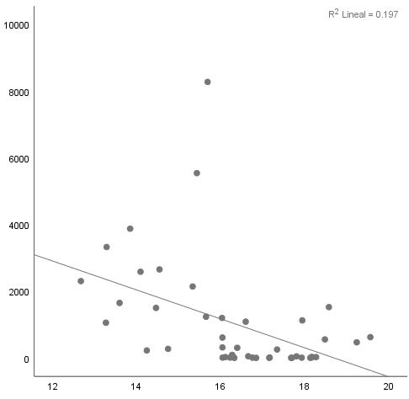  Fraxinus sp. S1 | p=0.12  r=-0.309 | 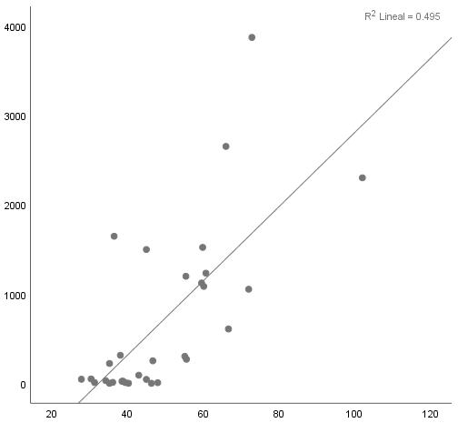  p=0.01  r=0.555 | 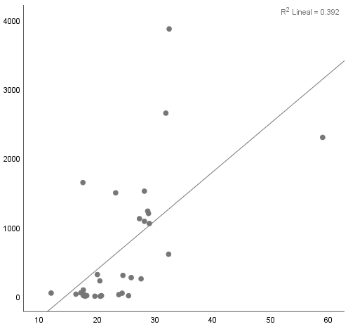  p=0.04  r=0.486 | 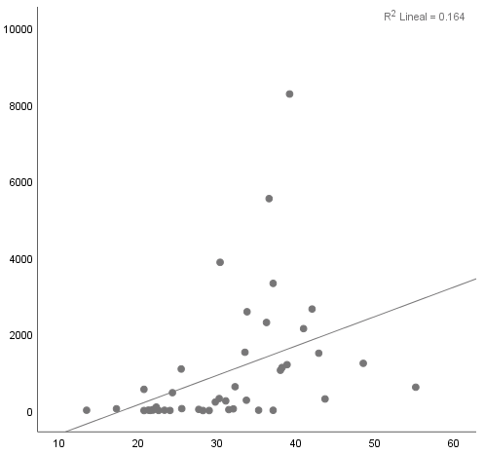  p=0.36  r=0.188 | 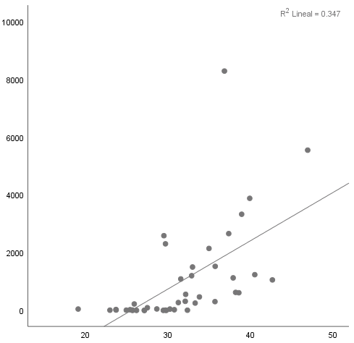  p=0.029  r=0.438 | 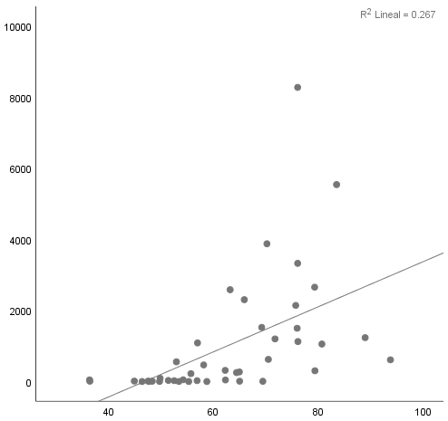  p=0.11  r=0.326 | 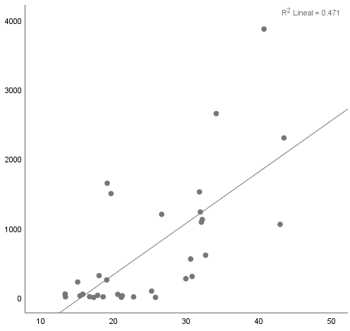  p=0.02  r=0.53 | 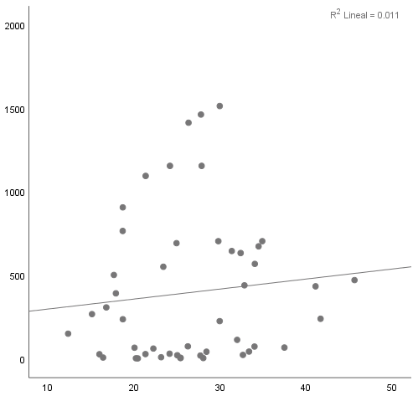  p=0.83  r=-0.44 | 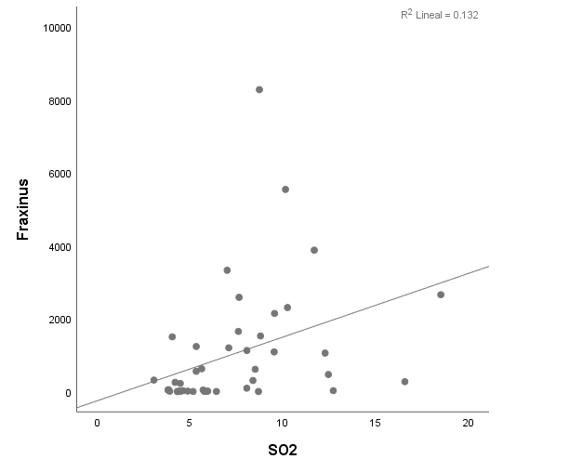  p=0.33  r=0.198
Fraxinus sp. S2 | 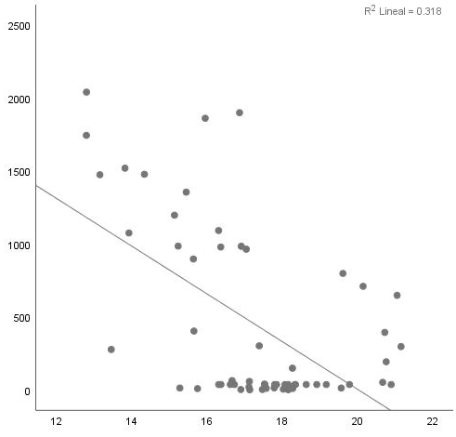  p<0.001  r=-0.64 | 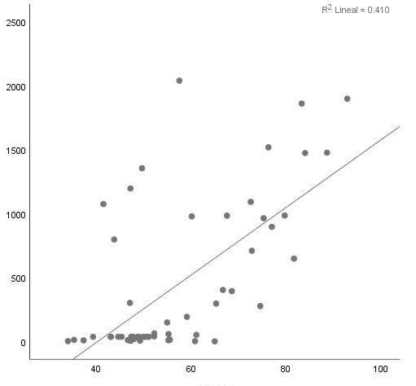  p=0.02  r=0.418 | 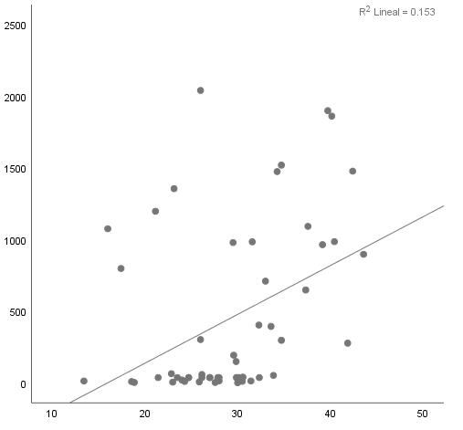  p=0.50  r=0.128 | 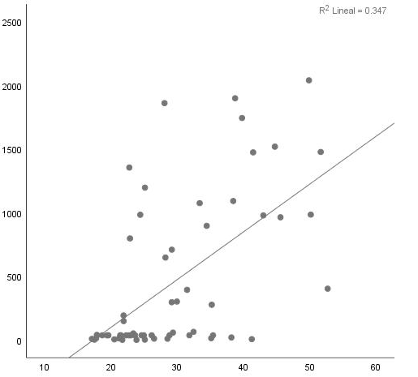  p=0.005  r=0.497 | 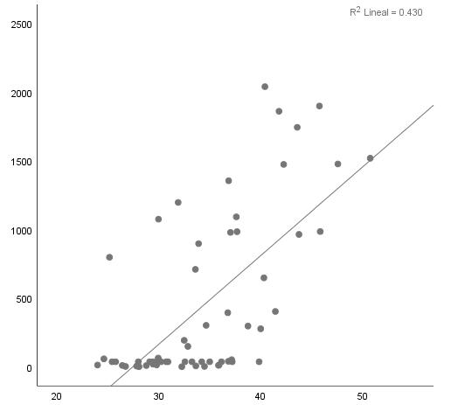  p=0.005  r=0.497 | 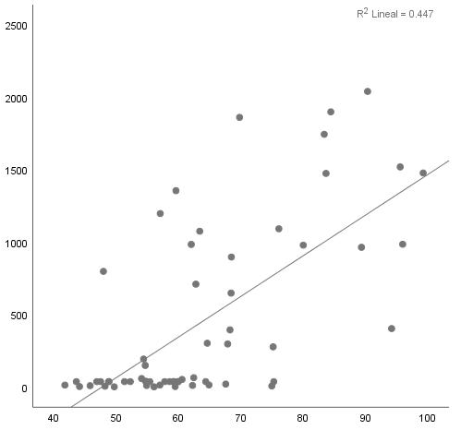  p=0.002 r=0.542 | 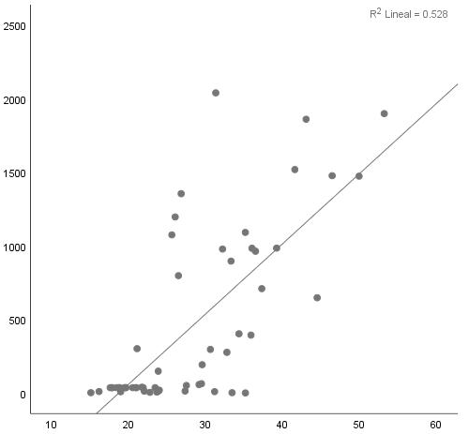  p=0.001  r=0.604 | 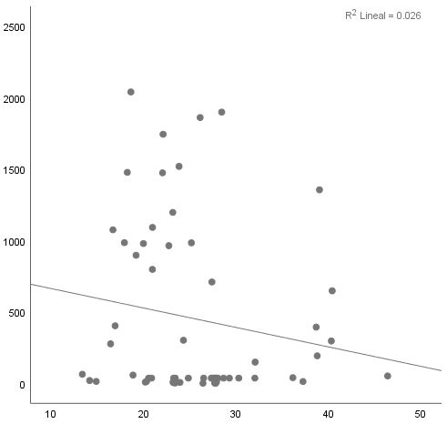  p=0.03  r=-0.38 | 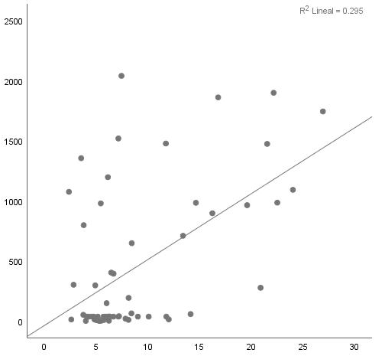  p=0.01  r=0.439
Fraxinus sp. S3 | 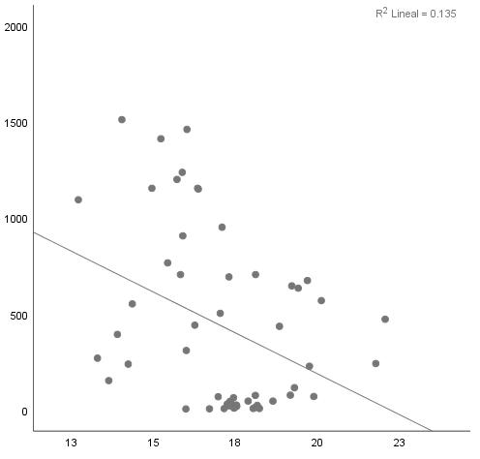  p=0.02  r=-0.37 | 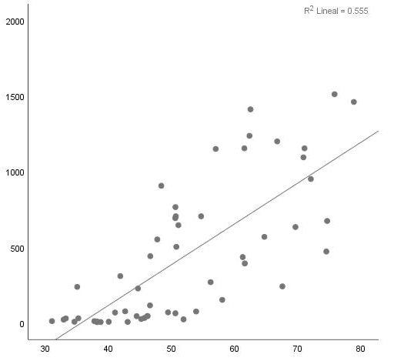  p<0.001  r=0.619 | 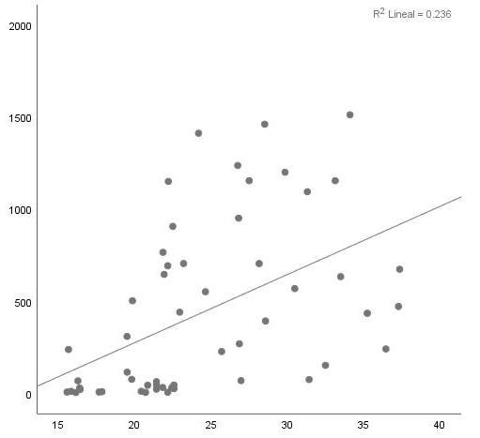  p=0.22  r=0.21 | 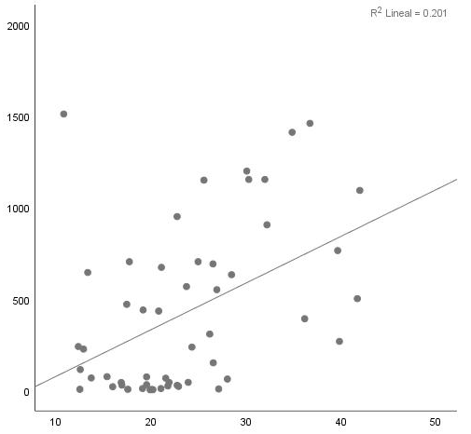  p=0.02  r=0.382 | 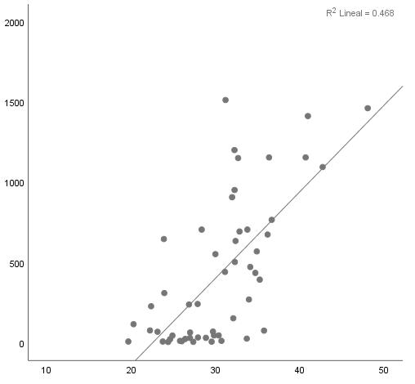  p<0.001  r=0.659 | 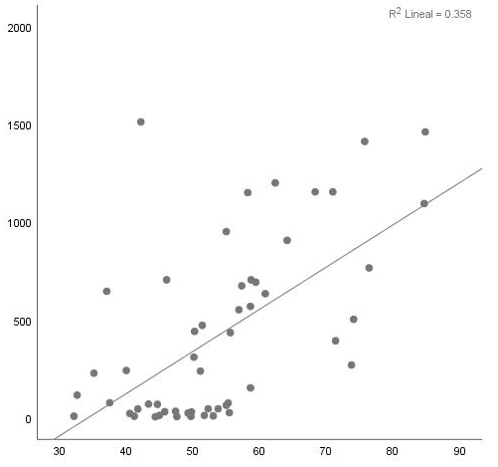  p=0.001  r=0.535 | 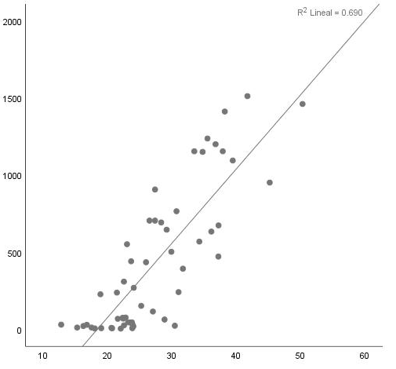  p<0.001  r=0.794 | 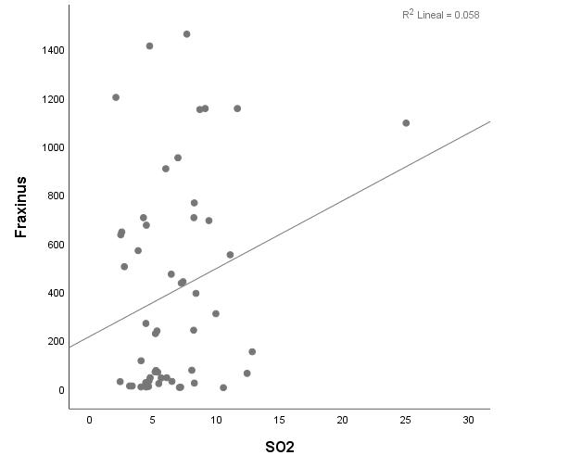  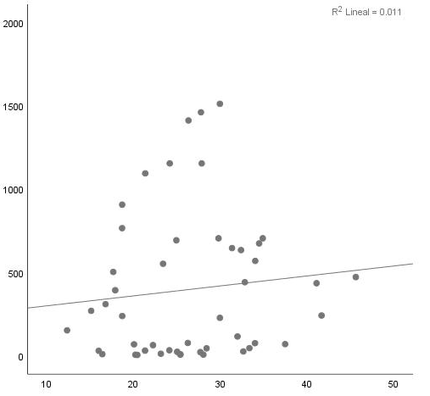  p=0.98  r=-0.003 | p=0.35  r=0.166
Fraxinus sp. S4 | 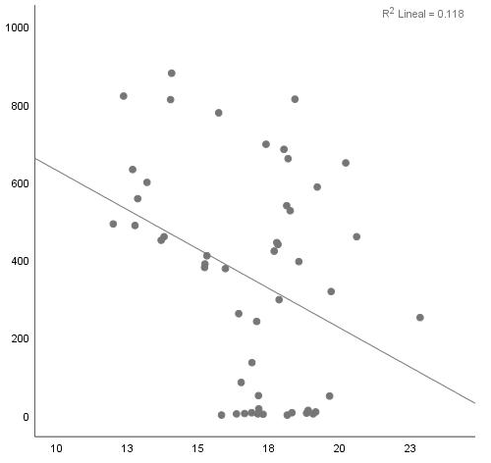  p=0.06  r=-0.317 | 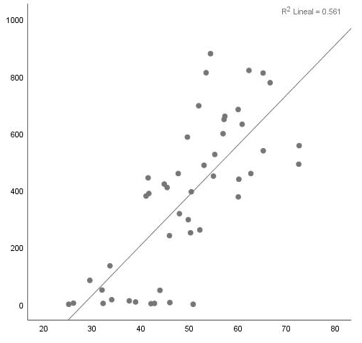  p<0.001  r=0.626 | 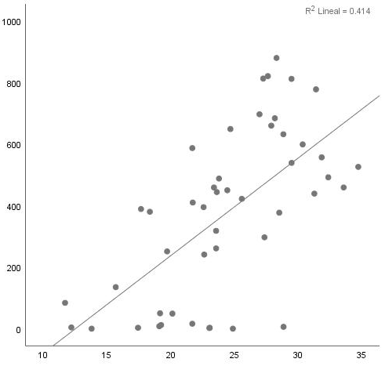  p<0.001  r=0.569 | 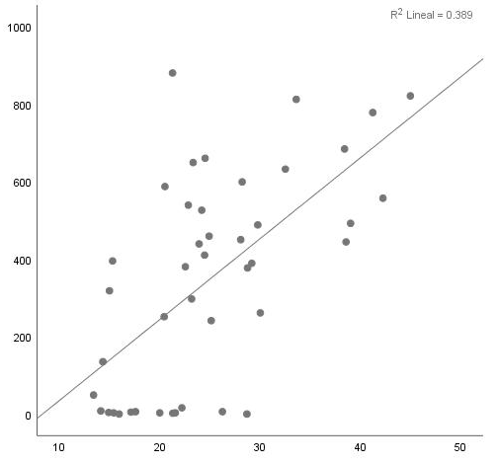  p=0.001  r=0.548 | 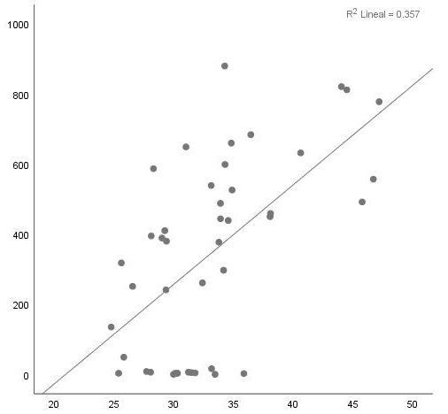  p<0.001  r=0.623 | 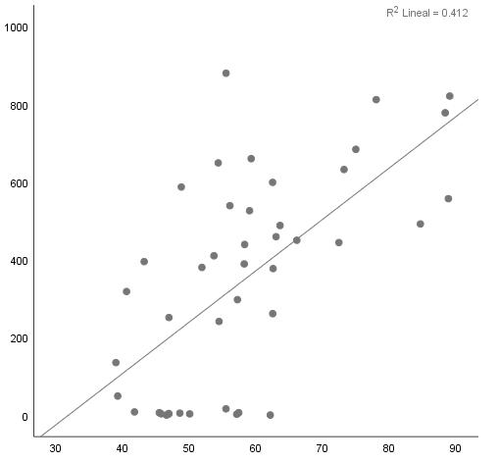  p<0.001  r=0.604 | 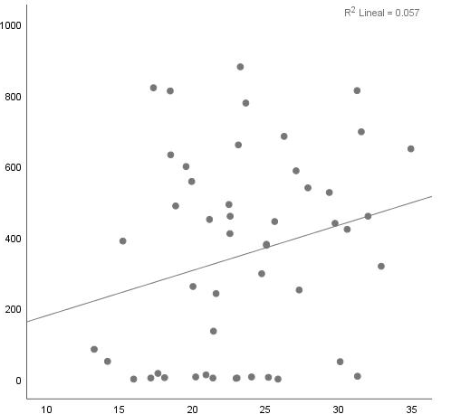  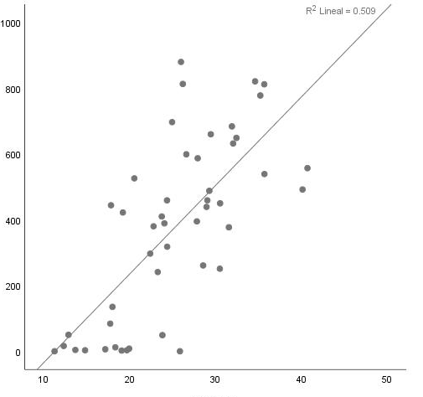  p=0.001  r=0.532 | p=0.88  r=0.025 | 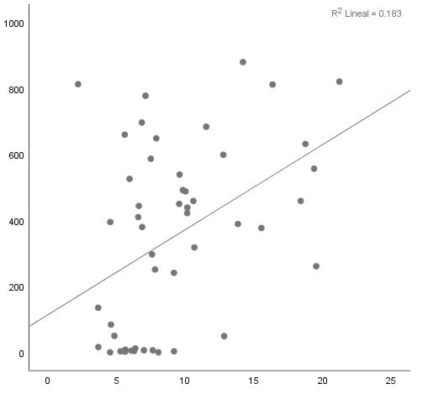  p=0.24  r=0.201
Cupressaceae S1 | 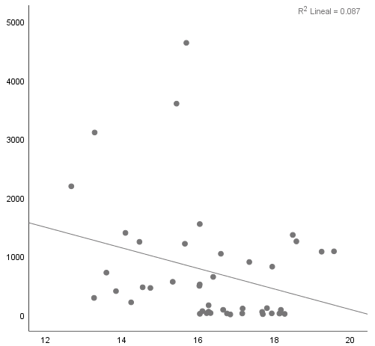  p=0.71  r=-0.075 | 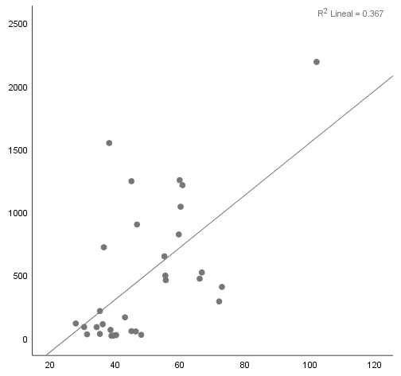  p=0.15  r=0.351 | 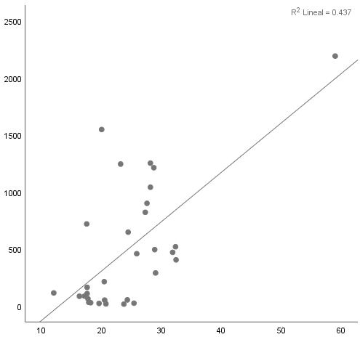  p=0.022  r=0.536 | 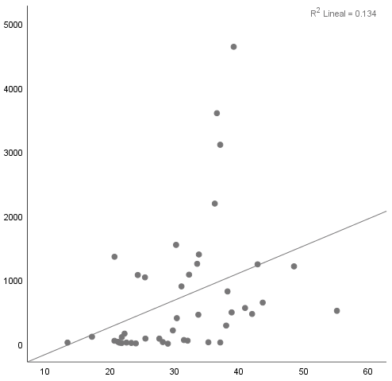  p=0.77  r=0.059 | 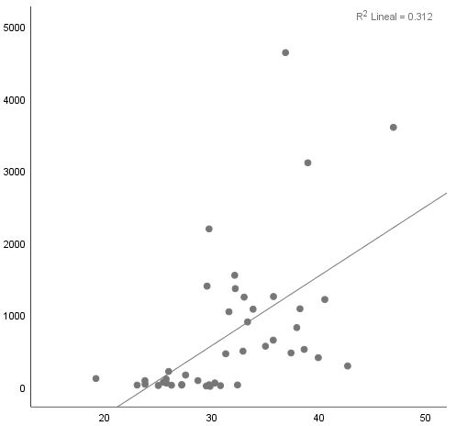  p=0.12  r=0.313 | 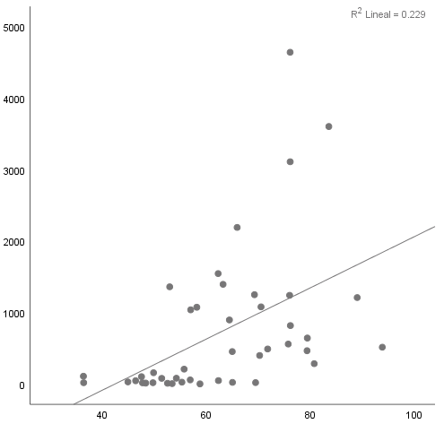  p=0.38  r=0.18 | 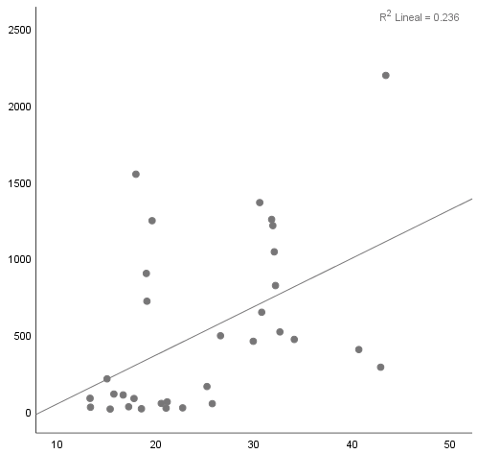  p=0.68  r=0.099 | 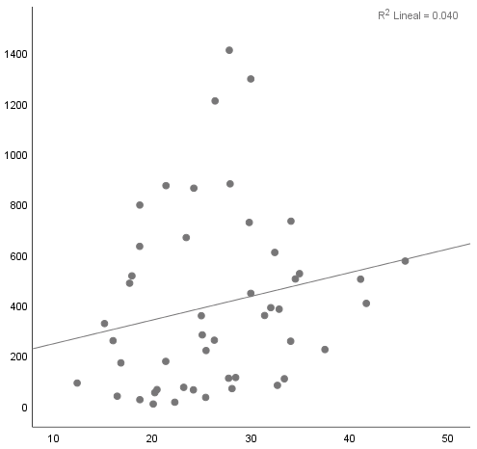  p=0.37  r=0.182 | 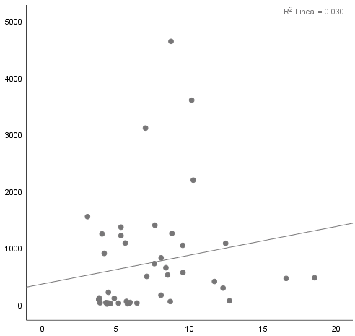  p=0.55  r=-0.123
Cupressaceae S2 | 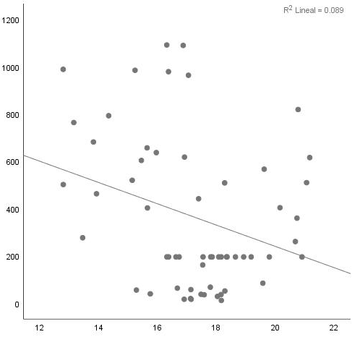  p=0.14  r=-0.273 | 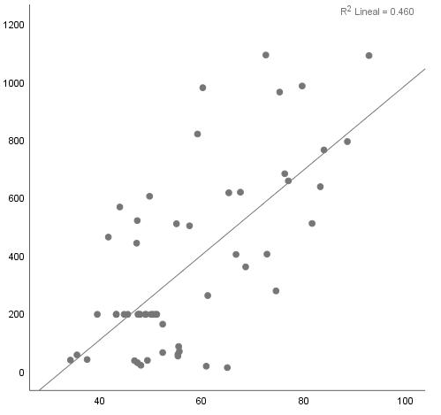  p=0.006  r=0.497 | 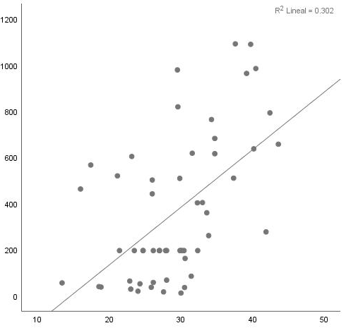  p=0.55  r=0.36 | 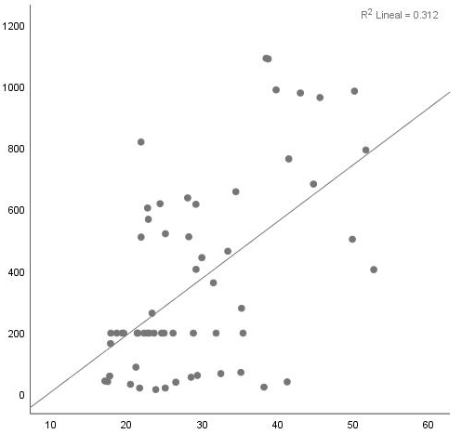  p=0.008  r=0.478 | 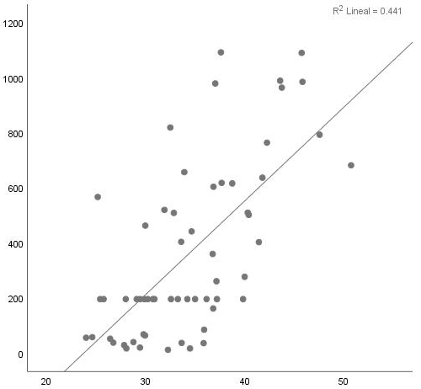  p=0.01  r=0.454 | 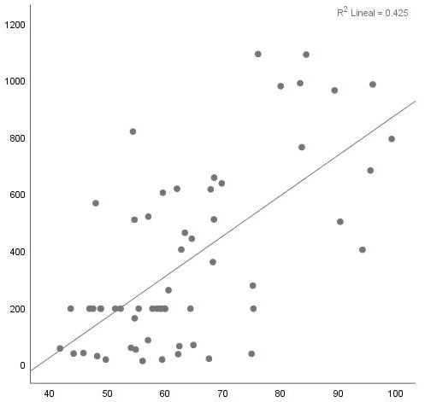  p=0.01  r=0.442 | 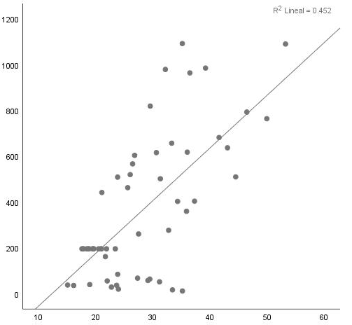  p=0.001  r=0.604 | 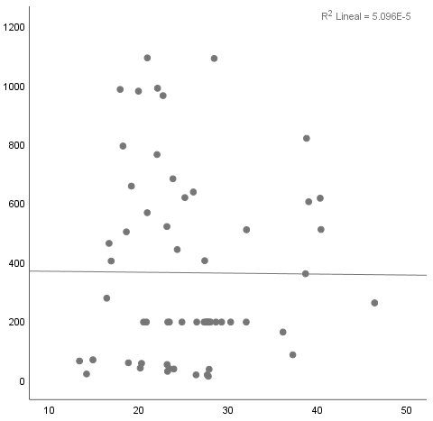  p=0.55  r=0.11 | 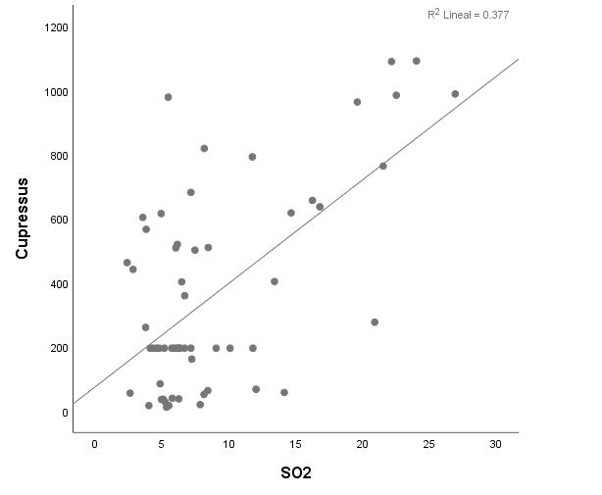  p=0.01  r=0.439
Cupressaceae S3 | 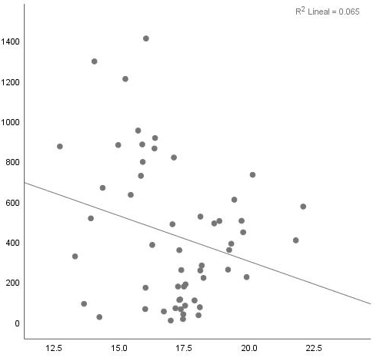  p=0.15  r=-0.248 | 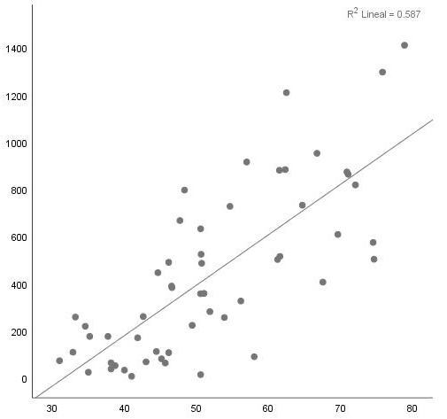  p< 0.001  r=0.676 | 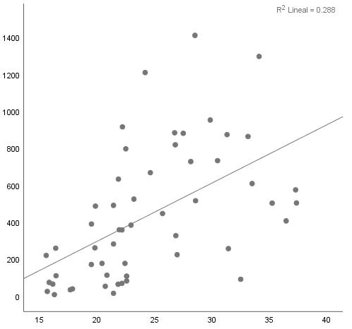  p=0.07  r=0.306 | 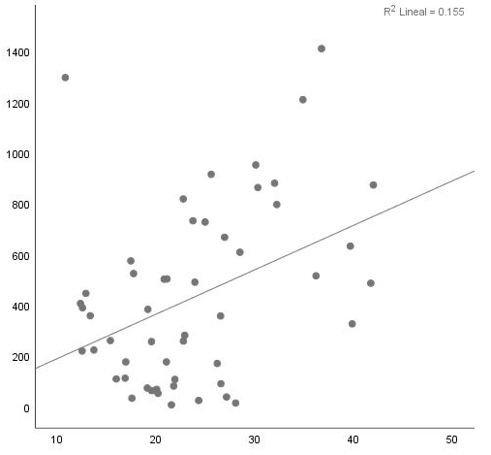  p=0.06  r=0.318 | 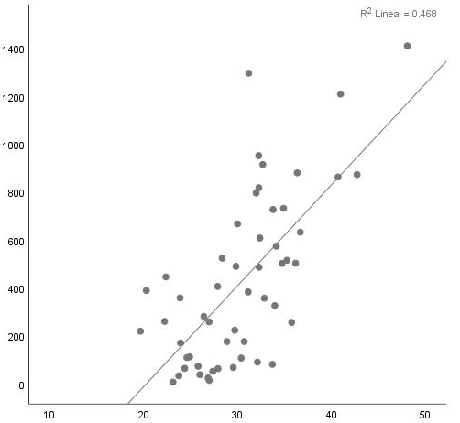  p=0.001  r=0.653 | 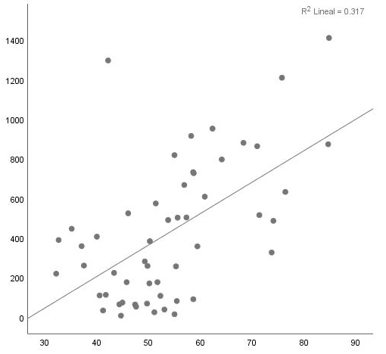  p=0.003  r=0.489 | 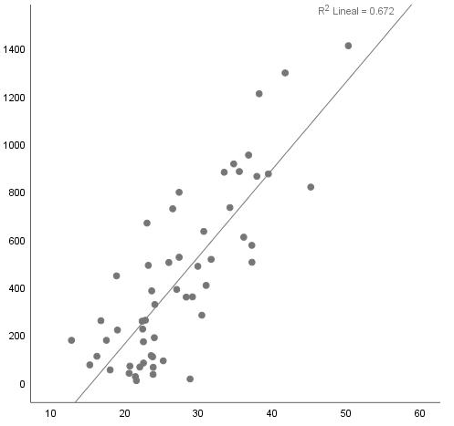  p<0.001  r=0.802 | 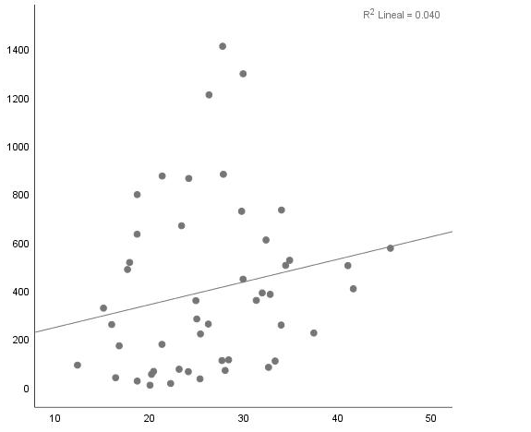  p=0.48  r=0.13 | 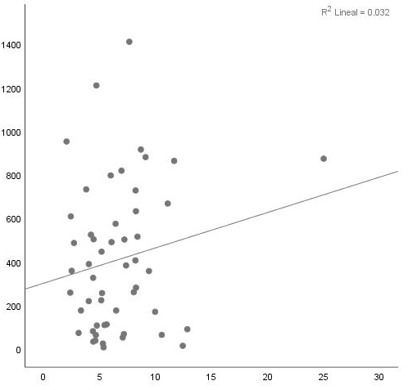  p=0.54  r=0.108
Cupressaceae S4 | 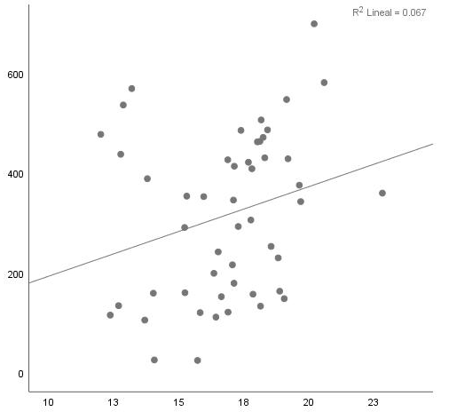  p=0.05  r=0.329 | 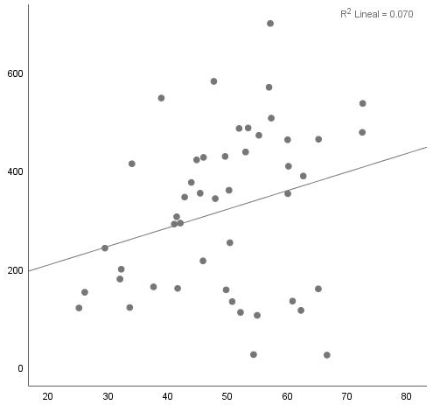  p=0.46  r=0.126 | 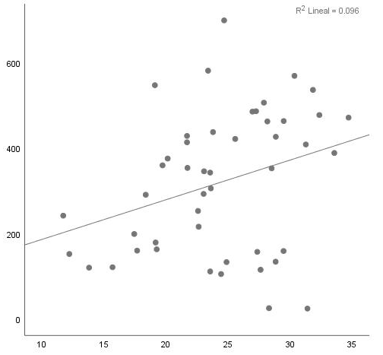  p=0.25  r=0.193 | 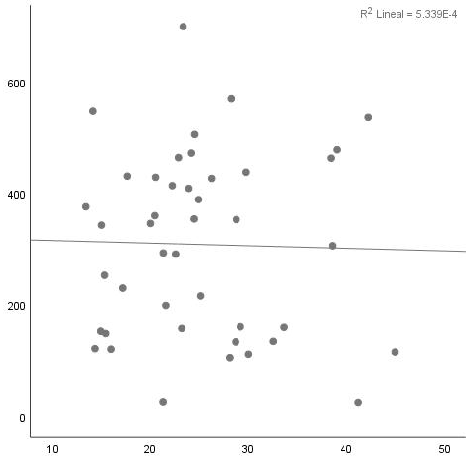  p=0.64  r=-0.085 | 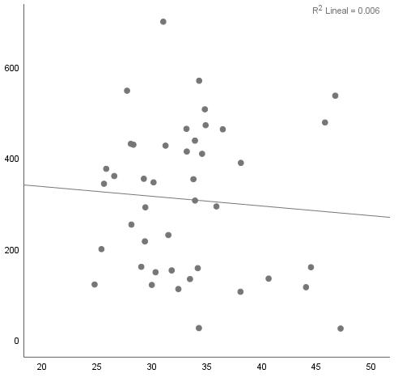  p=0.58  r=-0.099 | 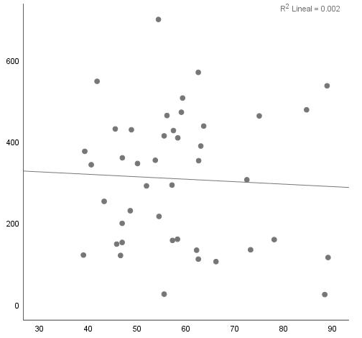  p=0.60  r=-0.095 | 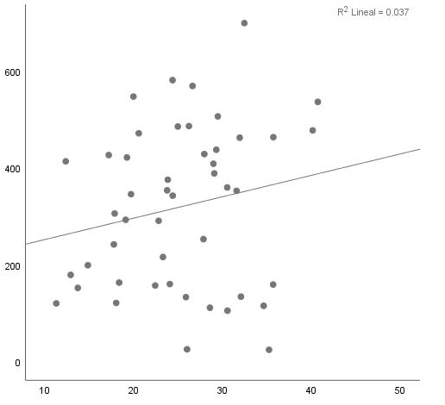  p=0.77  r=0.049 | 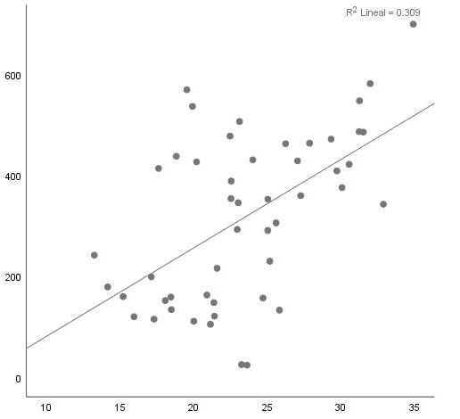  p=0.001  r=0.518 | 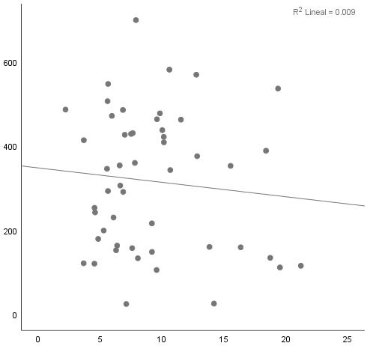  p=0.16  r=-0.238
Alnus sp. S1 | 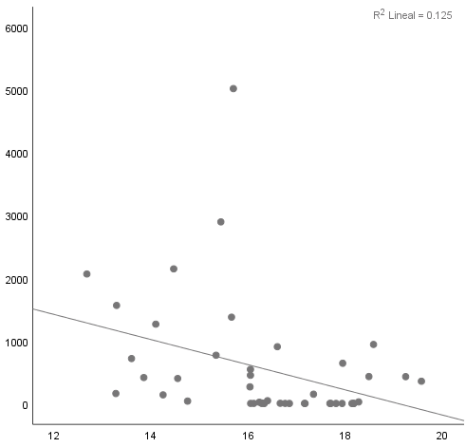  p=0.32  r=-0.201 | 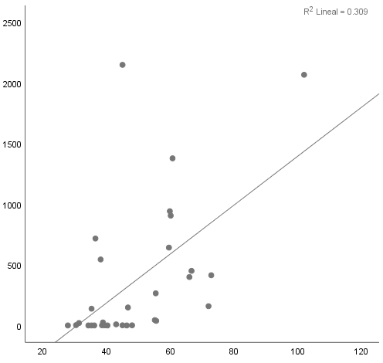  p=0.14  r=0.356 | 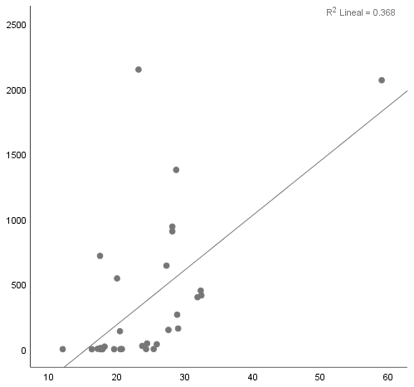  p=0.04  r=0.479 | 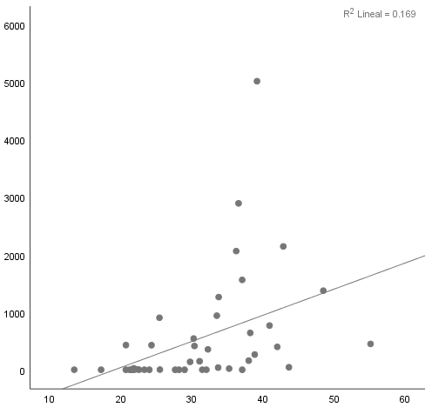  p=0.28  r=0.225 | 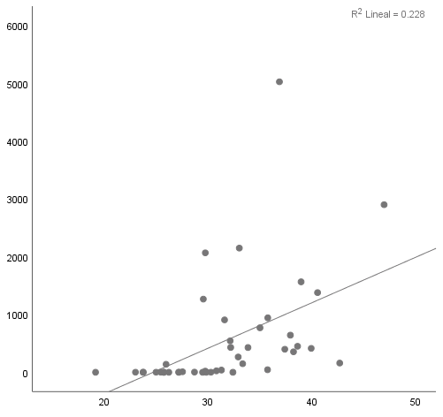  p=0.20  r=0.261 | 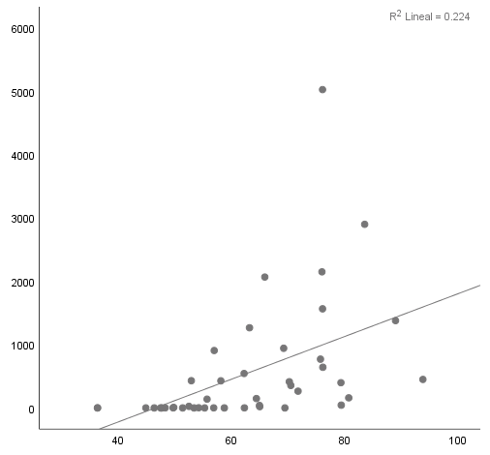  p=0.18  r=0.276 | 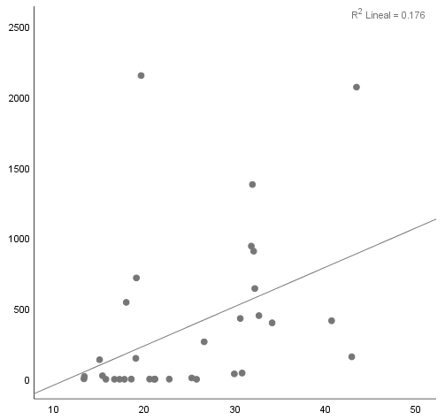  p=0.58  r=0.134 | 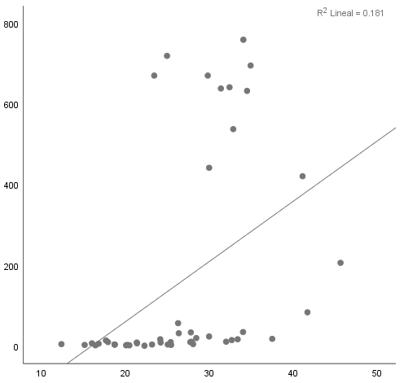  p=-0.01  r=0.949 | 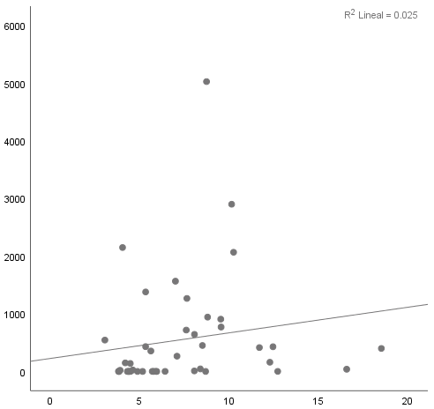  p=0.71  r=-0.074
Alnus sp. S2 | 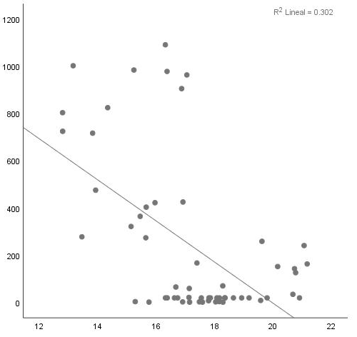  p<0.001  r=-0.601 | 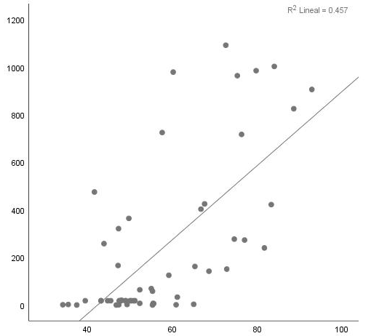  p=0.005  r=0.51 | 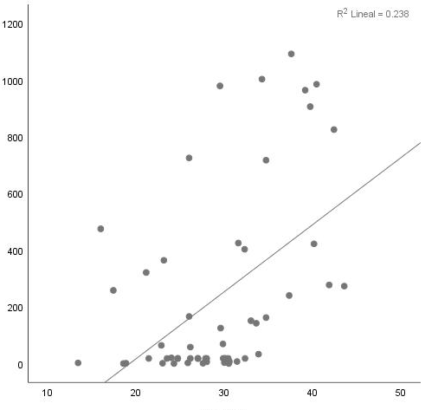  p=0.09  r=0.317 | 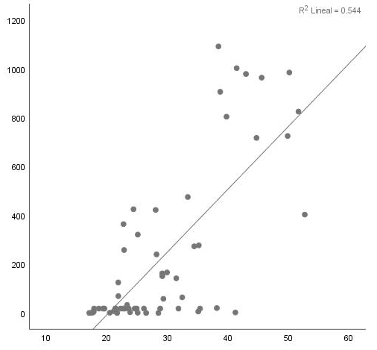  p<0.001  r=0.763 | 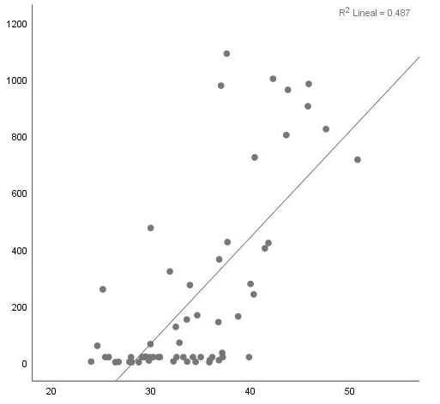  p<0.001  r=0.609 | 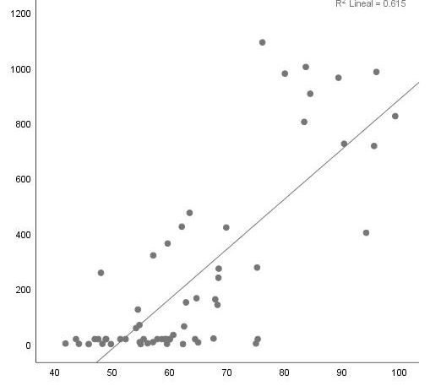  p<0.001  r=0.771 | 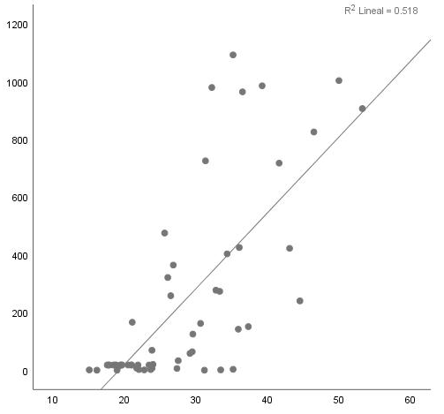  p<0.001  r=0.612 | 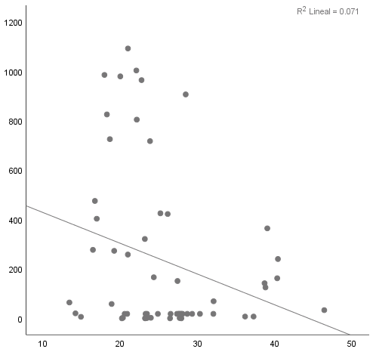  p=0.004  r=0.51 | 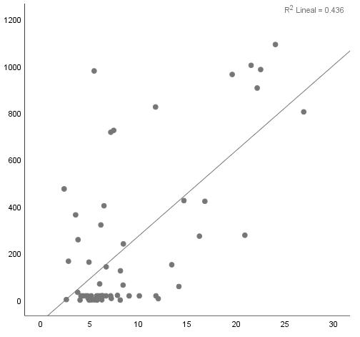  p=0.01  r=0.439
Alnus sp. S3 | 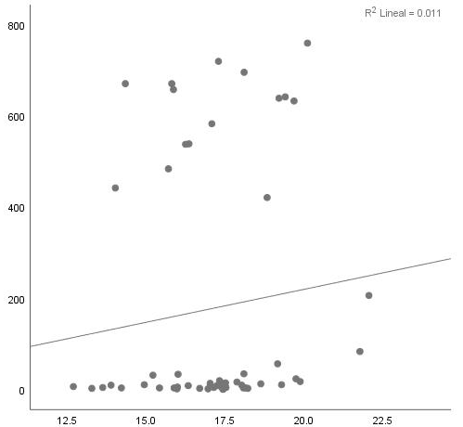  p=0.23  r=0.208 | 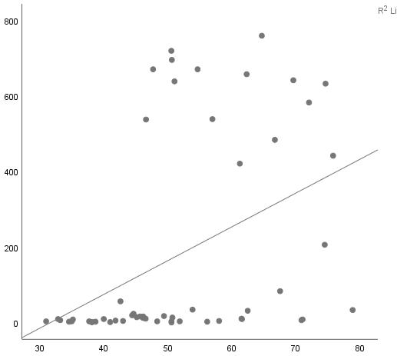  p=0.23  r=0.295 | 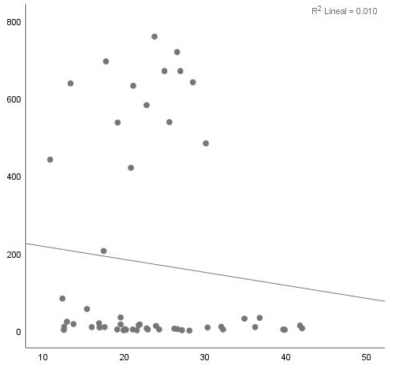  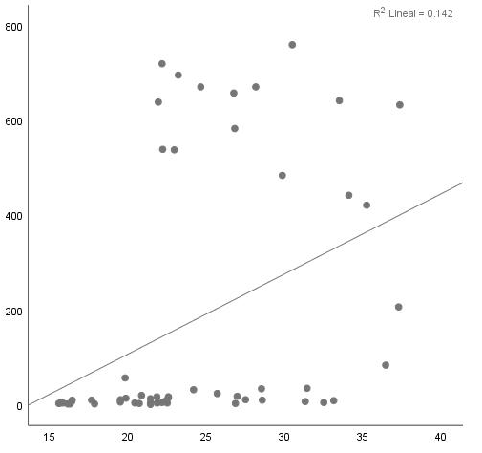  p=0.32  r=0.171 | p=0.11  r=-0.277 | 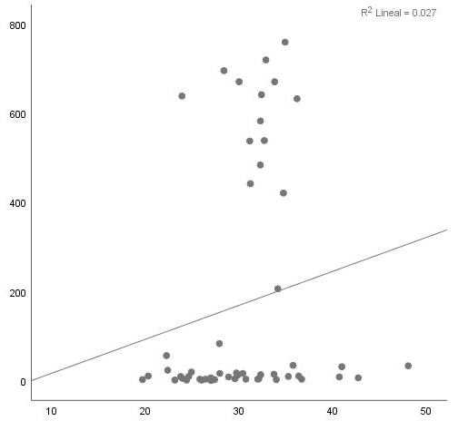  p=0.8  r=-0.045 | 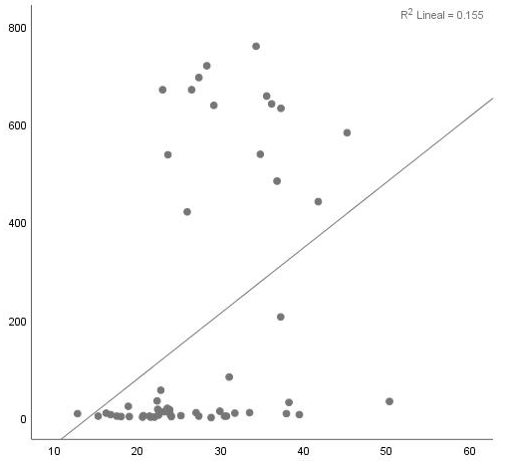  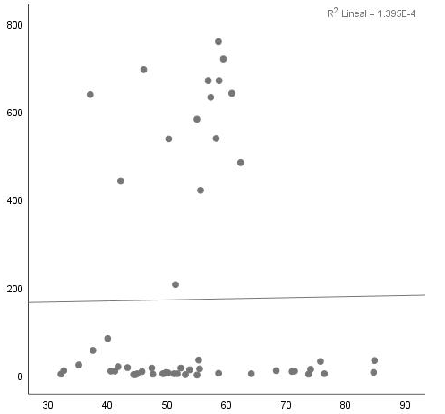  p=-0.20  r=-0.254 | 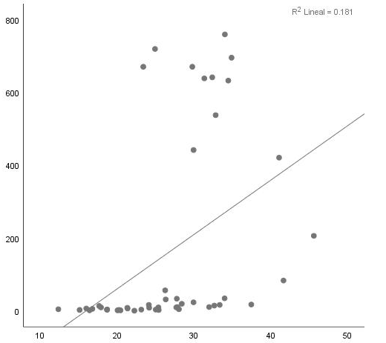  p=0.26  r=0.194 | p=0.01  r=0.436 | 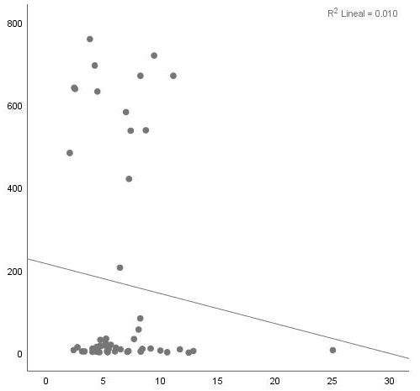  p=0.18  r=-0.234
Alnus sp. S4 | 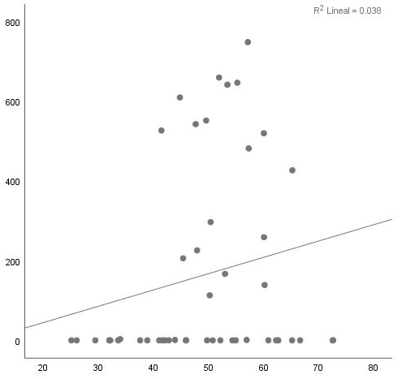  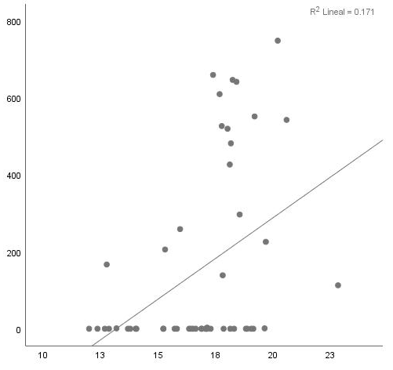  p=<0.001  r=0.566 | p=0.749  r=-0.055 | 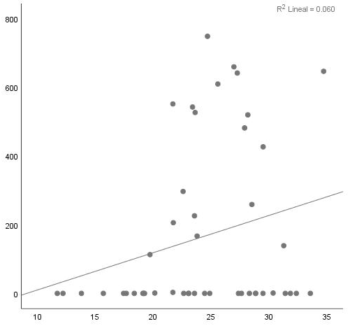  p=0.637  r=0.081 | 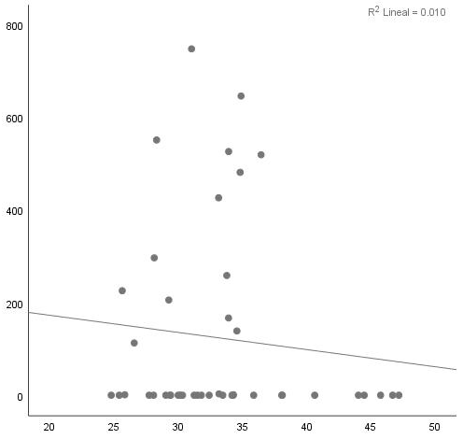  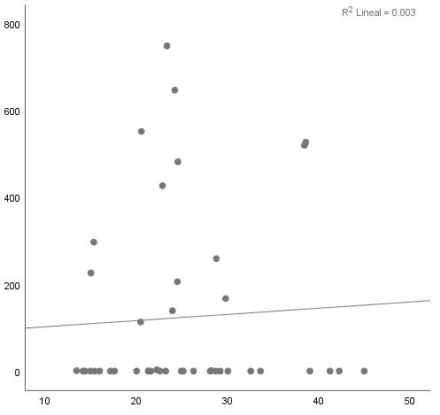  p=0.558  r=-0.107 | p=0.207  r=-0.229 | 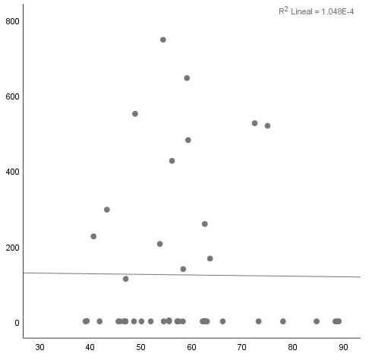  p=0.364  r=-0.166 | 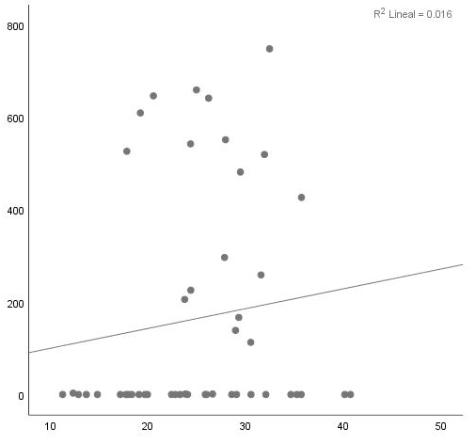  p=0.397  r=-0.146 | 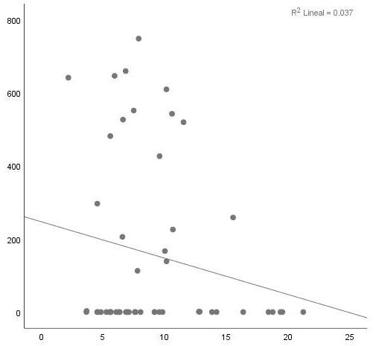  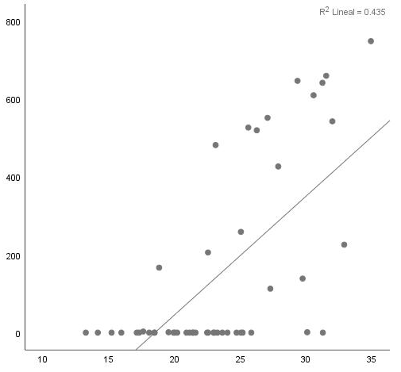  p=<0.001  r=0.718 | p=0.008  r=-0.436
Quercus sp. S1 | 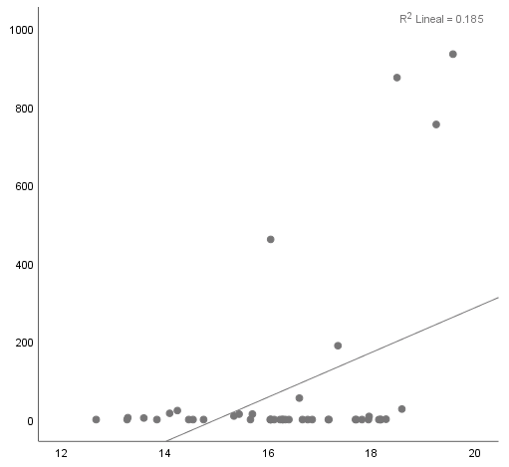  p<0.001  r=0.672 | 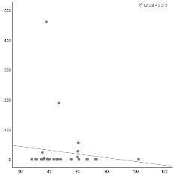  p=0.14  r=-0.358 | 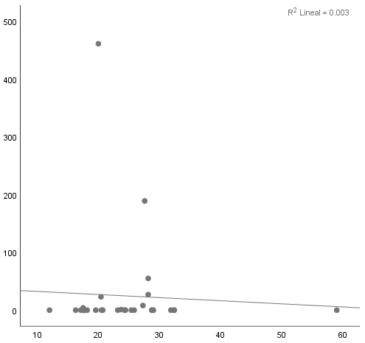  p=0.37  r=-0.223 | 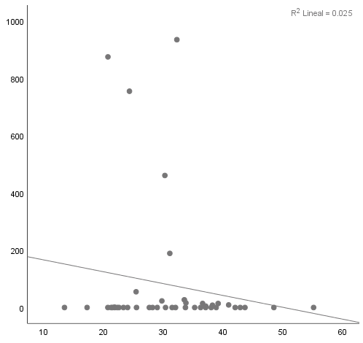  p=0.01  r=-0.503 | 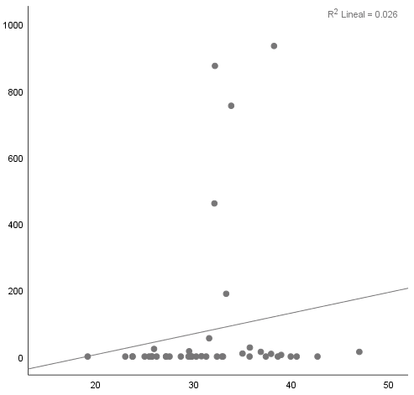  p=0.71  r=-0.076 | 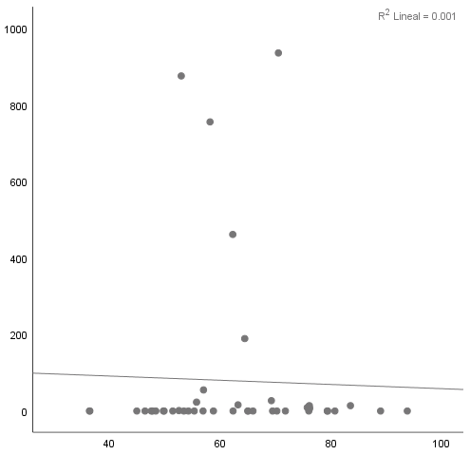  p=0.05  r=-0.394 | 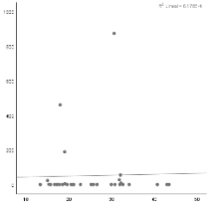  p=0.45  r=-0.184 | 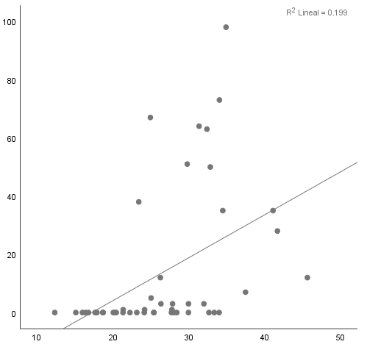  p<0.001  r=0.705 | 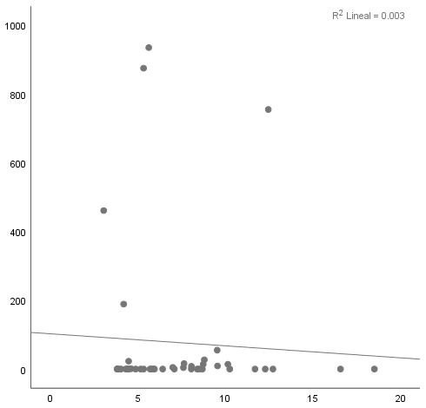  p=0.24  r=-0.234
Quercus sp. S2 | 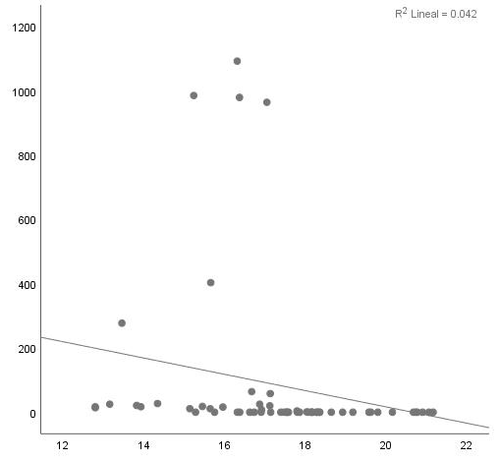  p=0.40  r=-0.305 | 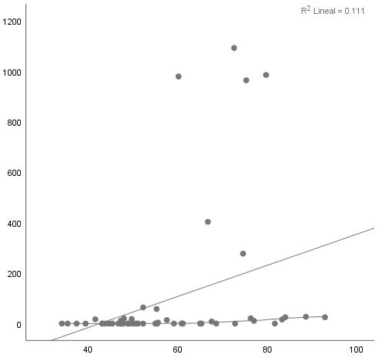  p=0.29  r=0.2 | 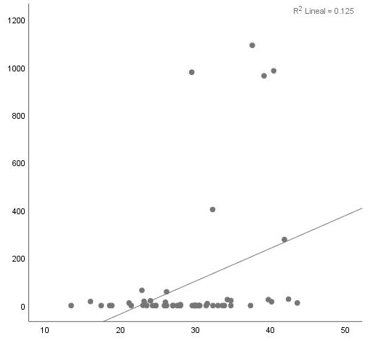  p=0.13  r=0.281 | 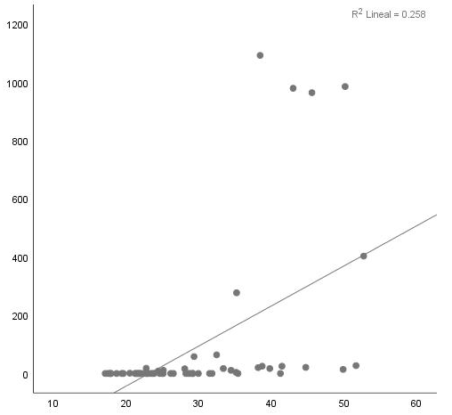  p=0.005  r=0.499 | 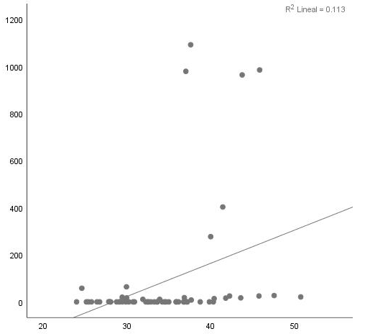  p=0.20  r=0.238 | 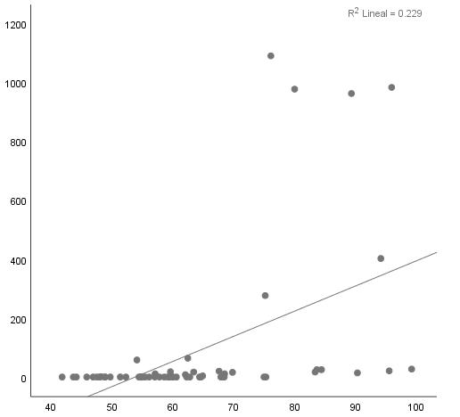  p=0.01  r=0.442 | 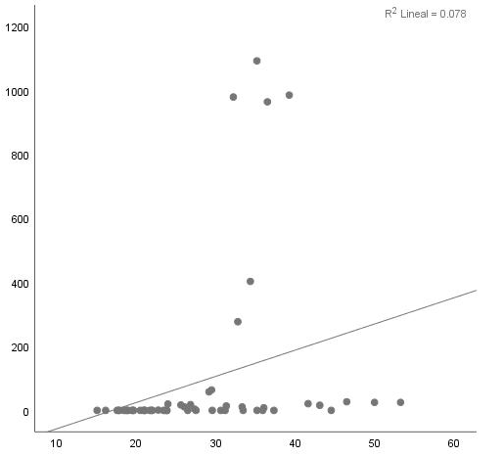  p=0.55  r=0.116 | 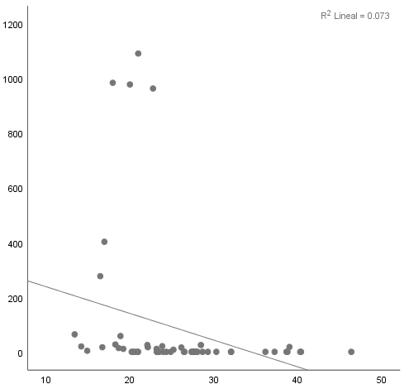  p=0.05  r=-0.35 | 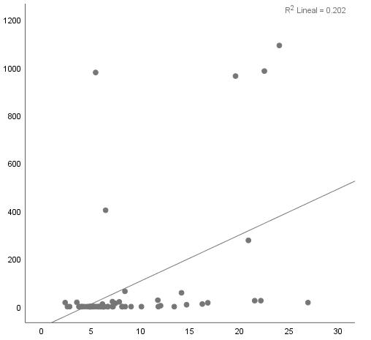  p=0.03  r=0.389
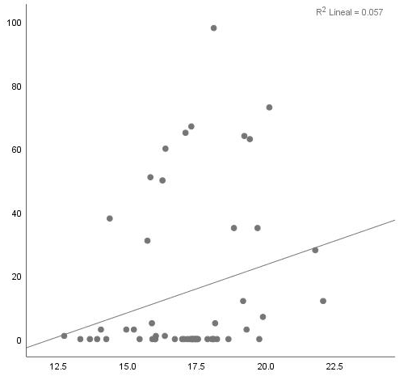  Quercus sp. S3 | p=0.005  r=0.348 | 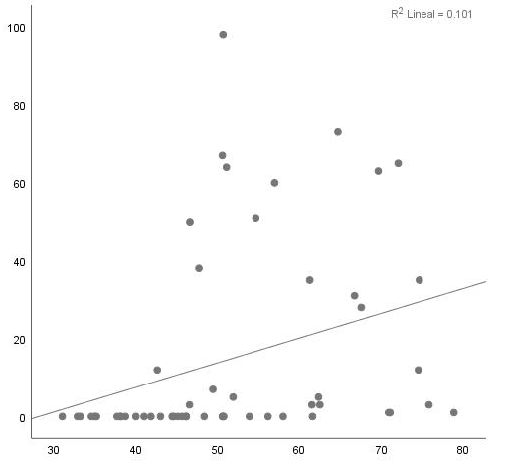  p=0.16  r=0.084 | 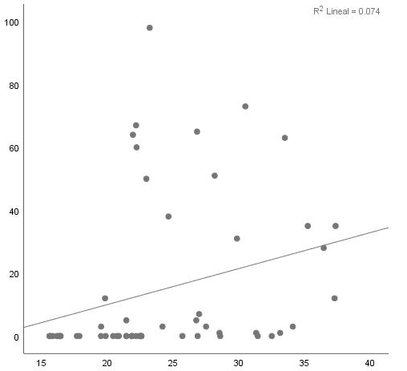  p=0.29  r=0.051 | 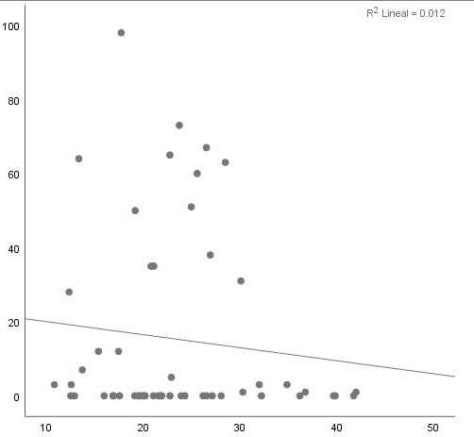  p=0.04  r=-0.28 | 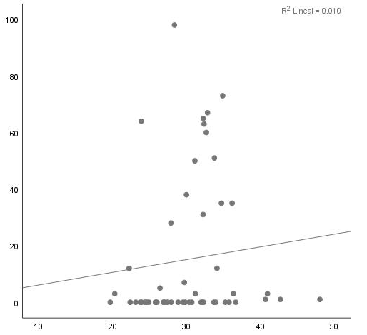  p=0.89  r=-0.112 | 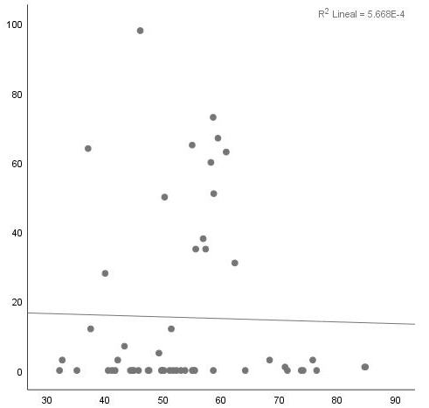  p=0.16  r=-0.233 | 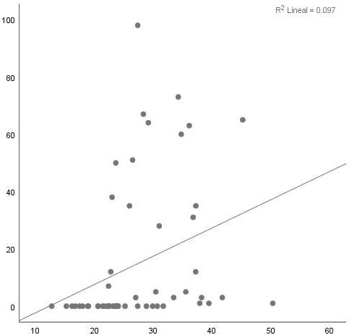  p=0.16  r=0.097 | 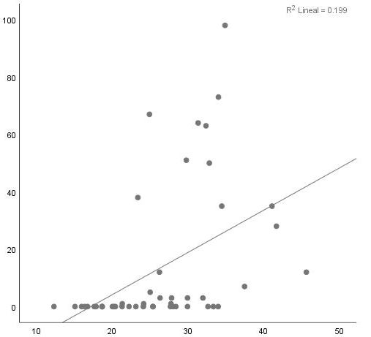  p<0.001  r=0.469 | 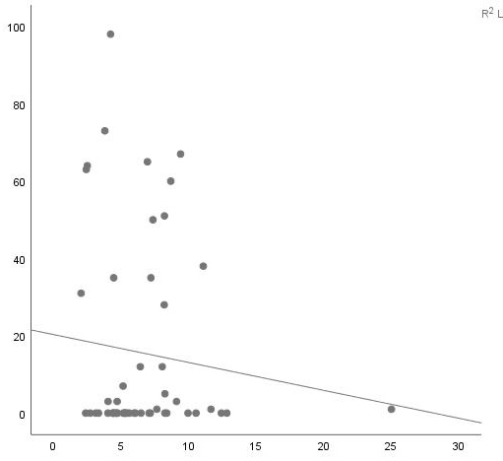  p=0.27  r=-0.243
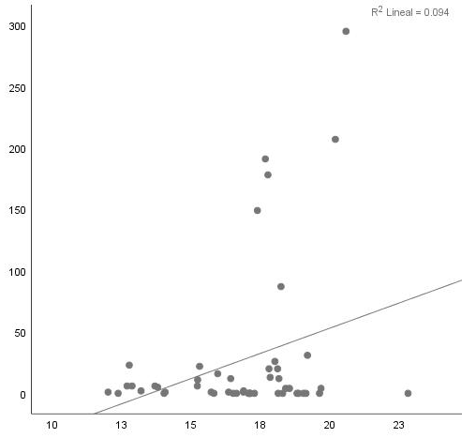  Quercus sp. S4 | p=0.18  r=0.393 | 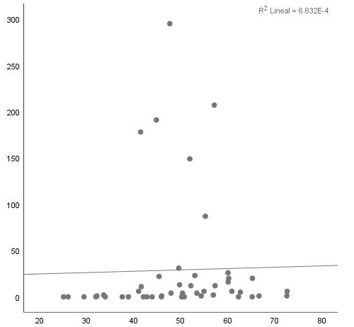  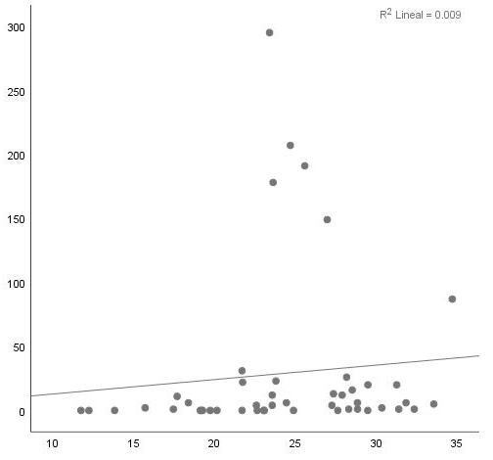  p=0.28  r=-0.184 | p=0.812  r=-0.041 | 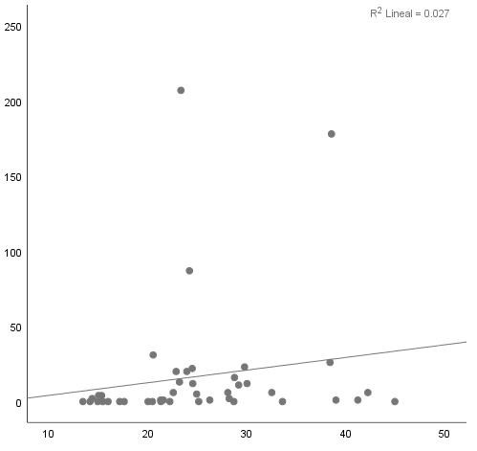  p=0.66  r=0.079 | 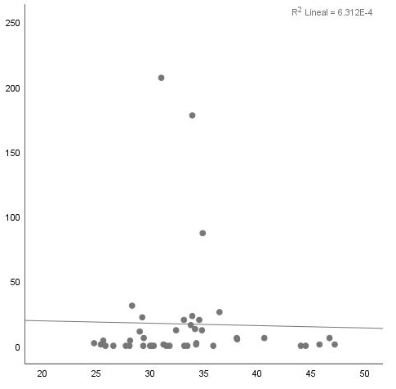  p=0.58  r=-0.102 | 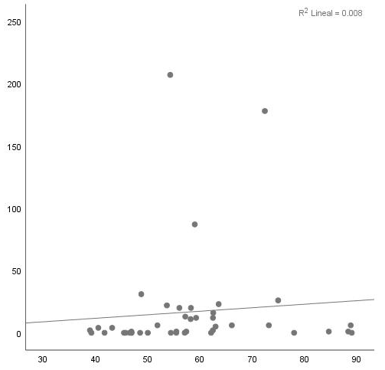  p=0.99  r=0.01 | 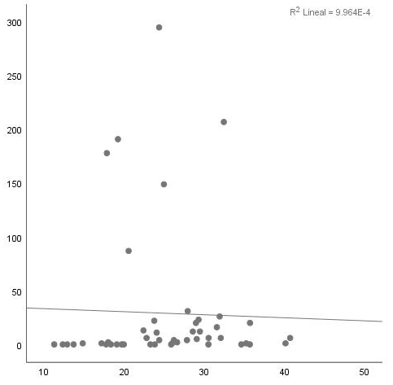  p=0.01  r=-0.251 | 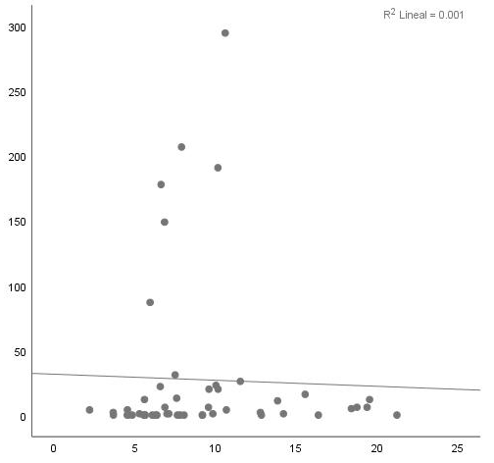  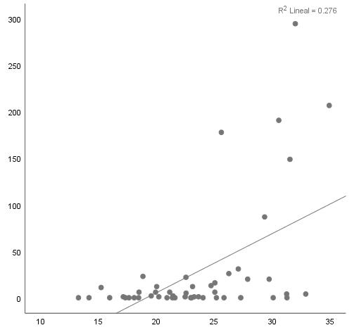  p<0.001  r=0.562 | p=0.32  r=-0.169
Supplementary Figure 2. Seasons correlations between meteorological variables and pollutants with pollen.
Abbreviations: CO, carbon monoxide; NO, nitrogen monoxide; NO₂, nitrogen dioxide; NO_{X}, nitrogen oxides; O₃, ozone; PM_{CO}, coarse fraction of PM₁₀ and PM_{2.5} particles; SO₂, sulfur dioxide; TMP, temperature; WSP, wind speed; RH, relative humidity; PM₁₀, particulate matter of 10 micrometers or less; PM_{2.5}, particulate matter of 2.5 micrometers or less; Season 1 (2014-2015); Season 2 (2015-2016); Season 3 (2016-2017); Season 4 (2017-2018).

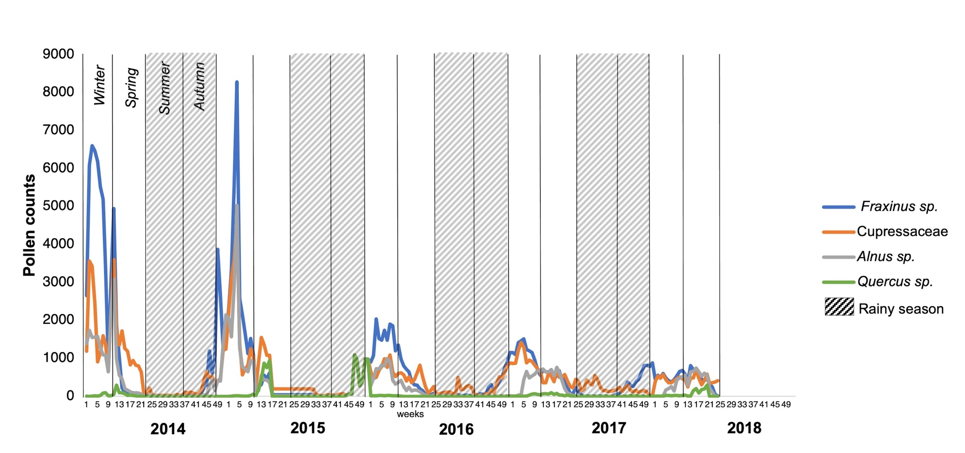
Supplementary Figure 3. Dynamics of pollen counts by climatological seasons.

Disease | Allergen | Positive |  | Negative |  | p | OR | CI 95% | Disease | Allergen | Positive |  | Negative |  | p | OR | CI 95%
Disease | Allergen | n | % | n | % |  |  |  |  |  | n | % | n | % | p | OR | CI 95%
AR | HDM | 173 | 89.2 | 21 | 10.8 | <0.001 | 7.1 | 4.18-12.15 | ARwA | HDM | 264 | 71.7 | 104 | 28.3 | <0.001 | 2.5 | 1.87-3.44
AR | Pollen | 104 | 53.6 | 90 | 46.4 |  |  |  |  | Pollen | 184 | 50 | 184 | 50 | <0.001 | 2.5 | 1.87-3.44
AR | Trees | 91 | 46.9 | 103 | 53.1 | <0.001 | 3.8 | 2.45-6.13 | ARwA | Trees | 156 | 42.4 | 212 | 57.6 | <0.001 | 2.8 | 2.04-3.91
AR | Grasses | 36 | 18.6 | 158 | 81.4 |  |  |  |  | Grasses | 76 | 20.7 | 292 | 79.3 | <0.001 | 2.8 | 2.04-3.91
AR | Fraxinus sp. | 36 | 18.6 | 158 | 81.4 | 1 | 1 | 0.59-1.66 | ARwA | Fraxinus sp. | 58 | 15.8 | 310 | 84.2 | 1 | 1 | 0.67-1.48
AR | Cupressaceae | 36 | 18.6 | 158 | 81.4 |  |  |  |  | Cupressaceae | 58 | 15.8 | 310 | 84.2 | 1 | 1 | 0.67-1.48
AR | Fraxinus sp. | 36 | 18.6 | 158 | 81.4 | 0.89 | 0.9 | 0.56-1.55 | ARwA | Fraxinus sp. | 58 | 15.8 | 310 | 84.2 | 0.92 | 1 | 0.64-1.42
AR | Quercus sp. | 38 | 19.6 | 156 | 80.4 |  |  |  |  | Quercus sp. | 60 | 16.3 | 308 | 83.7 | 0.92 | 1 | 0.64-1.42
AR | Fraxinus sp. | 36 | 18.6 | 158 | 81.4 | 0.01 | 2.2 | 1.21-4.08 | ARwA | Fraxinus sp. | 58 | 15.8 | 310 | 84.2 | 0.004 | 2 | 1.24-3.10
AR | Alnus sp. | 36 | 9.27 | 176 | 90.7 |  |  |  |  | Alnus sp. | 32 | 8.69 | 336 | 91.3 | 0.004 | 2 | 1.24-3.10
AR | Fraxinus sp. | 36 | 18.6 | 158 | 81.4 | 0.03 | 2 | 1.10-3.56 | ARwA | Fraxinus sp. | 58 | 15.8 | 310 | 84.2 | <0.001 | 2.6 | 1.56-4.20
AR | Casuarina sp. | 20 | 10.3 | 174 | 89.7 |  |  |  |  | Casuarina sp. | 25 | 6.79 | 343 | 93.2 | <0.001 | 2.6 | 1.56-4.20
AR | Quercus sp. | 36 | 19.6 | 156 | 80.4 | 0.89 | 1.1 | 0.64-1.77 | ARwA | Quercus sp. | 36 | 16.3 | 308 | 83.7 | 0.92 | 1 | 0.70-1.54
AR | Cupressaceae | 36 | 18.6 | 158 | 81.4 |  |  |  |  | Cupressaceae | 36 | 15.8 | 310 | 84.2 | 0.92 | 1 | 0.70-1.54
AR | Quercus sp. | 36 | 19.6 | 156 | 80.4 | 0.005 | 2.4 | 1.30-4.34 | ARwA | Quercus sp. | 36 | 16.3 | 308 | 83.7 | 0.002 | 2 | 1.29-3.22
AR | Alnus sp. | 36 | 9.27 | 176 | 90.7 |  |  |  |  | Alnus sp. | 36 | 8.69 | 336 | 91.3 | 0.002 | 2 | 1.29-3.22
AR | Quercus sp. | 36 | 19.6 | 156 | 80.4 | 0.02 | 2 | 1.11-3.61 | ARwA | Quercus sp. | 36 | 16.3 | 308 | 83.7 | 0.1 | 1.6 | 0.94-2.73
AR | Casuarina sp. | 20 | 10.3 | 174 | 89.7 |  |  |  |  | Casuarina sp. | 25 | 6.79 | 343 | 93.2 | 0.1 | 1.6 | 0.94-2.73
AR | Cupressaceae | 36 | 18.6 | 158 | 81.4 | 0.03 | 2 | 1.10-3.56 | ARwA | Cupressaceae sp. | 36 | 15.8 | 310 | 84.2 | 0.1 | 1.6 | 0.93-2.71
AR | Casuarina sp. | 20 | 10.3 | 174 | 89.7 |  |  |  |  | Casuarina sp. | 25 | 6.79 | 343 | 93.2 | 0.1 | 1.6 | 0.93-2.71
AR | Cupressaceae | 36 | 18.6 | 158 | 81.4 | 0.01 | 2.2 | 1.21-4.08 | ARwA | Cupressaceae | 36 | 15.8 | 310 | 84.2 | 0.004 | 2 | 1.24-3.10
AR | Alnus sp. | 36 | 9.27 | 176 | 90.7 |  |  |  |  | Alnus sp. | 36 | 8.69 | 336 | 91.3 | 0.004 | 2 | 1.24-3.10
AR | Alnus sp. | 36 | 9.27 | 176 | 90.7 | 0.07 | 1.8 | 0.91-3.19 | ARwA | Alnus sp. | 36 | 8.69 | 336 | 91.3 | 0.19 | 1.5 | 0.86-2.5
AR | Casuarina sp. | 20 | 10.3 | 174 | 89.7 |  |  |  |  | Casuarina sp. | 25 | 6.79 | 343 | 93.2 | 0.19 | 1.5 | 0.86-2.5

Supplementary Table 1. Allergic sensitivity by disease.
Abbreviations: AR, allergic rhinitis; ARwA, allergic rhinitis with asthma; HDM, house dust mite.

Pollen | 2014 |  | 2015 |  | 2016 |  | 2017 |  | 2018 |  | Global |  | Place of frequency of the allergic sensitization.
Pollen | APIn | % | APIn | % | APIn | % | APIn | % | APIn | % | APIn | % | Place of frequency of the allergic sensitization.
Fraxinus sp. | 5646 | 38.73 | 6294 | 29.46 | 14282 | 31.24 | 13591 | 33.57 | 11458 | 31.99 | 51271 | 32.46 | 1° (18%)
Cupressaceae | 4747 | 32.57 | 7066 | 33.07 | 12475 | 27.29 | 13453 | 33.23 | 11318 | 31.60 | 49059 | 31.06 | 3° (12.2%)
Alnus sp. | 2419 | 16.60 | 2525 | 11.82 | 5981 | 13.08 | 6777 | 16.74 | 7790 | 21.75 | 25492 | 16.14 | 4° (9.6%)
Casuarina sp. | 392 | 2.69 | 4147 | 19.41 | 4109 | 8.99 | 4124 | 10.19 | 2159 | 6.03 | 14931 | 9.45 | 6° (8.6%)
Pinus sp. | 676 | 4.64 | 463 | 2.17 | 3761 | 8.23 | 548 | 1.35 | 461 | 1.29 | 5909 | 3.74 | 0 (0%)
Quercus sp. | 143 | 0.98 | 21 | 0.10 | 2194 | 4.80 | 632 | 1.56 | 1303 | 3.64 | 4293 | 2.72 | 2° (14.3%)
Myrtaceae | 368 | 2.52 | 437 | 2.05 | 1326 | 2.90 | 1048 | 2.59 | 965 | 2.69 | 4144 | 2.62 | 0 (0%)
Salicaceae | 42 | 0.29 | 294 | 1.38 | 1117 | 2.44 | 32 | 0.08 | 2 | 0.01 | 1487 | 2.90 | 5° (9.2%)
Moraceae | 66 | 0.45 | 12 | 0.06 | 358 | 0.78 | 181 | 0.45 | 150 | 0.42 | 767 | 1.50 | 0 (0%)
Schinus sp. | 77 | 0.53 | 109 | 0.51 | 117 | 0.26 | 102 | 0.25 | 214 | 0.60 | 619 | 1.21 | 0 (0%)
Total of APIn collected by year. | 14576 | 100.00 | 21368 | 100.00 | 45720 | 100.00 | 40488 | 100.00 | 35820 | 100.00 | 157972 | 100.00
Supplementary Table 2. Comparison of Annual Pollen Integral by species with sensitization frequency.
Abbreviations: APIn, Annual Pollen Integral.

Disease | Allergen | Period | Positive |  | Negative |  | p | OR | CI 95% | Disease | Allergen | Period | Positive |  | Negative |  | p | OR | CI 95%
Disease | Allergen | Period | n | % | n | % |  |  |  |  |  |  | n | % | n | % | p | OR | CI 95%
AR | HDM | 2015-2018 | 100 | 100 | 0 | 0 | <0.001 | NA | NA | ARwA | HDM | 2015-2018 | 110 | 75.9 | 35 | 24.1 | 0.4 | 1.2 | 0.76-1.99
AR | HDM | 2012-2014 | 73 | 77.7 | 21 | 22.3 |  |  |  |  |  | 2012-2014 | 160 | 71.8 | 63 | 28.3 | 0.4 | 1.2 | 0.76-1.99
AR | Pollen | 2015-2018 | 64 | 64 | 36 | 36 | <0.001 | 2.7 | 1.53-4.89 | ARwA | Pollen | 2015-2018 | 101 | 69.7 | 44 | 30.3 | <0.001 | 4.3 | 2.72-6.78
AR | Pollen | 2012-2014 | 37 | 39.4 | 57 | 60.6 |  |  |  |  |  | 2012-2014 | 78 | 35 | 145 | 65 | <0.001 | 4.3 | 2.72-6.78
AR | Trees | 2015-2018 | 59 | 59 | 41 | 41 | <0.001 | 2.8 | 1.55-4.99 | ARwA | Trees | 2015-2018 | 94 | 64.8 | 51 | 35.2 | <0.001 | 4.8 | 3.05-7.50
AR | Trees | 2012-2014 | 32 | 34 | 62 | 66 |  |  |  |  |  | 2012-2014 | 62 | 27.8 | 161 | 72.2 | <0.001 | 4.8 | 3.05-7.50
AR | Grasses | 2015-2018 | 26 | 26 | 74 | 74 | 0.009 | 3 | 1.33-6.52 | ARwA | Grasses | 2015-2018 | 47 | 32.4 | 98 | 67.6 | <0.001 | 3.2 | 1.90-5.41
AR | Grasses | 2012-2014 | 10 | 10.6 | 84 | 89.4 |  |  |  |  |  | 2012-2014 | 29 | 13 | 194 | 87 | <0.001 | 3.2 | 1.90-5.41
AR | Fraxinus sp. | 2015-2018 | 29 | 29 | 71 | 71 | <0.001 | 5.1 | 2.09-12.27 | ARwA | Fraxinus sp. | 2015-2018 | 47 | 32.4 | 98 | 67.6 | <0.001 | 9.2 | 4.59-18.59
AR | Fraxinus sp. | 2012-2014 | 7 | 7.45 | 87 | 92.6 |  |  |  |  |  | 2012-2014 | 11 | 4.93 | 212 | 95.1 | <0.001 | 9.2 | 4.59-18.59
AR | Cupressaceae | 2015-2018 | 23 | 23 | 77 | 77 | 0.13 | 1.9 | 0.88-3.93 | ARwA | Cupressaceae | 2015-2018 | 41 | 28.3 | 104 | 71.7 | <0.001 | 4.8 | 2.58-8.81
AR | Cupressaceae | 2012-2014 | 13 | 13.8 | 81 | 86.2 |  |  |  |  |  | 2012-2014 | 17 | 7.62 | 206 | 92.4 | <0.001 | 4.8 | 2.58-8.81
AR | Quercus sp. | 2015-2018 | 26 | 26 | 74 | 74 | 0.009 | 3 | 1.33-6.52 | ARwA | Quercus sp. | 2015-2018 | 51 | 35.2 | 94 | 64.8 | <0.001 | 5.8 | 3.25-10.41
AR | Quercus sp. | 2012-2014 | 10 | 10.6 | 84 | 89.4 |  |  |  |  |  | 2012-2014 | 19 | 8.52 | 204 | 91.5 | <0.001 | 5.8 | 3.25-10.41
AR | Alnus sp. | 2015-2018 | 14 | 14 | 86 | 86 | 0.024 | 3.7 | 1.17-11.56 | ARwA | Alnus sp. | 2015-2018 | 22 | 15.2 | 123 | 84.8 | <0.001 | 3.8 | 1.74-8.30
AR | Alnus sp. | 2012-2014 | 4 | 4.26 | 90 | 95.7 |  |  |  |  |  | 2012-2014 | 10 | 4.48 | 213 | 95.5 | <0.001 | 3.8 | 1.74-8.30
AR | Casuarina sp. | 2015-2018 | 15 | 15 | 85 | 85 | 0.04 | 3.1 | 1.09-9.02 | ARwA | Casuarina sp. | 2015-2018 | 20 | 13.8 | 125 | 86.2 | <0.001 | 7 | 2.55-19.04
AR | Casuarina sp. | 2012-2014 | 5 | 5.31 | 89 | 94.7 |  |  |  |  |  | 2012-2014 | 5 | 2.24 | 218 | 97.8 | <0.001 | 7 | 2.55-19.04
Supplementary Table 3. Allergic sensitivity per period by disease.
Abbreviations: AR, allergic Rhinitis; ARwA, allergic rhinitis with asthma; HDM, house dust mite; NA, not applicable.

Variables | Fraxinus sp. S1 |  | Cupressaceae S1 |  | Alnus sp. S1 |  | Quercus sp. S1
Variables | Pearson r | p | Pearson r | p | Pearson r | p | Pearson r | p
TMP | -0.309 | 0.125 | -0.075 | 0.717 | -0.201 | 0.324 | 0.672 | <0.001
WSP | -0.158 | 0.44 | -0.228 | 0.263 | -0.255 | 0.209 | -0.14 | 0.494
RH | -0.199 | 0.329 | -0.187 | 0.362 | -0.144 | 0.481 | -0.255 | 0.208
PM₁₀ | 0.555 | 0.017 | 0.351 | 0.153 | 0.356 | 0.147 | -0.358 | 0.145
PM_{2.5} | 0.486 | 0.041 | 0.536 | 0.022 | 0.479 | 0.044 | -0.223 | 0.374
CO | 0.277 | 0.19 | 0.311 | 0.139 | 0.321 | 0.126 | -0.216 | 0.311
NO | 0.188 | 0.369 | 0.059 | 0.778 | 0.225 | 0.28 | -0.503 | 0.01
NO₂ | 0.438 | 0.029 | 0.313 | 0.128 | 0.261 | 0.208 | -0.076 | 0.719
NO_{X} | 0.326 | 0.112 | 0.18 | 0.389 | 0.276 | 0.181 | -0.394 | 0.051
O₃ | -0.044 | 0.833 | 0.182 | 0.373 | -0.013 | 0.949 | 0.705 | <0.001
PM_{CO} | 0.53 | 0.02 | 0.099 | 0.688 | 0.134 | 0.585 | -0.184 | 0.451
SO₂ | 0.198 | 0.331 | -0.123 | 0.551 | -0.074 | 0.719 | -0.234 | 0.249
Variables | Fraxinus sp. S2 |  | Cupressaceae S2 |  | Alnus sp. S2 |  | Quercus sp. S2
Variables | Pearson r | p | Pearson r | p | Pearson r | p | Pearson r | p
TMP | -0.64 | <0.001 | -0.273 | 0.144 | -0.601 | <0.001 | -0.158 | 0.405
WSP | 0.223 | 0.2236 | -0.001 | 0.994 | -0.095 | 0.619 | -0.305 | 0.101
RH | -0.3 | 0.107 | -0.187 | 0.323 | -0.007 | 0.971 | 0.455 | 0.012
PM₁₀ | 0.418 | 0.024 | 0.497 | 0.006 | 0.51 | 0.005 | 0.2 | 0.299
PM_{2.5} | 0.128 | 0.508 | 0.36 | 0.55 | 0.317 | 0.094 | 0.281 | 0.139
CO | 0.117 | 0.538 | 0.269 | 0.151 | 0.47 | 0.009 | 0.528 | 0.003
NO | 0.497 | 0.005 | 0.478 | 0.008 | 0.763 | <0.001 | 0.499 | 0.005
NO₂ | 0.497 | 0.005 | 0.454 | 0.012 | 0.609 | <0.001 | 0.238 | 0.205
NO_{X} | 0.542 | 0.002 | 0.442 | 0.014 | 0.771 | <0.001 | 0.442 | 0.014
O3 | -0.38 | 0.038 | 0.116 | 0.55 | 0.51 | 0.004 | -0.356 | 0.053
PM_{CO} | 0.604 | 0.001 | 0.389 | 0.033 | 0.612 | <0.001 | 0.116 | 0.55
SO₂ | 0.439 | 0.015 | -0.138 | 0.531 | 0.616 | <0.001 | 0.389 | 0.033
Variables | Fraxinus sp. S3 |  | Cupressaceae S3 |  | Alnus sp. S3 |  | Quercus sp. S3
Variables | Pearson r | p | Pearson r | p | Pearson r | p | Pearson r | p
TMP | -0.37 | 0.029 | -0.248 | 0.152 | 0.208 | 0.231 | 0.348 | 0.005
WSP | -0.553 | 0.001 | -0.552 | 0.001 | -0.001 | 0.996 | 0.1 | 0.821
RH | 0.472 | 0.004 | 0.452 | 0.006 | 0.108 | 0.535 | -0.01 | 0.602
PM₁₀ | 0.619 | <0.001 | 0.676 | <0.001 | 0.295 | 0.236 | 0.084 | 0.167
PM_{2.5} | 0.21 | 0.225 | 0.306 | 0.074 | 0.171 | 0.327 | 0.051 | 0.294
CO | 0.376 | 0.028 | 0.378 | 0.028 | -0.68 | <0.001 | -0.703 | <0.001
NO | 0.382 | 0.026 | 0.318 | 0.067 | -0.277 | 0.113 | -0.28 | 0.042
NO₂ | 0.659 | <0.001 | 0.653 | <0.001 | -0.045 | 0.8 | -0.112 | 0.894
NO_{X} | 0.535 | 0.001 | 0.489 | 0.003 | -0.201 | 0.254 | -0.233 | 0.165
O₃ | -0.003 | 0.989 | 0.13 | 0.487 | 0.436 | 0.014 | 0.469 | <0.001
PM_{CO} | 0.794 | <0.001 | 0.802 | <0.001 | 0.194 | 0.264 | 0.097 | 0.166
SO₂ | 0.166 | 0.357 | 0.108 | 0.549 | -0.234 | 0.189 | -0.243 | 0.271
Variables | Fraxinus sp. S4 |  | Cupressaceae S4 |  | Alnus sp. S4 |  | Quercus sp. S4
Variables | Pearson r | p | Pearson r | p | Pearson r | p | Pearson r | p
TMP | -0.317 | 0.06 | 0.329 | 0.05 | 0.566 | <0.001 | 0.393 | 0.18
WSP | -0.485 | 0.003 | -0.045 | 0.793 | -0.139 | 0.419 | 0.061 | 0.726
RH | -0.381 | 0.22 | -0.084 | 0.627 | -0.19 | 0.267 | -0.043 | 0.804
PM₁₀ | 0.626 | <0.001 | 0.126 | 0.464 | -0.055 | 0.749 | -0.184 | 0.284
PM_{2.5} | 0.569 | <0.001 | 0.193 | 0.258 | 0.081 | 0.637 | -0.041 | 0.812
CO | 0.486 | 0.003 | -0.429 | 0.009 | -0.301 | 0.074 | -0.306 | 0.07
NO | 0.548 | 0.001 | -0.085 | 0.644 | -0.107 | 0.558 | 0.079 | 0.667
NO₂ | 0.623 | <0.001 | -0.099 | 0.588 | -0.229 | 0.207 | -0.102 | 0.58
NO_{X} | 0.604 | <0.001 | -0.095 | 0.605 | -0.166 | 0.364 | 0.001 | 0.994
O₃ | 0.025 | 0.886 | 0.518 | 0.001 | 0.718 | <0.001 | 0.562 | <0.001
PM_{CO} | 0.532 | 0.001 | 0.049 | 0.778 | -0.146 | 0.397 | -0.251 | 0.14
SO₂ | 0.201 | 0.24 | -0.238 | 0.162 | -0.436 | 0.008 | -0.169 | 0.325
Supplementary Table 4. Seasons correlations between meteorological variables and pollution with pollen.
Abbreviations: CO, carbon monoxide; NO, nitrogen monoxide; NO₂, nitrogen dioxide; NO_{X}, nitrogen oxides; O₃, ozone; PM_{CO}, coarse fraction of PM₁₀ and PM_{2.5} particles; SO₂, sulfur dioxide; TMP, temperature; WSP, wind speed; RH, relative humidity; PM₁₀, particulate matter of 10 micrometers or less; PM_{2.5}, particulate matter of 2.5 micrometers or less; Season 1 (2014-2015); Season 2 (2015-2016); Season 3 (2016-2017); Season 4 (2017-2018).

