Multifunctional nanoparticles-mediated PTT/PDT synergistic immune activation and antitumor activity combined with anti-PD-L1 immunotherapy for breast cancer treatment.
Cunqing Kong^{1#}, Banghao Xu^{2#}, Guanhua Qiu¹, Meng Wei², Mengqi Zhang³, Shengxian Bao¹, Jiali Tang¹, Lequn Li^{2*}, JunJie Liu^{1*}

¹Department of ultrasound, Affiliated Tumor Hospital of Guangxi Medical University 71 Hedi Road, Nanning 530021, People’s Republic of China; ²Department of hepatobiliary surgery, Affiliated Tumor Hospital of Guangxi Medical University 71 Hedi Road, Nanning 530021, People’s Republic of China; ³Department of interventional therapy Affiliated Tumor Hospital of Guangxi Medical University 71 Hedi Road, Nanning 530021, People’s Republic of China

# These authors contributed equally to this work.
*Corresponding author: JunJie Liu, Department of ultrasound, Affiliated Tumor Hospital of Guangxi Medical University 71 Hedi Road, Nanning 530021, People’s Republic of China, Email: liujunjie@gxmu.edu.cn.
*Corresponding author : Lequn Li, Department of hepatobiliary surgery, Affiliated Tumor Hospital of Guangxi Medical University 71 Hedi Road, Nanning 530021, People’s Republic of China, Email: li_lequn@263.net.

Supplementary Material
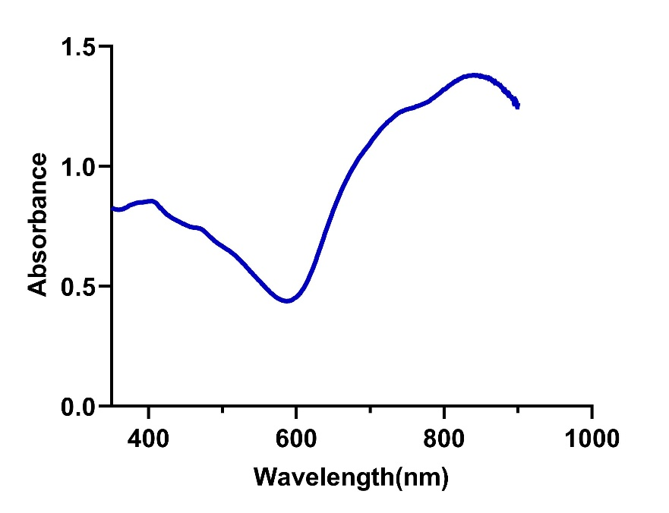
Supplementary Figure1 UV/vis-NIR absorption spectra of ICG@SANPs-cRGDs nanoparticles.
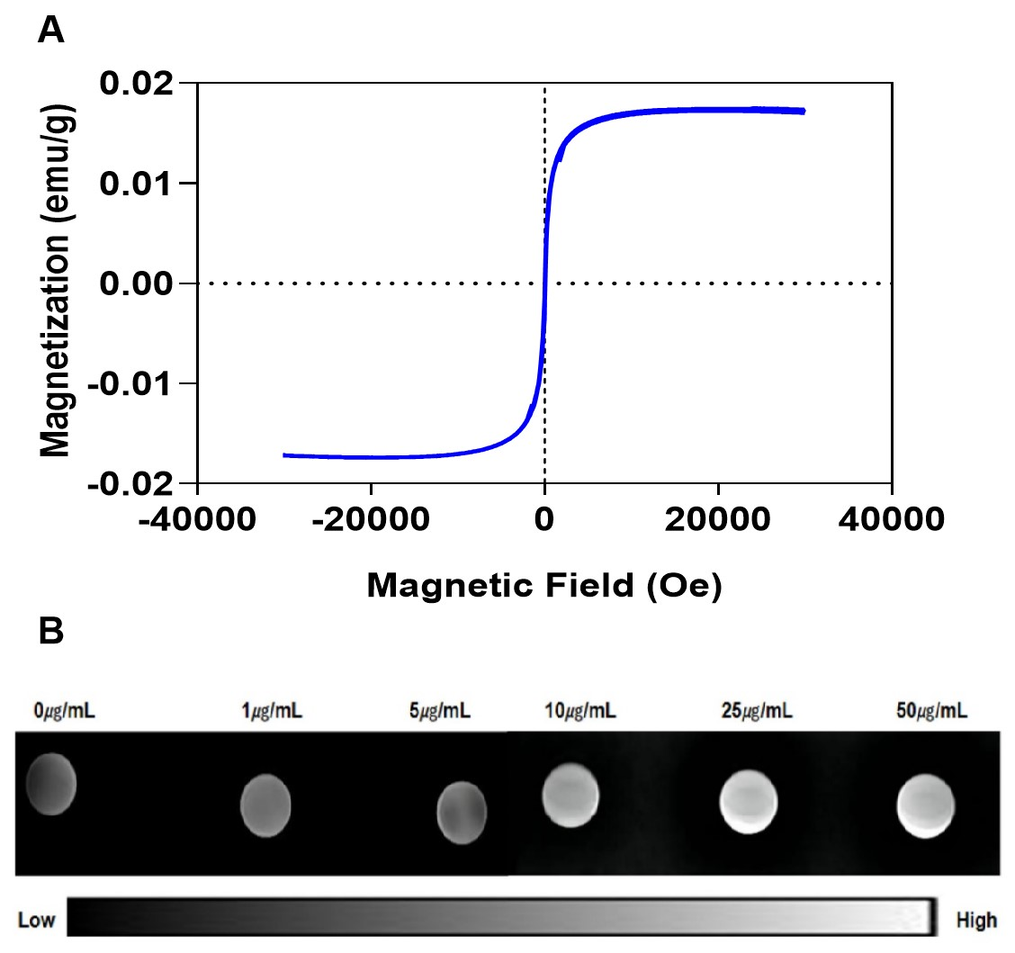
Supplementary Figure2 Magnetic properties of ICG@SANPs-cRGD. (A) Hysteresis loop of ICG@SANPs-cRGD nanoparticles. (B) T1WI image of ICG@SANPs nanoparticle solution.
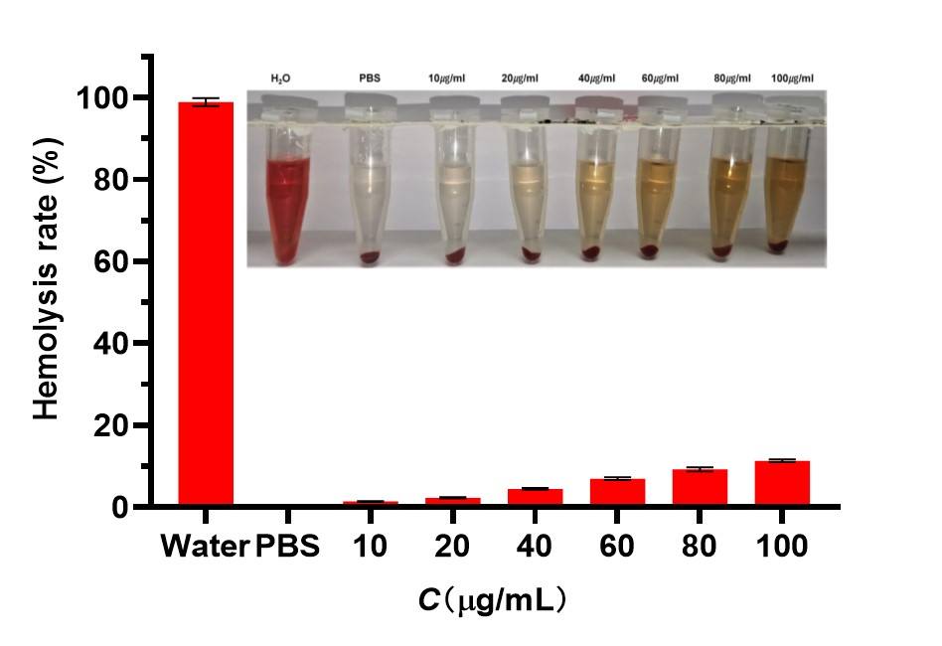
Supplementary Figure3 Hemolysis percentage of RBC in water, 1×PBS and ICG@SANPs-cRGD at various concentrations. The illustration is the corresponding digital photograph.

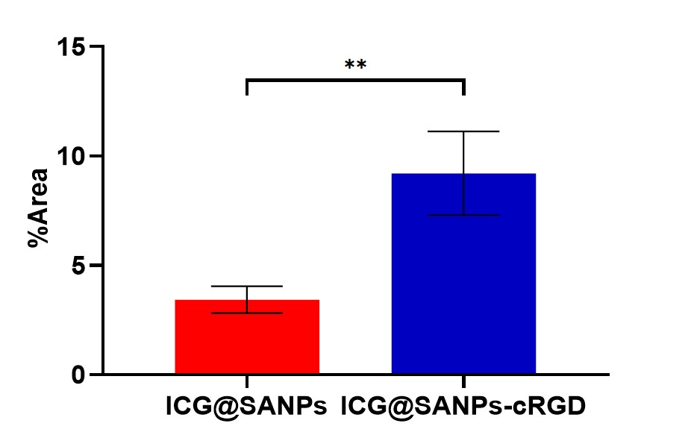
Supplementary Figure 4 The quantitative fluorescence area ratio of uptake of ICG@SANPs and ICG@SANPs-cRGD by 4T1 cells. (Data are expressed as means ± SD (n = 3). Statistical signifificances were calculated via Student’s t test, **p < 0.01)

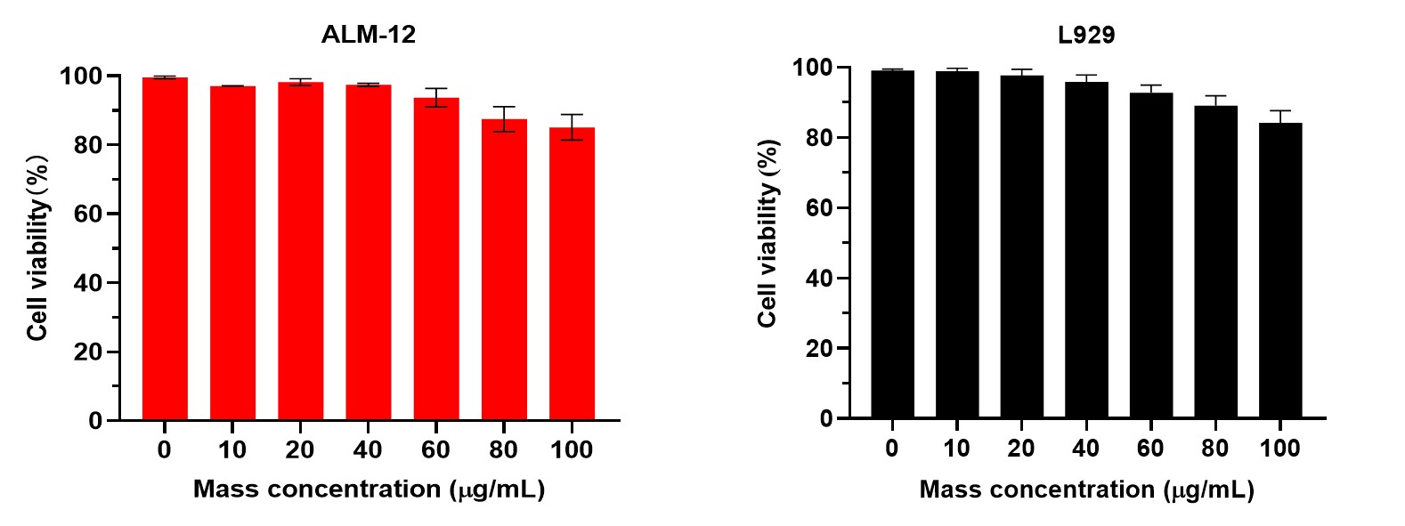
Supplementary Figure 5 Toxicity of ICG@SANPs-cRGD nanoparticles to normal cells. The cell viabilities of ALM-12 (A) and L929 (B) cells after incubations with ICG@SANPs-cRGD carriers of variable mass concentrations for 24h.

Supplementary Figure 6 Statistics of colonies formed by 4T1 cell clones in different groups.
(Data are expressed as means ± SD (n = 3). Statistical signifificances were calculated via ANOVA , **p < 0.01，****p < 0.0001).
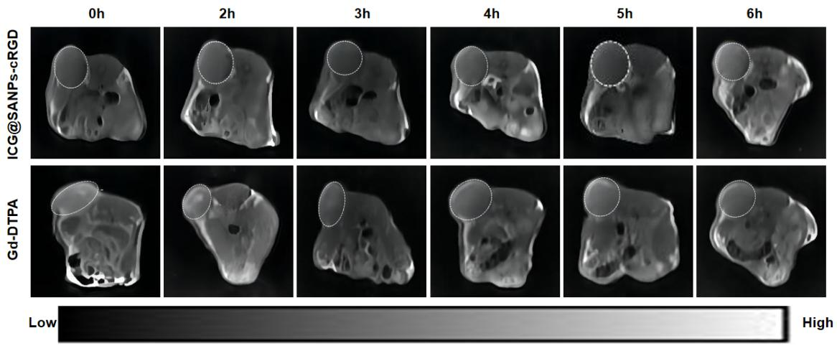
Supplementary Figure 7 T1-weighted MRI images of mice after intravenous injection with ICG@SANPs-cRGD and Gd-DTPA at 0-6 hours.

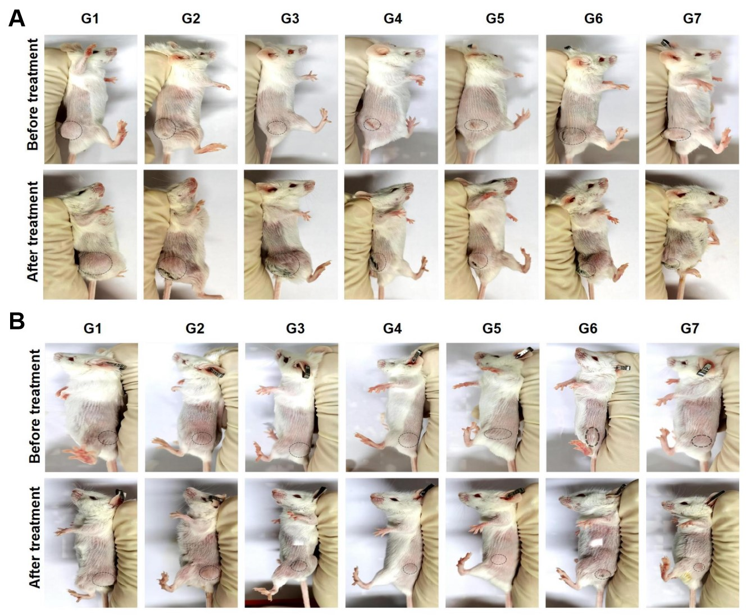
Supplementary Figure 8 Photographs of 4T1 tumor-bearing mice before and after different treatments. Tumor photographs of primary (A) and distant metastases (B) G1: Control; G2: ICG@SANPs; G3: ICG@SANPs-cRGD; G4: NIR+ICG@SANPs; G5: NIR+ICG@SANPs-cRGD; G6: Anti-PD-L1; G7: NIR+ICG@SANPs-cRGD+Anti-PD-L1
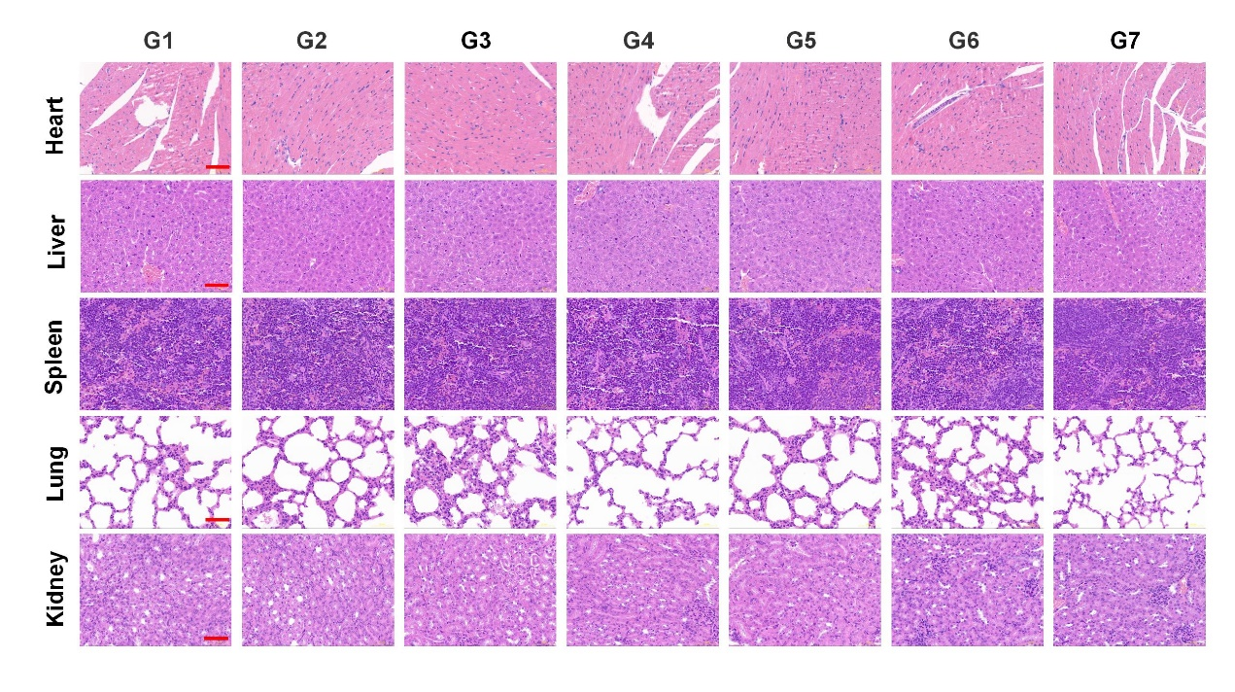
Supplementary Figure 9 H&E-stained tissue sections of major organs (heart, liver, spleen, lung and kidney) from mice with different treatments (All scale bar=50μm). G1: Control; G2: ICG@SANPs; G3: ICG@SANPs-cRGD; G4: NIR+ICG@SANPs; G5: NIR+ICG@SANPs-cRGD; G6: Anti-PD-L1; G7: NIR+ICG@SANPs-cRGD+Anti-PD-L1
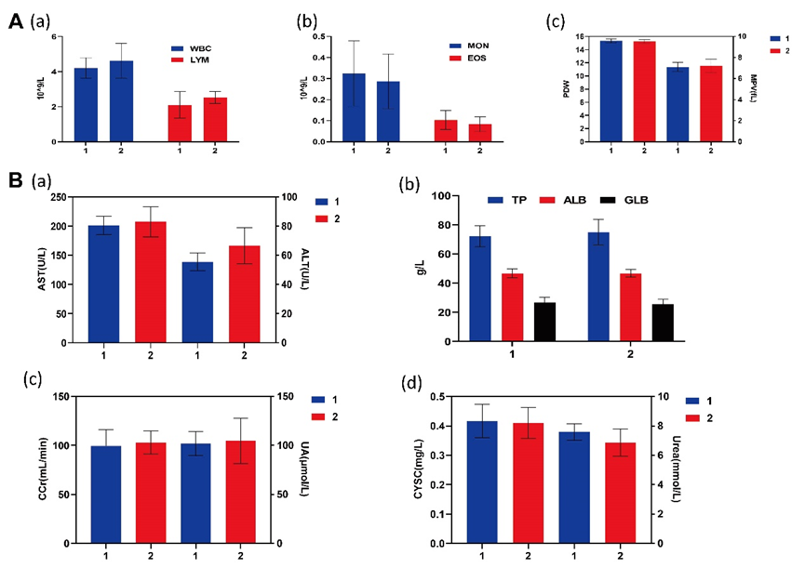
Supplementary Figure 10 Blood and serum biochemistry data. Untreated healthy mice were used as the control. (A) Blood data including White blood cell count (WBC), lymphocytes absolute value (LYM) (a), Monocyte absolute value (MON), Eosinophile granulocyte (E0S) (b), Mean platelet volume (MPV), Platelet distribution width (PDW) (c). (B) Serum biochemistry data including Aspartate aminotransferase (AST), Alanine aminotransferase (ALT) (a), Total protein (TP), serum albumin (ALB), Globulin (GLB) (b), Endogenous creatinine clearance (CCr), Uric Acid (UA) (c), Cystatin C (CYSC) and Urea(d) were measured. G1: Control; G2: ICG@SANPs; G3: ICG@SANPs-cRGD; G4: NIR+ICG@SANPs; G5: NIR+ICG@SANPs-cRGD; G6: Anti-PD-L1; G7: NIR+ICG@SANPs-cRGD+Anti-PD-L1. (Data are expressed as means ± SD (n = 3).
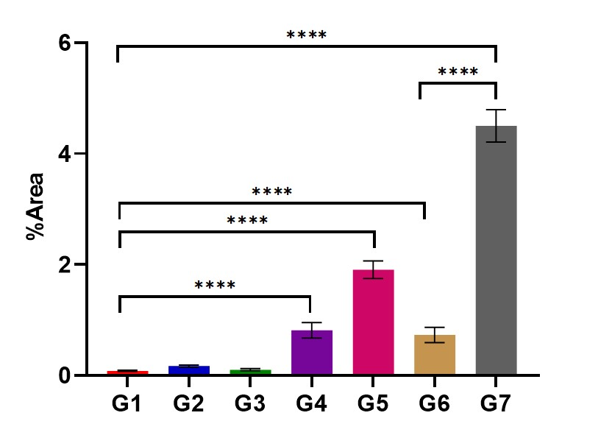
Supplementary Figure 11 Quantitative fluorescent area ratio of tumor tissue of each group was detected by TUNEL. G1: Control; G2: ICG@SANPs; G3: ICG@SANPs-cRGD; G4: NIR+ICG@SANPs; G5: NIR+ICG@SANPs-cRGD; G6: Anti-PD-L1; G7: NIR+ICG@SANPs-cRGD+Anti-PD-L1(Data are expressed as means ± SD (n = 3). Statistical signifificances were calculated via ANOVA, ****p < 0.0001).
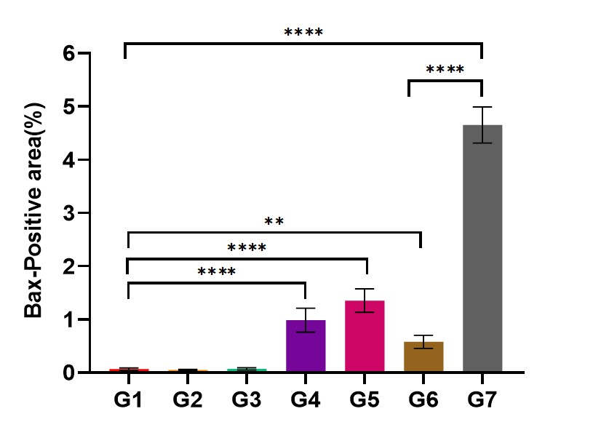
Supplementary Figure 12 Quantitative fluorescent area ratio of Bax of each group of tumor tissues. G1: Control; G2: ICG@SANPs; G3: ICG@SANPs-cRGD; G4: NIR+ICG@SANPs; G5: NIR+ICG@SANPs-cRGD; G6: Anti-PD-L1; G7: NIR+ICG@SANPs-cRGD+Anti-PD-L1.
(Data are expressed as means ± SD (n = 3). Statistical signifificances were calculated via ANOVA, ** p<0.01, ****p<0.0001)

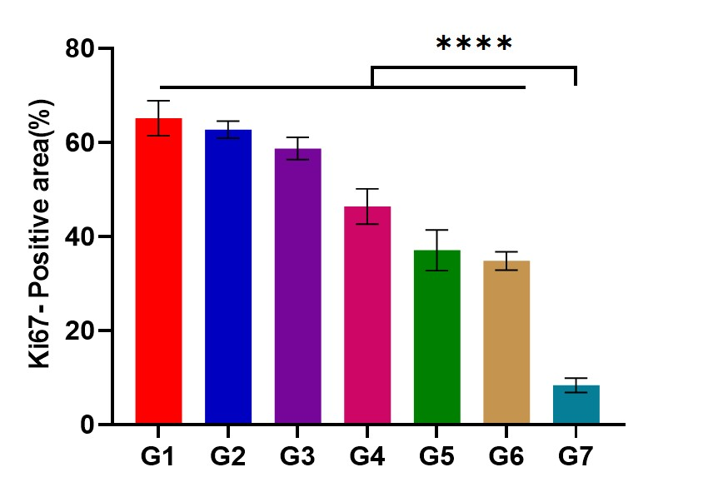
Supplementary Figure 13 Quantitative analysis of the ratio of positive nuclear area to total nuclear area in Ki67 immunohistochemical staining. G1: Control; G2: ICG@SANPs; G3: ICG@SANPs-cRGD; G4: NIR+ICG@SANPs; G5: NIR+ICG@SANPs-cRGD; G6: Anti-PD-L1; G7: NIR+ICG@SANPs-cRGD+Anti-PD-L1.(Data are expressed as means ± SD (n = 3). Statistical signifificances were calculated via ANOVA, ****p<0.0001).

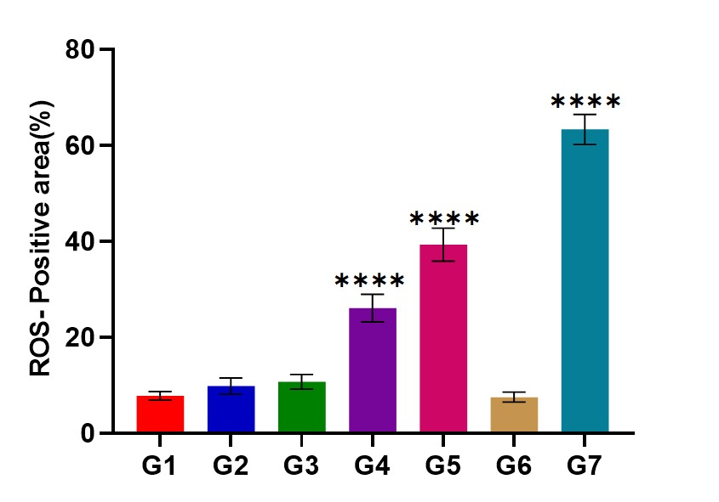
Supplementary Figure 14 Quantitative fluorescence area ratio of ROS in tumor tissues of each group. G1: Control; G2: ICG@SANPs; G3: ICG@SANPs-cRGD; G4: NIR+ICG@SANPs; G5: NIR+ICG@SANPs-cRGD; G6: Anti-PD-L1; G7: NIR+ICG@SANPs-cRGD+Anti-PD-L1. (Data are expressed as means ± SD (n = 3). Statistical signifificances were calculated via ANOVA, ****p<0.0001).

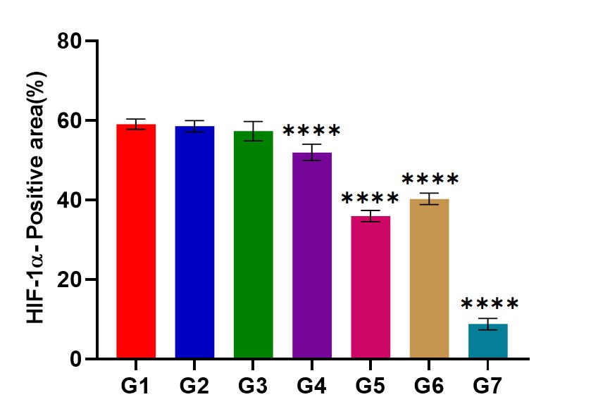
Supplementary Figure 15 Quantitative fluorescence area ratio of HIF-1α in tumor tissues of each group. G1: Control; G2: ICG@SANPs; G3: ICG@SANPs-cRGD; G4: NIR+ICG@SANPs; G5: NIR+ICG@SANPs-cRGD; G6: Anti-PD-L1; G7: NIR+ICG@SANPs-cRGD+Anti-PD-L1. (Data are expressed as means ± SD (n = 3). Statistical signifificances were calculated via ANOVA, ****p<0.0001).

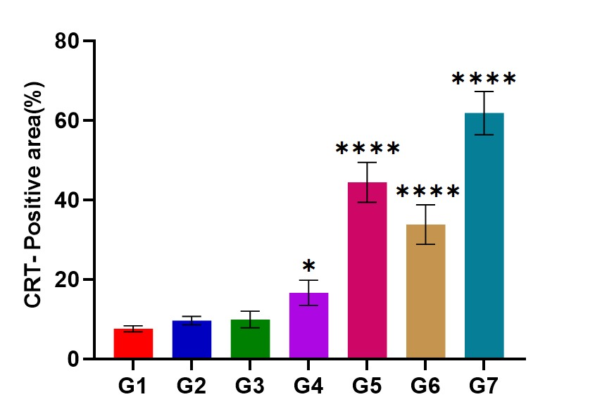
Supplementary Figure 16 Quantitative analysis of the ratio of positive nuclear area to total nuclear area in CRT immunohistochemical staining. G1: Control; G2: ICG@SANPs; G3: ICG@SANPs-cRGD; G4: NIR+ICG@SANPs; G5: NIR+ICG@SANPs-cRGD; G6: Anti-PD-L1; G7: NIR+ICG@SANPs-cRGD+Anti-PD-L1. (Data are expressed as means ± SD (n = 3). Statistical signifificances were calculated via ANOVA, *p<0.05, ****p<0.0001).
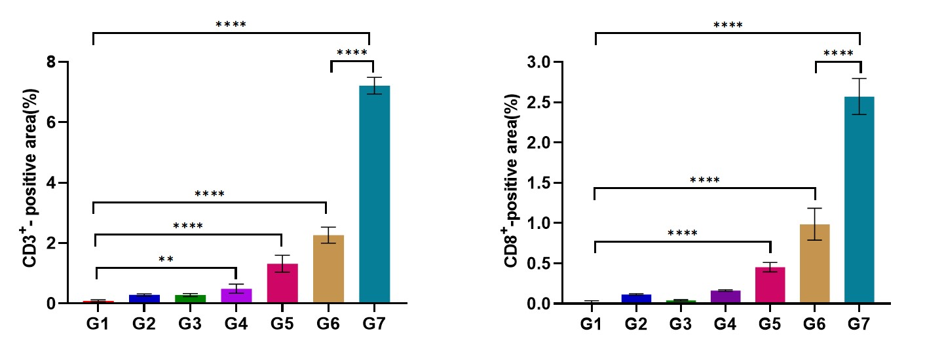
Supplementary Figure 17 The quantitative fluorescence area ratio of CD3⁺ T cells and CD8⁺T cells. G1: Control; G2: ICG@SANPs; G3: ICG@SANPs-cRGD; G4: NIR+ICG@SANPs; G5: NIR+ICG@SANPs-cRGD; G6: Anti-PD-L1; G7: NIR+ICG@SANPs-cRGD+Anti-PD-L1.
(Data are expressed as means ± SD (n = 3). Statistical signifificances were calculated via ANOVA, ** p<0.01, ****p<0.0001)

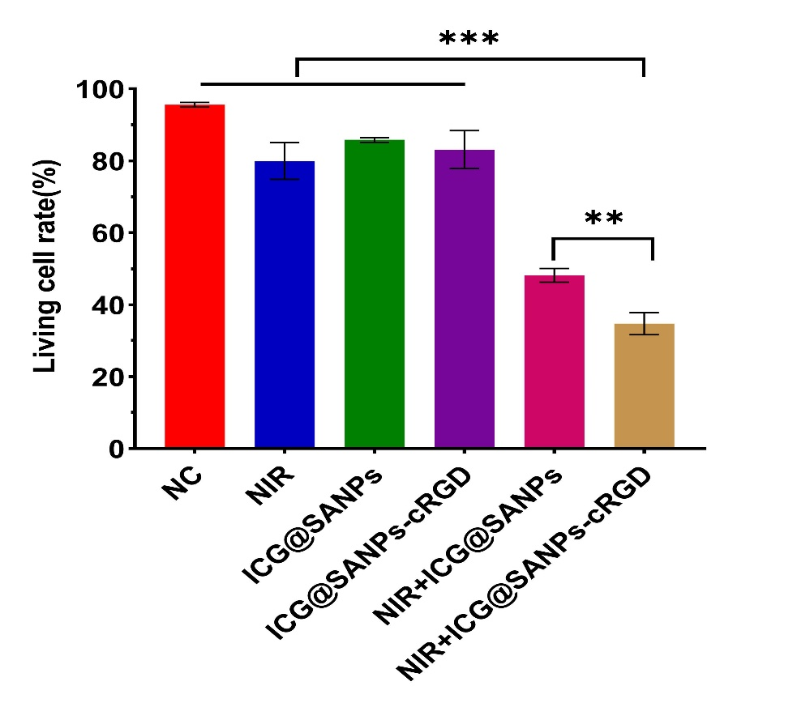
Supplementary Figure 18 Living cell ratio of 4T1 cells stained with calcein AM/PI under different treatment methods (808nm, 3 min, 0.8 W/cm²) (Data are expressed as means ± SD (n = 3). Statistical signifificances were calculated via ANOVA, ** p<0.01, ***p<0.001).

