Supplementary Table 1
List of primers used to perform Real Time RT-PCR
Gene  (Accession number) | Primers  (5’ 3’) | Amplicon Length (bps) | Ref.
huHPRT-1 (NM_000194) | FWD: AATTATGGACAGGACTGAACGTCTTGCT  REV: TCCAGCAGGTCAGCAAAGAATTTATAGC | 117 | [23]
hu RNA 18S  (NC_000021) | FWD: GCAATTATTCCCCATGAACG  REV: GGGACTTAATCAACGCAAGC | 68 | [24]
hu β2-Defensin  (NM_004942) | FWD: GACTCAGCTCCTGGTGAAGC  REV: GCAGGTAACAGGATCGCCTA | 128 | [21]
hu LL-37/hCAP-18  (NM_004345.4) | FWD: CTGCTGGGTGATTTCTTCCG  REV: GGCACACACTAGGACTCTGT | 122
hu BD4  (NM_080389.3) | FWD: TGTCGCAGCCAAGAATACAGA  REV: AGCTCTCATCCCATTTTCTCAAA | 76
hu S100A12  (NM_005621.2) | FWD: GGAGG GAATTGTCAATATC  REV: ATCTTGATTAGCATC CAGG | 175

Supplementary Table 2
NTA Analysis of supernatant collected from HaCaT cells. Particle concentration and size are reported as well as standard deviation.
Sample  (name) | Concentration  (Particles/ml) | Standard deviation  (Particles/ml) | Mean size  (nm) | Standard deviation  (nm)
Untreated | 5.41x10⁹ | 2.87x10⁸ | 102.4 | 1.3
IL-17A | 4.08x10¹⁰ | 1.20x10¹⁰ | 132.3 | 17.4
IL-22 | 5.76x10⁹ | 3.99x10⁸ | 134 | 2.2
IL-23 | 5.16x10⁹ | 4.60x10⁷ | 110.8 | 1.5
TNF-α | 4.88x10⁹ | 3.08x10⁸ | 132.2 | 1.8
IFN-γ | 9.08x10⁹ | 9.96x10⁸ | 131.8 | 5.5

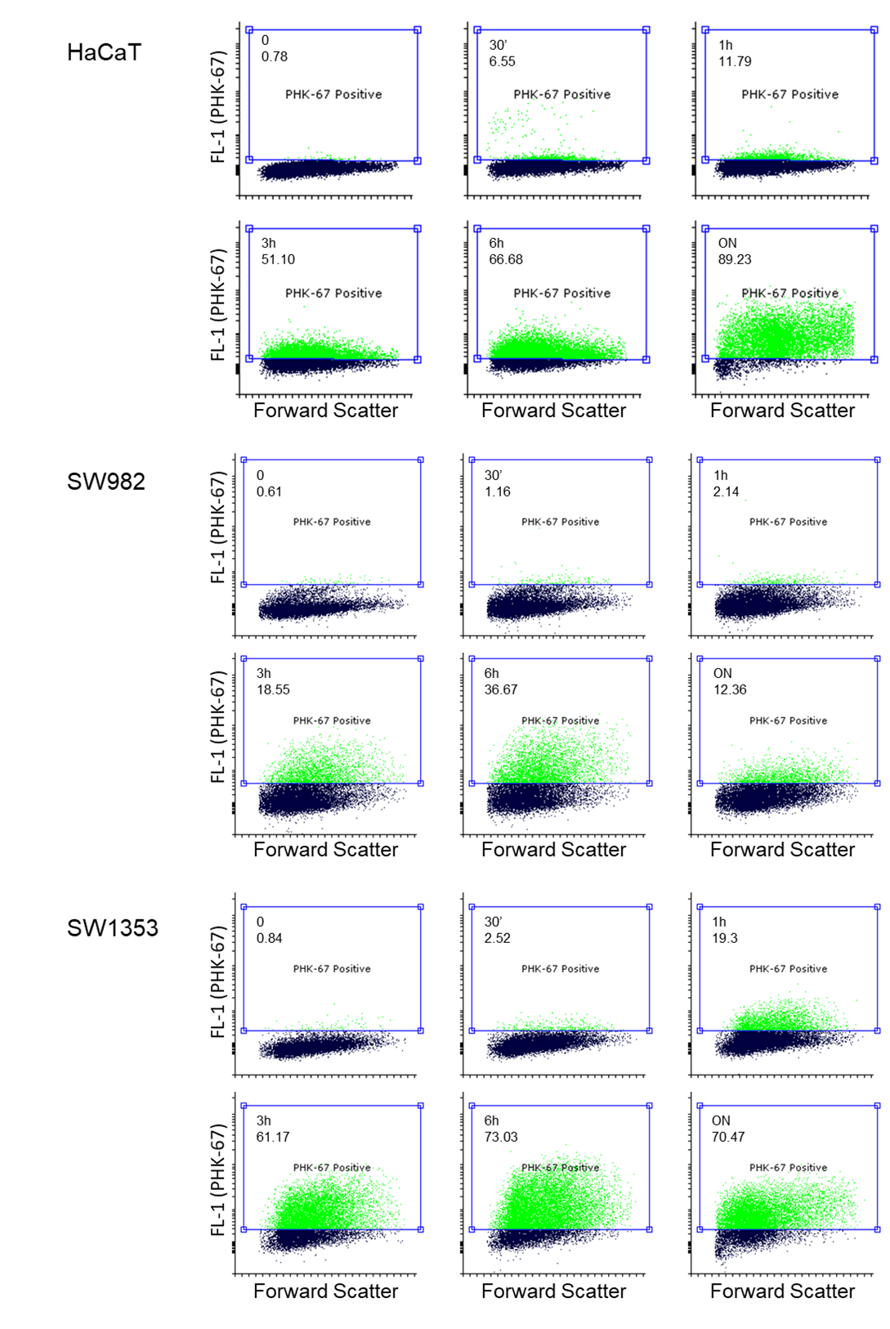

Supplementary Figure 1 (A) EVs internalization time course performed into HaCat (top panels), SW982 (middle panels) and SW1353 cells (lower panels). EVs were stained with PHK67 dye and internalization assay was performed as reported in Material and Methods. SW982 and SW1353 cytograms correspond to data in Figure 5.
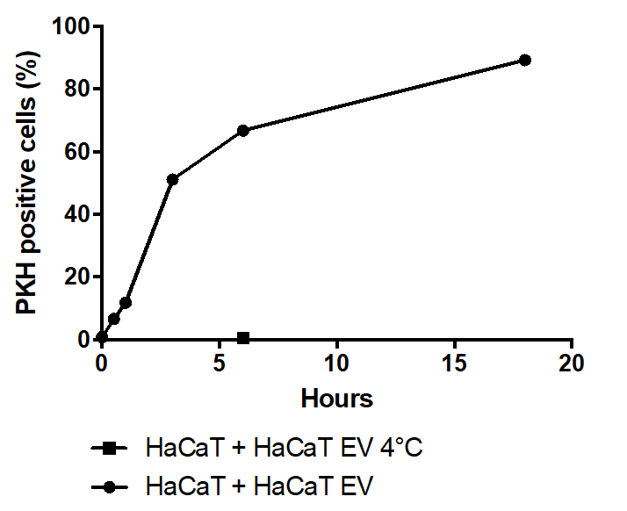

Supplementary Figure 1 (B) Histogram corresponding to cytograms of EVs internalized by HaCaT cells.

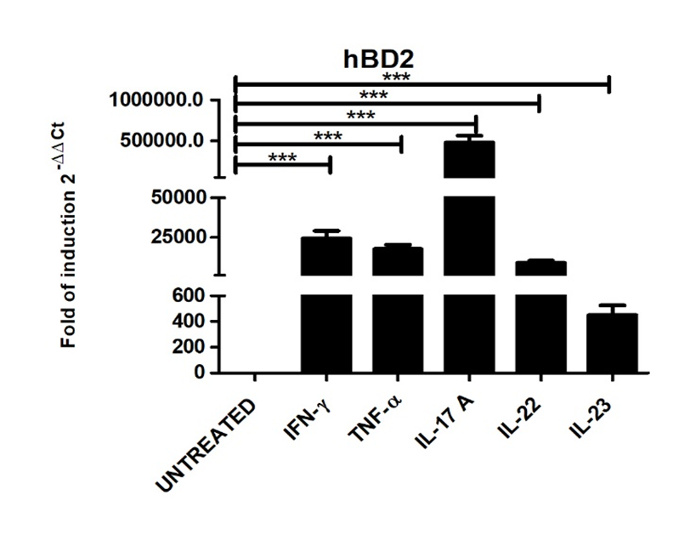

Supplementary Figure 2 Expression levels of hBD2 mRNA in Human Foreskin Keratinocytes (HFK, Lonza/Thermofisher, Basel, Switzerland) treated with IFNγ, TNFα, IL-17A, IL-22 and IL-23. Data are presented as the mean ± SD of three independent experiments performed in triplicate. *** P ≤ 0.001

