Supplementary Material
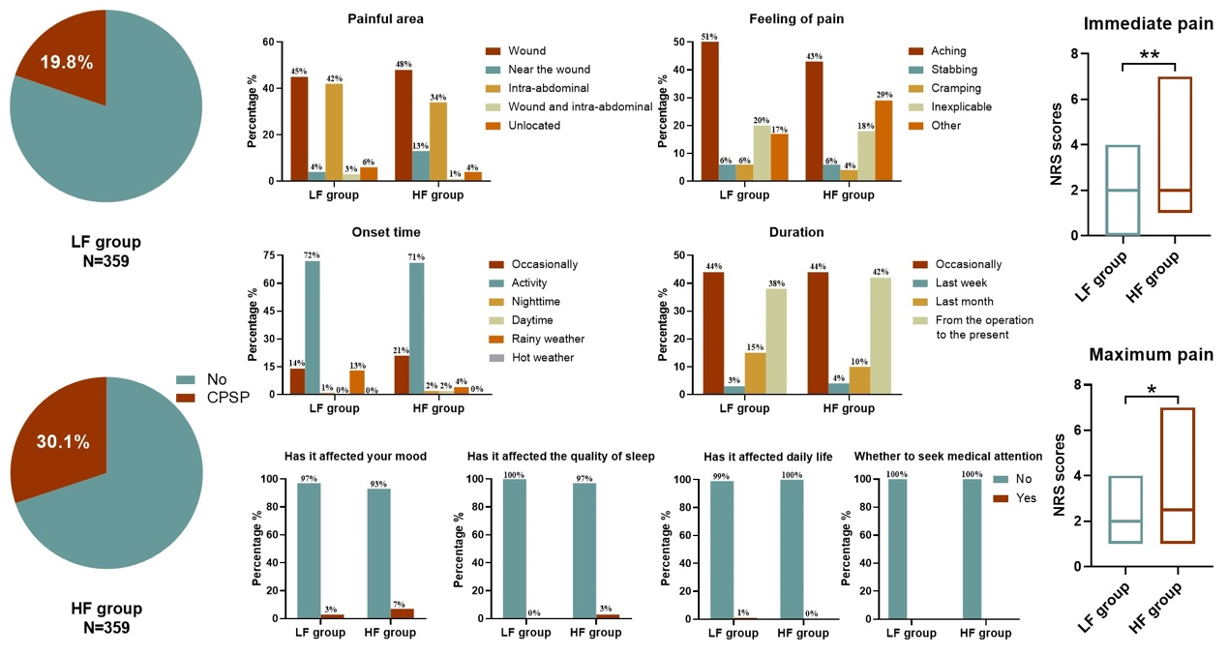
1. Figure S1

Figure S1. The pain features of CPSP at three months after CS in the LF group and the HF group.
**P<0.01; *P<0.05. Mood: whether the patient’s mood was affected by pain; quality of sleep: whether their quality of sleep was affected by pain; daily life: whether their normal daily life was affected by pain. CPSP, chronic postsurgical pain; CS, cesarean section; LF, low frequency; HF, high frequency.

2. Figure S2
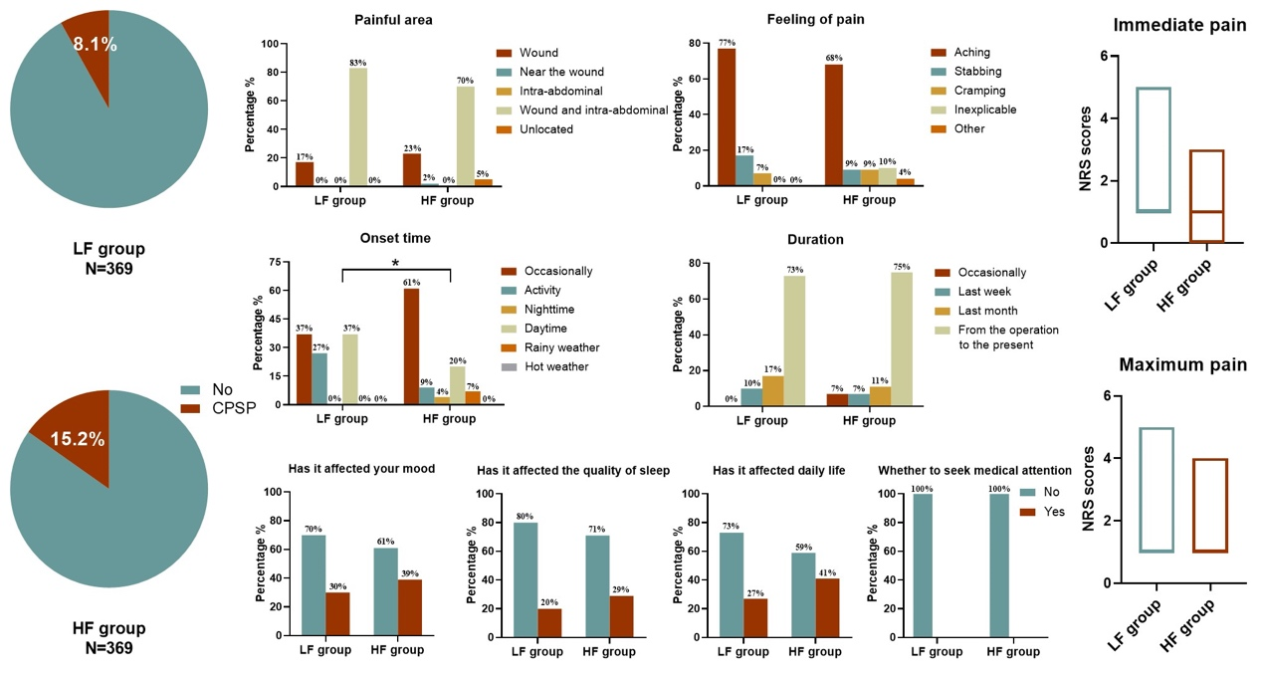
Figure S2. The pain features of CPSP at one year after CS in the LF group and the HF group.
*P<0.05. Mood: whether the patient’s mood was affected by pain; quality of sleep: whether their quality of sleep was affected by pain; daily life: whether their normal daily life was affected by pain. CPSP, chronic postsurgical pain; CS, cesarean section; LF, low frequency; HF, high frequency.

