Table S1. Clinical features in patients with pneumonia according to absence or presence of emphysema
 | Total (N=41) | No emphysema (n=4) | Emphysema (n=37) | P-value
Pneumonia type |  |  |  | 0.489
Typical pneumonia | 37 (90.2) | 4 (100) | 33 (89.2)
Atypical pneumonia | 4 (9.8) | 0 (0) | 4 (10.8)
Severity of pneumonia |  |  |  | 0.976
Outpatient department | 31 (75.6) | 3 (75) | 28 (75.7)
Inpatient department | 10 (24.4) | 1 (25) | 9 (24.3)
CURB score |  |  |  | 0.634
<2 | 34 (82.9) | 4 (100) | 30 (81.1)
2≤ | 7 (17) | 0 (0) | 7 (18.9)
CT pattern
Consolidation | 15 (36.6) | 0 (0) | 15 (40.5) | 0.11
Ground glass opacity | 18 (43.9) | 2 (50) | 16 (43.2) | 0.796
Opacities | 5 (12.2) | 1 (25) | 4 (10.8) | 0.41
Bronchopneumonia | 2 (4.9) | 0 (0) | 2 (5.4) | 0.634
Nodular lesion | 9 (22) | 1 (25) | 8 (21.6) | 0.877
Infiltration | 2 (4.9) | 0 (0) | 2 (5.4) | 0.634
CT involvement
RUL | 12 (29.3) | 0 (0) | 12 (32.4) | 0.176
RML | 13 (31.7) | 0 (0) | 13 (35.1) | 0.151
RLL | 23 (56.1) | 2 (50) | 21 (56.8) | 0.796
LUL | 22 (53.7) | 2 (50) | 20 (54) | 0.482
LLL | 17 (41.5) | 2 (50.0) | 15 (40.5) | 0.715
Death | 1 (2.4) | 0 (0) | 1 (2.7) | 0.739
Note: Data are presented as n (%) and median (SE)
Abbreviations: CURB-65, confusion, uremia, respiratory rate, BP, age ≥ 65 years; CT, computed tomography; RUL, right upper lobe; RML, right middle lobe; RLL, right lower lobe; LUL, left upper lobe; LLL, left lower lobe

Figure S1. Flowchart of patient inclusion and exclusion

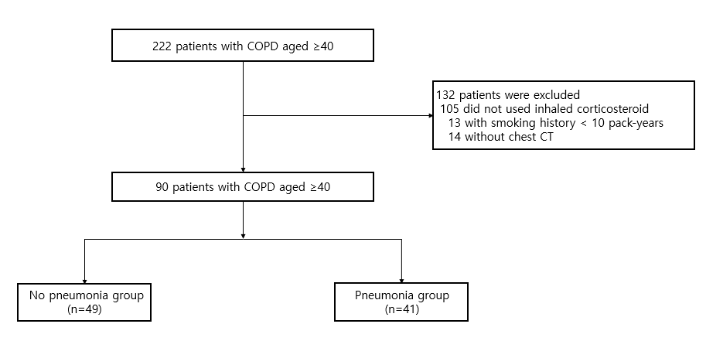

Figure S2. Kaplan-Meier curves for the time to first pneumonia event according to the absence or presence of emphysema
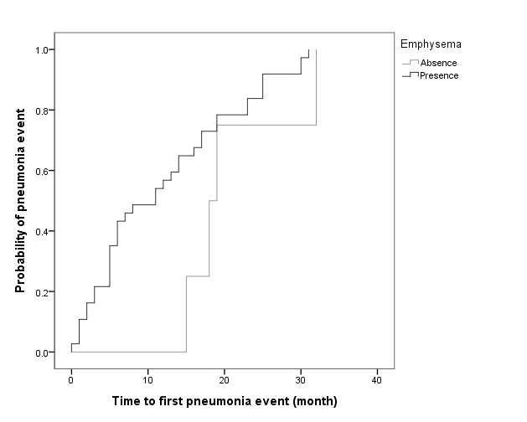
Log rank P=0.103
Absence
Presence

