Törmälehto et al. Seasonal effects on hospitalizations due to mood and psychotic disorders: A nationwide 31-year register study

Supplement material
Supplemental Table 1 Photoperiods, starting and ending dates of the period, number of days in the period, mean daylength in hours (h) and mean pace of change in daylength in minutes (min) per day
Photoperiodª | Starting date | Ending date | Days (n) | Daylength (h)^{b} | Pace of change (min)^{b}
Slowly increasing | 21 Dec | 1 Mar | 71 | 7.6 | 3.9
Spring^{c} | 14 Feb | 25 Apr | 71 | 12.3 | 5.5
Rapidly increasing | 2 Mar | 11 May | 71 | 13.7 | 5.4
Start of rapidly increasing | 22 Feb | 1 Apr | 39 | 11.6 | 5.5
End of rapidly increasing | 2 Apr | 11 May | 40 | 15.2 | 5.4
Long | 17 May | 26 Jul | 71 | 18.4 | 0.1
Slowly decreasing | 21 Jun | 30 Aug | 71 | 17.1 | –3.9
Fall^{c} | 19 Aug | 28 Oct | 71 | 12.2 | –5.4
Rapidly decreasing | 31 Aug | 9 Nov | 71 | 11.1 | –5.4
Start of rapidly decreasing | 23 Aug | 30 Sep | 39 | 13.3 | –5.4
End of rapidly decreasing | 1 Oct | 9 Nov | 40 | 9.7 | –5.3
Short | 17 Nov | 26 Jan | 71 | 6.4 | 0.01
Notes: ªThe photoperiods were based on astronomical seasons (summer and winter solstices and vernal and autumnal equinoxes), daylength and pace of change in daylength; ^{b}Daylength and pace of change in daylength are based on the sunrise and the sunset times in Helsinki, Finland (60°N). The dates of astronomical seasons and sunrise and sunset times were derived from the University Almanac Office²⁷; ^{c}Spring and fall photoperiods were defined different from the spring and the autumn seasons (the spring season included March, April, and May; the autumn season included September, October, and November)

Supplemental Table 2 Calculation of ratio of observed and expected daily counts (example for two years and two diagnosis-related groups)
 | Observed counts |  |  |  | Expected counts |  | Ratio of observed and expected counts
Year,Day | Diagnosis A | Diagnosis B | Daily sum | Daily index | Diagnosis A | Diagnosis B | Diagnosis A | Diagnosis B
1,1 | n_{1,1(A)} | n_{1,1(B)} | S_{1,1} | I_{1,1} = S_{1,1} /(S₁/365) | E_{1,1(A)} = I_{1,1} × (S_{1(A)}/365) | E_{1,1(B)} = I_{1,1} × (S_{1(B)}/365) | R_{1,1(A)} = n_{1,1(A)} / E_{1,1(A)} | R_{1,1(B)} = n_{1,1(B)} / E_{1,1(B)}
… | … | … | … | … | … | … | … | …
1,365 | n_{1,365(A)} | n_{1,365(B)} | S_{1,365} | I_{1,365} = S_{1,365} /(S₁/365) | E_{1,365(A)} = I_{1,365} × (S_{1(A)}/365) | E_{1,365(B)} = I_{1,365} × (S_{1(B)}/365) | R_{1,365(A)} = n_{1,365(A)} / E_{1,365(A)} | R_{1,365(B)} = n_{1,365(B)} / E_{1,365(B)}
Annual sum | S_{1(A)} | S_{1(B)} | S₁
 | Observed counts |  |  |  | Expected counts |  | Ratio of observed and expected counts
Year,Day | Diagnosis A | Diagnosis B | Daily sum | Daily index | Diagnosis A | Diagnosis B | Diagnosis A | Diagnosis B
2,1 | n_{2,1(A)} | n_{2,1(B)} | S_{2,1} | I_{2,1} = S_{2,1} /(S₂/365) | E_{2,1(A)} = I_{2,1} × (S_{2(A)}/365) | E_{2,1(B)} = I_{2,1} × (S_{2(B)}/365) | R_{2,1(A)} = n_{2,1(A)} / E_{2,1(A)} | R_{2,1(B)} = n_{2,1(B)} / E_{2,1(B)}
… | … | … | … | … | … | … | … | …
2,365 | n_{2,365(A)} | n_{2,365(B)} | S_{2,365} | I_{2,365} = S_{2,365} /(S₂/365) | E_{2,365(A)} = I_{2,365} ×(S_{2(A)}/365) | E_{2,365(B)} = I_{2,365} ×(S_{2,(B)}/365) | R_{2,365(A)} = n_{2,365(A)} / E_{2,365(A)} | R_{2,365(B)} = n_{2,365(B)} / E_{2,365(B)}
Annual sum | S_{2(A)} | S_{2(B)} | S₂

Supplemental Table 3 Calculation of weighted arithmetic mean for ratio of observed and expected daily counts (example for two years and two diagnosis groups)
 | Weighted arithmetic mean for ratio of observed and expected counts
Day | Diagnosis A | Diagnosis B
1 | R_{1(A)} = [R_{1,1(A)} × (S_{1(A)} / S₁) + R_{2,1(A)} × (S_{2(A)} / S₂)] / [(S_{1(A)} / S₁) +(S_{2(A)} / S₂)] | R_{1(B)} = [R_{1,1(B)} × (S_{1(B)} / S₁) + R_{2,1(B)} × (S_{2(B)} / S₂)] / [(S_{1(B)} / S₁) +(S_{2(B)} / S₂)]
… | … | …
365 | R_{365(A)} = [R_{1,365(A)} × (S_{1(A)} / S₁) + R_{2,365(A)} × (S_{2(A)} / S₂)] / [(S_{1(A)} / S₁) +(S_{2(A)} / S₂)] | R_{365(B)} = [R_{1,365(B)} × (S_{1(B)} / S₁) + R_{2,365(B)} × (S_{2(B)} / S₂)] / [(S_{1(B)} / S₁) +(S_{2(B)} / S₂)]

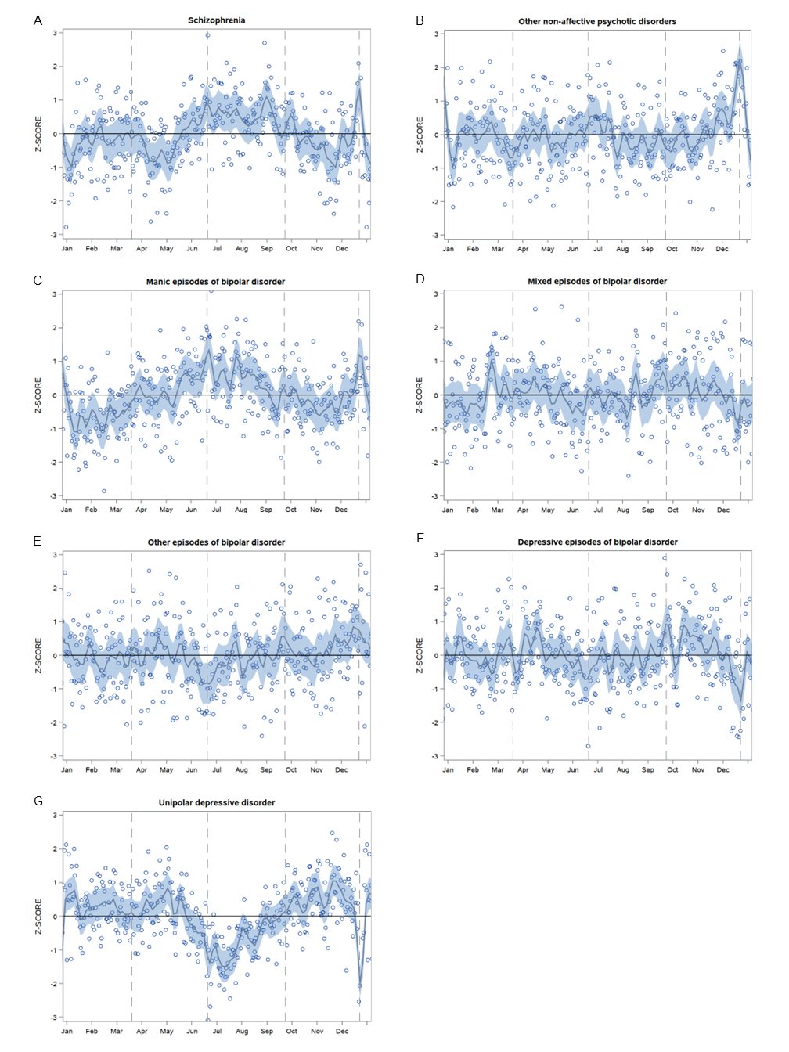
Supplemental Figure 1 The smoothed time series of adjusted ratio of observed and expected daily counts of hospital admissions (presented as standard Z-score) for schizophrenia (A), other non-affective psychotic disorders (B), manic episodes of bipolar disorder (C), mixed episodes of bipolar disorder (D), other episodes of bipolar disorder (E), depressive episodes of bipolar disorder (F), and unipolar depressive disorder (G) during the years 1987–2017 in Finland.
Notes: The circles represent a weighted arithmetic mean of O/E (observed/expected) values presented as standard Z-score during the study period. The shaded area represents the 95% confidence interval for the fitted curve. Vertical dashed lines from left to right represent vernal equinox, summer solstice, autumnal equinox, and winter solstice, respectively. Smoothing parameter 0.02.
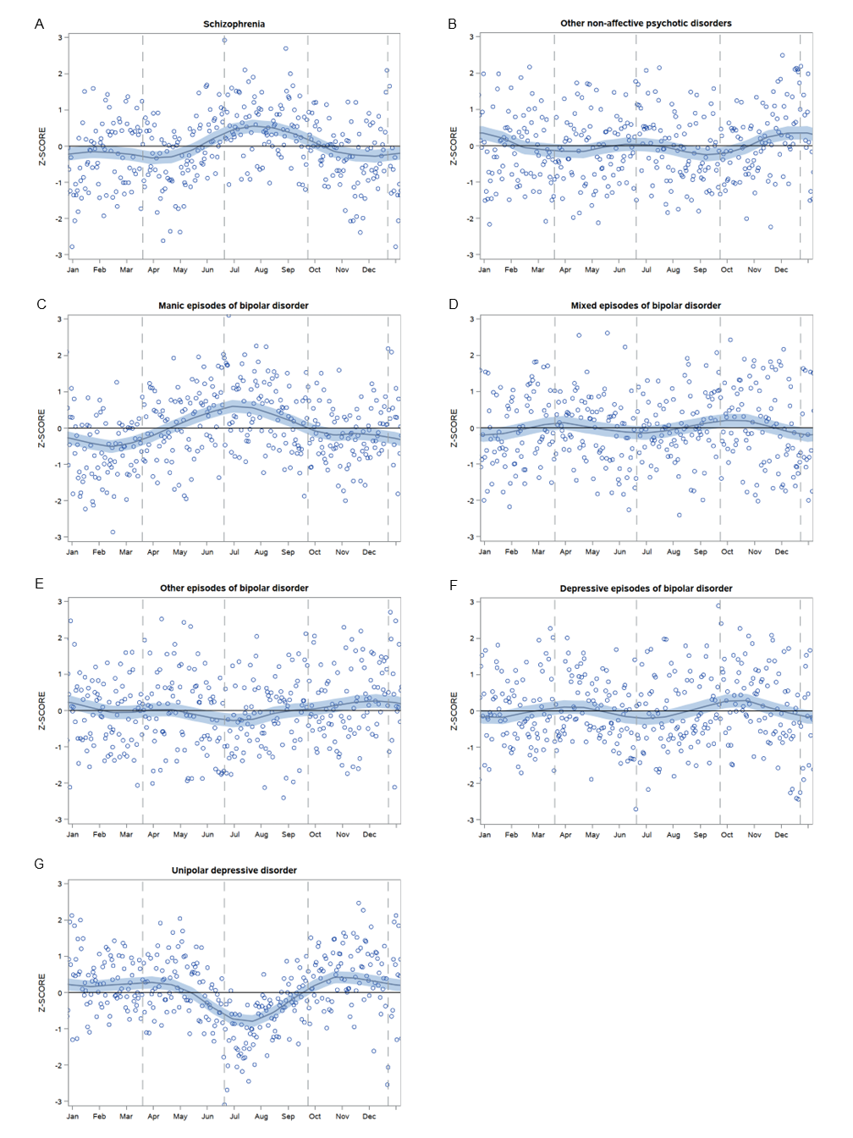
Supplemental Figure 2 The smoothed time series of adjusted ratio of observed and expected daily counts of hospital admissions (presented as standard Z-score) for schizophrenia (A), other non-affective psychotic disorders (B), manic episodes of bipolar disorder (C), mixed episodes of bipolar disorder (D), other episodes of bipolar disorder (E), depressive episodes of bipolar disorder (F), and unipolar depressive disorder (G) during the years 1987–2017 in Finland.
Notes: The circles represent a weighted arithmetic mean of O/E (observed/expected) values presented as standard Z-score during the study period. The shaded area represents the 95% confidence interval for the fitted curve. Vertical dashed lines from left to right represent vernal equinox, summer solstice, autumnal equinox, and winter solstice, respectively. Smoothing parameter 0.2.

