SUPPLEMENTARY DATA

Supplementary Figure 1. Study Design
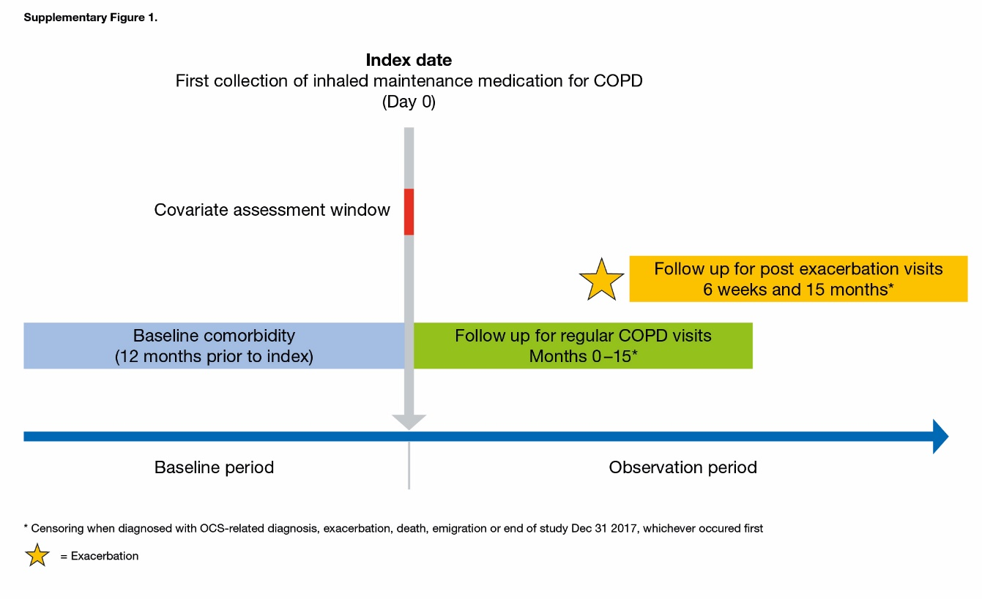
Supplementary Table 1. Incidence rate ratios (IRR) of COPD follow-up visits up to 15 months after index date and after an exacerbation
 | IRR (95% CI)
 | After the index date | After an exacerbation
Gender
Males | 1.00 (ref) | 1.00 (ref)
Females | 0.92 (0.88-0.97) | 0.95 (0.90-0.99)
Calendar year (cont) | 1.11 (1.10-1.12) | 1.10 (1.09-1.11)
Age at index (years)
40-55 | 1.00 (ref) | 1.00 (ref)
>55-70 | 1.15 (1.05-1.26) | 1.12 (1.02-1.22)
>70-85 | 1.31 (1.20-1.43) | 1.24 (1.13-1.36)
>85 | 1.56 (1.38-1.75) | 1.46 (1.29-1.64)
Charlson comorbidity index
CCI: 0-1 | 1.00 (ref) | 1.00 (ref)
CCI: 2 | 1.05 (0.99-1.11) | 1.05 (0.99-1.12)
CCI: 3 | 1.04 (0.96-1.12) | 1.05 (0.97-1.13)
CCI: 4 | 0.91 (0.81-1.01) | 0.91 (0.81-1.02)
CCI: 5+ | 1.21 (1.08-1.35) | 1.21 (1.08-1.35)
COPD treatment collected at index
LAMA or LABA | 1.00 (ref)
LAMA+LABA | 1.31 (1.16-1.47)
ICS | 0.63 (0.58-0.68)
ICS+LAMA or ICS+LABA | 0.79 (0.75-0.84)
ICS+LAMA+LABA | 1.09 (1.01-1.18)

