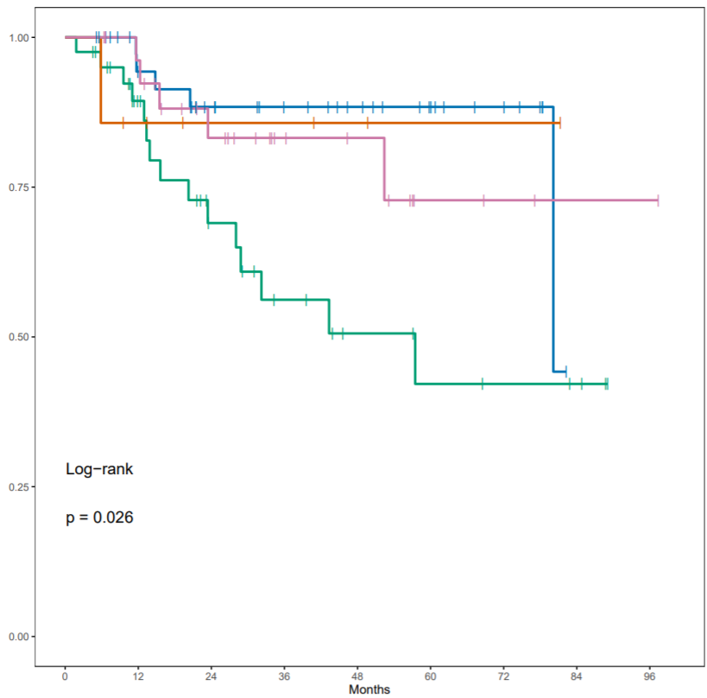
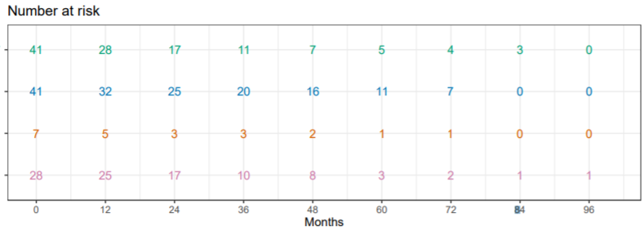
Supplementary Fig 1 Recurrence free survival of ER⁺-low and ER⁺-Intermediate patients who received ET vs those who did not.
Notes: Groups: --- ER⁺- low_ No_ ET, --- ER⁺-low _Yes_ET, --- ER⁺-Intermediate_No_ET, --- ER⁺-Intermediate_Yes_ET.

