Supplementary information
Methods
Urinary sample preparation for ¹H NMR analysis. The spectra were acquired using the Bruker® Avance III 600MHz spectrometer, with a Sample jet 96 well autosampler. Standard 1-D ¹H-NMR experiments with water suppression was performed at 300 K using the following parameters: relaxation delay of 4s; mixing time of 10ms; acquisition time of 2.726s and spectral width of 20 ppm. The resulting free induction decays (FIDs) were Fourier transformed, and a line-broadening factor of 0.3 Hz and zero filling factor of 2 was applied producing NMR spectra with 132K data points. All ¹H NMR spectra were automatically referenced to TSP at 0 ppm, phased and baseline-corrected on Topspin 3.2 (Biospin).
Serum sample preparation for UPLC-MS profiling. Metabolites extraction and protein precipitation was performed using isopropanol in a ratio 1:3 serum to solvent using 50μL of serum.³² The extracts were vortexed and centrifuged at 14,000g for 20 mins at 4°C. The supernatant (50μL) was transferred into LCMS vials with inserts for the bile acid assay. The supernatant for the hydrophilic liquid chromatography (HILIC) assay, was evaporated at room temperature in a vacuum concentrator (Eppendorf Concentrator Plus), reconstituted in H₂O/acetonitrile at a ratio of 10:90 and transferred into vials.³³ QC samples were prepared pooling 20μL from each serum extract. The samples were stored at -80°C until UPLC-MS analysis.
Urine sample preparation for UPLC-MS profiling. Aliquots (200μL) were evaporated and reconstituted with H₂O/isopropanol/acetonitrile (2:1:1) for the bile acid assay and H₂O/acetonitrile (10:90) for the HILIC assay. Samples were vortexed and centrifuged at 14,000g for 20 min at 4°C. QC samples were prepared pooling 20μL from each urine sample after evaporation and reconstitution. Samples were stored at -80°C until UPLC-MS analysis.
Faeces sample preparation for UPLC-MS profiling. Faecal samples were weighed (≈200 mg) prior to analysis and freeze dried. For the bile acid and polar metabolite profiling (HILIC) assays, samples were extracted with the following solvents’ mixtures of H₂O/isopropanol/acetonitrile, 2:1:1 and 1:1:1 respectively. Lysis was induced with a bead beater (Bertin Technologies, France) vibrating twice at 6500Hz for 40s. Samples were vortexed and centrifuged at 14,000g for 20 min at 4°C. The supernatant of samples prepared for the HILIC assay were evaporated and reconstituted with acetonitrile/H₂O (90:10). The supernatant fraction was transferred into a vial and a QC sample was prepared from pooled faecal samples (20μL from each sample). Samples were stored at -80°C until UPLC-MS analysis.
UPLC-MS HILIC profiling method. The validated HILIC-MS described in Lewis and co-workers was applied.³⁴ The ACQUITY UPLC (Waters Corp., Milford, MA, USA) was coupled to a Xevo G2-S QTOF MS (Waters Corp., Manchester, UK. The mobile phases solvents were prepared with acetonitrile with 0.1% formic acid (mobile phase A) and water with 20mM ammonium formate and 0.1% formic acid (mobile phase B). Separation of polar metabolites by HILIC was obtained through a seven-minute run with initial condition at 95% A on 0.6 μL/min flow rate for seven minutes followed by equilibration and return to initial conditions over an eight-minute run.
UPLC-MS BA profiling method. The protocol described by Sarafian and colleagues was followed.³² Supernatant (100 μL) was transferred to 0.5 mL Eppendorf 96- deep well plates, and 300 μL of ice-cold methanol was added to each sample. Analysis was performed by ACQUITY UPLC (Waters Ltd., Elstree, UK).

Supplementary Table 1: Samples collected from UC patient cohort. Number of urine, serum and faecal samples collected from SA and Caucasian patients at three different time points across the year.

Timepoint (months) | Visit 1  (month 0-3) |  | Visit 2  (month 4-8) |  | Visit 3  (month 9-12) |  | Total
 | SA | Cauc | SA | Cauc | SA | Cauc
Urine | 26 | 10 | 13 | 9 | 14 | 8 | 53/27
Serum | 22 | 15 | 14 | 10 | 11 | 6 | 47/31
Faeces | 26 | 12 | 14 | 8 | 14 | 9 | 56/29
SA: South Asian, Cauc: Caucasian

Supplementary Figure 1: Bar graph of Bifidobacterium relative abundance in individual samples of SA and Caucasian UC patients

Supplementary Table 2: OPLS DA Models for ¹H NMR profiling method.
Model | R2X | R2Y | Q2Y | CV ANOVA  p-value
Time point (TP)
TP1 vs TP3 | 0.132 | 0.698 | -0.158 | 1.00
Group
SA vs Cauc | 0.108 | 0.847 | 0.52 | 9.12x 10-11
HC SA vs SA | 0.134 | 0.914 | 0.18 | 0.203
HC Cauc vs Cauc | 0.209 | 0.78 | 0.217 | 0.132
HC SA vs HC Cauc | 0.193 | 0.951 | 0.285 | 0.286
Treatment
5-ASA vs None | 0.139 | 0.82 | -0.199 | 1
Steroid + Aza vs None | 0.174 | 0.8 | 0.244 | 0.02
SA None vs Cauc None | 0.173 | 0.616 | 0.212 | 0.557
Significant models in bold.
Cross Validation ANOVA - analysis of variance of the cross-validated residuals; OPLS-DA: orthogonal-projection to latent structure- discriminant analysis; Aza: azathioprine; SA: South Asian; Cauc: Caucasian.

Supplementary Figure 2: OPLS DA plot of urinary ¹H NMR metabolic profile of SA vs Caucasians UC patients. Robustness of the model is validated by the values of R2X, R2Y, Q2Y and CV-ANOVA p value.
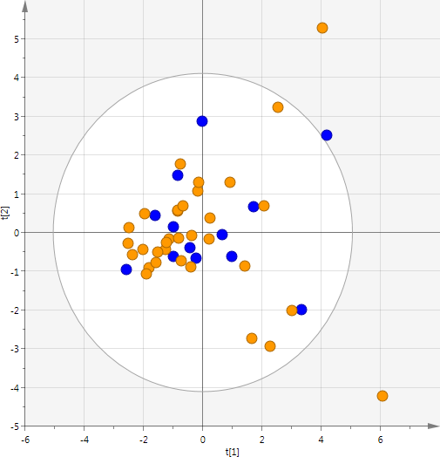
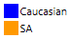
OPLS-DA
1 PC / 1 OC
R²X 0.108
R²Y 0.847
Q²Y 0.520
CV-ANOVA p-value 9.11x10⁻¹¹

Supplementary Figure 3A (top): OPLS-DA Loadings plot from ¹HNMR metabolic profiles of SA vs Caucasian UC patients. The peaks with positive covariance (Y axis) are higher in Caucasians, those with negative covariance are higher in SA. All the peaks are colour coded according to their correlation values. (high correlation values are in hot colours while low correlation valued are presented in cold colours) The peaks with high correlations are the most important in the class discrimination.

Supplementary Figure 3B (bottom): OPLS-DA Loadings plot from ¹HNMR metabolic profiles of SA vs Caucasians between 1-2.7ppm.

Supplementary Table 3: OPLS-DA Models for HILIC and BA profiling methods. Significant models in bold.

 |  | HILIC |  |  | Bile acid
 |  | Urine | Serum | Faecal | Urine | Serum | Faecal
SA vs  Cauc | R²X | 0.164 | 0.378 | 0.129 | 0.244 | 0.23 | 0.237
 | Q²Y | 0.526 | -0.448 | 0.596 | 0.102 | 0.517 | 0.277
 | p-value | 7.11x10-12 | 1 | 6.47x10-5 | 0.938 | 1.67x10-10 | 1.71x10-4
HC SA  vs SA | R²X | 0.164 | 0.109 | 0.106 | 0.245 | 0.219 | 0.309
 | Q²Y | 0.399 | -0.026 | 0.259 | 0.124 | 0.233 | 0.159
 | p-value | 0.001 | 1 | 0.003 | 0.314 | 0.174 | 0.251
HC SA  vs HC Cauc | R²X | 0.145 | 0.358 | 0.204 | 0.302 | 0.254 | 0.407
 | Q²Y | 0.266 | 0.409 | 0.629 | 0.191 | 0.331 | 0.547
 | p-value | 0.131 | 0.119 | 0.005 | 0.619 | 0.199 | 0.014
HC Cauc  vs Cauc | R²X | 0.109 | 0.329 | 0.118 | 0.162 | 0.315 | 0.269
 | Q²Y | 0.417 | 0.346 | 0.555 | -0.284 | 0.381 | 0.481
 | p-value | 0.001 | 0.076 | 1.62x10-5 | 1 | 0.003 | 0.001

Cross Validation ANOVA - analysis of variance of the cross-validated residuals; OPLS-DA: orthogonal-projection to latent structure- discriminant analysis; Aza: azathioprine; SA: South Asian; Cauc: Caucasian; HC: Healthy controls

Supplementary Table 4: Metabolic variations observed between Timepoint and Treatment in OPLS DA modelling of SA and Caucasian UC patients

 |  | HILIC |  |  | Bile acid
 | Sample type | Urine | Serum | Faecal | Urine | Serum | Faecal
Timepoint
TP1 vs TP3 | R²X | 0.133 | 0.281 | 0.173 | 0.132 | 0.251 | 0.0761
TP1 vs TP3 | Q²Y | -0.339 | -0.191 | -0.122 | -0.426 | -0.345 | -0.196
TP1 vs TP3 | p-value | 1 | 1 | 1 | 1 | 1 | 1
Treatment
5 ASA vs None | R²X | 0.149 | 0.271 | 0.102 | 0.18 | 0.291 | 0.113
5 ASA vs None | Q²Y | 0.008 | 0.266 | -0.175 | -0.394 | 0.245 | 0.119
5 ASA vs None | p-value | 0.973 | 1 | 1 | 1 | 0.002 | 0.151
Steroid + Aza vs None | R²X | 0.147 | 0.331 | 0.249 | 0.221 | 0.235 | 0.191
Steroid + Aza vs None | Q²Y | 0.331 | 0.127 | 0.563 | 0.176 | 0.141 | 0.379
Steroid + Aza vs None | p-value | 0.001 | 0.210 | 0.977 | 0.0737 | 0.184 | 0.006
SA none vs Cauc none | R²X | 0.228 | 0.314 | 0.18 | 0.155 | 0.321 | 0.216
SA none vs Cauc none | Q²Y | 0.392 | 0.111 | 0.506 | 0.0657 | 0.497 | 0.49
SA none vs Cauc none | p-value | 0.012 | 0.668 | 0.004 | 0.376 | 0.003 | 0.017
Remission vs flare | R²X | 0.977 | 0.431 | 0.265 | 0.379 | 0.363 | 0.3
Remission vs flare | Q²Y | 0.402 | -0.015 | -0.232 | 0.369 | 0.0929 | 0.388
Remission vs flare | p-value | 0.397 | 1 | 1 | 0.457 | 0.94 | 0.577
Significant models highlighted in bold

Supplementary Figure 4: OPLS DA score plots of faecal HILIC (A) and faecal BA samples (B) from SA and Caucasian UC patients. Robustness of the model is validated by the R²X, R²Y, Q²Y values and CV-ANOVA p-value.

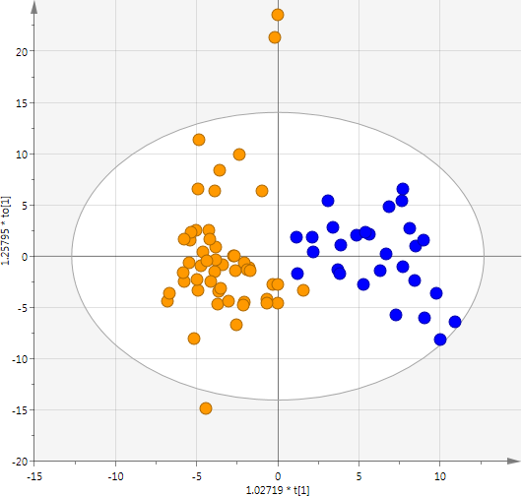
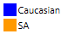
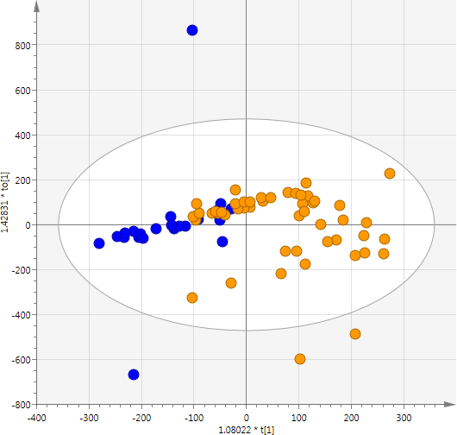
  - HILIC profiling B) Bile acid profiling
OPLS-DA
1 PC / 1 OC
R²X 0.129
R²Y 0.800
Q²Y 0.596
CV-ANOVA p-value 6.47x10-14
OPLS-DA
1 PC / 1 OC
R²X 0.237
R²Y 0.528
Q²Y 0.277
CV-ANOVA p-value 1.7x10-4

Supplementary Table 5: Significant metabolites identified by faecal HILIC.
Model | m/z | RT (min) | Metabolite affected  by the model | p values
SA vs Cauc | 229.153 | 5.78 | Leucylproline | 0.001
SA vs Cauc | 114.065 | 2.53 | Creatinine | 0.001
SA vs Cauc | 264.076 | 1.3 | Pantothenic acid* | 0.036
HC SA vs SA | 166.073 | 2.21 | Phenylalanine | 0.035
HC Cauc vs HC SA | 166.073 | 2.21 | Phenylalanine | 0.011
HC Cauc vs Cauc | 205.084 | 0.7 | Tryptophan | 0.021
HC Cauc vs Cauc | 166.073 | 2.21 | Phenylalanine | 0.007
Positive ESI *Validated against standards. SA: South Asian; Cauc: Caucasian; HC: healthy controls.

Supplementary Table 6: Identification of discriminant features obtained on faecal BA of OPLS-DA model.
m/z | RT  (min) | Bile Acid annotation | Higher  /Lower/No change (SA relative to Caucasian) | p-value from Univariate analysis with Bonferroni correction
405.263 | 6.56 | 5β-cholanic acid-3α, 6α-diol-7-one | Higher | 2.92 x 10-4
373.273 | 10.24 | 5-Cholenic acid-3β-ol | Higher | 3.1 x 10-4
391.284a | 8.25 | Unknown BA | Higher | 0.003
407.279b | 6.38 | Unknown 1 Isomer CDCA | Higher | 0.0025
567.314 | 1.16 | Unknown BA 2 | Higher | 9.37 x 10-5
549.344 | 3.28 | Unknown BA 3 sulfated | Higher | 0.005
373.274 | 10.76 | 3-Ketocholanic acid | Lower | 0.0021
375.29 | 10,90 | Lithocholic acid | Lower | 0.0024
375.29 | 10.56 | Isolithocholic acid | Lower | 7.33 x 10-5
389.269 | 9.05 | 3α-hydroxy-12-ketolithocholic acid | Lower | 0.017
467.277 | 10.77 | Unknown BA 4 | Lower | 0.0018
493.293 | 10.87 | Unknown 5 isomer sulfated diketo CDCA | Lower | 0.0011
389.269 | 7.61 | Unknown 6 Isomer Keto CDCA | Lower | 0.009
453.262 | 10.55 | Unknown 7 isomer sulafted hydroxy CDCA | Lower | 0.006
494.296 | 10.87 | Unknown BA 8 | Lower | 0.0014
514.283 | 4.94 | Taurocholic acid | No change | 0.054
391.284 | 10.33 | Chenodeoxycholic acid | No change | 5.27 x 10-4
407.279 | 8.50 | Cholic acid | No change | 4.8 x 10-4

Supplementary Figure 5: PCA plot of weighted Unifrac distance comparing SA and Caucasian healthy controls (HC) at Timepoint 1.

Supplementary Table 7: Urinary ¹H NMR analysis at Timepoint 1 of healthy controls (HC) vs SA and Caucasian UC patients.
 | R2X | R2Y | Q²Y | p value
Group
HC SA vs SA | 0.185 | 0.906 | 0.196 | 0.179
HC Cauc vs Cauc | 0.276 | 0.876 | -0.019 | 1.000
HC SA vs HC Cauc | 0.176 | 0.789 | 0.140 | 0.199

Supplementary Table 8: Metabolic variations in diet observed at Timepoint 1 in OPLS DA modelling.
 |  | Faecal HILIC | Urine BA | Faecal BA | ¹HNMR
Protein | R²X | 0.401 | 0.329 | 0.239 | 0.215
Protein | Q²Y | 0.18 | 0.14 | -0.193 | -0.011
Protein | p value | 0.568 | 0.608 | 1 | 0.780
Fats | R²X | 0.350 | 0.324 | 0.181 | 0.210
Fats | Q²Y | -0.032 | -0.072 | 0.094 | 0.006
Fats | p value | 1 | 1 | 0.777 | 0.117
Fibre | R²X | 0.396 | 0.322 | 0.230 | 0.205
Fibre | Q²Y | -0.101 | -0.33 | 0.090 | -0.079
Fibre | p value | 1 | 1 | 0.790 | 0.250
Veg/Non-veg | R²X | 0.229 | 0.263 | 0.233 | 0.210
Veg/Non-veg | Q²Y | -0.111 | 0.0821 | 0.027 | 0.005
Veg/Non-veg | p value | 1 | 0.819 | 0.97 | 1.000

Supplementary Figure 6: PCA plot of weighted Unifrac distance of disease severity (A) and disease phenotype (B) at Timepoint 1.
A
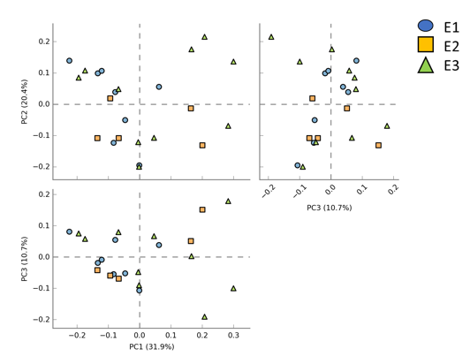
B

Supplementary Figure 7: OPLS DA model of high/low Fat and Protein intake in Faecal bile acid assay at Timepoint 1.

Supplementary Table 9: Metabolic variations in disease severity and phenotype observed at Timepoint 1 in OPLS DA modelling.

 |  | Faecal HILIC | Urine BA | Faecal BA | ¹HNMR
Disease extent | R²X | 0.148 | 0.319 | 0.235 | 0.158
Disease extent | Q²Y | -0.178 | -0.143 | -0.232 | 0.299
Disease extent | p value | 1 | 1 | 1 | 0.480
Disease severity | R²X | 0.148 | 0.362 | 0.240 | 0.221
Disease severity | Q²Y | 0.004 | -0.0786 | -0.241 | 0.274
Disease severity | p value | 1 | 1 | 1 | 0.780

Supplementary Figure 8: OPLS DA model of disease severity in faecal bile acid (A) and HILIC (B) assay at Timepoint 1.

- Faecal bile acid B) Faecal HILIC

