HA-DOPE Modified Honokiol-Loaded liposomes Targeted Therapy for Osteosarcoma

Xiangxiang Zhang¹, Huaen Chen¹, Yang Zhang¹, Qijing Huang¹, Jianjia Feng¹, Haoyu Xing¹, Xiaguo Fu¹, Xiufang Yan¹, Yingying Zhang¹, Qin Xu¹, Jianming Liang¹
¹ Artemisinin Research Center, The First Affiliated Hospital, Guangzhou University of Chinese Medicine, Guangzhou, 510405,People’s Republic of China
Correspondence: Jianming Liang, Artemisinin Research Center, The First Affiliated Hospital, Guangzhou University of Chinese Medicine, Guangzhou, 510405,People’s Republic of China, Email liangjianming@gzucm.edu.cn

Supplementary Figure
Figure S1 FT-IR spectra of hyaluronic acid (HA), dioleoyl phosphoethanolamine (DOPE), and HA-conjugated DOPE (HA-DOPE).
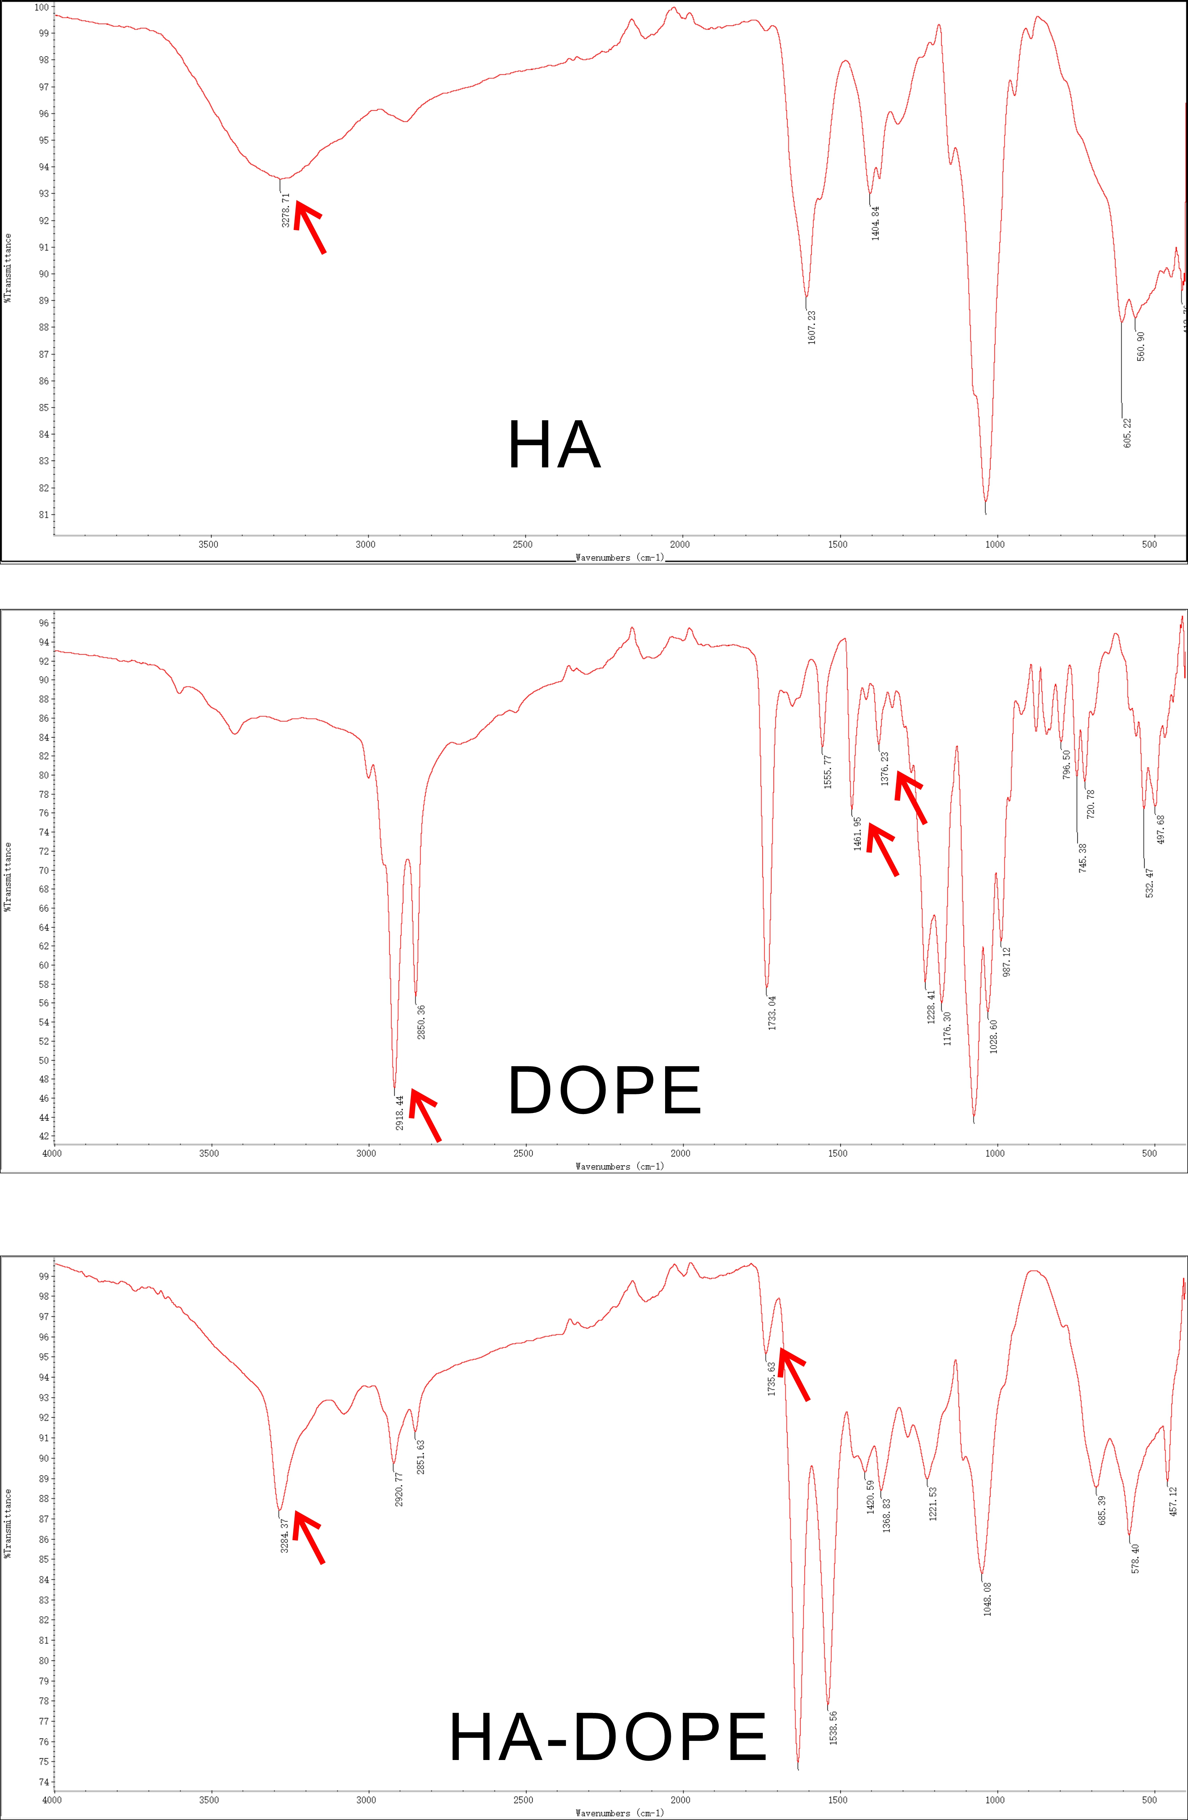

HA and HA-DOPE were identified by HPLC. Briefly, BioCore SEC column was used for identifying the HA conjugated DOPE, and the composition of the mobile phase was 0.1M phosphate buffered saline (pH=7.0): methanol (80:20, v/v), the flow rate was 1.0 mL/min, and the detection wavelength was 214 nm, the BioCore SEC Column temperature was set at 30°C.

Figure S2 High Performance Liquid Chromatograms of (A) HA and (B) HA-DOPE.
A
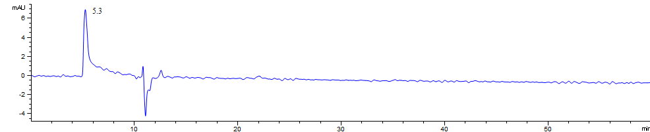
HA
B
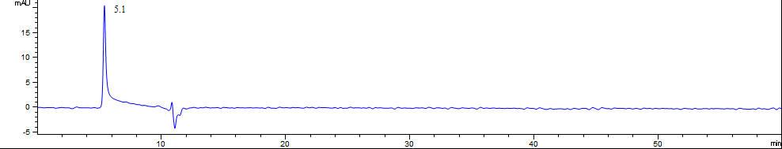
HA-DOPE

Figure S3 FT-IR spectra of (A) HNK, (B) blank liposomes, (C) physical mixture (SPC, CHO, HA-DOPE and HNK) and (D) HA-DOPE@Lips/HNK.
