Supplementary Figure 1 Absolute number of confirmed diagnoses (J30.1, J30.2, J30.3 and J30.4) per quarter of the year 2019
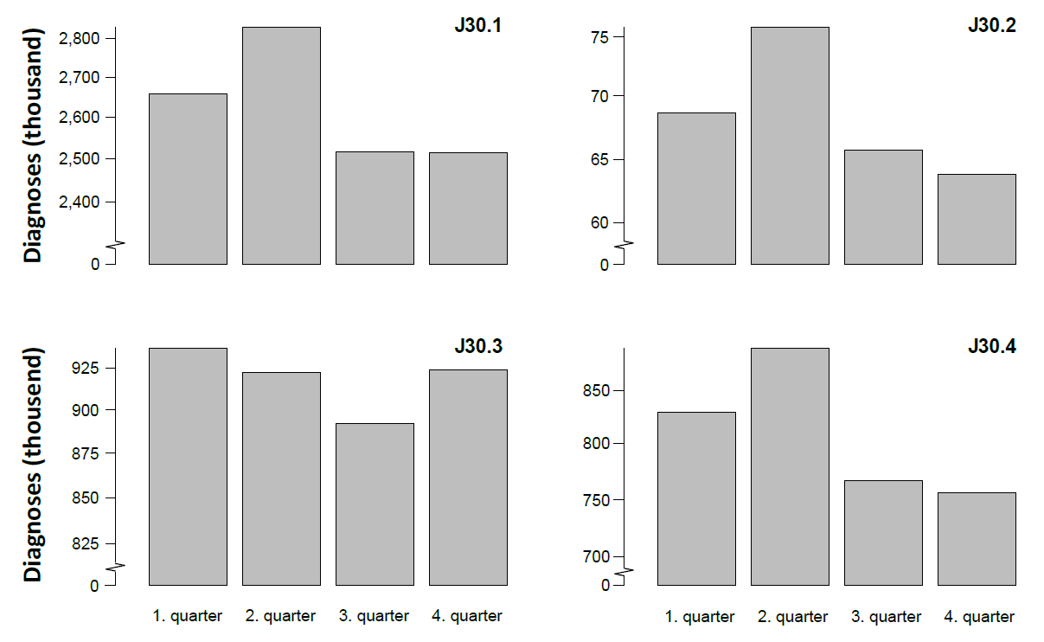
Notes: The scaling of y-axes of the four graphs is not identical and therefore not directly comparable. Source: Nationwide outpatient claims data encompassing all German statutory health insurances (SHI) according to § 295 SGB V
J30.1, allergic rhinitis due to pollen; J30.2, other seasonal allergic rhinitis; J30.3, other seasonal allergic rhinitis; J30.4, allergic rhinitis, unspecified.

Supplementary Figure 2 Annual prevalence ratio of the age- and sex-standardized prevalence in western compared to eastern Germany (without Berlin) in the years 2010 to 2019
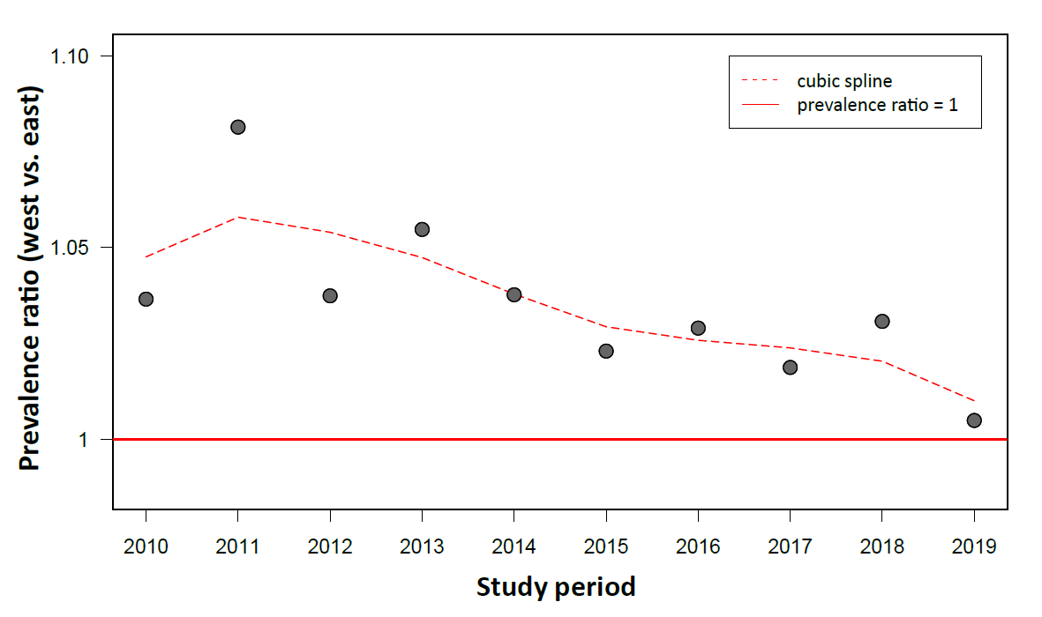
Source: Nationwide outpatient claims data encompassing all German statutory health insurances according to §295 SGB V

