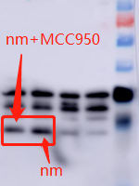
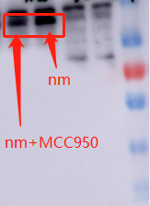
Supplymentary Data
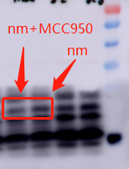
Figure S1 NLRP3 original image
Figure S2 ASC original image

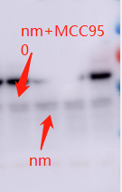
Figure S4 P20 original image
Figure S3 Pro-Caspase-1 original image

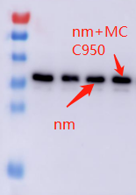
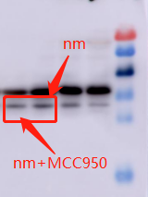
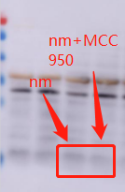
Figure S6 IL-1β original image
Figure S7 GAPDH original image
Figure S5 Pro-IL-1β original image

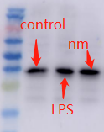
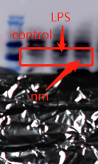
Figure S9 GAPDH original image
Figure S8 AIM2 original image

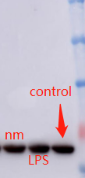
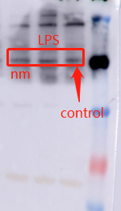
Figure S11 α-tublin original image
Figure S10 NLRP1original image

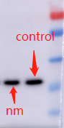
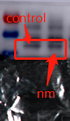
Figure S13 GAPDH original image
Figure S12 CSTB original image

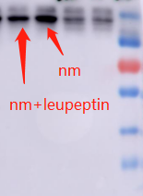
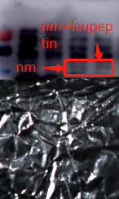
Figure S15 NLRP3 original image
Figure S14 CSTB original image

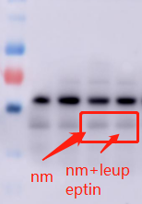
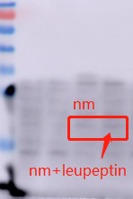
Figure S17 Caspase-1 original image
Figure S16 ASC original image

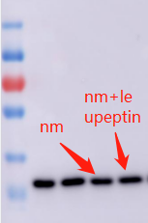
nm:SiNP
Figure S18 GAPDH original image

