Supplement I
In this study, both MRA and MRE images were acquired for each volunteer or patient during the same scan. In addition, to prevent the potential head motion, the head was fixed firmly inside the head coil with sand bags and foams. Therefore, the main purpose of the registration between MRA and MRE images were to align the image coordinates due to the field of view and image resolution differences. This is necessary for applying the masks of the segmented vessel ROIs from MRA images to MRE.
Since clear anatomical feature of the ventricle regions can be observed in both MRA images and magnitude images of MRE, we used cross correlation to register the image volumes based on the slices containing the ventricle region. A mean translation of MRA images with respect to the MRE images were 43 and 74 pixels in X and Y axes. The registration parameters for all data sets showed the translation of the image coordinates were within ±3 pixels (<1mm) relative to the mean values (Figure S1a). The cross-correlation values of the whole brain showed the robustness of the registration (Figure S1b). Within a correlation value of 98%, the registration translation error in the x axis is within 2 pixels (<0.6mm), and the registration translation error in the y axis is within 3.5 pixels (<1mm). Therefore, vessels with a diameter less than 1mm in the ROIs were removed since the largest possible registration error was 3.5 pixels (1mm).

Supplement II
Since the resolution of the RBP map were comparable to the size of blood vessels, the displacement field obtained from the MRE phase images were interpolated before the modulus inversion. To validate the procedure of the interpolation, we carried out a simulation study to show that the displacement field interpolation can help improve the accuracy of the modulus estimation. The effect of different patch sizes and smooth parameters for the modulus inversion was also analyzed using a direct inversion algorithm.
We constructed a cubic region with a size of 130mm$×$120mm$×$50mm and a shear modulus of 2.5kPa for simulation (Figure S2). Since the diameter of cerebral vessels is generally 2mm ~ 4mm, three slender cylindrical bars with a diameter of 3mm and a shear modulus of 0.5kPa were embedded in the cube. In addition, a sphere with a diameter of 20mm and a shear modulus of 0.5kPa were also embedded. A shear wave with a frequency of 60Hz was applied. The displacement images were obtained with a voxel size of 3$×$3$×$3 mm³, the same as that in the MRE experiment (Figure S2). The computational model was constructed using COMSOL (COMSOL Inc.).
Compared with the modulus eastimated without interpolation, the estimated shear moduli was improved with better contrast between the inclusions and the background (Figure S3). By selecting different sizes of the fitting window for inversion, we also observed that a smaller window size for modulus fitting could improve the modulus estimation. Therefore, a window size of 3$×$3$×$3 pixels was used in this study. Using the same fitting window size, we observed that a larger Gaussian smooth filter can keep the estimated moduli at the same magnitude level, but will result in a loss of contrast details.
As can be seen between Figure S3(a) and Figure S3(i), interpolation can improve the resolution but not the contrast details. In addition, from Figure 9(c, g-i), we observed that the Gaussian smooth parameters could influence the contrast of the modulus map. With a smaller Gaussian smooth filter kernel, more local displacement information was kept, leading to a decrease in the estimated modulus. The estimated mean shear modulus of the background tissue without displacement interpolation was 2.34kPa (Figure S3b). The corresponding fitting window size was 3×3×3, filter kernel size was 3×3×3, and the filter standard deviation σ=1. The estimated mean shear modulus of the background tissue after displacement interpolation was 1.72kPa with the same post-processing parameters (Figure S3c). A similar modulus decrease was also observed for the brain tissue (Figure S4).

Figures

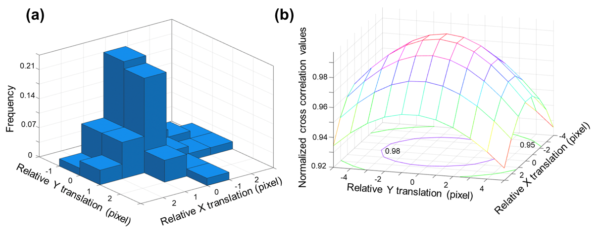
Figure S1. (a) A 3D histogram plot of the relative translation values registration of the MRA and MRE images. The relative translation was defined as translation offset with respect to the mean translation values of 43 and 74 pixels in X and Y axes, respectively. (b) A distribution of the cross-correlation values for all the data sets.

Figure S2. A simulation model constructed to investigate the effect of the fitting window size to estimate the shear moduli. Three slender cylindrical inclusions and one spherical inclusion were embedded. The absolute displacement of the central slice in the x-y plane was plotted to show the wave propagation.

Figure S3. (a) Ground truth of shear modulus. (b) Estimated shear modulus without interpolation ($×$1), and with fitting window size=3$×$3$×$3, filter kernel size=3$×$3$×$3, and filter standard deviation $σ$=1. Estimated maps of shear moduli after interpolation ($×$4) with the same smooth filter parameters (3$×$3$×$3, $σ$=1) but different modulus fitting window sizes of (c) 3$×$3$×$3, (d) 9$×$9$×$3, (e) 15$×$15$×$3, and (f) 21$×$21$×$3. Estimated maps of shear moduli after interpolation with the same modulus fitting window sizes (3$×$3$×$3) but different smooth filter parameters of (g) 5$×$5$×$3, $σ$=2, (h) 7$×$7$×$3, $σ$=3, (i) 9$×$9$×$3, $σ$=4.

Figure S4. (a) The absolute shear modulus |G*| of the whole brain estimated without interpolation of the displacement field. (b) The corresponding maps of |G*| values estimated after interpolation of the displacement field.

