Online supplement

Table S1: Predictive performance of various FEV₁/ FEV₆ cut-off points against RADICALS trial diagnostic criteria (Post-BD FEV₁/FVC <0.7 and clinical correlation).
FEV₁/ FEV₆ cut-off | Sensitivity (%) | Specificity (%) | AUROC | PPV (%) | NPV (%)
<0.66 | 50.8 | 85.1 | 0.679 | 90.6 | 37.8
<0.67 | 53.2 | 85.1 | 0.691 | 91.0 | 38.9
<0.68 | 57.3 | 83.9 | 0.706 | 91.0 | 40.8
<0.69 | 61.7 | 80.5 | 0.711 | 90.0 | 42.4
<0.70 | 65.7 | 79.3 | 0.725 | 90.1 | 44.8
<0.71 | 70.6 | 73.6 | 0.721 | 88.4 | 46.7
<0.72 | 75.8 | 65.5 | 0.707 | 86.2 | 48.7
<0.73 | 83.9 | 59.8 | 0.718 | 85.6 | 56.5
<0.74 | 89.9 | 46.0 | 0.679 | 82.6 | 61.5
<0.75 | 93.1 | 35.6 | 0.644 | 80.5 | 64.6
Positive Predictive Value (PPV), Negative Predictive Value (NPV), Area Under the Receiver Operating Characteristic Curve (AUROC).

Table S2: The predictive performance of various FEV₁/ FEV₆ cut-off points against FEV₁/FVC <0.7.
FEV₁/ FEV₆ cut-off | Sensitivity (%) | Specificity (%) | AUROC | PPV (%) | NPV (%)
<0.66 | 56.5 | 88.9 | 0.727 | 91.3 | 49.7
<0.67 | 59.2 | 88.9 | 0.740 | 91.7 | 51.3
<0.68 | 63.7 | 88.0 | 0.758 | 91.6 | 54.0
<0.69 | 68.2 | 84.3 | 0.762 | 89.9 | 56.2
<0.70 | 72.6 | 83.3 | 0.780 | 90.0 | 59.6
<0.71 | 77.1 | 76.9 | 0.770 | 87.3 | 61.9
<0.72 | 82.1 | 70.4 | 0.762 | 85.1 | 65.5
<0.73 | 87.9 | 59.3 | 0.736 | 81.7 | 70.3
<0.74 | 91.5 | 42.6 | 0.670 | 76.7 | 70.8
<0.75 | 94.2 | 32.4 | 0.633 | 74.2 | 72.9
Positive Predictive Value (PPV), Negative Predictive Value (NPV), Area Under the Receiver Operating Characteristic Curve (AUROC).

Table S3: Predictive performance of various FEV₁/ FEV₆ cut-off points against FEV₁/FVC<LLN.
FEV₁/ FEV₆ cut-off | Sensitivity (%) | Specificity (%) | AUROC | PPV (%) | NPV (%)
<0.66 | 68.0 | 90.2 | 0.791 | 87.4 | 73.8
<0.67 | 71.2 | 89.5 | 0.804 | 87.2 | 75.7
<0.68 | 76.5 | 87.6 | 0.820 | 86.0 | 78.8
<0.69 | 79.7 | 82.4 | 0.810 | 81.9 | 80.3
<0.70 | 84.3 | 80.4 | 0.824 | 81.1 | 83.7
<0.71 | 87.6 | 73.2 | 0.804 | 76.6 | 85.5
<0.72 | 89.5 | 64.1 | 0.768 | 71.4 | 86.0
<0.73 | 96.1 | 54.2 | 0.752 | 67.7 | 93.3
<0.74 | 97.4 | 38.6 | 0.680 | 61.3 | 93.7
<0.75 | 98.0 | 28.8 | 0.634 | 57.9 | 93.6
Positive Predictive Value (PPV), Negative Predictive Value (NPV), Area Under the Receiver Operating Characteristic Curve (AUROC).

Table S4: Predictive performance of various FEV₁/ FEV₆ cut-off points against mild and moderate-severe COPD
FEV₁/ FEV₆ cut-off | Mild COPD |  |  | Moderate – Severe COPD
FEV₁/ FEV₆ cut-off | Sensitivity (%) | Specificity (%) | AUROC | Sensitivity (%) | Specificity (%) | AUROC
<0.66 | 37.8 | 54.2 | 0.460 | 85.3 | 69.7 | 0.775
<0.67 | 40.6 | 53.5 | 0.471 | 86.8 | 67.8 | 0.773
<0.68 | 44.4 | 51.0 | 0.477 | 91.2 | 64.8 | 0.780
<0.69 | 49.4 | 47.7 | 0.486 | 94.1 | 60.3 | 0.772
<0.70 | 55.0 | 47.1 | 0.510 | 94.1 | 56.2 | 0.751
<0.71 | 61.7 | 43.9 | 0.528 | 94.1 | 49.8 | 0.720
<0.72 | 68.9 | 39.4 | 0.541 | 94.1 | 42.3 | 0.682
<0.73 | 78.9 | 34.8 | 0.569 | 97.1 | 33.7 | 0.654
<0.74 | 86.7 | 26.5 | 0.566 | 98.5 | 24.0 | 0.612
<0.75 | 90.6 | 20.0 | 0.553 | 100 | 18.0 | 0.590
Positive Predictive Value (PPV), Negative Predictive Value (NPV), Area Under the Receiver Operating Characteristic Curve (AUROC).

Figure S1: ROC curves for SGRQ, CAT and mMRC against post-BD FEV₁/FVC <0.7 and clinical correlation.
- SGRQ (AUROC=0.651, 95%CI 0.586–0.716, p-value=0.0001).

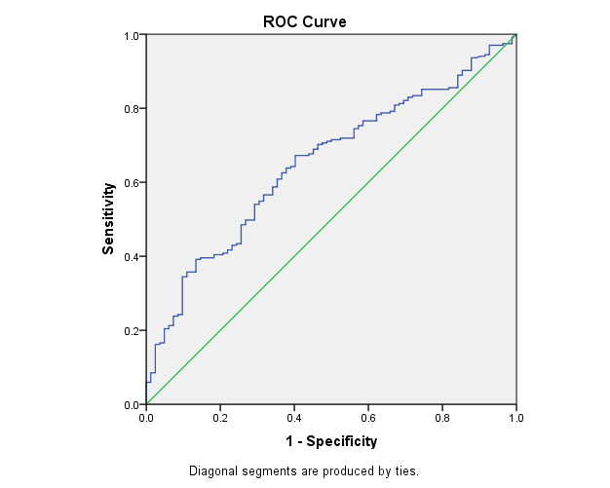

- CAT (AUROC=0.620, 95%CI 0.536–0.703, p-value=0.009).

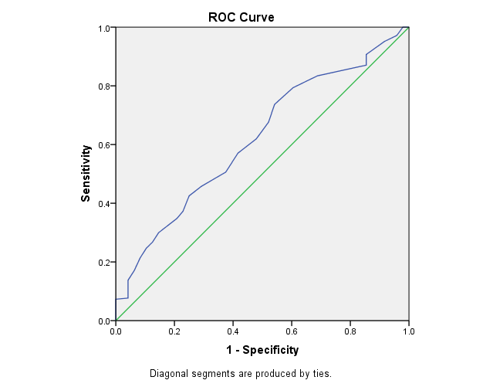

- mMRC (AUROC=0.612, 95%CI 0.528–0.696, p-value=0.014).
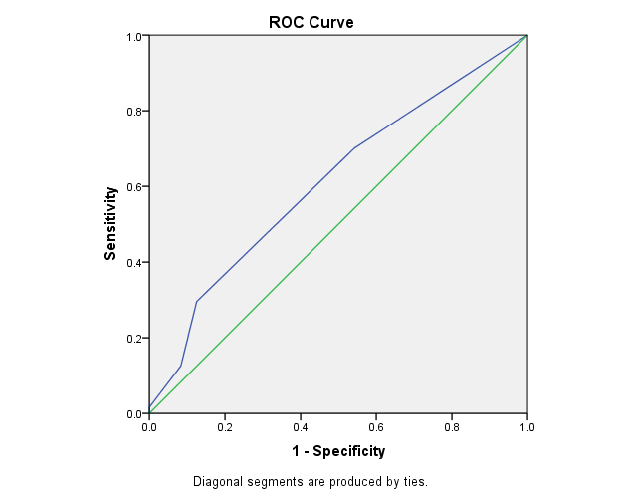

Figure S2: ROC curves for SGRQ, CAT and mMRC against post-BD FEV₁/FVC <0.7.
- SGRQ (AUROC=0.641, 95%CI 0.579–0.704, p-value <0.001).

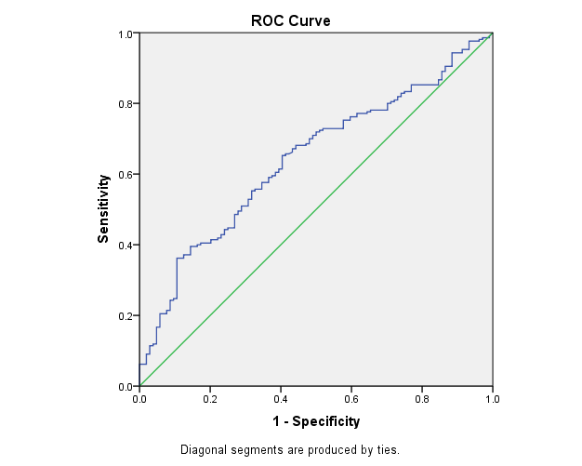

- CAT score (ROC=0.605, 95%CI 0.532–0.678, p-value=0.007).

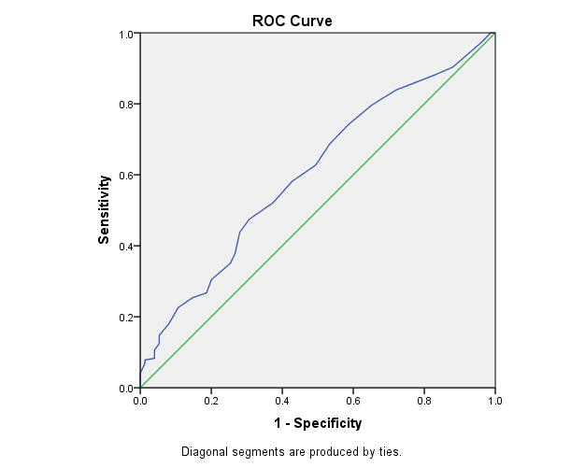

- mMRC (AUROC=0.608, 95%CI 0.537–0.680, p-value=0.005).

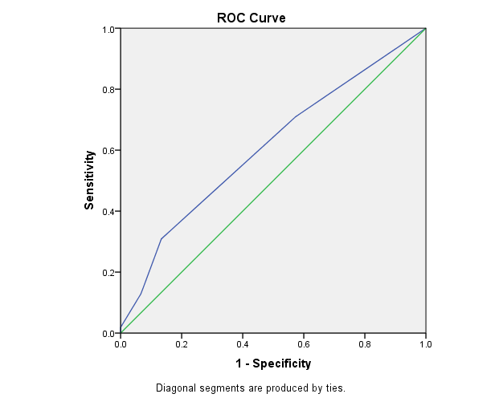

Figure S3: ROC curves for SGRQ, CAT and mMRC against post-BD FEV₁/FVC <LLN.
- SGRQ (AUROC=0.679, 95%CI0.617–0.740, p-value <0.0001).
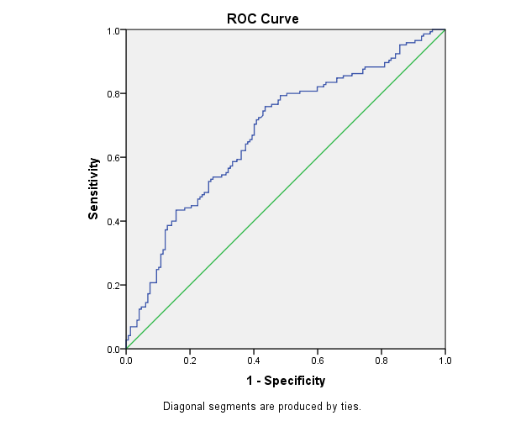

- CAT (AUROC=0.633, 95%CI 0.566–0.700, p-value <0.0001).

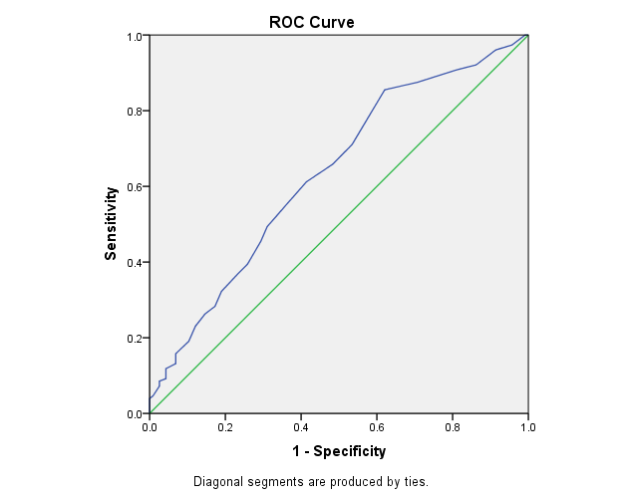

- mMRC (AUROC=0.616, 95%CI 0.548–0.683, p-value 0.001).
