Lysophosphatidylcholine (17:0) improves HFD-induced hyperglycemia & insulin resistance: A mechanistic mice model study
Li Bao^{1,2}, Ying Zhang^{2,3}, Sichao Yan^{1,2}, Dan Yan^{2,3}, Dechun Jiang^{1,2,}*
¹ Department of Pharmacy, Beijing Shijitan Hospital, Capital Medical University, Beijing, China; ² Beijing Key Laboratory of Bio-characteristic Profiling for Evaluation of Rational Drug Use, Beijing, China; ³Department of Pharmacy, Beijing Friendship Hospital, Capital Medical University, Beijing, China.

Correspondence: Professor, Dechun Jiang
Department of Pharmacy, Beijing Shijitan Hospital, Capital Medical University, No.10 Tieyi-Road, Haidian District, 10038, Beijing, China
Tel: +86-10-63926723
Email: jdc@bjsjth.cn

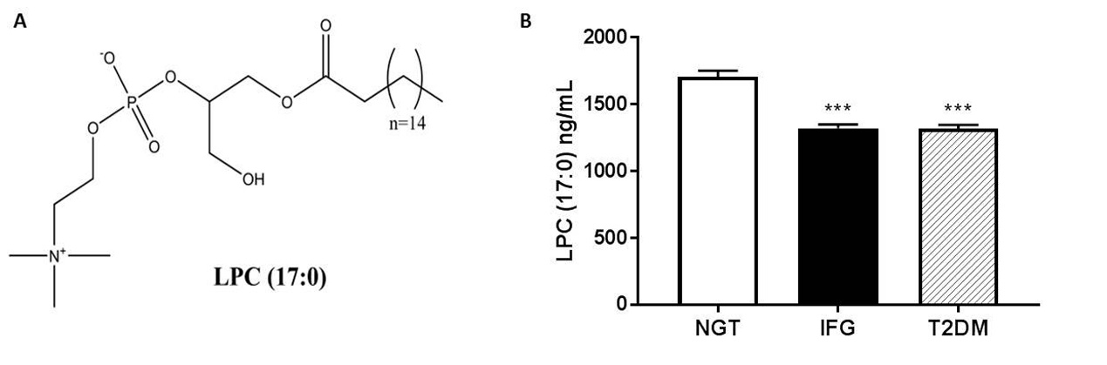
Figure S1 Structures of LPC (17:0) (A) and the LPC (17:0) content in human serum (B).
NGT: normal glucose tolerance (n=314), IFG: impaired fasting glucose (n=318), T2DM: type 2 diabetes mellitus (n=368). Data are presented as the mean ± standard error of the mean (SEM), Statistical analysis was done using one-way ANOVA followed by the Turkey post hoc test. ∗∗∗P < 0.001 compared with NGT. (B) Adapted from Long JL, Yang H, Yang ZR, et al. Integrated biomarker profiling of the metabolome associated with impaired fasting glucose and type 2 diabetes mellitus in large-scale Chinese patients. Clin Transl Med. 2021;11(6):e432. © 2021 The Authors. Clinical and Translational Medicine published by John Wiley & Sons Australia, Ltd on behalf of Shanghai Institute of Clinical Bioinformatics.⁷

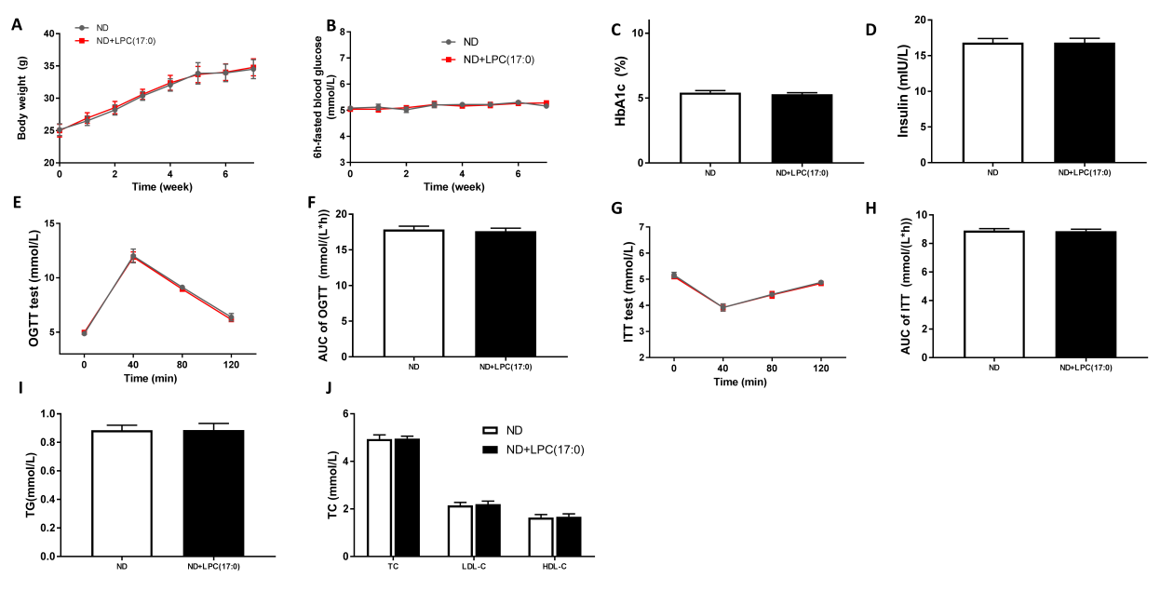
Figure S2 LPC (17:0) had no effect on the metabolic characteristics in normal-diet mice (A) Body weight, (B) 6h-fasted blood glucose, (C)HbA1c, (D) Plasma insulin, (E) OGTT and (F) AUC, (G) ITT and (H) AUC, (I) serum TG, (J) serum TC, LDL-C and HLD-C, Data are presented as the mean ± standard error of the mean (SEM); N = 5 mice per group.

Figure S3 LPC (17:0) inhibited the appetite of HFD mice.

